Latihan Modul 5

Alyaa

2022-09-26

## R Markdown

This is an R Markdown document. Markdown is a simple formatting syntax for authoring HTML, PDF, and MS Word documents. For more details on using R Markdown see <http://rmarkdown.rstudio.com>.

When you click the **Knit** button a document will be generated that includes both content as well as the output of any embedded R code chunks within the document. You can embed an R code chunk like this:

summary(cars)

## speed dist   
## Min. : 4.0 Min. : 2.00   
## 1st Qu.:12.0 1st Qu.: 26.00   
## Median :15.0 Median : 36.00   
## Mean :15.4 Mean : 42.98   
## 3rd Qu.:19.0 3rd Qu.: 56.00   
## Max. :25.0 Max. :120.00

## Including Plots

You can also embed plots, for example:



Note that the echo = FALSE parameter was added to the code chunk to prevent printing of the R code that generated the plot.

library (dslabs)  
data ("murders")  
murders$state

## [1] "Alabama" "Alaska" "Arizona"   
## [4] "Arkansas" "California" "Colorado"   
## [7] "Connecticut" "Delaware" "District of Columbia"  
## [10] "Florida" "Georgia" "Hawaii"   
## [13] "Idaho" "Illinois" "Indiana"   
## [16] "Iowa" "Kansas" "Kentucky"   
## [19] "Louisiana" "Maine" "Maryland"   
## [22] "Massachusetts" "Michigan" "Minnesota"   
## [25] "Mississippi" "Missouri" "Montana"   
## [28] "Nebraska" "Nevada" "New Hampshire"   
## [31] "New Jersey" "New Mexico" "New York"   
## [34] "North Carolina" "North Dakota" "Ohio"   
## [37] "Oklahoma" "Oregon" "Pennsylvania"   
## [40] "Rhode Island" "South Carolina" "South Dakota"   
## [43] "Tennessee" "Texas" "Utah"   
## [46] "Vermont" "Virginia" "Washington"   
## [49] "West Virginia" "Wisconsin" "Wyoming"

data = nchar(murders$state)  
for (x in 1:length(data)){  
 if(data[x] > 8 ){  
 new_names = murders$abb[data[x]];  
 print(new_names)  
 }  
}

## [1] "FL"  
## [1] "GA"  
## [1] "ME"  
## [1] "DC"  
## [1] "ID"  
## [1] "DC"  
## [1] "GA"  
## [1] "ID"  
## [1] "FL"  
## [1] "FL"  
## [1] "IL"  
## [1] "HI"  
## [1] "HI"  
## [1] "HI"  
## [1] "IL"  
## [1] "HI"  
## [1] "DC"  
## [1] "FL"  
## [1] "ID"  
## [1] "DC"

sum_n <- function(x) {  
 s <- sum(x)  
 n <- length(x)  
 s+n  
}

s <- 0  
sum_n(1:5000)

## [1] 12507500

compute_s_n <- function(x){  
 s <- sum(x)  
 n <- length(x)  
 s+n  
}

compute_s_n(1^2+2^2+3^2+4^2+5^2+6^2+7^2+8^2+9^2+10^2)

## [1] 386

compute_s_n(1^2+10^2)

## [1] 102

compute <- function(n) {  
 x <- 1:n  
 sum(n)  
}

for (i in 1:25) {  
 print(i)  
}

## [1] 1  
## [1] 2  
## [1] 3  
## [1] 4  
## [1] 5  
## [1] 6  
## [1] 7  
## [1] 8  
## [1] 9  
## [1] 10  
## [1] 11  
## [1] 12  
## [1] 13  
## [1] 14  
## [1] 15  
## [1] 16  
## [1] 17  
## [1] 18  
## [1] 19  
## [1] 20  
## [1] 21  
## [1] 22  
## [1] 23  
## [1] 24  
## [1] 25

m <- 25  
s_n <- vector("numeric", 25)  
for(n in 1:m){  
 s_n[n] <- compute(n)  
}  
s_n

## [1] 1 2 3 4 5 6 7 8 9 10 11 12 13 14 15 16 17 18 19 20 21 22 23 24 25

n <- 1:m  
plot(n, s_n)

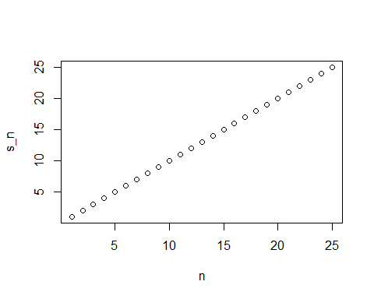

x<- 1:25  
sapply(x, sqrt)

## [1] 1.000000 1.414214 1.732051 2.000000 2.236068 2.449490 2.645751 2.828427  
## [9] 3.000000 3.162278 3.316625 3.464102 3.605551 3.741657 3.872983 4.000000  
## [17] 4.123106 4.242641 4.358899 4.472136 4.582576 4.690416 4.795832 4.898979  
## [25] 5.000000

n <- 1:25  
x_n <- sapply(n, compute_s_n)  
x_n

## [1] 2 3 4 5 6 7 8 9 10 11 12 13 14 15 16 17 18 19 20 21 22 23 24 25 26