LatihanModul4

Alyaa

2022-09-20

## R Markdown

This is an R Markdown document. Markdown is a simple formatting syntax for authoring HTML, PDF, and MS Word documents. For more details on using R Markdown see <http://rmarkdown.rstudio.com>.

When you click the **Knit** button a document will be generated that includes both content as well as the output of any embedded R code chunks within the document. You can embed an R code chunk like this:

summary(cars)

## speed dist   
## Min. : 4.0 Min. : 2.00   
## 1st Qu.:12.0 1st Qu.: 26.00   
## Median :15.0 Median : 36.00   
## Mean :15.4 Mean : 42.98   
## 3rd Qu.:19.0 3rd Qu.: 56.00   
## Max. :25.0 Max. :120.00

## Including Plots

You can also embed plots, for example:



Note that the echo = FALSE parameter was added to the code chunk to prevent printing of the R code that generated the plot.

## import dataset

library(dslabs)  
data('murders')

murders$population

## [1] 4779736 710231 6392017 2915918 37253956 5029196 3574097 897934  
## [9] 601723 19687653 9920000 1360301 1567582 12830632 6483802 3046355  
## [17] 2853118 4339367 4533372 1328361 5773552 6547629 9883640 5303925  
## [25] 2967297 5988927 989415 1826341 2700551 1316470 8791894 2059179  
## [33] 19378102 9535483 672591 11536504 3751351 3831074 12702379 1052567  
## [41] 4625364 814180 6346105 25145561 2763885 625741 8001024 6724540  
## [49] 1852994 5686986 563626

pop <- murders$population

index <- order(pop)  
order(index)

## [1] 29 5 36 20 51 30 23 7 2 49 44 12 13 47 37 22 19 26 27 11 33 38 43 31 21  
## [26] 34 8 14 17 10 41 16 48 42 4 45 24 25 46 9 28 6 35 50 18 3 40 39 15 32  
## [51] 1

min(murders$total)

## [1] 2

i_min <- which.min(murders$total)  
murders$state[i_min]

## [1] "Vermont"

min(murders$population)

## [1] 563626

i_min <- which.min(murders$population)  
murders$state[i_min]

## [1] "Wyoming"

temp <- c(35, 88, 42, 84, 81, 30)  
city <- c("Beijing", "Lagos", "Paris", "Rio de Janeiro",  
"San Juan", "Toronto")  
city_temps <- data.frame(name = city, temperature = temp)

ranks<- c(city_temps)  
ranks

## $name  
## [1] "Beijing" "Lagos" "Paris" "Rio de Janeiro"  
## [5] "San Juan" "Toronto"   
##   
## $temperature  
## [1] 35 88 42 84 81 30

country <- c("Korea", "Jepang", "Thailand", "Vietnam",  
"Australia", "singapore")  
ranking <- c(20, 25, 15, 40, 30, 35)  
my_df<- data.frame(country = country,ranking_rendah = ranking)  
my_df

## country ranking_rendah  
## 1 Korea 20  
## 2 Jepang 25  
## 3 Thailand 15  
## 4 Vietnam 40  
## 5 Australia 30  
## 6 singapore 35

ind <- order(my_df$ranking)  
my_df$ranking[ind]

## [1] 15 20 25 30 35 40

population_in_millions <- murders$population/log10(4999999)  
total_gun_murders <- murders$total  
plot(population_in_millions, total_gun_murders)

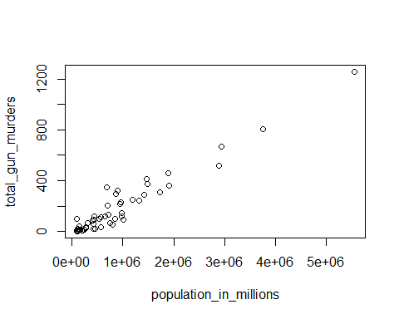

negarabagian<-with(murders,total_gun_murders/population_in_millions*4999999)  
hist(negarabagian)

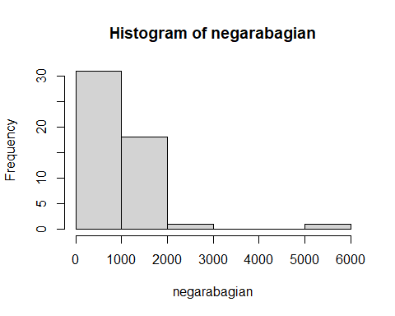

murders$rate<-with(murders,total_gun_murders/population_in_millions*4999999)  
boxplot(rate~region, data = murders)

