School of Informatics & Cybersecurity
  - Student Information
Student Number: B00169348 B00174351
Student Name:
Alya khalil Benjamin Oludipe

  - Module Information
Module Title:
network security
Module Code:H1001

  - Assessment Information
Assessment Title: Open Source Firewall Assignment CA 1

  - Declaration
☐ I confirm that I have read and understood the University’s Academic Integrity Policy.
https://www.tudublin.ie/explore/about-the-university/academic-affairs/academic-quality-assurance-and-enhancement/academic-integrity/
☐ I have completed the TU Dublin AI Driving License theory test.
https://www.tudublin.ie/explore/about-the-university/academic-affairs/lta/lta-resources/artificial-intelligence-driving-license/
☐ I declare that this assessment submission is my own work.
☐ I confirm that I have read and understood the AI traffic light system used as part of this assessment brief and I have adhered to the level of AI usage allowed for this assessment.

  - Student signature
  - Date:

School of Informatics & Cybersecurity 1
Introduction to NFtables 2
Network Architecture 2
Network topology diagram 3
NFtables Configuration 3
Testing Methodology and Results 4
Test 1: Testing defense measures against external network scanning 4
Test 2: Application-Layer Attack Mitigation 4
Test 3: Denial-of-Service Resilience 6
Discussion 7
Security Effectiveness 7
Problems encountered 7
Introduction to Ipfire 7
Network Architecture 8
Ipfire Configuration 8
Testing 9
Test 1: Stealth mode verification 9
Test 2: Internal Network Connectivity 10
Test 3: TCP service connection attempt 11
Problems encountered 11
Comparison of NFtables and IPfire 11
Conclusion 12
References 12

Introduction to NFtables
Firewalls are a fundamental tool for network security, it serves as the first line of defence against unauthorised access and any malicious attacks. The evolution of packet filtering reached a higher standard when it adopted the net filter project. NFtableswas originally designed to address the limitations of its predecessor such as IPtables or ip6tables, which had actually focused on the individual parts of packet filtering ”Nftables provides a similar and more unified infrastructure for packet filtering”(Wikipedia,2025). By integrating the functions of iptables into a system, netfilter offers a unified kernel system which simplifies and focuses on long term maintenance. The system architecture uses a new virtual machine to provide effective and adaptable packet filtering along with enchanted syntax. There are many significant benefits such as better rule updating and dual stack architecture for complex rules with an improved performance. NFtablesis the cutting edge standard and integrated evolution for firewalls and even complex network policies on Linux systems.

Network Architecture
A three virtual machine topology was constructed by me using oracle virtual box to stimulate a network environment
Kali linux : Stood for an external attacker, configured with Host-Only networking to simulate an untrusted external network for the purpose of this assignment
NFtables firewall: Served as the network gateway with two adapters, separating the internal and external network
Internal Ubuntu Server: Hosted Apache web services which was being protected by the firewall

Network topology diagram
Kali Linux (ATTACKER)(192.168.56.3) | Firewall  (192.168.3.1)  (10.0.0.1) | Internal Server  (10.0.0.1)

NFtables Configuration
The firewall was configured with a security first approach, I first implemented a default accept policy for any legitimate traffic. In future 1 it shows the key configurations
Figure 1

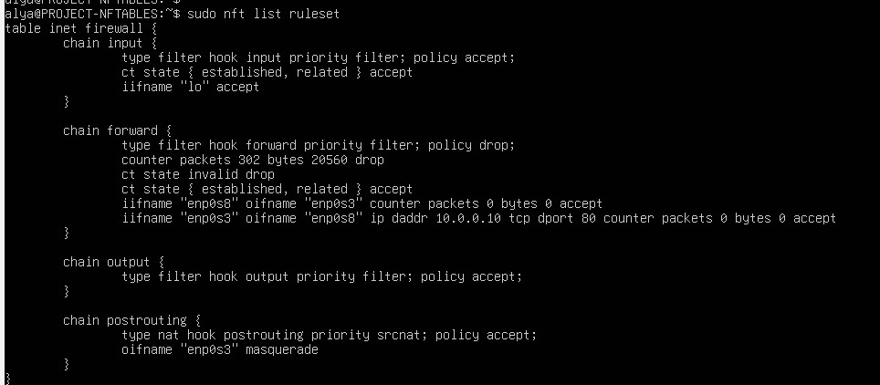
Firewall configuration has logic split across different chain, the input,forward,output and postrouting all which provide a specific function in a firewall. The input chain allows traffic that is either established or a related connection and accepts packets from a loop back interface. The forward chain is the most important chain as it controls all the data traffic flowing between the network interfaces of the internal server and external servers. The forward chain is set to a drop policy blocking all traffic unless it’s an established connection and dropping invalid packets. The forward chain also allows traffic from enp0s3 or enp0s8 directed to the internal server to allow access to the web server. The output chain accepts all outbound traffic generated by the firewall this allows unrestricted communication from the host.and lastly the postrouting chain includes a NAT masquerading rule which allows the internal server to share the Ips public IP for outbound connections. Together these chains create a strong perimeter defence which allows necessary functionality while enforcing strict rules between different networks (STD, rocks, 2024) (Anderson & Moldstud research team, 2025)

Testing Methodology and Results
This section of the report asses the firewalls ability to resist external attempts to find any active hosts, open ports and available services within the protected network. Resistance from a network that is being scanned ensures that the firewall will conceal the internal network topology and hide majority of the important information that is exposed to potential attackers during network probing efforts (TeachMeNetworking, n.d)

Test 1: Testing defense measures against external network scanning
Procedure: Nmap was employed from the Kali attacker system to scan against and through the firewalls external interface and the internal web server.
Figure 2: nmap results against firewall
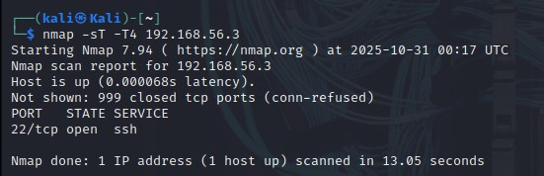
Figure 3: nmap results through firewall
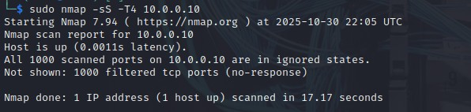
Results: The scan results demonstrated the firewalls effective port stealth capabilities. The initial attack against the firewalls external interface which is shown in figure 2 showed that it returned with minimal information but still told us there was a host up. Nmap reported all ports as Filtered with only port 22 responding. This shows that the firewall effectively blocks unsolicited probes and does not reveal unnecessary open ports.

Test 2: Application-Layer Attack Mitigation
This test asses the effectiveness of the firewall against application layer attacks like brute forcing and automated http scanning. With this test I aim to see if the firewall can identify and block malicious web based requests. It also assesses how well the firewall prevents attackers from gathering information of exploiting vulnerabilities within the networks web server.
Procedure: the dirb tool was used to perform directory probing against the internal web server, followed by rapid sequential HTTP requests to simulate automated attack behaviour.
Figure 4: Dirb attack results
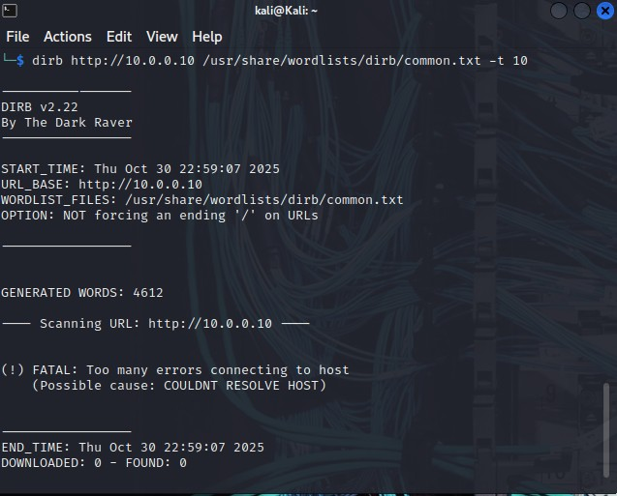
Figure 5: Rapid HTTP request results
[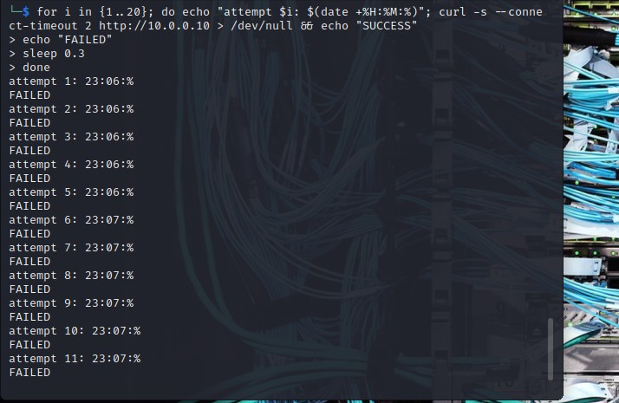
Analysis: The results show the rapid HTTP request test showed consistent failures across all attempts by blocking harmful traffic at the network layer. Although this indicates strong security, it also shows a limitation: the firewall cannot tell harmful application traffic from useful application traffic without performing a deeper inspection.

Test 3: Denial-of-Service Resilience
Evaluating the firewalls stability, resource management and packet handling under flood attack conditions while ensuring that internal services remains available.
Procedure: A SYN flood attack was launched against the firewall's external interface using hping3, During the attack, internal service availability was monitored through system performance metrics.
Figure 6: hping3 attack results
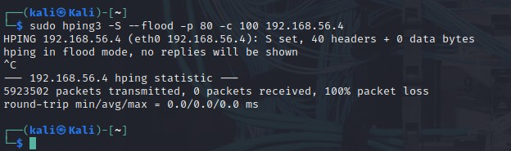
Figure 7: Internal service availability
Analysis: nftables exhibited remarkable resilience during DoS attacks by effectively processing and dropping harmful packets while still safeguarding the target services. Internal services remained fully operational; throughout the attack while the firewall kept the system stable

Discussion

Security Effectiveness
With proper configuration, testing showed that nftables can be a very efficient packet filtering solution. The strong security guarantees from the default deny stance, along with explicitly defined allow criteria, shows prevention of all unauthorized access while still allowing useful functionality. Provided the attack conditions, the stability and resource functionality of the firewall were truly remarkable. More importantly, the testing underscored the need for specific rule determination. The initial period of misconfiguration would either provide too much access or render the service entirely inoperative, emphasizing the intricacies of the firewall's operation, and the necessity for careful pre production testing.

Problems encountered
Practical challenges were overcome during this assignment. The first issue I had encountered was network misconfiguration. The internal server was initially isolated because of an incorrect /32 subnet mask instead of a /24 mask. When assigning IPs I forgot to put a subnet mask therefore allowing it to automatically give one, an incorrect one. Another ip conflict was between the kali and firewall vms, both had been on the same adapters giving it the same IP address, this was resolved by moving kali onto a host only network.
Firewall policy error was another issue that was encountered, the initial nftables ruleset used a policy accept for the forward chain which did not block any traffic. This was corrected with a secure policy drop with specific allow rules

Introduction to Ipfire
Ipfire has been recognised as a streamlined and efficitent option when compared to OPNsense, as it’s easier to deploy and maintain.(RS Inc, n.d.) A key strength is its colour-coded zone architecture system (Green, Red, Orange, Blue networks), each serving different roles in network segmentation. (IPFire, n.d. Installation) while reducing the risk of potential cross-network exploitation. This type of structure allows for the simplicity of managing traffic trust levels, this allows for fine control over how the internal devices, wireless networks, DMZ systems, and external traffic. Ipfire uses a distinctive web based management interface. It also has an integrated Intrusion Detection System (IDS), an automatic online rule update which enhances its ability to detect, analyze, and respond effectively to evolving network threats.

Network Architecture
The three virtual machine topology I made consisted of using Oracle VirtualBox, Kali Linux and Internal Ubuntu Server.
Kali Linux adapter – Host only: This was the external attacker, which was configured with Host-only networking to simulate an untrusted external network for this project.
Ipfire – Adapter 1 – Internal Network GREEN was the network gateway which is the same virtual switch that is connected to the Ubuntu Server.
Adapter 2- Internal Network RED, is host only, the red interface was connected to the host, the physical network which can access the internet.
Internal Ubuntu Server ADAPTER – Internal Network: Hosted the Apache web services, which was protected by internal infrastructure.

Network topology diagram
Kali Linux (ATTACKER)(192.168.3.10) → | IPFirewall  RED (192.168.3.1) →  GREEN (192.168.1.1) → | Internal Server  (192.168.1.100)

Ipfire Configuration
The Ipfirewall is configured with a security first approach, which is implementing a default deny policy which has explicit allow rules for all legitimate traffic.
Figure 1.
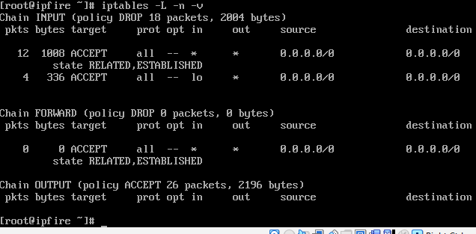

This configuration uses a structured chain based architecture. The chain input processes the incoming traffic which is directed to the firewall itself. They both maintain a drop policy. This helps the firewall system remain secure against unsolicited external access. The forward chain also has a drop policy, which blocks all the internal network communication by default. The output chain has an accept policy which is for all the outbound traffic that is generated by the firewall. This makes sure that communication is not restricted.

Testing

Test 1: Stealth mode verification
Procedure: Nmap was employed by Kali Linux (The attacker) to perform a series of scans targeting the Ipfire firewalls.

Figure 2: Nmap scanning through the firewall to internal server
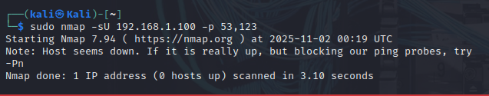
Results: The result of 0 hosts up indicates that the firewall is functioning at an optimal level for protection. This means that Kali cannot determine whether the internal server is online or reachable. The firewall is effectively dropping all probes sent to ports. The firewall blocks unauthorised access but also conceals the presence of an internal system.

Test 2: Internal Network Connectivity

Figure 3: internal network connectivity
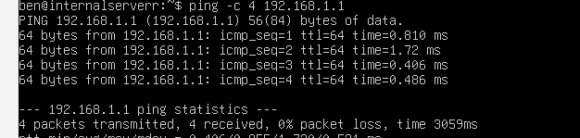:
Figure 4: local service verification
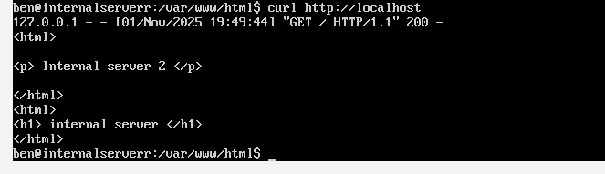
Figure 5 :kali trying to ping web server
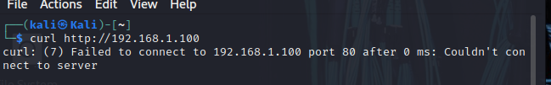
Results: The tests shown in both figures 3 and 4 were successful this highlights the firewalls strategic positioning and how the internal server can perfectly access the web server locally or within the same network, but it remains inaccessible from external networks as shown in figure 5. This proves that the firewall is acting correctly just as it was configured to.

Test 3: TCP service connection attempt

Figure 6:
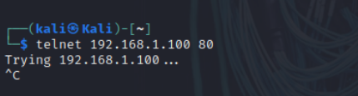
Results: this demonstrates optimal firewall security behaviour through silent packet dropping. As shown in figure 6, the telnet command keeps loading but never gives a result. It confirms that the firewall is actively intercepting and discarding tcp packets trying to go to port 80. This prevents attackers from gathering any information from internal servers as they see no feedback what so ever.

Problems encountered
Network segmentation challenges were found early in the assignment, my adapters originally were placed on VMS of the same network because I didn't change the names for different networks. In the beginning I set all the adapters to an internal network allowing direct communication between kali and internal server which then allowed kali to ignore the firewall completely and successfully attack the internal server. As the traffic was ignoring the firewall the security rules could not be enforced at all.Another issue I encountered was that when ipfire was rebooted when I shutdown the vm it required rule configuration after each system restart which had taken a lot of time and efforts in the long run and in the real world wouldn't be effective.The last issue that I had encountered was when the apache web service on my internal server wouldnt properly install. I had to use the python web server instead for testing purposes but regardless still worked good.

Comparison of NFtables and IPfire
Nftables and IPfire are powerful firewalls that are use to secure networks from malicious attacks. They also truly differ as they operate at different levels and serve different purposes. Nftables serve as a packet filtering frame work at a kernel level that is integrated into Linux systems. This provided administrators with efficient control over network traffic thought a command line configuration(SW team,2024). In comparison to IPfire it’s a complete firewall that has been built on top of Linux offering a web based interface that makes management of complex security tasks easier. While NFtables emphasises flexibility and custom rule creation, IPfire focuses on accessibility, and ease of use and integrated security features such as instruction detection.
NFtables is a low level, command line framework which is intended for expriences network admins who would usually require a lot of control over packet filtering and traffic flow. It operates within the Linux kernel meaning its lightweight and fast but it does need a lot of knowledge. In contrast IPfire is a complete high level firewall operating system that provides and al in one platform for managing network security through a GUI. While nftables focuses mostly on packets and rule enforcing, Ipfire actually integrates multiple layers of defense and real time traffic. These differences make it very ideal for administrators who value high performance configurations. To the Ipfire community, it is stable enough for business use (Ipfire community, 2024)
In summary NFtables is best suited for Linux environments where an administrator would need complete control over firewall rules and network behaviour. It’s flexibility makes it ideal for any custom built security. On the other hand Ipfire is a more suitable for small to medium sized networks, or home users who would require a strong protection. It is a user interface and has an easy maintenance making it a practical choice as it has minimal configuration effort.

Conclusion
This project conveys what both nftables and Ipfire can accomplish as fully equipped firewalls. For nftables, a comprehensive range of tests were implemented across multiple attacks, such as testing defense measures against external network scanning, application layered attacks and denial of service resilience.
Tests for nftables showed strong implementation, efficient packet filtering while integrating the firewall capabilities effectively.For Ipfire we conducted various tests such as stealth mode verification, internal network connectivity, and tcp service connection attempts.
Tests for Ipfire showed scans against external RED interface, showing how the firewall effectively hid its presence and dropped unautherised probes. Connectivity from internal GREEN and its direct connection attempts to the internal Ubuntu server’s web service, validated the port forwarding rules by successfully allowing external access to the web service on port 80. while scans confirmed all other ports were securely filtered. This all demonstrated how the firewall was successfully enforced showing that only explicit defined traffic was permitted across all network segments.

RS Inc. (n.d.) IPFire is an OPNsense alternative actually worth trying out. Available at https://www.rsinc.com/ipfire-is-an-opnsense-alternative-actually-worth-trying-out.php

References

Wikipedia,2025,nftableshttps://en.wikipedia.org/wiki/Nftables

Debian wiki,2025,nftableshttps://wiki.debian.org/nftables

Std,rocks,2024 https://std.rocks/gnulinux_nftables_commands.html

TeachMeNetworking, n.d A Comprehensive Guide to Conducting Firewall Testing and Analyzing Test Results

Anderson & Moldstud research team, 2025 Building a Firewall with nftables for Linux Security | MoldStud

Houelecauarcy,I,2023https://medium.com/@ihouelecaurcy/the-complete-nftables-guide-modern-linux-firewall-mastery-79fb86894d5c

Ipfire community, 2024 Benefits of IPFire over other Open Source solutions - IPFire Community

SW team,2024 nftables: A Deep Look at Linux Security - SW Hosting's Blog

IPFire (2025.) Installation — Step 5: Network Setup. https://www.ipfire.org/docs/installation/step5
IPFire (2025) Configuration — Firewall / IPS. https://www.ipfire.org/docs/configuration/firewall/ips
HackersOnlineClub (2019) Linux Distribution Intrusion Prevention System IPFire 2.23v … https://hackersonlineclub.com/linux-distribution-intrusion-prevention-system-ipfire/
IPFire Community (n.d.) Should admin interface be available on RED? https://community.ipfire.org/t/should-admin-interface-be-available-on-red/8861
IPFire (n.d.) Configuration — Firewall / Default Policy. https://www.ipfire.org/docs/configuration/firewall/default-policy
IPFire (n.d.) Configuration — Firewall Rules. https://www.ipfire.org/docs/configuration/firewall/rules

