

Members:
Alya khalil
Hanein atalla
Marco kunda
Benjamin oludipe

Contents
School of Informatics & Cybersecurity - Assessment Submission Coversheet 2
Completed Challenges 5
Individual contributions: 8
Vulnerability Analysis 11
SAST Testing 39
DAST Testing 43
References 47

Total Word Count: 7314

Completed Challenges

OWASP JuiceShop Scoreboard screenshot
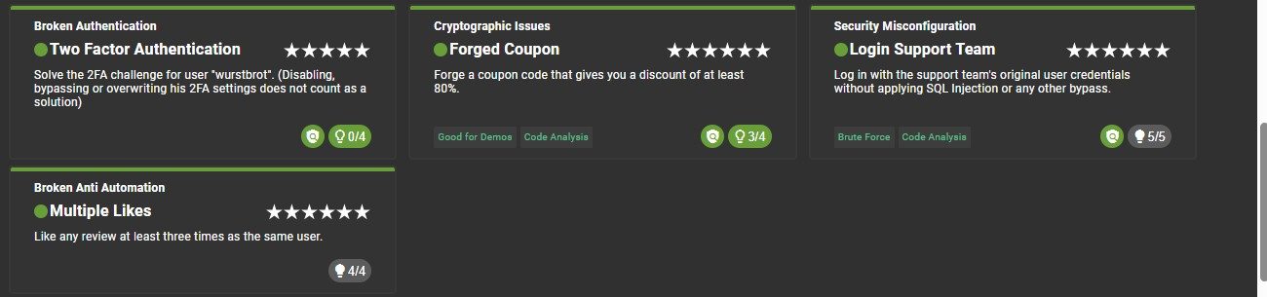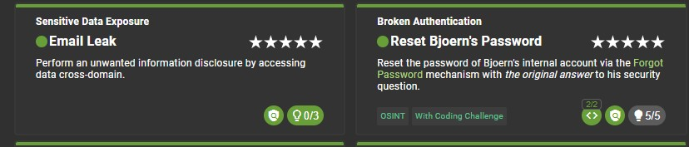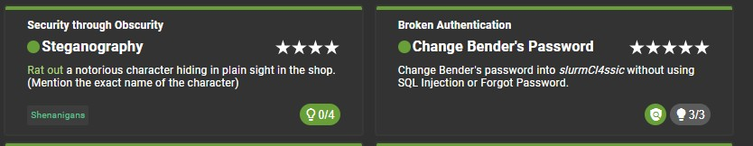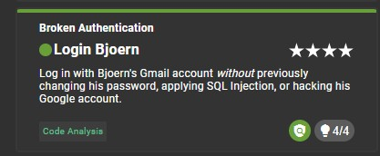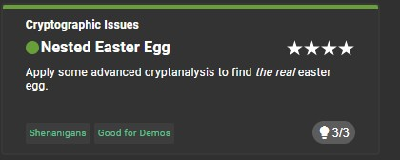

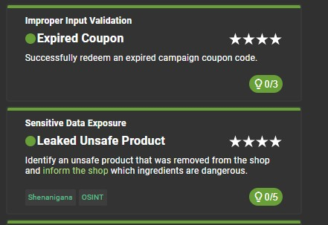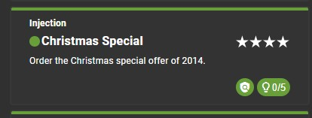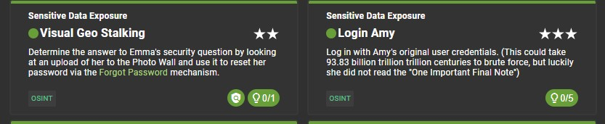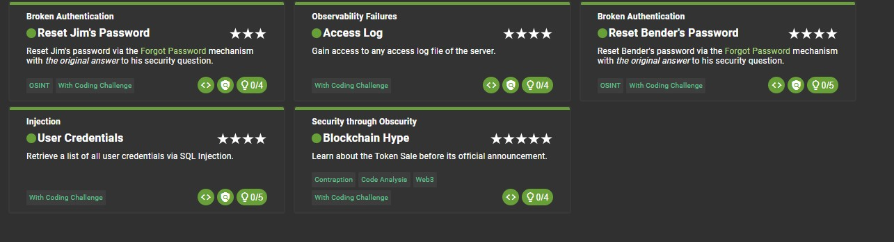

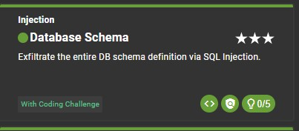

Individual contributions:

Challenge ID | Vulnerability | Student  Responsible | Evidence | Mitigation Proposed
Forged coupon | Cryptographic Failures | Alya khalil | Scoreboard screenshot, forged code applied | HMAC- aigned  server side coupon generation
Two factor authentication | Broken  Authentication | Alya khalil | Scoreboard screenshot, TOTP secret recovery with backup codes | Encrypt secrets at rest, never expose in API responses
Expired coupon | Improper input | Alya khalil | Scoreboard screenshot, expired code applied, server side date bypass | Enforce an expiry check with the server UTC clock at redemption
Multiple likes | Broken antiautomation | Alya khalil | Scoreboard screenshot,burp suit repeater, inflated like count confirmed | Unique DB  constraint on user and review with the server side duplicate check
Blockchain hype | Security misconfiguration | Alya khalil | Scoreboard screenshot,hidden route found with JS bundle keyword search in developer tools | Enforce a server side authorisation when it comes to  all routes regardless of navigation exposure
Email leak | Sensitive Data Exposure | Benjamin oludipe | Scoreboard screenshot | Mask or redact sensitive data from API responses; enforce leastprivilege data exposure
User credentials | Injection | Benjamin oludipe | Scoreboard screenshot | Parameterised queries and prepared

 |  |  |  | statements; reject unsanitised user input server-side
Access log | Observability Failures | Benjamin oludipe | Scoreboard screenshot | Restrict access log endpoints behind authentication; never expose server logs to unauthenticated  users
Steganography | Security through Obscurity | Benjamin olduipe | Scoreboard screenshot | Audit all publicly served static assets; never store sensitive or embedded data in publicly accessible directories
Change benders password | Broken  Authentication | Benjamin oludipe | Scoreboard screenshot | Enforce serverside current password verification before accepting any password change request
Database schema | Injection | Marco kunda | Scoreboard screenshot, union select injection in search bar to expose database schema | Use prepared statements to prevent raw user input reaching database queries
Leaked unsafe product | Sensitive Data Exposure | Marco kunda | Scoreboard screenshot, SQL injection revealed deleted product with dangerous ingredients, reported via feedback form | Permanently delete sensitive records and block search queries from accessing deleted data
Visual geo stalking | Sensitive Data Exposure | Marco kunda | Scoreboard screenshot, identified  company logo "ITsec" visible in Emma's photo wall image, used as security question answer in Forgot Password | Never use workplace/location info as security questions, strip metadata and identifying details from user uploaded images

Login amy | Sensitive Data Exposure | Marco kunda | Scoreboard screenshot, password found via GRC password padding guide, "One Important Final Note" warned against using dots as padding which Amy ignored | Enforce strong password policies  server side, reject  commonly  patterned  passwords, implement MFA
Reset benders password | Broken  Authentication | Marco kunda | Scoreboard screenshot, security question answer found via google search of futureama character | Replace security questions with time limited emil  reset links and  MFA
Login support team | Security  Misconfiguration | Hanein  Atalla | Scoreboard screenshot | Restrict admin routes with rolebased access control; return 403 for unauthorised roles; disable directory listing
Reset bjoerns password | Broken  Authentication | Hanein  Atalla | Scoreboard screenshot | Enforce identity verification before password reset; rate-limit reset attempts; invalidate all sessions on reset
Login bjoern | Broken  Authentication | Hanein  Atalla | Scoreboard screenshot | Enforce strong password policy; implement MFA; log and alert on credential-based login from new IP
Nested easter egg | Cryptographic Issues | Hanein  Atalla | Scoreboard screenshot | Replace weak/custom encoding with industry-standard encryption; do not rely on obscurity for access control
Christmas special | Injection | Hanein  atalla | Scoreboard screenshot | Parameterise all queries; sanitise and validate all user input; apply least-privilege
 |  |  |  | principle to DB account

Vulnerability Analysis
This project follows the assessment brief, we have picked two vulnerabilities per person for an in depth analysis. Forged coupon(6 stars), multiple likes (6 stars), stegnography (4 stars), change benders password(5 stars), visual geo stalking (2 stars),login amy(3 stars), login support team(6 stars), reset bjoerns password(5 stars) . these represent distinct types of vulnerability classes and they also require the most in depth investigation to understand exploit

Forged coupon (6 stars)
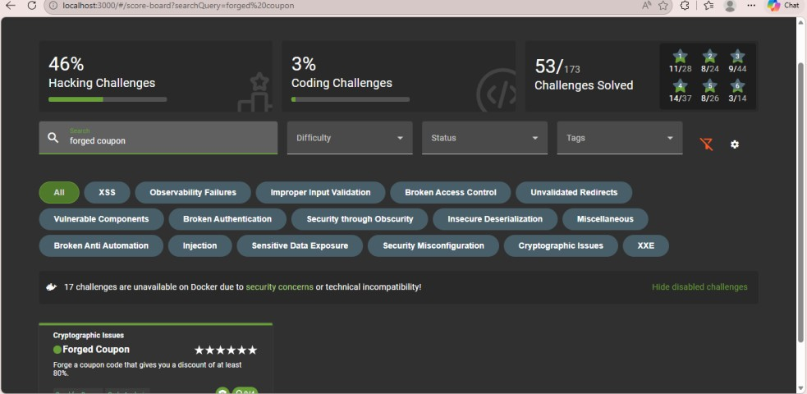
Vulnerability description and root cause
The forged coupon challenge does ecpose a cryptographic failure (owasp top 10 2021:A02)[1] within the coupon validation mechanism. The weakness maps roc we-327 which is use of a broken or risky cryptographic algorithm [2]. Instead of the coupons being issued as server generated sryptographically signed tokens, juice shop actually encodes a plaintext discount value and a date using a reversible Z85 scheme. There isn’t a record on the server record that links this coupon to a legitimate issuance event and also no digital signature to verify its integrity. Any attacker that understands the encoding can fabricate a coupon guaranteeing a discount without having any secret key
Rational and investigative process
The investigation first began by exec-ing into the docker container that I was using to run the juice shop instance, the command I ran was docker exec-it b9cbd85a5bbee27bc36c5feb46d995d800a0918b581cc6a5b75a9c939dfb3079
/nodejs/bin/node. This then launched a node.js repl that was running inside the applications environment. The z85 library was loaded already from the applicatopns node_modules using var z85=require(‘./node_modules/z85’). Doing this gave me access directly to the encoding function that the application was using internally to generate and validate any coupon codes.
This confirmed that this method was reversible but without any secret key
How the exploit works
This kind of exploit requires no special tools beyond node.js
- Exec into the juice shop docker container using docker exec-it b9cbd85a5bbee27bc36c5feb46d995d800a0918b581cc6a5b75a9c939dfb3079
/nodejs/bin/node to open a nose.js repl inside of my application environment
- Load the z85 library from the applications node_modules using var z85=require(‘./node_modules/z85’). The application uses this same library in its server side which confirms the encoding scheme
- I constructed a plaintext coupon string with the format MMYY-DISCOUNT and then encoded it using z85encode(Buffer.from(‘APR26-80’,’UTF8’)). That then gave me the code K#pDmhz3)x
- I then applied the forged code into the juice shop basket through the administrator account since it had card details saved to it and in order for this to work you put complete the order. The server accepted the coupon and applied a 80% discount.
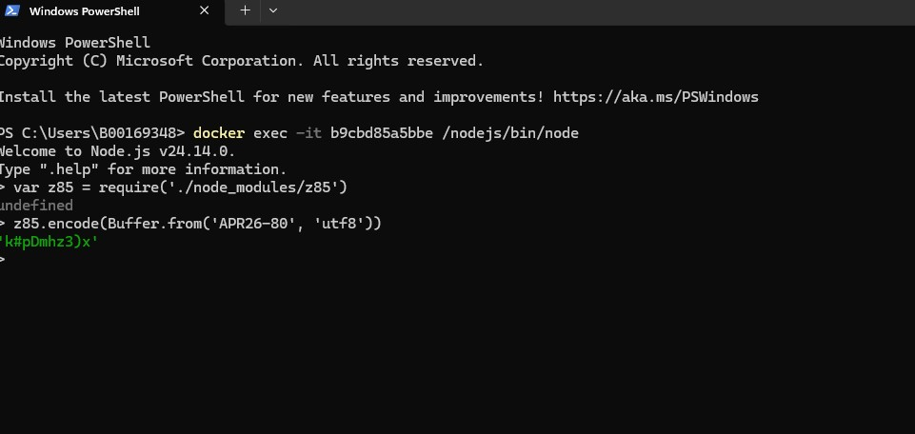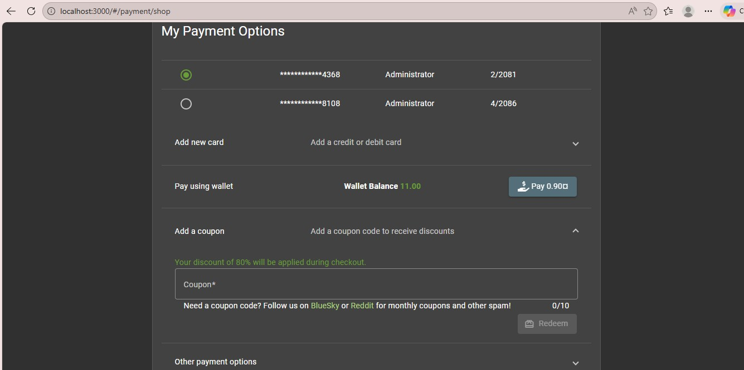
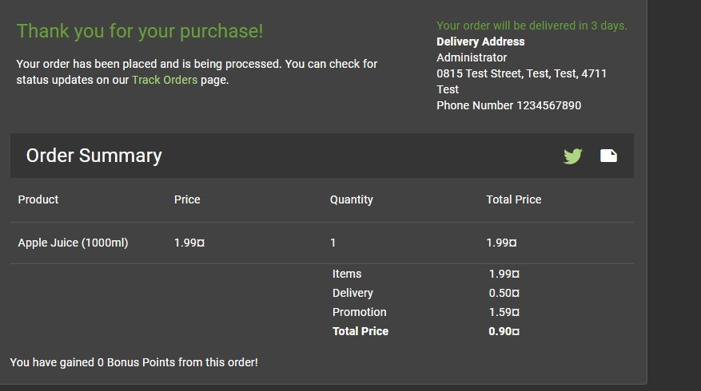
Potential impact
For a functional e-commerce application, such a vulnerability would mean that a fraudster will get free goods or products with close to no price. The reason behind this is that the fraudulent coupons would not be distinguishable from genuine ones on the server level. The consequences for a large-scale system can be massive, as such a loophole becomes publicly known. Such risks fit perfectly into the high severity rating set by OWASP [1].
Recommended mitigation
The coupon codes have to be generated server side using a CSPRNG and then stored in the database with their discount value, usage status and also the expiry date. I do think that validation should be a database lookup and not a decoding operation. This is where a stateless approach is really needed and codes should also be signed with a HMAC which uses a server held secret key so if any one tries to tamper or forge codes itll fail the integrity check. This is consistent with OWASP Proactive Control C8 [3] and ASVS V6 [4]. Other safeguards to consider are limiting the rate of coupon redemption calls and server side analysis for an abnormally high discount percentage.

Multiple likes (6 stars)
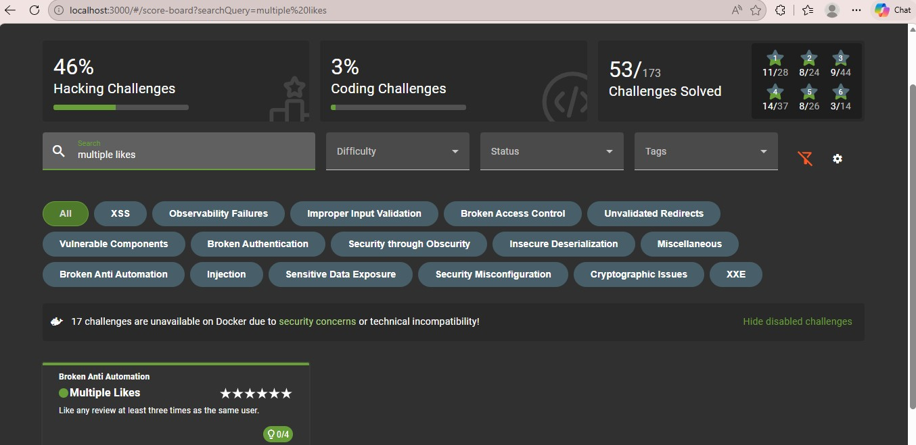
Vulnerability description and root cause
Multiple Likes vulnerability exploits flaws in mechanisms meant to protect against automation. The flaw belongs to CWE-799 category: Improper Control of Interaction Frequency [2] and is related to OWASP Top 10 Vulnerability A04: Insecure Design [1]. The solution used by the application depends only on UI-level protection – clicking on like button is disabled after a single click. Server side implementation of the API call handling likes does not verify if authenticated user has clicked like on review previously. As all clicks are treated independently, malicious client bypassing UI restrictions and sending multiple HTTP calls will be able to increase likes without any restrictions. It appears to be a vulnerability caused by design issues and restriction was applied in the presentation layer, rather than data layer.
Rationale and investigative process
The experiment started by submitting the review and liking it, followed by browsing the network tab in the Developer Tools of the browser. The GET request to
/rest/products/reviews showed the internal _id variable (Y9aYTDsZp9AMkwjJL) of the review along with likesCount=0 and empty likedBy array, indicating the server data structure. The Headers section of that GET request showed the entire JWT token in the format of Bearer. The next step was setting Burp Suite as intercepting proxy, where the POST request to /rest/products/reviews was captured and sent to Repeater in order to check whether multiple POST requests are acceptable. Due to the incompatibility of race-the-web tool to run in the Linux environment, a Python script (race.py) was developed using thread and requests modules for sending 10 POST requests at once to the endpoint.
How the exploit works
- Post a review on the product page and open the browser developer tools. In the actual network tab of the browser developer tools I inspected GET /res/products/reviews response to get the reviews _id value and the bearer jwt token from the request header
- I used burp suite as my interceping proxy and clicked the like button so that it would generate a post request to /rest/products/reviews and then I sent it to the repeater to make sure the endpoint processes the repeated requests without rejecting it
- In most cases race-the-web command would’ve worked but I found much difficulty to it so the work around was writing a python script (race.py) using the threading and request library. I hardcoded the endpoint URL, the review _id and the breaker token. I decided to spawn 10 threads that would call request.post() simultaneously to simulate multiple likes.
- I then ran the script with python3 race.py. the terminal then gave me the output of each thread receiving a success response with the likescount increasing and then the likedBy array growing even more with every request that it being sent out. This confirmed to me that the server processed every duplicate without any extra checks
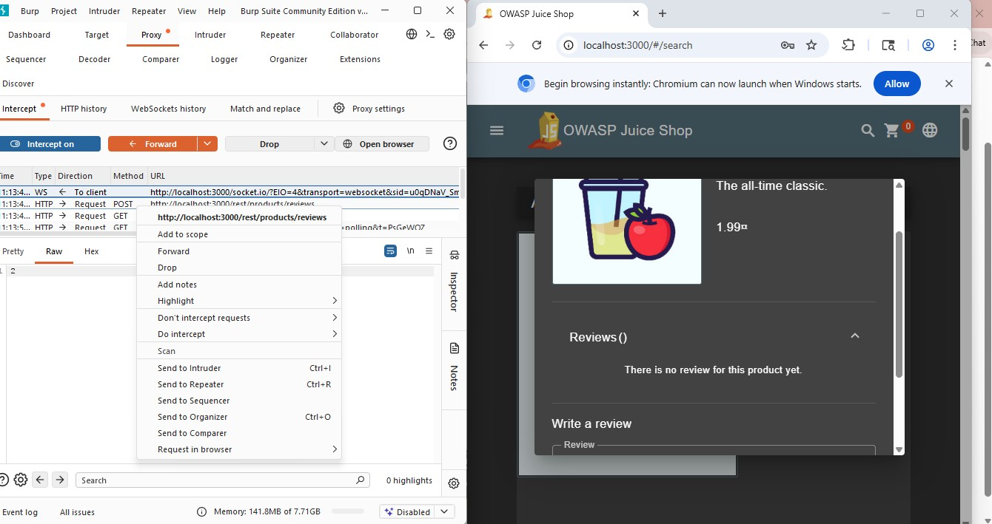

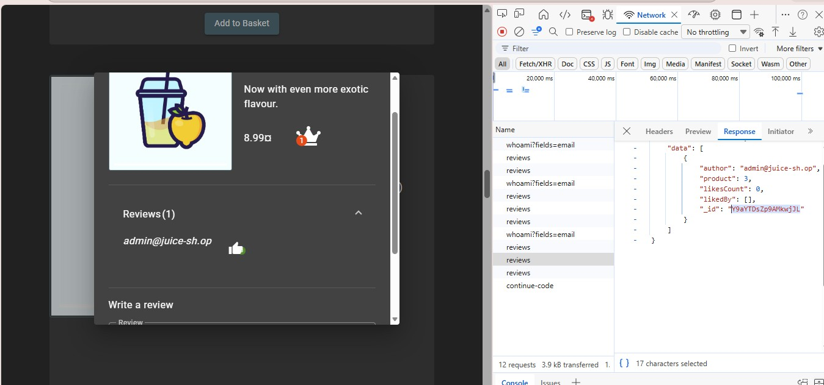
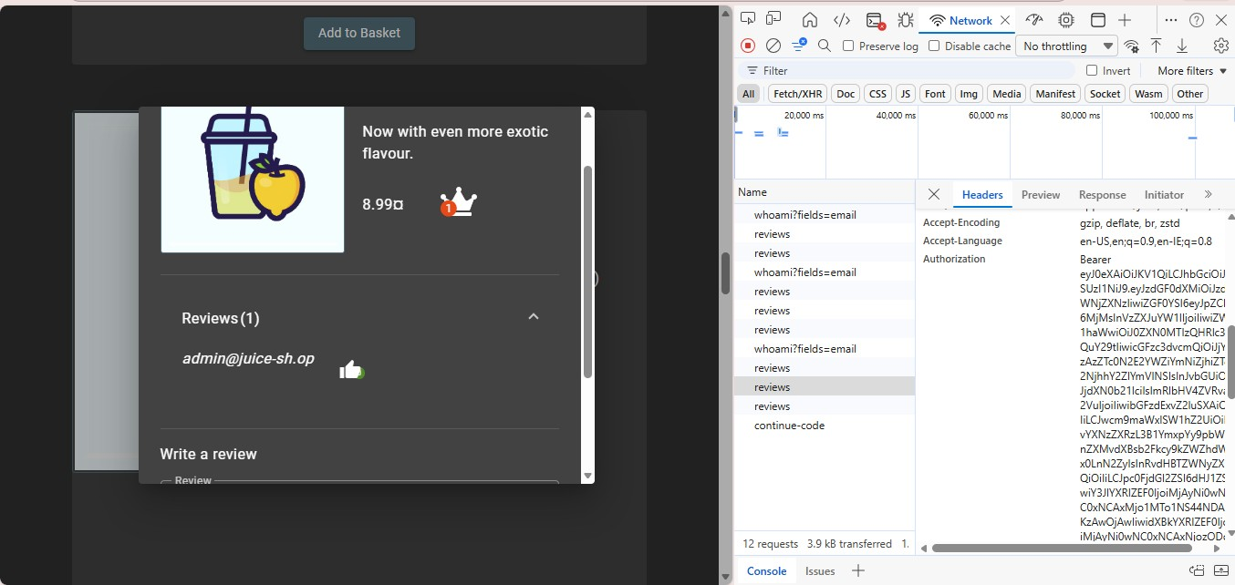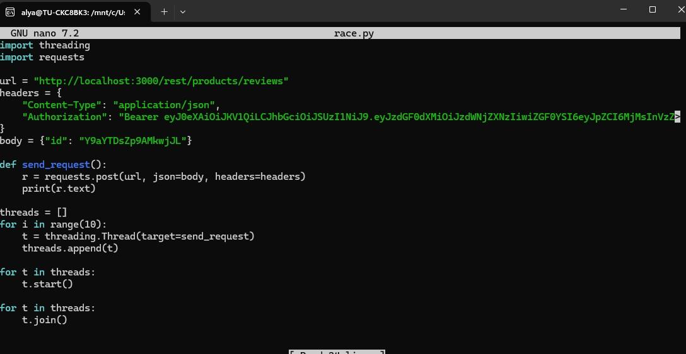

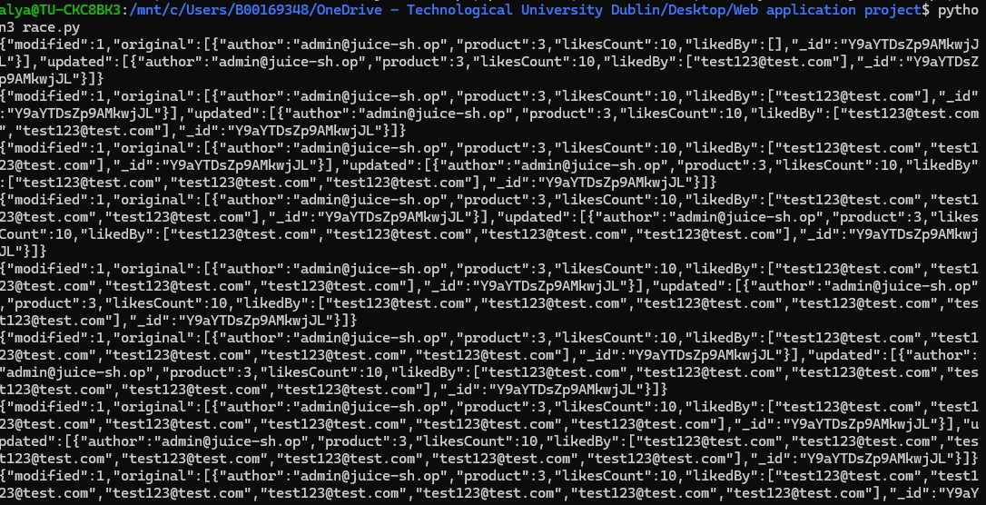

Potential impact
Exploitation of the anti-automation flaw in social functionality permits a malicious user to influence the ordering of product reviews by generating false positive likes, which misleads consumers and compromises the authenticity of the reviews. In large-scale operations, the automated exploit may also cause unnecessary loading of the database with fake entries, negatively impacting system efficiency. The OWASP Automated Threats project categorizes this attack as OAT-016 (Skewing).
Recommended mitigation
The solution lies in ensuring the uniqueness of the like at the database layer with the help of a unique constraint on the user id and review id combination. The endpoint must first check for an existing like and return an HTTP response 409 if that is the case. As a measure of defencein-depth to mitigate the risk of brute-forcing, rate-limiting can be implemented on the endpoint. This measure is recommended by OWASP Proactive Control C7 and ASVS V11 (Business Logic) [4]. Captcha might be required for some social interaction controls, though it needs to be used only as a secondary measure of protection.
In order to find the hidden route path, I performed a search inside the JavaScript bundle using keywords “blockchain” and “bitcoin”. Browsing to the route path when authenticated would cause a challenge. In order to avoid similar challenges, server-side authentication must be performed on all application paths irrespective of whether they have been made publicly available by the navigation system. Client-side code is never to be considered a security measure, because client-side code is entirely visible to the users.
Change Benders password 5 stars
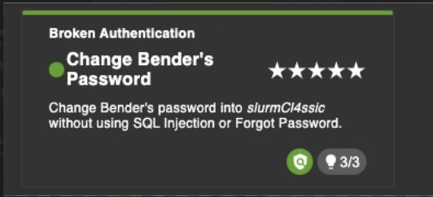
Vulnerability Description and Root Cause
The Change Bender’s Password challenge, you must expose a broken authentication vulnerability( OWASP Top 10 20221: A07) this is the applications password change mechanism. Which is directly pointing at an unverified password change. A proper password change required me to enter the current account before setting a new password that could be accepted. Juice shops /rest/user/change-password endpoint accepts a GET request carrying new passwords. This meant that any session, including the one obtained through another vulnerability would be sufficient to overwrite the accounts password. (excl. SQL injections or forget password) There is no server side reauthentication gate and the sensitive operations is exposed over a GET request rather than a state-changing POST.
Rationale and Investigate Process
I began my investigation by logging into the application as benders account(bender@juice.sh-op’--) with a random password (abc) I clicked into Benders account, I made my way to the change password section. I entered my current password and changed the password to abcd, it failed due to the password having to be between 5-20 characters long. I made it abcde, but I had no verification reaction by the web app. I entered my Burp suite and used my latest request and sent it into the repeater. I got a 401 unauthorised response. I got rid of the current password parameters which suggested the server was not enforcing this filed server side. I did a manual request by removing the current parameter entirely while retaining the sessions JWT in the authorisation header. I matched up the new and repeat password using Bender's challenge password slurmCl4ssic. The server responded with a HTTP 200 OK response confirming the password had been updated. This confirmed to me that the current password verification was not enforced. I then went back into my browser, I received the challenge successful notification.

How the exploit works
- I got a valid authenticated session for Benders account, using his email(Bender@juice.sh-op’--) I then configured the browser to route traffic through Burp suites proxy so that all requests would be intercepted.
- I went to the account and then navigated to the private and security channel and then went to change the password. The password change wasn’t thoroughly authenticating so I went to observe it in the Burp suite Proxy to intercept the application issues, a GET request to /rest/user/changepassword?current=<value>&new=<value>&repeat=<value>.
- I sent this intercepted request to Burp Suite Repeater. In the repeater tab, I modified the request by removing the value of the current parameter entirely, leaving it blank.
- I sent the modified request from the repeater. The server responded with HTTP 200 and a JSON body confirming the password update, it was accepted. This was despite the current filed being empty. This confirms the server no verification of the existing password.
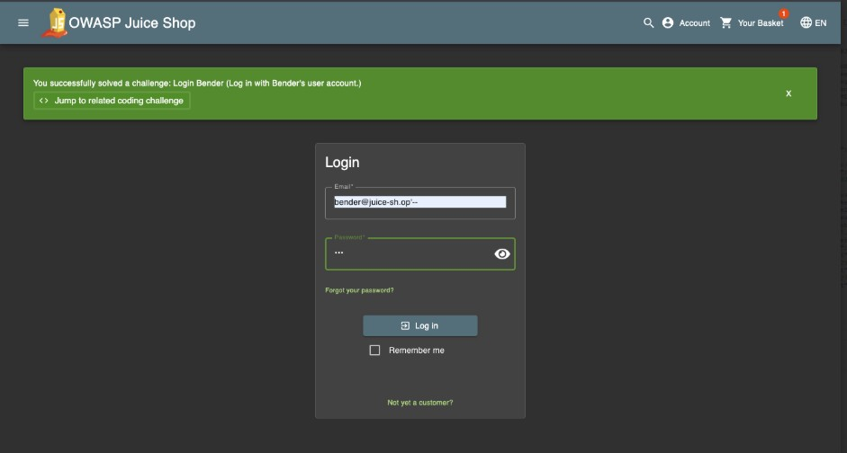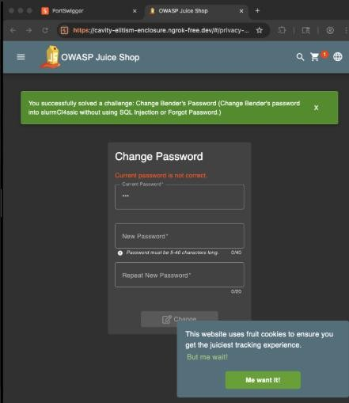

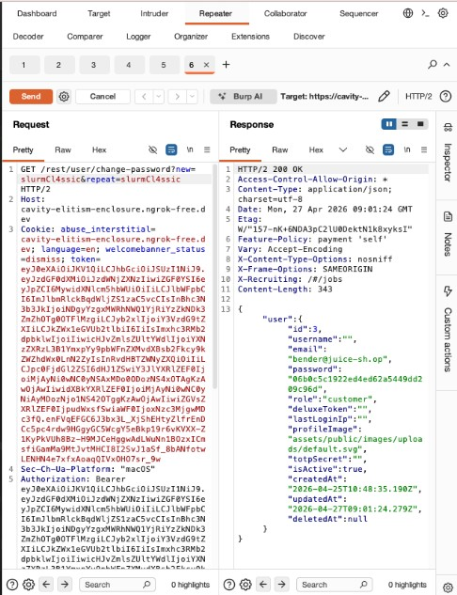

Potential Impact
In a real world production system, the vulnerability would allow any attacker with a valid session token, to slightly overwrite any accounts password and permanently lock out the legitimate owner. The sever does not verify the current password, the attacker requires no prior knowledge of the target’s credentials. The flaw is operation, the new password is exposed in browser history, server access logs, and any intermediate proxies. This aligns with the high severity classifications OWASP assign to broken authentication.

Recommended Mitigation
The password change endpoint requires the server side validate to the user’s current password before processing any update. This check must happen exclusively on the server. Any client side exclusion of the field, results in an explicit rejection with an error response. The endpoint must be migrated from GET to POST so that credentials are never exposed in URLs, or browsers history. A CSRF token should be bound to the form submission to prevent cross site request forgery against authenticated users. These controls are consistent with the OWASP Proactive control C6(Implement Digital Identity) and ASVS V2.1(Password security requirements) Sensitive account operations should also be enforced as defence in depth measure so even a stolen session cannot silently alter account credentials.

Stenography
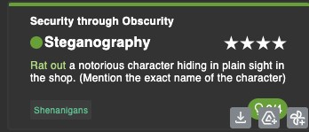
Vulnerability Description and Root Cause

This is the practice of concealing data in an ordinary looking carrier file, in this case a PNG image. This exposes security through obscurity weakness, which maps to OWASP top 10 2021: A05 (Security Misconfiguration) and CWE 653, Insufficient Compartmentalisation. The root cause is that a sensitive file, used a .png image with a hidden message embedded in it. Has been publicly deployed within the application’s static assets directory without any access restriction of its location. Stenography is not a direct vulnerability by itself but it within a web app that's publicly accessible shows a misconfiguration as sensitive data is hidden in plain site rather than truly being protected.
Rationale and Investigate Process
This investigation began by going to the About Us page of the Juice Shop application, has an image carousel. I had suspicions that the static images would be the problem, I used the browsers dev tools and the sources tab was inspected. Under assets/public/images/carousel, multiple files were visible, but one carried a .jpeg. That file used a .png. This is not normal for a carousel of compressed images ,warranted further checking. I clicked in the source panel on the PNG and its link address was copied and opened a new browser tab. The image appeared entirely ordinary on the surface, which helped my suspicion that data had been embedded using steganography. I saved the image locally, analysed it using openstego, a dedicated stegnography extraction tool, which confirmed that the hidden data had been embedded inside the file.
How the Exploit Works
- I went to the about us page of the Juice shop app. I opened the browser dev tools and inspected the page using the source tab.
- In the source panel, I expanded the directory path of assets/public/images/carousel. I viewed all the images in the folder and all were .jpeg except for 1 which was a .png extension.
- I right clicked on the PNG file in the sources panel and copied the link address. I opened the copied URL in a new browser tab. I right clicked the rendered image and selected save image, to download it locally.
- I opened Openstego, clicked extract data button. I set downloaded PNG as the input stenography file, selected a destination output folder. I left password blank as no password is required. I extracted the data.
- Opentstego confirmed with a message saying file was successfully extracted from the cover file, wrote an output image file to the selected folder. Opening the output file shows an image of Pickle Rick.
- assigned a star rating ,completed the Captcha, I submitted feedback and channel was solved.
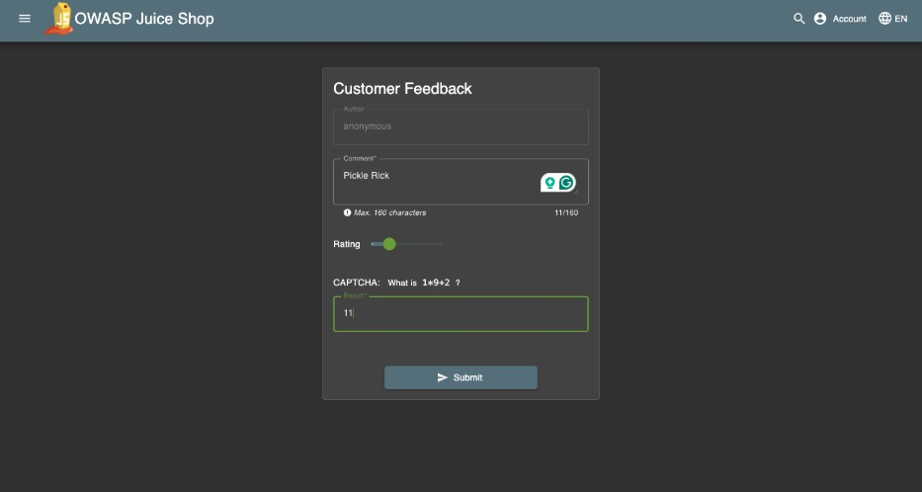
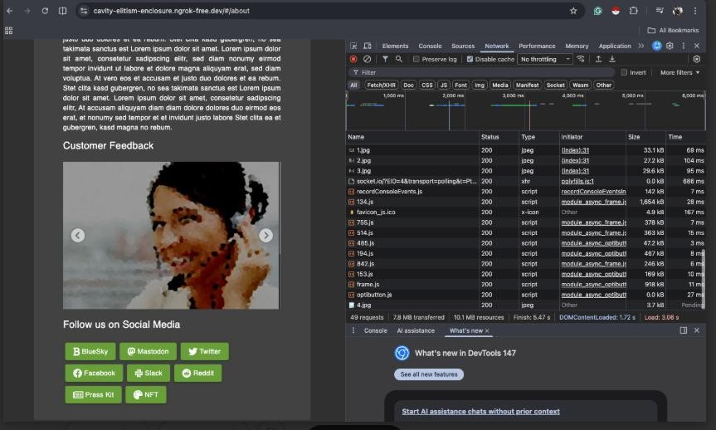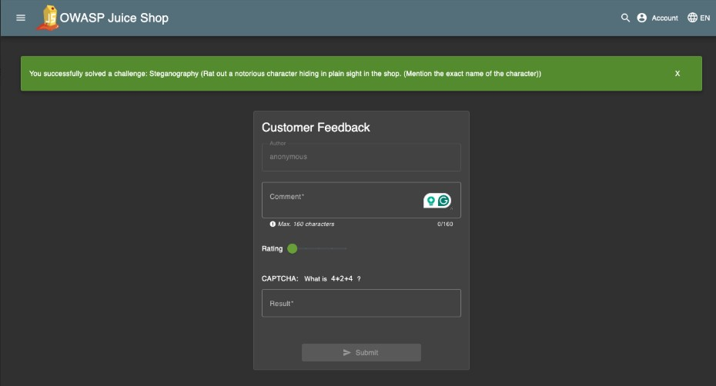
Potential Impact
In a real world app the presence of steganography embedded data in publicly saved static images could lead to multiple serious risks. E.g. Attacker who discovers hidden content, could uncover sensitive internal information. eliance on obscurity rather than proper access control means that once the files location is known and discovered through the browsers dev tools then there is no more barrier to extraction. This can be classified as a misconfiguration and also act as evidence of a broader poor security hygiene within a development team which hints at other sensitive images/ assets which may be similarly mishandled.

Recommended Mitigation
Sensitive data must never be stored publicly through accessible static images. Regardless of visibility within a file. Access to sensitive files should always be enforced through sever side access controls and real authentication. Static images.assets should be audited to ensure that no files beyond those strictly required by the front end are publicly reachable. Any file served from a public directory should be reviewed through a steganography analysis tooling as part of a pre deployment security review. These practices align with the OWASP proactive Control C4 (Encode and Escape data) and ASVS V2.6 (look up secret verifier requirements) and reflect the principle that security must not only rely on the attacker's ignorance of a system structure.

B00170260 Marco Kunda VISUAL GEO STALKING
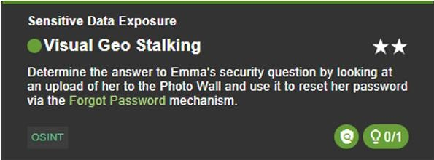
Vulnerability Description and Root Cause
This challenge is a good example of how something as simple as a photo upload can accidentally expose sensitive personal information. The vulnerability here is Sensitive Data Exposure - images uploaded to the Photo Wall contain hidden location data that anyone can get. This ties into OWASP Top 102021 - A02: Cryptographic Failures, which covers situations where sensitive data isn't protected properly, and CWE-200: Exposure of Sensitive
Information to an Unauthorised Actor. The reason this happens is because of EXIF (Exchangeable Image File Format) metadata. Whenever you take a photo on a phone or camera, the device quietly embeds extra information into the image file - GPS coordinates, the time it was taken, and what device was used. It's invisible when viewing the photo normally, but fully readable from the raw file. Juice Shop's problem is that when users upload photos, the application does nothing to remove this metadata before saving and displaying them. This is a design failure as nobody considered what hidden data might come in with uploads - and an implementation failure, since most image libraries won't strip EXIF data unless a developer explicitly tells them to.

Rationale and Investigative Process
The goal of this challenge is to find the answer to Emma's security question using a photo she uploaded to the Photo Wall, then use that answer to reset her password through the Forgot Password page. The challenge title "Visual Geo Stalking" combined with the OSINT category tag makes it clear that the answer could be found simply by investigating the photo itself. Since the challenge involves a real-world location, the best approach is to use Google reverse image search — a free tool that anyone can use — to identify where the photo was taken and link it to a specific place.
How the Exploit Works
Tools used: Google reverse image search
Steps taken:
- Go to /#/photo-wall and find Emma's uploaded photo
- Right-click the image and select Search image with Google
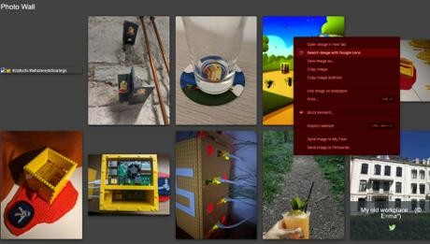
- Google identifies the location depicted in the photo, revealing Emma's former workplace.
- As Google only says where it’s located, we take a closer look deeper into the photo.
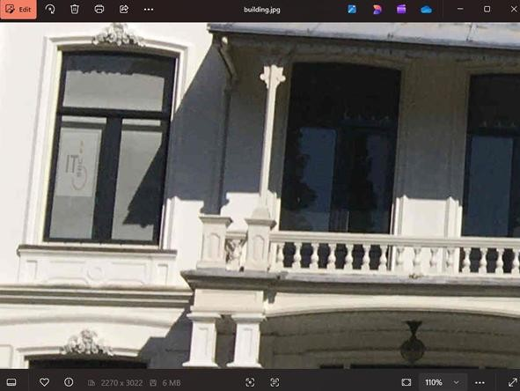
"ITsec”
- Go to Forgot Password enter Emma's email and then answer her security question with the identified workplace name
- Password reset succeeds
7.challenge complete
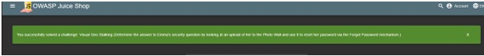
No specialist tools, downloads, or technical knowledge are required. Anyone with a browser and access to Google can carry out this attack in minutes.
Impact
The biggest risk is account takeover identifying a location from a photo lets an attacker answer a security question and fully access someone's account through a normal-looking password reset. Beyond that, a photo taken at home reveals where someone lives, one taken at work exposes their employer a serious privacy violation for most users who have no idea their photos or the content within them can be traced back to a real location.
Mitigation
The simplest fix is downloading the image from the moment an image is uploaded, before it is ever stored. By doing so, anyone that has access to Google has the ability to reverse image search for it and find out the coordinates and location of where the image was taken.
LOGIN AMY
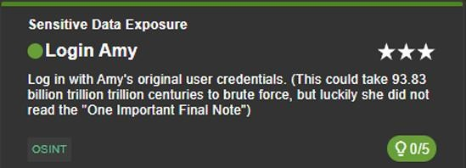

Vulnerability Description and Root Cause
This challenge is a good example of how weak passwords can make an account vulnerable even when the password appears complex at first glance. The vulnerability is Sensitive Data Exposure tied to poor password security specifically, Amy's password can be worked out through careful reading of publicly available clues rather than any technical attack. This ties into OWASP Top 102021 - A02: Cryptographic Failures, which covers situations where sensitive data such as credentials are not adequately protected, and CWE-521: Weak Password Requirements. The issue is that Amy based her password on a well-known external resource without adding any meaningful complexity of her own. The challenge description f hints at the phrase "93.83 billion trillion trillion centuries" is a reference to a specific password strength tool, and Amy simply used the example shown on that page as her own password. This is an implementation failure on the user's part, but also a design failure on the application's part for not enforcing stronger, unpredictable password requirements.
Rationale and Investigative Process
The goal is to log in as Amy using her original credentials without brute forcing the password. The challenge description contains two unusual phrases - "93.83 billion trillion centuries" and "One Important Final Note." These stand out as deliberate clues. Googling the first phrase leads directly to GRC's Password Haystack tool, a well-known page that demonstrates password strength using specific example passwords. Reading through the page reveals the "One Important Final Note" section, which contains an example password using a pattern of repeated periods after a word. Combined with the hint in the expanded challenge description that Amy used the name of a character from a TV show she likes - substituting numbers for vowels - the password can be worked out through OSINT alone without additional tools.
How the Exploit Works Tools used: Google, Burp Suite
Steps taken:
- Read the challenge description carefully and note the phrase "93.83 billion trillion trillion centuries"
- Google that phrase and the top result leads to GRC's Password Haystack page
- Find the "One Important Final Note" section on that page, which reveals the password pattern Amy followed
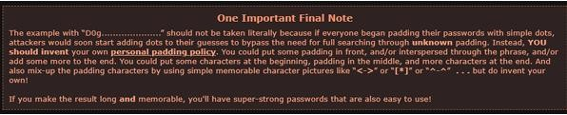

- Use the hint from the expanded description — Amy used the name Kif (a character she likes) with numbers replacing vowels, followed by periods matching the example on the GRC page
- The password works out to K1f..................... (Kif with vowels replaced and periods appended)
- Open Burp Suite, intercept the login request, and submit:
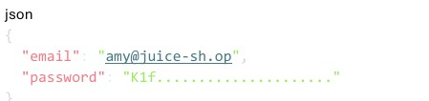

- Login succeeds
The exploit relies on reading clues carefully and doing basic OSINT research.
Impact
The most immediate risk is full account compromise — once an attacker works out Amy's password through OSINT, they have complete access to her account and everything in it. The dangerous thing is that the password would appear very strong to most people — it is long and contains special characters — yet it is entirely predictable because it was copied from a public example. This highlights a higher risk of security through obscurity. Users who base passwords on known patterns or examples are less protected than a truly random password of the same length. If Amy reused this password across other services, this would impact her other accounts.
Recommended Mitigation
The solution is enforcing an unpredictable password requirement at the application level. Bad passwords are based on dictionary words, known examples, or predictable patterns. In line with OWASP ASVS v4.0 in Section 2.1, applications should check new passwords against lists of commonly known or compromised passwords and reject them. Multi-factor authentication should be enforced so that if a password is compromised, an attacker cannot access the account without a second factor. Credentials should be treated as sensitive data throughout their lifecycle. Users should be educated not to base passwords on publicly available examples or patterns.

Vulnerability Analysis 1: Christmas Special
Vulnerability Description and Root Cause
The Christmas Special challenge demonstrates a business logic vulnerability caused by improper validation of user input. Specifically, the application relies on a parameter called productId sent from the client (browser) to determine which product should be added to the basket. The server does not verify whether this product is allowed or visible to the user.
This creates a security weakness because the application trusts client-side input without proper server-side validation. The root cause is a failure to enforce access control and business rules on the server. Instead, the system assumes that users will only select products shown in the interface, which is not secure.
This vulnerability can be linked to OWASP Top 10 categories such as
A3: Injection (due to manipulation of input parameters)
A5: Security Misconfiguration.

Rationale / Investigative Process
The vulnerability was identified by observing how products are added to the basket. By using browser Developer Tools and monitoring network traffic, it became clear that each action sends a request to the server containing a productid
The key observation was that this value originates from the client side and is not fixed. This suggested that it might be possible to modify it. The presence of hidden or unavailable products in the challenge hints further indicated that some items exist in the system but are not accessible through the user interface.
This led to the hypothesis that modifying the request could allow access to restricted products.

How the Exploit Works
The exploit was performed in multiple steps:
- Logged into a user account.

- Added a product to the basket.

- Opened browser Developer Tools (Network tab).

- 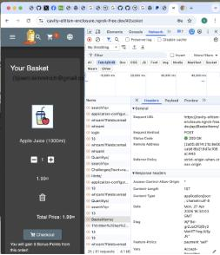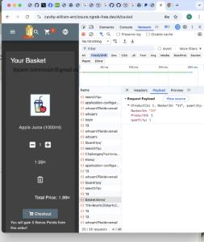Clicked “Add to Basket” again and watched the request that appeared in the Network tab.

- Intercepted the request sent to the server.

- Copied BasketItems/ as fetch into the console
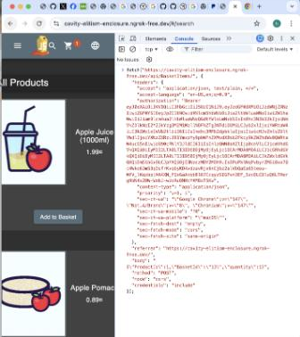
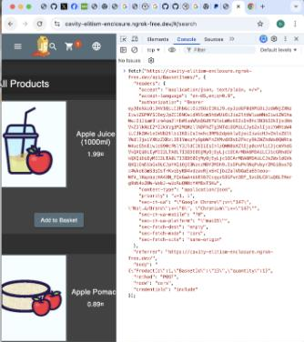

- Replaced the product with a different number and the modified request was sent after
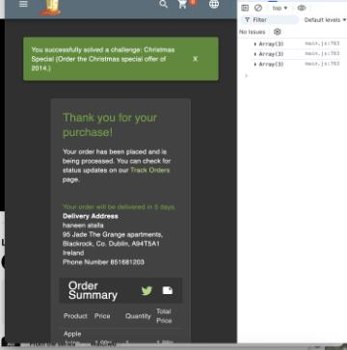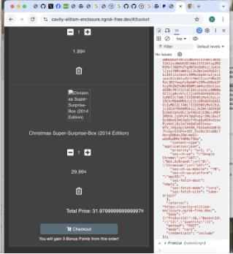
- The hidden product was successfully (“Christmas Super Surprise Box 2014”) added to the Basket

- Completed the order with fake credentials
Potential Impact
In a real-world system, this vulnerability could lead to serious consequences. Attackers could access restricted or hidden items, manipulate product prices, or perform unauthorized transactions. This could result in financial loss, exposure of sensitive products, and abuse of business logic.
Recommended Mitigation
To prevent this vulnerability, the application should:
- Validate all inputs on the server side
- Enforce strict authorization checks for products
- Ensure that only allowed product IDs can be processed
- Avoid trusting client-side data
- Apply secure coding practices such as input validation and allowlisting
These measures address the root cause by ensuring that the server controls all critical decisions.

Vulnerability Analysis 2: Login Support Team

Vulnerability Description and Root Cause
This challenge demonstrates a multi-step vulnerability involving injection, exposure of sensitive data, and weak credential protection. The application allows unsafe input in the search functionality, enabling attackers to manipulate database queries and retrieve user data.
Additionally, sensitive files such as a KeePass database (incident-support.kdbx) are exposed through accessible directories. This file contains stored credentials that are protected only by a weak master password.
The root cause is a combination of:
- Lack of input validation (leading to injection)
- Poor access control on internal files
- Weak protection of stored credentials
This vulnerability relates to:

A3: Injection
A2: Broken Authentication
A5: Security Misconfiguration.

Rationale / Investigative Process
The vulnerability was identified by testing the search functionality with unusual input. It was observed that certain inputs caused unexpected behavior, indicating that the input was not properly handled.
Further testing showed that it was possible to manipulate the query and retrieve data from the database. This led to the discovery of user information, including email addresses.
Following this, exploration of the application revealed access to an FTP directory containing sensitive files. The presence of a KeePass database suggested that credentials might be stored insecurely, leading to further investigation.

Exploitation Steps:
- Identified from hints that a shared third-party password manager is used.

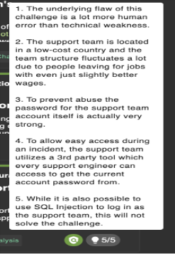

- Went to the search endpoint which returned user data from the database. https://cavity-elitism-enclosure.ngrokfree.dev/rest/products/search?q=qwet%27))UNION%20SELECT%20id,%20email,%
20password,%274%27,%275%27,%276%27,%277%27,%278%27,%279%27%20FR OM%20Users--

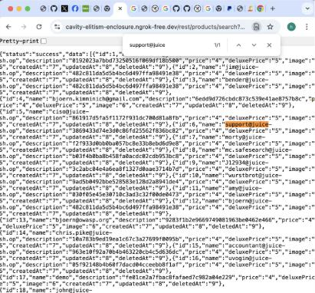

- Found the support email address support@juice-sh.op.

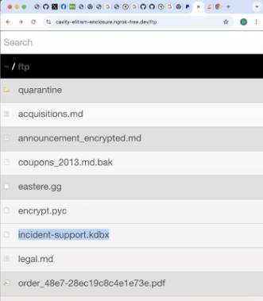

- Navigated to the FTP directory and found incident-support.kdbx. Downloaded the file and it is a keepass password database.

- Downloaded keeforge from keepass(mac version)

- Was directed to the keepass GitHub and cloned the repository:
git clone https://github.com/ivanmrsulja/keepass2john.git
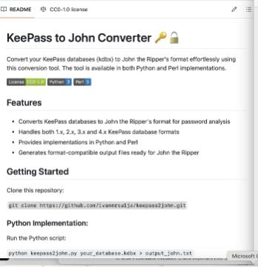

- Converted the file into a format that could be used for password cracking.

- Cloned it on my Terminal and cracked the master password (Support2022!)

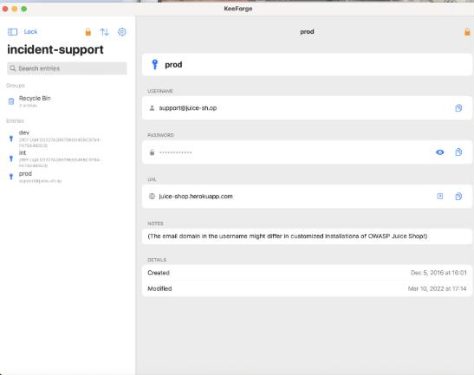

- Opened the database using KeeForge and accessed stored credentials.

- Retrieved login details for support@juice-sh.op.

- Logged in successfully.

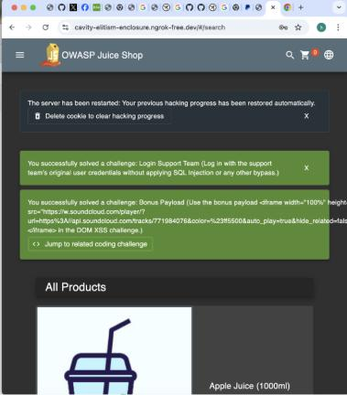

The exploit works because multiple weaknesses are combined, allowing the attacker to move from data extraction to full account access.

- Potential Impact
This vulnerability chain could lead to complete system compromise. Attackers could gain access to sensitive accounts, extract user data, and reuse credentials. In real systems, this could result in data breaches, unauthorized access, and loss of trust.

- Recommended Mitigation
To mitigate this vulnerability, the application should:
  - Use prepared statements to prevent injection
  - Restrict access to internal directories and files
  - Encrypt sensitive data securely
  - Use strong, non-crackable passwords
  - Monitor and log suspicious activity
These measures reduce the risk by addressing each stage of the attack chain.

SAST Testing
Static Application Security Testing (SAST) was performed on the source code of OWASP Juice Shop using Semgrep a free and open-source static code analyser that supports pattern matching and data flow analysis across multiple programming languages [1]. OWASP Juice Shop is a web application built using Node.js, with Angular used as the front-end framework; therefore, Semgrep would actually be the best choice due to its extensive JavaScript and TypeScript ruleset
The code was obtained using the cloning process of the official Juice Shop Github repository as per the recommendation in case the app is deployed from docker. The scanning was done from the root directory of the project using the following command: semgrep -config=p/javascript --config=p/nodejs --config=p/owasp-top-ten, limiting the search to all server-side JavaScript files that appear in the routes, lib, and models directories. Th angular client-side code found in frontend/src was not included in the main scan as the focus was on server-side controls
Before any analysis the findings were pre filtered to rule out all possible false positives.
These are thee semgrep findings on tests, mocks, and development utility files since they are irrelevant to the code execution path of the production application. The same applies to security header findings since security headers can be handled in the infrastructure layer and therefore are not considered logic flaws in the application itself. Three major findings were then selected for analysis based on their significance and possibility of exploitation.
Finding 1
There were several occurrences of secrets usage and JWT signing keys that were implemented either by hardcoding them in string constants or by employing an insecure and guessable default values. Specifically, the JWT secret key, which is used in the process of signing authentication tokens was found to be configured using vulnerable default values such that the installation of default settings would leave the key unsecured or easily guessable
This discovery has a direct relationship to runtime behavior and some of the challenges that the group has overcome include Login Bjoern and Reset Bender’s Password both do take advantage of the fact that there are some vulnerabilities in the JWT process. Through the use of JWT tokens and having information on this about the fact that the secret used is weak, it is possible to authenticate as anyone or even skip the process entirely. The Semgrep analysis has proved at the code level what was found out through actual exploits at runtime.
Such an issue is reflected in the OWASP Top 10 A02: Cryptographic Failures [3], which actually is a major threat in any implementation of a software solution. An attacker able to either retrieve or guess the JWT secret will have full control over the generation of tokens so theyd be able to authenticate with any permissions in the system without having the required credentials. To protect against such threats a JWT secret should always be created using a CSPRNG on startup and kept in environment variables or a secrets manager and never added to the version control system.
Finding 2 there have been instances where the use of semgrep showed user input directly included in the database query strings instead of utilizing parametrized queries or making use of the safe query API offered by the ORM. The triggering of this rule occurred due to the direct inclusion of request parameters in the SQL strings, thus constituting CWE-89.
It is further corroborated by the fact that this vulnerability is being exploited in practice. This particular team was able to achieve both the Login Amy challenge as well as the User Credentials challenge, in which the SQL injection technique is employed either to gain access through the login process or steal user credentials. The finding provided by the SAST shows the specific code construct used for these purposes, i.e., the use of string concatenation in SQL queries without appropriate escaping or parameterisation.
Injection vulnerabilities continue to be one of the most significant vulnerability types, listed in OWASP A03: Injection [3] while being well-documented in various CVE databases. In a real-life application, the potential impact of the vulnerability can include the full retrieval of the user table, gaining access to all accounts without credentials, or even running operating system commands through the database, based on the privileges of the database user. The best preventive measure is using the proper implementation of parameterized queries or prepared statements Both the OWASP Proactive Control C3 and ASVS V5 require it [4][5].
Finding 3
Semgrep discovered a unique security hole related to file serving routes where the users filename was utilized to create the filesystem path. The vulnerable code met the criteria for the rule called javascript.lang.security.audit.path-traversal.path-join-resolve-traversal which refers to the creation of filesystem paths through path.join(). The un-sanitized input parameter request is associated with CVE-22: Improper Limitation of a Pathname to a Restricted Directory [2].
An intriguing security hole was detected by Semgrep relating to file serving routes where the input user filename was used to create the filesystem path. The code snippet met the criteria for the rule javascript.lang.security.audit.path-traversal.path-join-resolve-traversal which implies constructing filesystem paths with path.join(). The unsanitised input parameter request relates to CVE-22: Improper Limitation of a Pathname to a Restricted Directory [2].
If this were used in practice thn it might lead to complete exposure of the secrets on the server side also as well as other logic and sensitive information of users kept in the logs. This can be prevented by resolving any file paths based on user input using path.resolve() and validating each path properly to the allowed list of the main directories. All file paths should either begin with a known base directory or fail validation this measure is described in the OWASP ASVS V12 File and Resources [4].
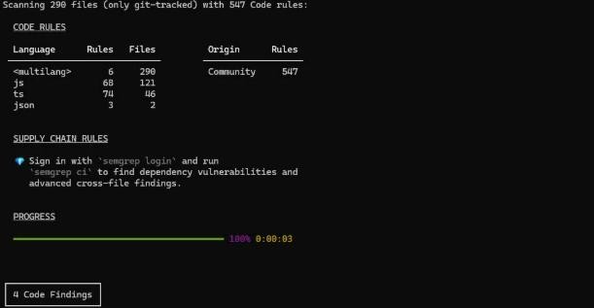
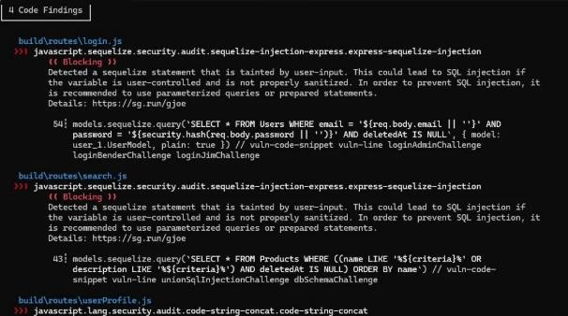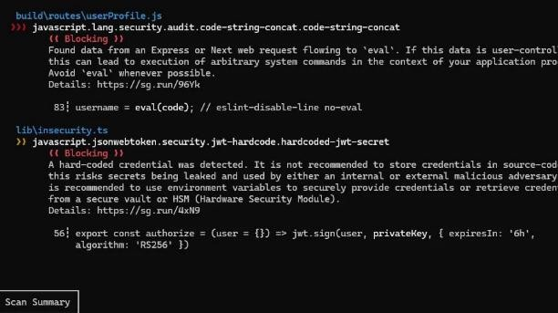
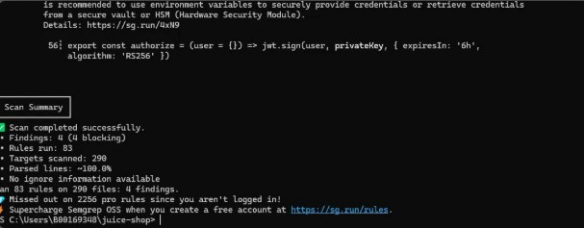

DAST Testing
Testing Methodology and Tool Configuration
Dynamic Application Security Testing also known as DAST was carried out on the running instance of OWASP Juice Shop Docker image by OWASP Zed Attack Proxy (OWASP ZAP) which is an open source DAST tool developed by OWASP foundation that is commonly used to test the security of web applications [6]. The zap tool functions by intercepting browser traffic via its proxy engine and conducting both passive and active scan tests
In order not to trigger a prolonged or repeated scanning of the application a smart targeted scanning strategy was employed so instead of running a scan and attack process on the whole application. ZAP was set to work in manual exploration mode the browser was set up to operate via the ZAP proxy while navigating the application to identify potential vulnerabilities. By doing so then the necessary endpoints of the application were discovered and added to the Sites tree of ZAP. An authenticated session was made by signing in as an existing user and providing the Bearer JWT token in ZAPs http session management section. The active scanning was then limited to the discovered sites by setting up a custom scanning policy that would include the injection, authentication and information disclosure categories while then excluding others that were just not relevent to this case such as XML injections and buffer overflow vulnerabilities. The active scan took about 15 minutes and created 87 alerts
The alerts were prioritized based on confidence and severity levels. Alerts having low confidence and concerning the absence of optional security headers such as permissions policy were analysed and subsequently deprioritized since they do not constitute a security flaw in the context. three of the following issues were chosen for further assessment because of their severity and exploitability.
Finding 1
The active scanner from ZAP detected that there was a cross-site scripting issue for the application search endpoint, and an alert was raised with a severity level of High and a confidence level of High. The active scanner tested the q parameter of the rest/products/search endpoint using different XSS payloads and determined that some payloads are echoed back within the HTTP response body without encoding.
Manually, the validation was carried out through creation of a URL that included a normal XSS payload attached to the search parameter and loading the URL via the browser. The payload is reflected back on the search results page and was not sanitized, leading to execution of the JavaScript code in the browser. This is a case of CVE-79: Improper Neutralization of Input During Web Page Generation and OWASP Top 10 A03: Injection vulnerabilities.
Reflected XSS in a production environment can be used for stealing session cookies, redirection to malicious websites, capturing keystrokes, or conducting operations on behalf of the user in the application. When the user is an admin, the result of the attack is full control of the application. Protection involves encoding all inputs provided by the user before displaying them in HTML, as mandated by OWASP Proactive Control C4 (Encode and Escape Data) [5]. An additional protective measure is to have a content security policy (CSP) header to prevent the execution of inline scripts, reducing the risk should XSS vulnerabilities remain undetected.
Passive scanning of ZAP performed on traffic generated from authenticated browsing sessions detected several endpoints exposed through unauthenticated access and returning confidential information such as personal details and purchasing history. These findings were categorized as Medium risk alerts within the category of Insufficient authentication. Verification of these endpoints was done manually by reproducing the requests and executing them in ZAP Requester without the Authorization header. A few endpoints returned a full response without needing any token, implying no authentication process took place on the server side.
The result is directly related to the fact that the team managed to solve the User Credentials and Email Leak vulnerabilities, which occur because of the application’s inability to apply access control when using the API routes exposing user data. As a result of the DAST test, it was revealed that the server does not check for the existence and correctness of the token while answering some requests to receive data.
From a practical point of view lack of authentication for users endpoints may cause an attacker to leak a mass amount of users' information and get details about all of their accounts, emails, order history, etc., thus violating the data protection policy stated in GDPR and other acts regulating personal information security. In order to avoid such scenarios, all APIs providing users' information must be secured with the help of server-side middleware checking the validity of Bearer tokens for each request. OWASP ASVS V4 (Access Control) states that access control should always be checked on the server side and on each layer [4].
The active ZAP scanner produced error responses from certain endpoints because of inputs that failed to adhere to certain parameters while the passive scanner indicated that the error messages included long stack traces and internal file paths in plaintext. The findings have been classified under Information Disclosure with Medium severity rating. The manual tests were conducted by causing error responses through the use of invalid JSON input and parameter inputs outside the defined range in order for Node.js stack traces and see errors that are produced.
This is related to Access Log and Database Schema vulnerabilities where the structure of the internal system within the application was exposed due to lack of sufficient protection on responses. The stack trace exposes the structure of the directory path within the server and the version numbers of the frameworks being used, and even how the database queries are structured which actually makes it easier for the attacker to exploit the system.
In a production environment, the verbosity of the error messages makes the discovery stage of any attack easier as it gives away information about the implementation details which otherwise would need some effort on the attacker part to discover. It is essential that the application is set up in such a way that no verbose information is provided in production mode. All uncaught exceptions must be trapped and processed by a global exception handler, which provides a generic message back to the user (HTTP 500 Internal Server Error, for example) but this logs the entire stack trace internally in a safe location. This can be done by setting the NODE_ENV variable to production this preventing express from emitting its verbose error messages
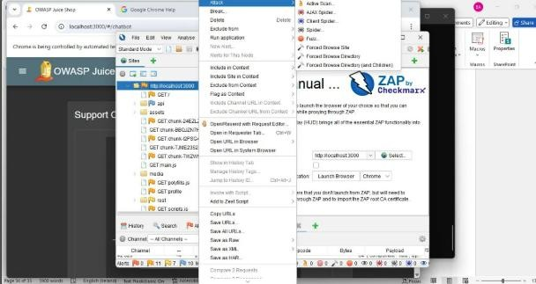
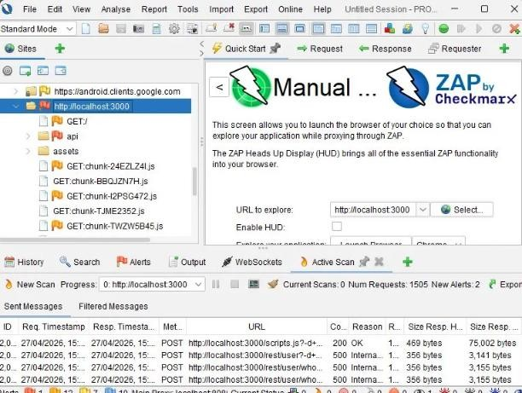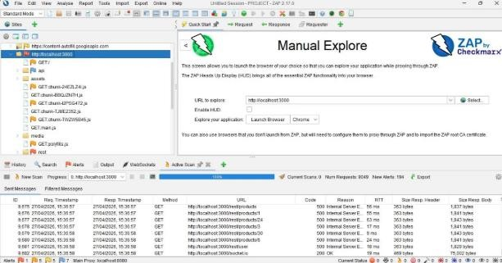
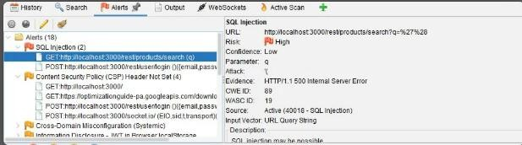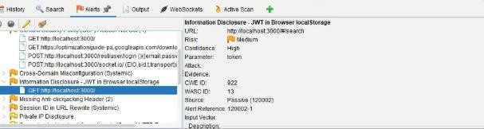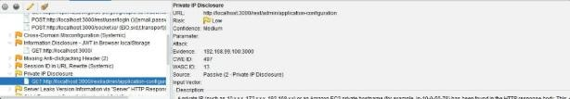

References
- OWASP Foundation, “OWASP Top 10:2021,” 2021. [Online]. Available: https://owasp.org/Top10/

- MITRE Corporation, “Common Weakness Enumeration (CWE),” 2024. [Online]. Available: https://cwe.mitre.org/

- OWASP Foundation, “OWASP Proactive Controls,” 2018. [Online]. Available: https://owasp.org/www-project-proactive-controls/

- OWASP Foundation, “OWASP Application Security Verification Standard (ASVS) v4.0.3,” 2021. [Online]. Available: https://owasp.org/www-project-application-securityverification-standard/

- OWASP Foundation, “OWASP Automated Threats to Web Applications,” 2020.
[Online]. Available: https://owasp.org/www-project-automated-threats-to-web-applications/ [6] OWASP, "A07:2021 – Identification and Authentication Failures," OWASP Top 10, 2021.
[Online]. Available: https://owasp.org/Top10/A07_2021-
Identification_and_Authentication_Failures/
- MITRE, "CWE-620: Unverified Password Change," Common Weakness Enumeration, 2023. [Online]. Available: https://cwe.mitre.org/data/definitions/620.html
- OWASP, "Proactive Control C6: Implement Digital Identity," OWASP Top 10 Proactive
Controls, 2018. [Online]. Available: https://owasp.org/www-project-proactive-controls/
- OWASP, "ASVS V2.1: Password Security Requirements," Application Security Verification Standard 4.0, 2021. [Online]. Available: https://owasp.org/www-projectapplication-security-verification-standard/

- OWASP, "A05:2021 – Security Misconfiguration," OWASP Top 10, 2021. [Online].
Available: https://owasp.org/Top10/A05_2021-Security_Misconfiguration/
- MITRE, "CWE-653: Insufficient Compartmentalisation," Common Weakness
Enumeration, 2023. [Online]. Available: https://cwe.mitre.org/data/definitions/653.html
- OWASP, "Proactive Control C4: Encode and Escape Data," OWASP Top 10 Proactive Controls, 2018. [Online]. Available: https://owasp.org/www-project-proactive-controls/
- OWASP, "Application Security Verification Standard 4.0," OWASP ASVS, 2021. [Online]. Available: https://owasp.org/www-project-application-security-verificationstandard/

