Project Documentation: CorpGuard & AuthLab
An Interactive Cybersecurity Simulation & Educational Ecosystem
Made By: M. Alyan Tariq, Shahmeer Haider, Sanial Bhatti
Roll Numbers: 23F-0719, 23F-0671, 23F-0658
Date: 13th May 2026

1. Executive Summary
The CorpGuard Employee Portal & AuthLab is a specialized web-based simulation environment designed to demonstrate the critical bridge between application development and offensive security. By implementing a dual-mode toggle system (Vulnerable vs. Secure), the project provides a side-by-side comparison of OWASP Top 10 vulnerabilities and their modern mitigations. Unlike static learning tools, this project leverages the Web Crypto API for real-time cryptographic operations and a sophisticated front-end state machine to simulate a full-stack environment without requiring a complex backend, making it highly portable and accessible for educational purposes.

2. System Architecture & Tech Stack
The portal is built with a focus on high performance and zero external dependencies (other than typography and icons), ensuring the logic is transparent and verifiable.
- Logic Engine: Vanilla JavaScript (ES6+) utilizing an asynchronous state management pattern.
- Cryptography: Web Crypto API for browser-side SHA-256/SHA-512 hashing and ECDSA digital signatures.
- Styling: Custom CSS3 with CSS Variables for a dynamic "Threat-Level" UI.
- Visual Assets: Font Awesome 6 (SVG-based) and Google Fonts (Syne for headers, IBM Plex Mono for code).
- Simulation Layer: Simulated database latencies using Promises and setTimeout to mimic real-world server responses.

3. Vulnerability Implementation Matrix
Module | Vulnerability | Attack Vector | Mitigation Strategy
SQLi | SQL Injection | Tautology-based login bypass (' OR '1'='1) | Parameterized queries (PDO Prepared Statements)
IDOR | Broken Access Control | Client-side URL parameter tampering (role=admin) | Server-side session validation ($_SESSION)
XSS | Stored XSS | Script injection via unsanitized noticeboard inputs | htmlspecialchars() encoding & HttpOnly cookie flags
Crypto | Plaintext Storage | Exposure of credentials during database breach | Dynamic one-way hashing (SHA-512)
AuthLab | JWT Exploitation | Algorithm confusion (Accepting alg: none) | Strict signature enforcement (HS256/RS256)
CSRF | Cross-Site Request Forgery | Unauthenticated state-changing requests | Synchronizer Token Pattern (Anti-CSRF Tokens)

4. Technical Deep Dive

4.1 Real-Time Cryptographic Hashing
To demonstrate that secure systems do not store passwords, the portal performs live hashing. When the user switches to "Secure Mode" in the Cryptography tab, the following asynchronous logic is executed:
if (isSecure) {
const msgBuffer = new TextEncoder().encode(e.pw);
const hashBuffer = await crypto.subtle.digest('SHA-256', msgBuffer);
const hashArray = Array.from(new Uint8Array(hashBuffer));
const hexHash = hashArray.map(b => b.toString(16).padStart(2, '0')).join('');
hashDisplay = `<span class="hash-pw">${hexHash.slice(0, 32)}…<span style="opacity:0.5">${hexHash.slice(32, 48)}…</span></span>`;
} else {
hashDisplay = `<span class="plain-pw">${e.pw}</span>`;
}

4.2 AuthLab: The Advanced Playground
The AuthLab serves as a "Level 2" module for advanced concepts:
- Digital Signatures (ECDSA): Users can sign a message and then manually alter a single character to see how the mathematical integrity check fails instantly.
- 2FA Simulation: Implements a time-sensitive OTP simulation. In vulnerable mode, the system accepts any 6-digit input; in secure mode, it validates against a generated secret.
- AI Anomaly Detection: Features a simulated Gradient Boosted Decision Tree scoring system that analyzes login events based on Geo-velocity (impossible travel) and User-Agent fingerprinting.

5. UI Design Philosophy
The interface was designed to mimic a professional Security Operations Center (SOC) dashboard.
- The Threat Bar: A top-level visual indicator that pulses red during vulnerability exposure and transitions to a static "Secure Green" when mitigations are active.
- Professionalism over Emojis: Replaced all standard emojis with Font Awesome icons to align with corporate software standards.
- Code-Parallel Learning: Every tab features a code panel that swaps between "Bad Code" and "Good Code" snippets, providing the user with an immediate programmatic fix for the visual exploit.

6. Learning Outcomes & Objectives
- Exploitation Awareness: Understanding the "attacker's mindset" by successfully bypassing authentication and escalating privileges.
- Mitigation Mastery: Implementing industry-standard defenses like input sanitization and secure session management.
- Cryptographic Literacy: Differentiating between encryption, hashing, and digital signatures.
- Modern Defense: Understanding how AI/ML complements traditional rule-based security through anomaly detection.

7. Conclusion
The CorpGuard & AuthLab project successfully demonstrates that web security is not a single feature, but a multi-layered discipline. By providing a tangible, interactive experience, this portal serves as a powerful proof-of-concept for how modern web applications must be secured from the ground up. The project is modular, allowing for future expansion into vulnerabilities like SSRF or Cloud-specific security flaws.
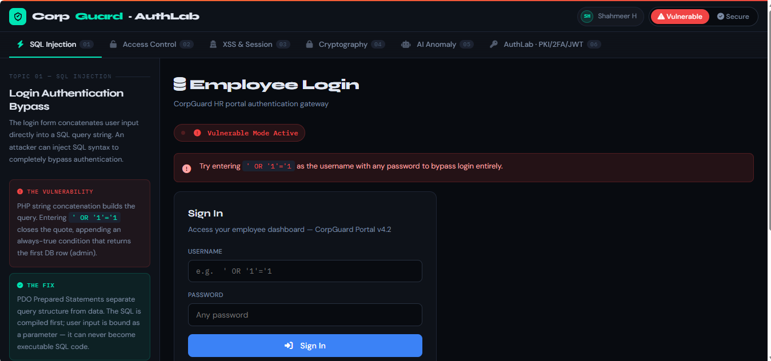
Medium Link: Medium Blog
Github Repo: Github Repository

