NAME: M. Alyan Tariq & Sanial
CLASS: BS(CS)-6D
ROLL NO. 23F-0719 & 23F-0658
AI Assignment 1
1. Implementation Explanation
The objective of this task was to build an AI Pathfinder to visualize how various "blind" or uninformed search algorithms navigate a grid environment from a Start Point (S) to a Target Point (T) .
Environment and Grid Mechanics: The environment is a 20x20 grid developed using Python. To fulfill the visualization requirement directly within a Jupyter Notebook environment, matplotlib and IPython.display were utilized to create a real-time, step-by-step animation of the algorithms "flooding" the grid. The graphical interface clearly distinguishes between unexplored nodes, frontier nodes (waiting in the queue/stack), explored nodes, and the final path .
+2
Movement Logic: Node expansion strictly follows the mandated 8-way clockwise order :
- Up
- Top-Right (Diagonal)
- Right
- Bottom-Right (Diagonal)
- Bottom
- Bottom-Left (Diagonal)
- Left
- Top-Left (Diagonal)
Dynamic Obstacles and Re-planning: A core feature of the environment is its dynamic nature. As the agent traverses the calculated path, there is a predefined 5% probability per step that a dynamic obstacle will spawn on a random empty cell. If this new obstacle blocks the agent's currently planned route, a runtime exception is triggered, the current path is discarded, and the agent recalculates a brand-new route from its current position to the target.
2. Algorithms Implemented: Pros & Cons
All six mandatory algorithms were implemented to handle the 8-way grid. Below is a discussion of their advantages and disadvantages based on observations during testing.
I. Breadth-First Search (BFS)
BFS explores the grid level by level, expanding outward equally in all directions.
- Pros: It is guaranteed to find the shortest possible path (optimal) in this unweighted grid environment. It is highly reliable for finding the target if a path exists (complete).
- Cons: It is highly memory-intensive. In the worst-case scenario (an open grid with the target far away), BFS explores almost every single node in the grid, leading to massive memory consumption in the queue.

II. Depth-First Search (DFS)
DFS dives as deep as possible along a single path before backtracking.
- Pros: It is highly memory-efficient compared to BFS, as it only needs to store a single path from the root to a leaf node, plus unexplored sibling nodes, in its stack.
- Cons: It is not optimal. DFS will often find a very long, convoluted path to the target even if a much shorter, direct path exists. It can also get easily trapped exploring deep, sub-optimal corners of the grid.

III. Uniform-Cost Search (UCS)
UCS expands nodes based on the lowest cumulative cost. Since our grid assumes a uniform step cost of 1 per movement, it behaves similarly to BFS but utilizes a priority queue.
- Pros: It guarantees the shortest path (optimal) and is complete. It is the best choice if we were to introduce terrain with varying movement costs (e.g., mud vs. road).
- Cons: Because it requires maintaining and updating a priority queue (min-heap), the computational overhead is higher than standard BFS, making it slightly slower on a strictly uniform grid.

IV. Depth-Limited Search (DLS)
DLS operates exactly like DFS but strictly enforces a maximum depth limit to prevent infinite loops.
- Pros: It solves the infinite-path problem of standard DFS and remains highly memory-efficient.
- Cons: It is not complete. If the target node is located at a depth greater than the predefined limit, DLS will fail to find it entirely, returning no path.
V. Iterative Deepening DFS (IDDFS)
IDDFS repeatedly runs DLS, increasing the depth limit by 1 each iteration until the target is found.
- Pros: It combines the best of both worlds: the memory efficiency of DFS and the completeness/optimality of BFS. It guarantees finding the shortest path without requiring massive queue memory.
- Cons: It involves redundant computation. The upper levels of the search tree are generated and explored repeatedly during every single iteration, which can be computationally expensive on large, open grids.

VI. Bidirectional Search
This approach runs two simultaneous BFS searches: one forward from the start, and one backward from the target, stopping when the two frontiers intersect.
- Pros: It drastically reduces the search space and time. Because the search space grows exponentially, meeting in the middle cuts the required exploration area significantly, making it the fastest optimal algorithm in an open grid.
- Cons: It requires the exact state of the target to be known in advance. It is also more complex to implement, especially when managing dynamic obstacles that might block the intersection point.
3. Test Cases (Visual Proof)

I. Breadth-First Search (BFS)
- Best Case Scenario: The target is relatively close, allowing the radial search to find it without filling the grid.
- Worst Case Scenario: The target is blocked by a large wall or is in the opposite corner, forcing BFS to explore nearly the entire grid.
- Screenshot:
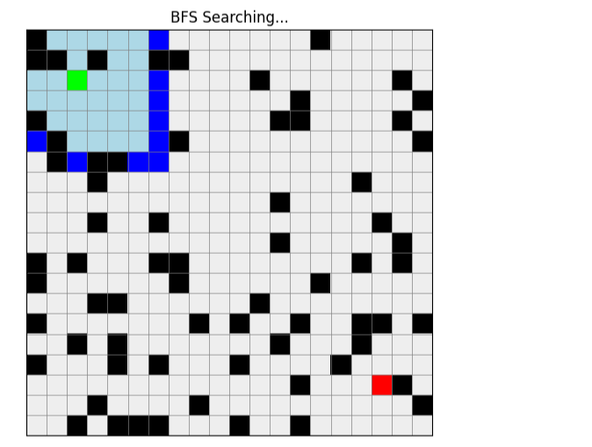
II. Depth-First Search (DFS)
- Best Case Scenario: The target happens to lie directly along the first deep path DFS chooses to explore.
- Worst Case Scenario: The target is nearby, but DFS picks the wrong initial direction, exploring the entire map before backtracking to the start.
- Screenshot:
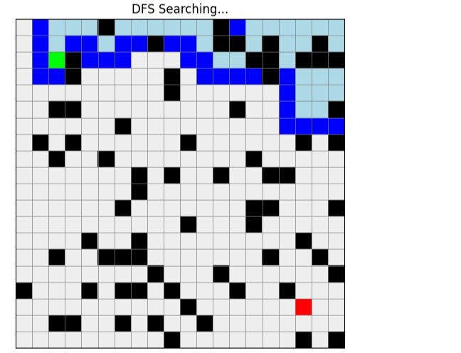
III. Uniform-Cost Search (UCS)
- Best Case Scenario: An unobstructed, straightforward path to the target.
- Worst Case Scenario: A maze-like structure forcing the priority queue to constantly update and expand outwards heavily.
- Screenshot:
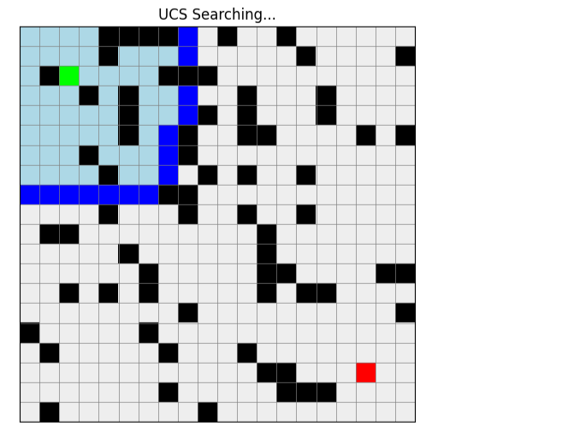

IV. Depth-Limited Search (DLS)
- Best Case Scenario: Target is found within the specified depth limit (e.g., depth limit 20, target at depth 10).
- Worst Case Scenario: The target lies just outside the depth limit, causing the algorithm to fail and search the whole bounded area needlessly.
- Screenshot:
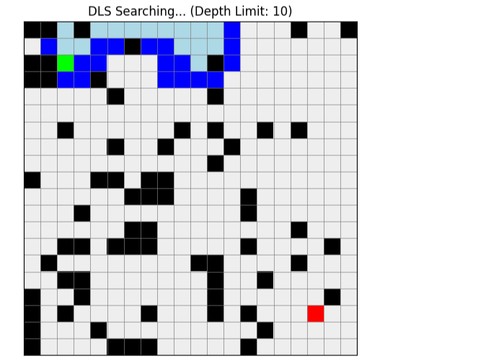

V. Iterative Deepening DFS (IDDFS)
- Best Case Scenario: Target is very close to the start, requiring only a few depth iterations.
- Worst Case Scenario: The target is far away, forcing the algorithm to repeatedly re-calculate the entire massive grid from depth 0 up to the target's depth.
- Screenshot:
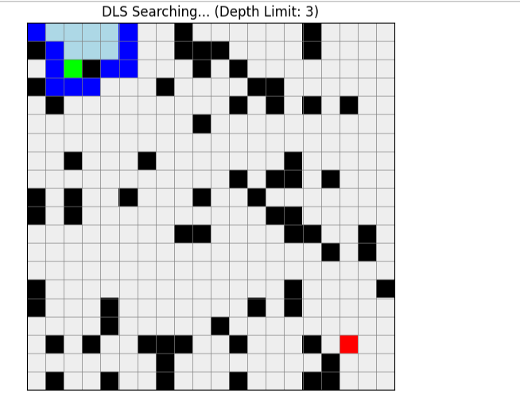
VI. Bidirectional Search
- Best Case Scenario: Open space between Start and Target; the two frontiers meet perfectly in the middle very quickly.
- Worst Case Scenario: A solid wall separates the two halves of the grid, forcing both the forward and backward searches to heavily explore their respective sides before finding a gap.
- Screenshot:
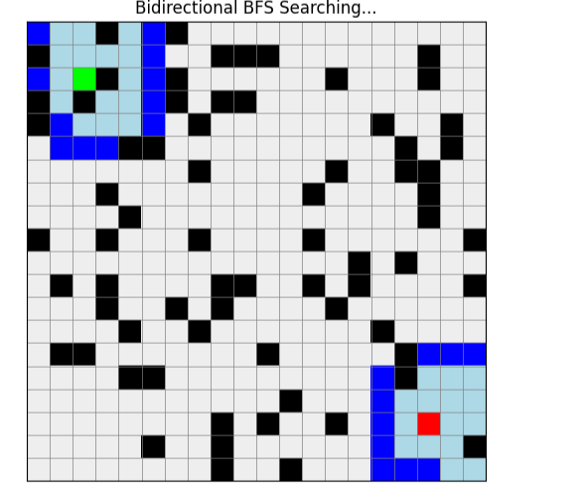
Github Link:
https://github.com/Alyan-T/uninformedsearchImplement/tree/main

