NAME: M. Alyan Tariq
CLASS: BS(CS)-6D
ROLL NO. 23F-0719
AI Assignment 2
Question 6:

1.
Implementation Logic
The Dynamic Pathfinding Agent was developed using Python and the Pygame library to fulfill the mandatory Graphical User Interface (GUI) requirements. The core logic is divided into environment management, search execution, and dynamic re-planning.
Environment & Grid Management:
- Dynamic Grid Sizing: The grid dimension is fully adjustable in real-time using the UP and DOWN arrow keys, automatically recalculating node sizes.
- Interactive Map Editor: Users can manually draw or erase obstacles using the left and right mouse buttons, respectively. The Start (Red) and Goal (Turquoise) nodes are fixed once placed but can be cleared to reset the board.
- Random Map Generation: Pressing R triggers a function that randomly converts empty nodes into obstacles with a 30% density.
Search Algorithms:
The core pathfinding relies on a PriorityQueue to evaluate nodes. We can toggle between algorithms and heuristics in real-time:
- A* Search (Key A): Evaluates nodes using f(n) = g(n) + h(n), combining the exact cost from the start with the estimated distance to the goal.
- Greedy Best-First Search (Key G): Evaluates nodes strictly based on the heuristic f(n) = h(n), ignoring the path cost accumulated so far.
- Heuristics: Toggleable between Manhattan Distance (Key M) and Euclidean Distance (Key E).
Dynamic Obstacles and Re-planning Mechanism: When Dynamic Mode is enabled (Key D), the agent executes its movement step-by-step.
- Spawning: At each step, the spawn_dynamic_wall function has a 20% probability of converting a random empty node into an obstacle.
- Detection & Re-planning: The system checks if the newly spawned obstacle exists within the agent's remaining optimal path array. If a collision is detected, the agent immediately clears the current frontier and visited lists (preserving the physical walls) and re-runs the search algorithm originating from its current physical location rather than the initial start node.

2.
Pros & Cons Analysis
Based on experimental findings within the Pygame environment, both algorithms exhibited distinct operational trade-offs.
A* Search
- Pros: It is optimal and complete. In the dynamic mode, when a wall blocks the path, A* consistently calculates the next mathematically shortest bypass route. It handles complex, maze-like structures without getting trapped in infinite loops.
- Cons: It is memory and time-intensive. Because it factors in g(n), it expands significantly more nodes (represented by the Blue visited squares) to ensure the path it found is truly the shortest, which slightly increases the execution time in milliseconds.
Greedy Best-First Search (GBFS)
- Pros: It is incredibly fast and memory-efficient in open terrain. Since it only follows the heuristic h(n), it drives straight toward the target, expanding very few nodes compared to A*.
- Cons: It is not optimal. GBFS easily falls into "local maximum" traps, such as U-shaped wall configurations. In dynamic mode, if an obstacle spawns in its direct line of sight, its re-planning often forces it to scrape along walls rather than gracefully routing around them, resulting in a higher final path cost.

3.
Test Cases

Scenario A: A* Search
- Best Case Scenario:
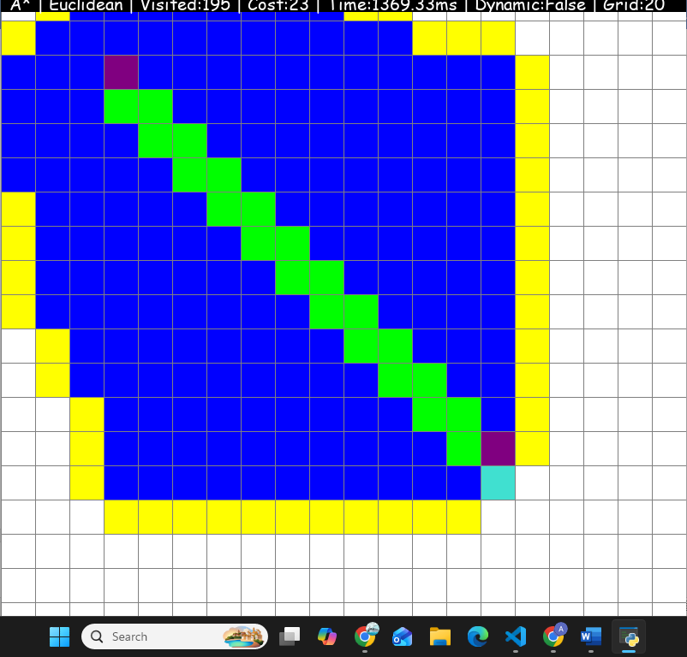
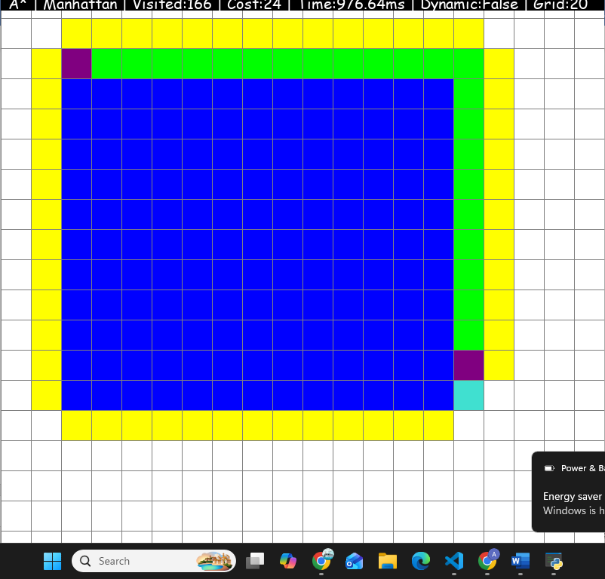
- Worst Case Scenario:

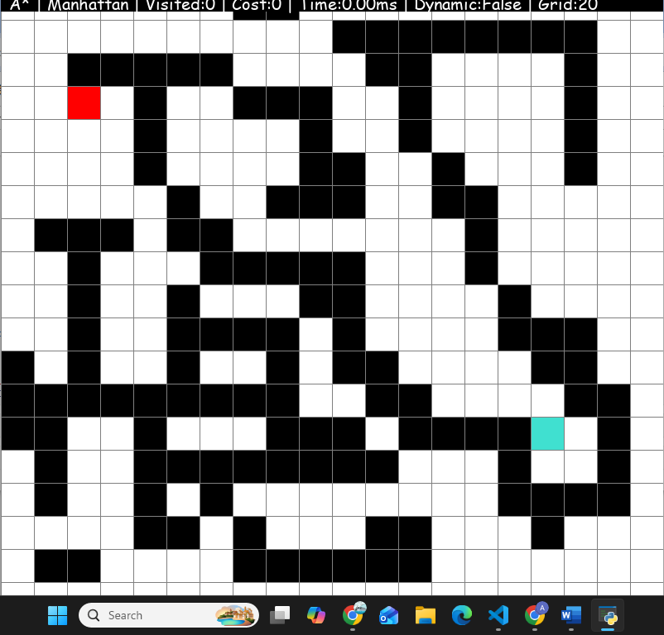
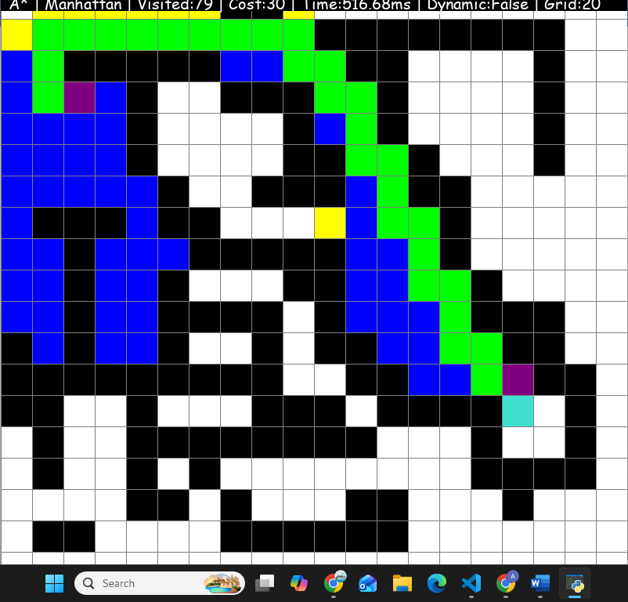

Scenario B: Greedy Best-First Search
- Best Case Scenario:
Description: A clear ma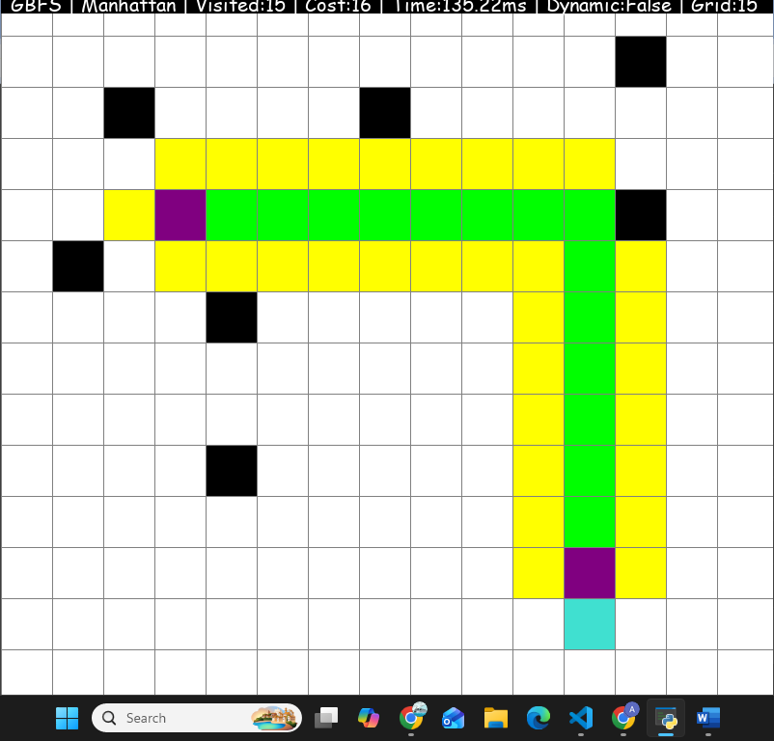
- Worst Case Scenario:



