M. Alyan Tariq (23F-0719)
Sanial (23F-0658)
Shahmeer Haider (23F-0671)
BS(CS)-5D
Computer Networks
Project:
Topology:
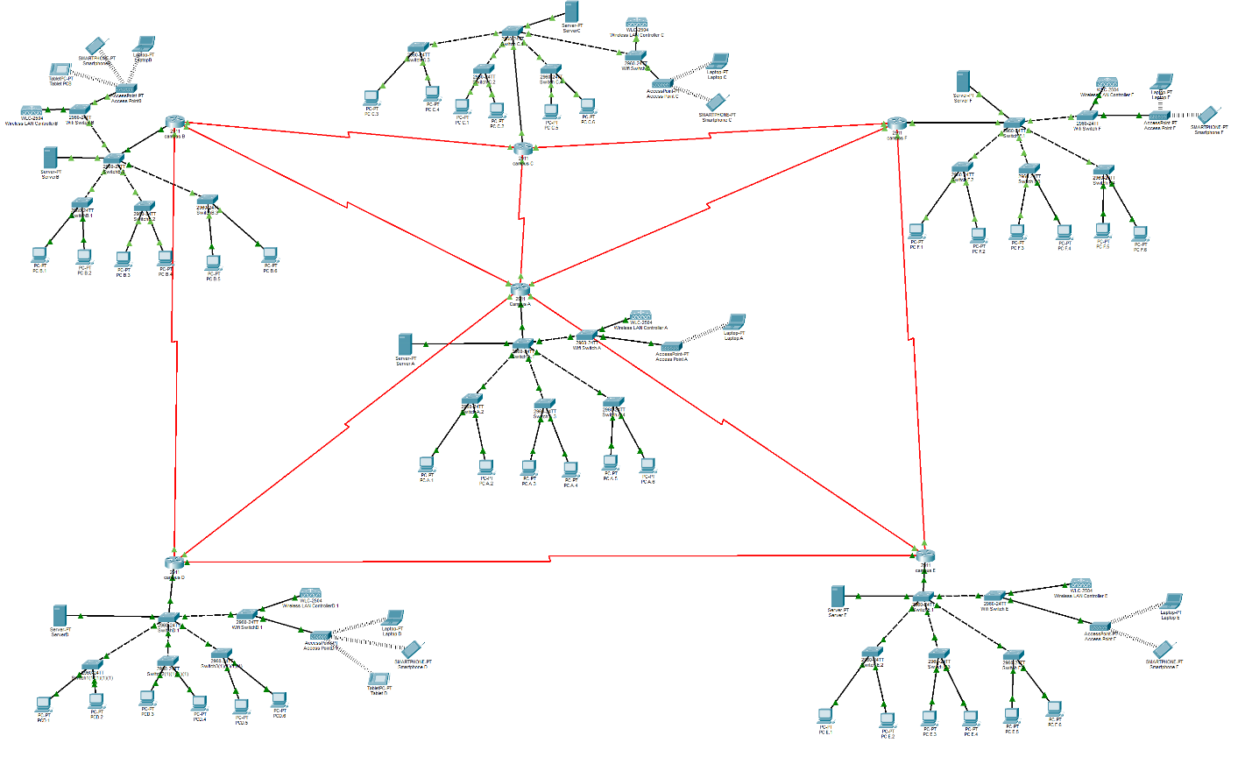
- Wireless Connections:
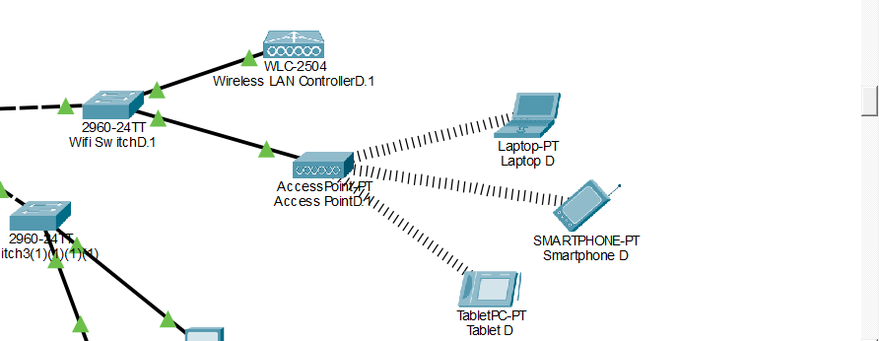
- Messages:
- Between Routers:
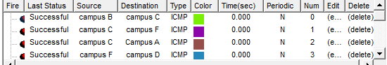
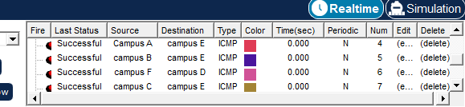
- Between PCs of same campus:
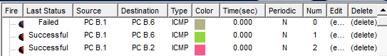
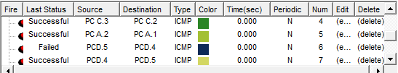
- Between PCs of different campuses:
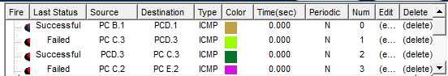
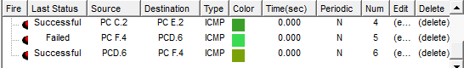

- Between wireless devices:
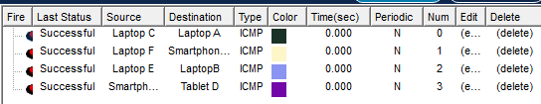
- Network Addressing Table:
Device | Interface | IP Address | Subnet Mask | Description / Connection
Router A | Gi0/0.10 | 10.1.5.1 | 255.255.255.192 | VLAN 10 Gateway
 | Gi0/0.20 | 10.1.4.1 | 255.255.255.0 | VLAN 20 Gateway
 | Gi0/0.30 | 10.1.0.1 | 255.255.252.0 | VLAN 30 Gateway
 | Gi0/0.40 | 10.1.5.65 | 255.255.255.248 | VLAN 40 Gateway
 | Se0/0/0 | 172.16.0.1 | 255.255.255.252 | WAN Link
 | Se0/0/1 | 172.16.0.5 | 255.255.255.252 | WAN Link
 | Se0/1/0 | 172.16.0.9 | 255.255.255.252 | WAN Link
 | Se0/1/1 | 172.16.0.13 | 255.255.255.252 | WAN Link (to Router D)
 | Se0/2/0 | 172.16.0.17 | 255.255.255.252 | WAN Link (to Router F)
Router B | Gi0/0.10 | 10.2.5.1 | 255.255.255.192 | VLAN 10 Gateway
 | Gi0/0.20 | 10.2.4.1 | 255.255.255.0 | VLAN 20 Gateway
 | Gi0/0.30 | 10.2.0.1 | 255.255.252.0 | VLAN 30 Gateway
 | Gi0/0.40 | 10.2.5.65 | 255.255.255.248 | VLAN 40 Gateway
 | Se0/0/0 | 172.16.0.2 | 255.255.255.252 | WAN Link
 | Se0/0/1 | 172.16.0.21 | 255.255.255.252 | WAN Link
 | Se0/1/0 | 172.16.0.42 | 255.255.255.252 | Direct Link to Router D
Router C | Gi0/0.10 | 10.3.5.1 | 255.255.255.192 | VLAN 10 Gateway
 | Gi0/0.20 | 10.3.4.1 | 255.255.255.0 | VLAN 20 Gateway
 | Gi0/0.30 | 10.3.0.1 | 255.255.252.0 | VLAN 30 Gateway
 | Gi0/0.40 | 10.3.5.65 | 255.255.255.248 | VLAN 40 Gateway
 | Se0/0/0 | 172.16.0.6 | 255.255.255.252 | WAN Link
 | Se0/0/1 | 172.16.0.22 | 255.255.255.252 | WAN Link
 | Se0/1/0 | 172.16.0.25 | 255.255.255.252 | WAN Link
Router D | Gi0/0.10 | 10.5.5.1 | 255.255.255.192 | VLAN 10 Gateway
 | Gi0/0.20 | 10.5.4.1 | 255.255.255.0 | VLAN 20 Gateway
 | Gi0/0.30 | 10.5.0.1 | 255.255.252.0 | VLAN 30 Gateway
 | Gi0/0.40 | 10.5.5.65 | 255.255.255.248 | VLAN 40 Gateway
 | Se0/0/0 | 172.16.0.14 | 255.255.255.252 | WAN Link (to Router A)
 | Se0/0/1 | 172.16.0.30 | 255.255.255.252 | WAN Link
 | Se0/1/0 | 172.16.0.41 | 255.255.255.252 | Direct Link to Router B
Router E | Gi0/0.10 | 10.4.5.1 | 255.255.255.192 | VLAN 10 Gateway
 | Gi0/0.20 | 10.4.4.1 | 255.255.255.0 | VLAN 20 Gateway
 | Gi0/0.30 | 10.4.0.1 | 255.255.252.0 | VLAN 30 Gateway
 | Gi0/0.40 | 10.4.5.65 | 255.255.255.248 | VLAN 40 Gateway
 | Se0/0/0 | 172.16.0.10 | 255.255.255.252 | WAN Link
 | Se0/0/1 | 172.16.0.17 | 255.255.255.252 | WAN Link
 | Se0/1/0 | 172.16.0.29 | 255.255.255.252 | WAN Link
Router F | Gi0/0.10 | 10.6.5.1 | 255.255.255.192 | VLAN 10 Gateway
 | Gi0/0.20 | 10.6.4.1 | 255.255.255.0 | VLAN 20 Gateway
 | Gi0/0.30 | 10.6.0.1 | 255.255.252.0 | VLAN 30 Gateway
 | Gi0/0.40 | 10.6.5.65 | 255.255.255.248 | VLAN 40 Gateway
 | Se0/0/0 | 172.16.0.18 | 255.255.255.252 | WAN Link
 | Se0/0/1 | 172.16.0.26 | 255.255.255.252 | WAN Link
The network design utilizes Variable Length Subnet Masking (VLSM) to optimize IP address allocation. By using different subnet masks (ranging from /22 for high-density user VLANs to /30 for point-to-point WAN links), the design minimizes address wastage and ensures scalable hierarchy.
- Connectivity Method:
The network utilizes Serial WAN Links (Point-to-Point) for inter-campus communication.
- Standard: Serial cabling using V.35 / RS-232 standards.
- Protocol: HDLC (Cisco Default) or PPP (Point-to-Point Protocol) encapsulation is used on serial interfaces for stable WAN communication.
- Justification: Serial links provide dedicated, secure bandwidth between campuses, suitable for the simulated distance between the "Head Office" (Router A) and branch campuses (B, C, D, E, F).
- Topology Design
The logical topology is a Hybrid Topology combining Hub-and-Spoke and Partial Mesh.
- Hub-and-Spoke: Router A acts as the central Hub (Head Office), connecting to Spoke Routers (C, E, F) and D. This ensures centralized management and simplifies routing updates.
- Partial Mesh: A direct link was established between Router D and Router B (and potential others). This "mesh" link reduces latency for heavy traffic between these two specific branches without passing through the central hub.
- Redundancy Strategy (Primary vs. Backup)
To ensure high availability, the routing design distinguishes between primary and backup paths:
- Primary Path: The direct Serial links (e.g., F -> A) are the primary carriers of traffic.
- Backup Path: Indirect paths through adjacent campuses act as backups.
- Implementation: This is achieved using Floating Static Routes or OSPF dynamic convergence. If the primary link (F -> A) fails, traffic can reroute via an alternative neighbor if physically cabled.
- Routing Implementation
Selected Scenario: Scenario 1 (OSPF + Static Routing)
This project implements a combination of OSPF (Open Shortest Path First) for general dynamic connectivity and Static Routing for traffic engineering (specific path selection).
5.1. Interior Gateway Protocol: OSPF (Dynamic)
OSPF Area 0 (Backbone) is configured on all routers to ensure that if a new subnet is added, all routers learn it automatically.
- Process ID: 1
- Area: 0 (Single Area OSPF)
- Sample Configuration (Router A):
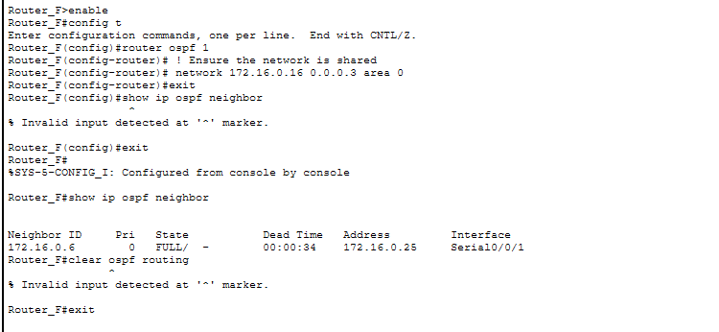
5.2. Exterior / Traffic Engineering: Static Routing
Static routes were explicitly configured to override the dynamic OSPF path selection for specific organizational requirements.
- Policy: Traffic from Campus F to Campus D is forced via Campus A.
- Policy: Traffic between Campus D and Campus B is forced via the Direct Link.
- Reasoning: Static routes (Administrative Distance 1) take precedence over OSPF routes (Administrative Distance 110), ensuring critical traffic follows the engineered path while OSPF handles the rest.
- Network Services
6.1. DHCP (Dynamic Host Configuration Protocol)
Router A is configured as the DHCP Server to automatically assign IPs to end devices in VLANs 10, 20, and 30.
- Sample Configuration (VLAN 10 Pool):
6.2. Access Control Lists (ACLs)
Standard ACLs are implemented to restrict inter-VLAN access for security (e.g., preventing the "Guest" VLAN from accessing the "Finance" VLAN).
- Implementation: Extended ACL numbered 100.
- Rule: Deny VLAN 30 (Guest) access to VLAN 10 (Management).
6.3. NAT (Network Address Translation)
To simulate Internet access, NAT Overload (PAT) is configured on the Edge Router (Router A). This allows multiple private internal users to share a single public IP address.
- Inside Interface: LAN interfaces (Gi0/0 subinterfaces).
- Outside Interface: The connection to the ISP (e.g., Serial 0/0/0).
- Configuration:
Bash
ip nat inside source list 1 interface Serial0/0/0 overload
access-list 1 permit 10.0.0.0 0.255.255.255
- Network Security & Redundancy
7.1. Port Security
Port security is enabled on switch access ports to prevent unauthorized devices from connecting.
- Action: If an unauthorized MAC address connects, the port shuts down.
7.2 WPA2-PSK:
Used WPA2 protocol to provide secure connections:
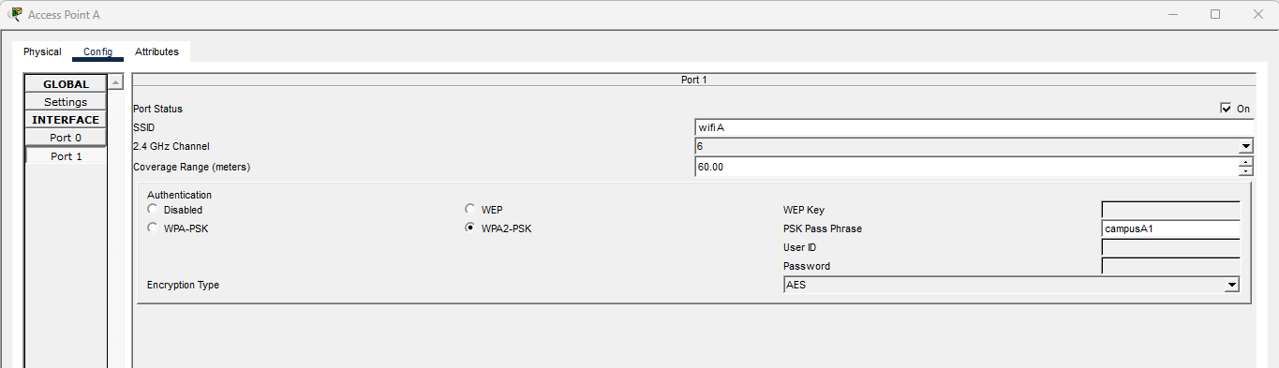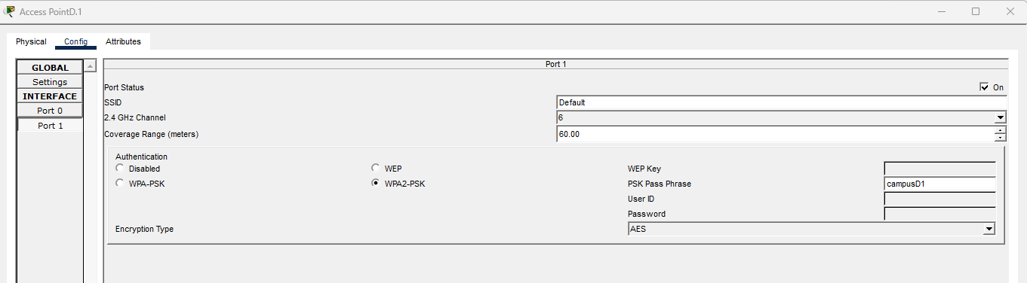
- CLI Commands:
