ffff

**Dharmsinh Desai University**



**Academic Year: 2022-23 Department: Faculty of Management &**

**Information Science**

**Subject: Deleted Data Recovery Mechanism**

**Full Name: Alyani Mamad Submitted to Prof. Hetal Patel**

**Roll No: MA003 MCA**

**ID No : 22MAPBG029 Department**

**Student Sign: Professor Sign:**

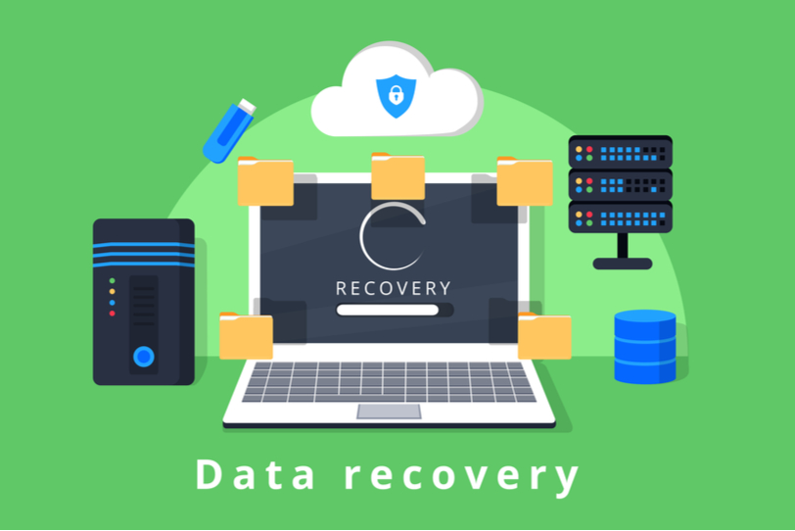

* **Deleted Data Recovery Machanism Overview:**

* Deleted data recovery mechanism is a process used to retrieve lost or deleted data from computer storage devices. When data is deleted from a storage device, it is not immediately removed from the device but marked as "deleted" or "unallocated" in the file system. This means that the data still exists on the storage device until it is overwritten by new data. The process of deleted data recovery involves searching for and extracting this "deleted" data from the storage device.
* There are two main methods of deleted data recovery: software-based recovery and hardware-based recovery.
* Software-based data recovery involves the use of software tools to recover lost or deleted data. These tools work by scanning the storage device for files that have been marked as "deleted" or "unallocated" and attempting to recover them. Some of the popular data recovery software include Recuva, EaseUS Data Recovery Wizard, and Stellar Data Recovery.
* Software-based recovery tools typically come with a user-friendly interface that guides the user through the recovery process. The user can choose to scan for specific types of files, such as documents, images, or videos, and the software will search for them accordingly. The software also offers different recovery modes, including quick scan, deep scan, and RAW recovery. Quick scan mode is used to search for recently deleted files, while deep scan mode is used to scan the entire storage device for any lost or damaged files. RAW recovery mode is used to recover data from damaged or corrupted files.
* Hardware-based data recovery involves the use of specialized equipment to recover lost or deleted data. This method is typically used when the storage device has suffered physical damage or has failed completely. The process of hardware-based data recovery involves extracting the storage device from the computer or device and connecting it to specialized equipment. The equipment can read data directly from the storage device and transfer it to a separate storage device.
* Hardware-based data recovery is a more complex process and is typically performed by specialized data recovery companies. It is often used in cases where the data is extremely valuable, such as in forensic investigations or corporate espionage cases.
* However, it is important to note that deleted data recovery can also be used for malicious purposes. Cybercriminals may use data recovery techniques to retrieve sensitive information that has been deleted, such as passwords, credit card numbers, or other personal data. Therefore, it is crucial to implement proper security measures to protect against unauthorized access and ensure that deleted data is securely erased to prevent it from being recovered.



# Deleted Data Recovery Techniques



Deleted data recovery is the process of restoring data that has been deleted from a system. It involves using specialized software to recover data from the storage device. There are several techniques used for data recovery, including file carving, forensics imaging, and data carving, Undelete utilities, Remote data recovery.

* **File Carving:**
  + File carving is a technique used to recover files that have been deleted or lost due to formatting or corruption. It involves searching through the raw data on a storage device for patterns that match the file structure of specific file types, such as JPEG or PDF files.
  + File carving software scans the device for specific file headers and footers and attempts to piece together the files using the data found between them. File carving can be a time-consuming process, but it can recover files that may be inaccessible using other methods.
* **Forensics Imaging::** 
  + Forensic imaging is a technique used to create a bit-by-bit copy of a storage device for data recovery and analysis. It involves using specialized software to create a sector-by-sector image of the device, including any deleted data or unallocated space.
  + The forensic image can be analyzed using various tools to recover deleted files or information. Forensic imaging is commonly used in forensic investigations and data recovery cases where data may be critical to an investigation or legal case.
* **Data Carving**:
  + Data carving is a technique used to recover data from unallocated space on a storage device. Unallocated space refers to the areas on a device where data has been deleted or lost, but the space has not been overwritten.
  + Data carving software scans the unallocated space for file signatures and attempts to recover the data by piecing together fragments of deleted files. This technique can be useful in recovering deleted files or data from a formatted storage device.
* **Undelete utilities:**
  + Undelete utilities are software tools used to recover recently deleted files. These tools scan the storage device for recently deleted files and can recover them if they have not been overwritten by new data.
  + Undelete utilities are easy to use and can recover files quickly, but they may not be effective in recovering files that have been deleted for an extended period.
* **Remote data recovery :** 
  + Remote data recovery is a technique used to recover data from a storage device that is not physically accessible. It involves establishing a remote connection to the storage device and using specialized software to recover the data.
  + Remote data recovery can be useful in situations where the storage device is located in a remote location or is inaccessible due to physical damage. It requires specialized knowledge and tools and is commonly used in corporate environments or forensic investigations.
* these are some of the most common deleted data recovery techniques used in data recovery cases. The choice of technique depends on the specific situation, the type of storage device, and the type of data that needs to be recovered. It's important to note that data recovery can be a complex and challenging process, and it's often best to seek the assistance of a data recovery professional to ensure the best chance of success.

# Challenges in Deleted Data Recovery:

Deleted data recovery is a complex process and involves several challenges. Some of the challenges faced during deleted data recovery are:

* **Overwritten data:**
  + - Overwritten data is one of the biggest challenges in deleted data recovery. When data is deleted from a storage device, the operating system marks the space it occupied as available for new data. If new data is written over the deleted data, it may become irretrievable. The chances of successful recovery decrease with every write operation that occurs after the data is deleted. Therefore, it's crucial to stop using the storage device immediately after the data is deleted to increase the chances of recovery.
* **Physical damage to the storage device:**
  + - Physical damage to the storage device is another significant challenge in deleted data recovery. The device may become unreadable due to damage caused by physical impact, water damage, fire, or other environmental factors. In some cases, physical damage can result in the loss of data altogether, making recovery impossible.
* **Encryption:** 
  + - It used to protect data by scrambling it so that it's unreadable without the encryption key or password. If the data is encrypted, it can be challenging to recover it, even if it's still present on the storage device. Without the encryption key or password, the data may be inaccessible, making recovery impossible. However, there are methods to recover encrypted data, such as brute force attacks, but these methods can be time-consuming and resource-intensive.
* **Fragmentation:**
  + - Fragmentation is a process where files are broken up into smaller pieces and scattered across different parts of the storage device. If a file is fragmented, it may be more challenging to recover, as the data may be spread across different sectors of the storage device. This can make it more difficult for data recovery software to locate and reconstruct the deleted file. However, professional data recovery services have specialized tools and techniques to overcome this challenge.
* **Legal restrictions:** 
  + - In some cases, deleted data recovery may be subject to legal restrictions. For example, data recovery from a device that was seized as part of a criminal investigation may require a court order or other legal authorization. Additionally, some countries have laws that prohibit the recovery of data without the owner's permission or a court order.
* **Time constraints:**
  + - Deleted data recovery can be a time-consuming process, and in some cases, time may be a critical factor. For example, if the data is needed urgently for a legal case or business operation, there may be pressure to recover the data quickly. However, rushing the process can increase the risk of making mistakes, and it's essential to work with a professional data recovery service to ensure that the recovery process is carried out correctly.
* **deleted data recovery can be challenging due to overwritten data, physical damage to the storage device, encryption, fragmentation, legal restrictions, and time constraints. Professional data recovery services have specialized tools and techniques to overcome these challenges and increase the chances of a successful recovery.**

# Prevention and Mitigation:

Prevention and mitigation strategies for deleted data recovery mechanism can help reduce the likelihood of data loss and increase the chances of successful recovery in the event of data loss. Here are some prevention and mitigation strategies:

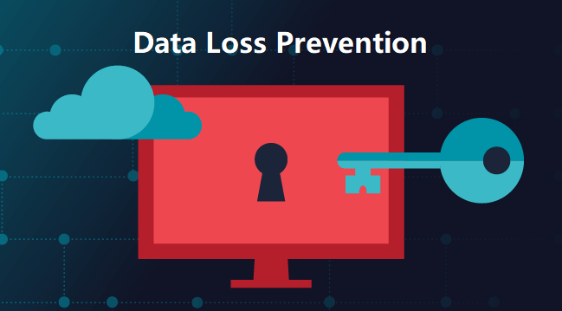

* **Regular backups:**
  + - Regular backups of important data can be an effective prevention and mitigation strategy for deleted data recovery. Backups should be stored in a secure location that's separate from the primary storage device. This way, if data is lost or deleted, it can be restored from the backup. It's essential to test backups regularly to ensure that they're working correctly and that the data can be restored successfully.
* **Use data recovery software:**
  + - Data recovery software can be an effective mitigation strategy for deleted data recovery. This software can be used to scan the storage device for deleted or lost data and recover it. However, it's essential to use reputable software and follow the instructions carefully to avoid further data loss.
* **Use disk imaging:**
  + - Disk imaging is a process where an exact copy of the storage device is created. This can be an effective prevention and mitigation strategy for deleted data recovery, as it allows for the recovery of lost or deleted data from the disk image. However, it's important to create regular backups of the disk image to ensure that the data is up to date.
* **Encryption:**
  + - Encryption can be a prevention strategy for deleted data recovery. Encrypting sensitive data can prevent unauthorized access to the data if the storage device is lost or stolen. However, it's important to remember that encryption can also make deleted data recovery more challenging.
* **Proper handling and storage of storage devices:**
  + - Proper handling and storage of storage devices can help prevent physical damage to the device, which can make data recovery impossible. Devices should be stored in a cool, dry place and handled with care to avoid physical impact.
* **Professional data recovery services:**
  + - In the event of data loss, professional data recovery services can be a mitigation strategy for deleted data recovery. These services have specialized tools and techniques to recover lost or deleted data. It's essential to choose a reputable data recovery service to ensure that the data is recovered successfully and securely.
* **prevention and mitigation strategies for deleted data recovery include regular backups, the use of data recovery software, disk imaging, encryption, proper handling and storage of storage devices, and professional data recovery services. Implementing these strategies can reduce the likelihood of data loss and increase the chances of successful recovery in the event of data loss.**
* **Conclusion :**
* deleted data recovery mechanism is a crucial process for recovering data that has been accidentally or intentionally deleted from a storage device. There are various techniques used in deleted data recovery, including file carving, forensics imaging, and data carving, which can be effective in recovering deleted data from different storage devices.
* However, deleted data recovery also presents significant challenges, including the possibility of data corruption, data overwriting, and physical damage to the storage device. It's essential to handle the storage device carefully and follow best practices to minimize the risks of data loss.
* Prevention and mitigation strategies, such as regular backups, the use of data recovery software, disk imaging, encryption, proper handling, and storage of storage devices, and professional data recovery services, can help reduce the likelihood of data loss and increase the chances of successful recovery in the event of data loss.
* Overall, deleted data recovery mechanism is a critical process in modern data management and cybersecurity. Understanding the techniques and challenges involved in deleted data recovery can help individuals and organizations protect their data and ensure that they can recover from data loss effectively.