**Dharmsinh Desai University**



Academic Year 2022-23

Department:

Faculty of Management and information science

Subject:

Cyber Security and Digital Forensics

**Full Name:** Sutariya Savankumar Sureshbhai

**Roll No.:** MA065

**ID No.:** 22MAPOG030

**Submitted to: Prof. Hetal M. Patel | MCA Department**

|  |  |
| --- | --- |
| **Student sign.** | **Professor sign.** |

Table Contents

1. Introduction 3

2. Explanation 5

2.1. Cloud Forensics: 5

2.2. Mobile Forensics: 6

2.3. Mobile cloud forensics 7

3. Case Studies 9

3.1. the death of Bollywood actor Sushant Singh Rajput 9

3.2. San Bernardino shooting in 2015 9

4. Methodologies and techniques 11

4.1. Evidence Acquisition: 11

4.2. Data Analysis: 11

4.3. Forensic Imaging: 11

4.4. Timeline Analysis: 11

4.5. Hash Analysis: 11

4.6. Network Forensics: 11

4.7. Memory Analysis: 12

4.8. Mobile Application Analysis: 12

Software can be used 12

5. Challenges and Limitations 14

5.1. Encryption: 14

5.2. Jurisdictional Issues: 14

5.3. Cloud Complexity: 14

5.4. User Behavior: 14

5.5. Hardware Limitations: 14

5.6. Fragmented Data: 14

5.7. Legal and Ethical Issues: 15

6. Conclusion 16

# Introduction

* As technology continues to advance and become more integrated into our daily lives, the use of cloud computing and mobile devices has become increasingly prevalent. While these technologies offer many benefits, such as increased mobility and accessibility, they also present unique challenges when it comes to digital forensics.
* Cloud forensics, mobile forensics, and mobile cloud forensics are all important areas of study that focus on the investigation and analysis of digital evidence related to cloud computing and mobile devices.
* **Cloud forensics** involves the examination of digital evidence related to cloud computing services, such as data stored on remote servers and virtualized computing resources. Mobile forensics, on the other hand, involves the investigation of data and applications stored on mobile devices, such as smartphones and tablets.
* **Mobile forensics**, a subtype of digital forensics, is concerned with retrieving data from an electronic source. The recovery of evidence from mobile devices such as smartphones and tablets is the focus of mobile forensics. Because individuals rely on mobile devices for so much of their data sending, receiving, and searching, it is reasonable to assume that these devices hold a significant quantity of evidence that investigators may utilize.
* **Mobile cloud forensics** is a combination of both cloud and mobile forensics, and involves the investigation of digital evidence that spans both mobile devices and cloud computing services.
* These areas of digital forensics are critical for investigating crimes and other legal matters that involve the use of cloud computing and mobile devices. They require specialized knowledge and expertise, as well as specialized tools and techniques, to collect and analyze digital evidence in a forensically sound manner.
* In this document, we will explore the key concepts and techniques involved in cloud forensics, mobile forensics, and mobile cloud forensics. We will discuss the challenges and opportunities presented by these areas of digital forensics, as well as the best practices and tools that can be used to effectively investigate and analyze digital evidence related to cloud computing and mobile devices.

# Explanation

## Cloud Forensics:



* Cloud forensics involves the investigation and **analysis of digital evidence** related to **cloud computing services**. Cloud computing refers to the use of remote servers and networks to store, manage, and process data, rather than using a local server or personal computer. As a result, cloud forensics requires specialized knowledge and techniques to investigate and collect evidence related to cloud services.
* One of the key challenges of cloud forensics is **identifying the location of the relevant data**, as it may be stored on remote servers in different geographic locations. Additionally, cloud forensics requires specialized tools and techniques to access and analyze data stored on remote servers in a forensically sound manner.

## Mobile Forensics:

|  |  |
| --- | --- |
| Mobile Forensics - Computer Forensics Resources - Computer Forensic Experts | Mobile forensics involves the investigation and analysis of digital evidence related to mobile devices, such as **smartphones and tablets**. Mobile devices store a wealth of information, including **call logs, text messages, emails, and location data**, which can be crucial in criminal investigations. |

* The phrase mobile device usually refers to [mobile phones](https://en.wikipedia.org/wiki/Mobile_phone); however, it can also relate to any digital device that has both internal memory and [communication](https://en.wikipedia.org/wiki/Telecommunication) ability, including [PDA](https://en.wikipedia.org/wiki/Personal_digital_assistant) devices, [GPS](https://en.wikipedia.org/wiki/GPS) devices and [tablet computers](https://en.wikipedia.org/wiki/Tablet_computers).
* Mobile forensics requires specialized tools and techniques to access and analyze data stored on mobile devices in a forensically sound manner. This includes techniques such as **data carving**, which involves the extraction of data from the raw binary format used by mobile devices, and **jailbreaking**, which involves gaining root access to the device to access data that is otherwise inaccessible.
* There is growing need for mobile forensics due to several reasons and some of the prominent reasons are:
  + Use of mobile phones to store and transmit personal and corporate information
  + Use of mobile phones in online transactions
  + Law enforcement, criminals and mobile phone devices
* Mobile cloud forensics requires specialized knowledge and techniques to collect and analyze data from both mobile devices and cloud services in a forensically sound manner. This includes understanding the synchronization processes used by mobile devices and cloud services, as well as understanding the potential for data to be stored in multiple locations.

## Mobile cloud forensics

* Mobile cloud forensics is a branch of digital forensics that involves the investigation and analysis of digital evidence that is distributed across mobile devices and cloud computing services. In today's world, mobile devices have become an integral part of our lives and we rely heavily on cloud services to store our data. As a result, mobile cloud forensics has become increasingly important in digital investigations.
* The data on mobile devices and cloud services can be synchronized in a number of ways, such as through automatic backups, manual uploads, or cloud-based app services. This synchronization process makes it possible for data to be stored in multiple locations, creating a complex digital landscape that can be challenging to investigate.
* Mobile cloud forensics requires specialized knowledge and tools to access and analyze data stored in mobile devices and cloud services in a forensically sound manner. The investigation may involve analyzing data from various sources such as mobile devices, cloud services, network traffic, and cloud-based app services.
* Some of the challenges that investigators may encounter in mobile cloud forensics include:
  + **Identifying the location of relevant data**: Because data can be stored in multiple locations, it can be challenging to identify where the relevant data is located.
  + **Accessing cloud data**: Accessing data stored in cloud services may require specialized tools and techniques that differ from those used to access data on mobile devices.
  + **Ensuring forensic soundness**: The forensic soundness of the investigation must be maintained throughout the process, which may involve using specialized tools to create forensic images of the data to ensure its integrity.
* Mobile cloud forensics is an evolving field, and as more and more people rely on cloud services to store their data, the importance of mobile cloud forensics in digital investigations will only continue to grow. By using specialized knowledge and tools, digital forensic investigators can access and analyze data stored in mobile devices and cloud services to uncover important evidence that can help solve crimes and bring justice to victims.

# Case Studies

## the death of Bollywood actor Sushant Singh Rajput

One recent case in India that involved the use of digital forensics was the investigation into the death of Bollywood actor Sushant Singh Rajput in 2020.

The Central Bureau of Investigation (CBI) was brought in to investigate the case, and digital forensics played a crucial role in uncovering evidence related to the actor's death. The CBI used digital forensics techniques to examine Sushant's mobile phone, laptop, and other electronic devices for evidence.

According to news reports, the CBI was able to recover deleted messages and chats from Sushant's mobile phone, as well as emails and documents from his laptop. The digital evidence collected by the CBI was used to build a timeline of events leading up to Sushant's death and to identify potential suspects in the case.

The use of digital forensics in the investigation into Sushant's death highlights the important role that these techniques can play in criminal investigations in India. As more and more digital evidence is created and stored on electronic devices and cloud services, the use of digital forensics will only become more important in investigating and solving crimes.

## San Bernardino shooting in 2015

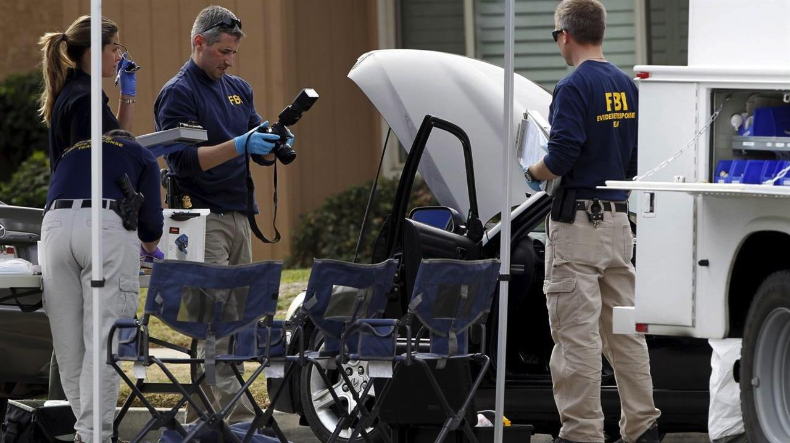

One case study on mobile cloud forensics is the investigation into the San Bernardino shooting in 2015. The shooting, which occurred in California, resulted in 14 deaths and multiple injuries. Following the incident, the Federal Bureau of Investigation (FBI) was called in to investigate the case and used mobile cloud forensics to access the data stored on the shooter's iPhone.

The shooter's iPhone was protected by a passcode, and the FBI initially requested Apple's assistance to unlock the device. When Apple refused to comply with the request, citing privacy concerns, the FBI turned to mobile cloud forensics to access the data stored on the shooter's iCloud account.

The FBI was able to obtain a search warrant to access the shooter's iCloud account, and used mobile cloud forensics techniques to extract data such as photos, emails, and text messages from the account. This data was used by the FBI to piece together the shooter's motives and identify any potential accomplices.

The use of mobile cloud forensics in the San Bernardino shooting investigation highlights the importance of this technique in digital investigations. By accessing the data stored on mobile devices and cloud services, investigators can uncover critical evidence that can help solve complex cases. However, the use of mobile cloud forensics also raises important privacy concerns, and investigators must ensure that they maintain forensic soundness and adhere to legal and ethical standards throughout the investigation.

# Methodologies and techniques

## Evidence Acquisition:

This involves the collection of digital evidence from cloud services and mobile devices. The process involves identifying and preserving relevant data, such as call logs, text messages, social media activity, and other relevant data.

## Data Analysis:

This involves the processing and analysis of digital evidence collected from cloud services and mobile devices. The process involves identifying patterns, relationships, and anomalies within the data, and creating a timeline of events to reconstruct the sequence of events leading up to a particular incident.

## Forensic Imaging:

This involves creating an exact copy of a mobile device or cloud storage account, which can be used to conduct a more thorough analysis of the data.

## Timeline Analysis:

This involves the creation of a chronological timeline of events based on the digital evidence collected from cloud services and mobile devices. This helps investigators understand the sequence of events leading up to a particular incident.

## Hash Analysis:

This involves the use of cryptographic hash functions to verify the authenticity and integrity of digital evidence collected from cloud services and mobile devices.

## Network Forensics:

This involves the analysis of network traffic to identify patterns, trends, and anomalies that may be relevant to an investigation.

## Memory Analysis:

This involves the analysis of volatile memory data, such as RAM, to identify information that may not be available on the physical device or cloud service.

## Mobile Application Analysis:

This involves the analysis of mobile applications to identify any suspicious behavior or activity that may be relevant to an investigation.

* These methodologies and techniques are constantly evolving, and investigators must stay up to date with the latest tools and best practices to conduct effective investigations in cloud forensics, mobile forensics, and mobile cloud forensics.

## Software can be used

## Cellebrite UFED:

This is a mobile forensic software tool used to extract and analyze data from mobile devices.

## Oxygen Forensic Detective:

This is a mobile forensic software tool used to extract and analyze data from mobile devices, including cloud-based services.

## EnCase:

This is a digital forensic software tool used for evidence acquisition, data analysis, and incident response across multiple devices and cloud services.

## Magnet AXIOM:

This is a digital forensic software tool used for evidence acquisition, data analysis, and incident response across multiple devices and cloud services.

## FTK Imager:

This is a digital forensic software tool used for imaging, data acquisition, and analysis of digital evidence.

## XRY:

This is a mobile forensic software tool used to extract and analyze data from mobile devices, including cloud-based services.

## Autopsy:

This is an open-source digital forensic software tool used for evidence acquisition, data analysis, and incident response across multiple devices and cloud services.

# Challenges and Limitations

Like any other forensic investigation, cloud forensics, mobile forensics, and mobile cloud forensics have their own set of challenges and limitations. Here are some of the challenges and limitations in these areas:

## Encryption:

The use of encryption to secure data on mobile devices and cloud services makes it difficult to extract and analyze the data.

## Jurisdictional Issues:

Cloud storage is often located in different jurisdictions, which can create challenges in accessing and collecting digital evidence.

## Cloud Complexity:

Cloud services are often complex and constantly changing, making it difficult for investigators to keep up with the latest technology and to conduct effective investigations.

## User Behavior:

Users of mobile devices and cloud services can delete or modify data, which can make it difficult for investigators to collect and analyze digital evidence.

## Hardware Limitations:

Mobile devices have limited storage capacity, which can make it difficult to conduct a complete forensic analysis of the device.

## Fragmented Data:

Data on mobile devices and cloud services can be fragmented and spread across multiple locations, making it difficult to reconstruct a complete picture of the events.

## Legal and Ethical Issues:

Conducting forensic investigations in cloud and mobile environments can raise legal and ethical issues, such as the right to privacy and the admissibility of evidence in court.

# Conclusion

In conclusion, the increasing use of mobile devices and cloud services has led to a rise in the importance of digital forensics in investigating crimes and incidents involving these technologies. Cloud forensics, mobile forensics, and mobile cloud forensics are specialized areas of digital forensics that focus on investigating data stored on mobile devices and cloud services.

In this document, we have discussed the importance of these fields, provided case studies to illustrate their application in real-life situations, and outlined some of the common methodologies and software tools used in these areas.

We have also discussed the challenges and limitations that investigators may face when conducting forensic investigations in mobile and cloud environments. It is important for investigators to be aware of these challenges and limitations and to develop appropriate strategies for overcoming them.

Overall, mobile cloud forensics is a rapidly evolving field, and it is important for investigators to stay up to date with the latest technology and techniques in order to conduct effective investigations and to ensure that justice is served.