**ALYANNA MARIE N. BILAZON**

**CS3C**

**The math module provides a wide range of mathematical functions, please provide 1 example with result image on each of the ff below:**

* **Number functions**

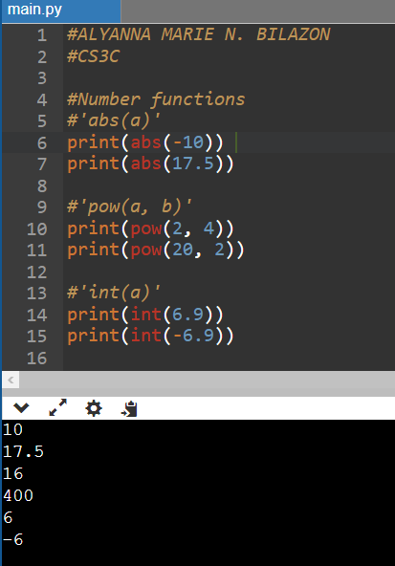

* 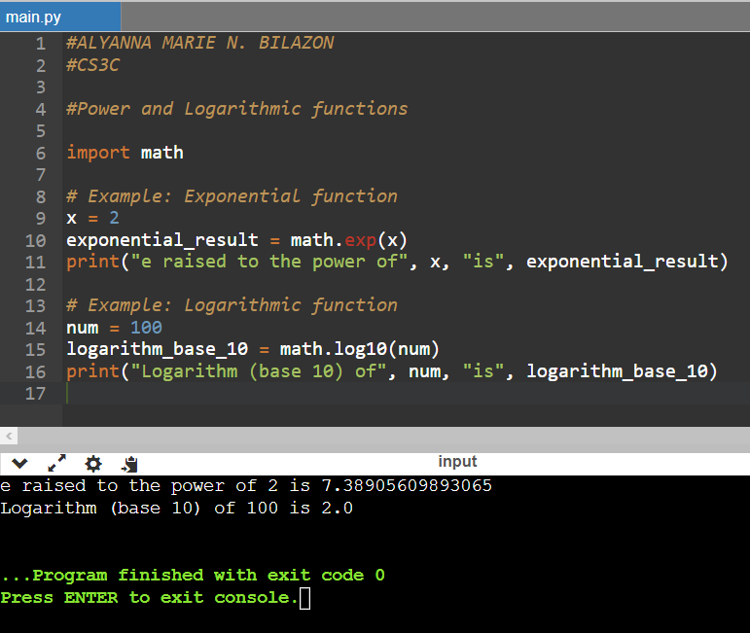**Power and logarithmic functions**
* 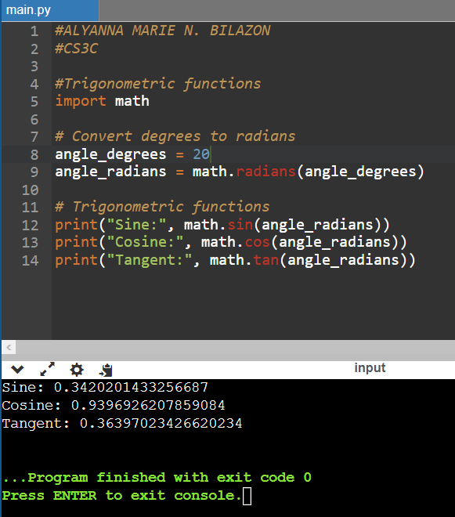**Trigonometric functions**
* 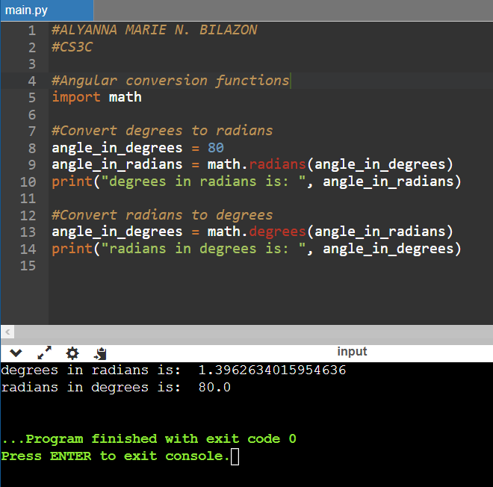**Angular conversion functions**
* 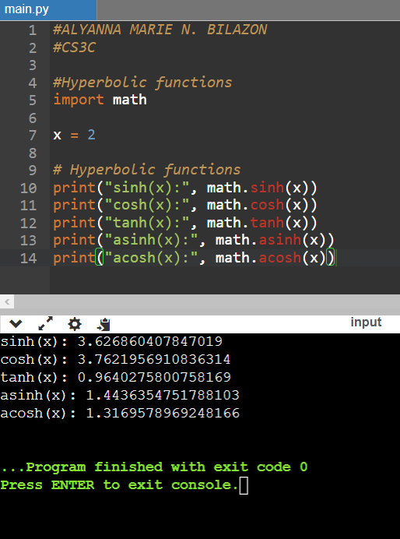**Hyperbolic functions**