IGGLE POP
DESCRIPTION
IgglePop is a PacMan based game, PacMan is an arcade game of the 80’s where the player controls the agent through a maze ﬁlled with pills and ghosts.

VISUALS

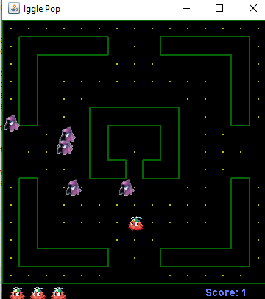

INSTALLATION

The game works on any java supportive work environment, we have used Eclipse. After downloading Eclipse, import the src folder which contains all the classes for the game and set the correct path for the images, afterwards run the code and the game will start working.

CONTRIBUTION

- ALYHA MAHMOOD 291991
- DANIYAH IMRAN 287498
- FARZAM HABIB KHAN 302615

