University of Baltistan

Public College, Skardu

Binary Number Converter using EMU8086

Computer Organization And Assembly Language

By:

Alina Kulsoom 2024-uobsac-1366

Nosheen Zehra 2024- uobsac -1404

Rabia Batool 2024- uobsac -1390

Sonia Inayat 2024- uobsac -1378

Instructor: Mr. Sajid Ali

Department of Computer Science

Contents

Introduction 1
Objective 1
Tools and Technology 1
Methodology 2
Importance of the Project 2
Conclusion 3
INTERFACE 4
IF WE ENTER 1 5
IF WE ENTER 2 6
IF WE ENTER 3 7
IF WE ENTER 4 8

Introduction

In the field of computer science and engineering, understanding number systems—particularly binary—is fundamental. Every computer system operates on binary logic, and converting between number systems is a necessary skill. This project titled "Binary Number Converter" is designed to help students understand and implement basic number system conversions using Assembly Language on the EMU8086 emulator.

Objective

The main objective of this project is to create a simple binary number converter that takes a binary input from the user and converts it into Decimal, Hexadecimal, and Octal formats. This tool helps build a practical understanding of how computers interpret and manipulate data at the hardware level.

Tools and Technology

- Programming Language: Assembly Language
- Platform: EMU8086 (x86 Emulator)

Methodology

The project will use assembly instructions to perform the following steps:
- Prompt the user to input a binary number
- Validate the input to ensure it only contains 0s and 1s
- Use shift and arithmetic operations to compute the decimal equivalent
- Convert decimal to hexadecimal and octal using division logic
- Display all results on screen using interrupt 21h
The code will use memory registers, loops, conditional jumps, and character handling to perform accurate conversions.

Importance of the Project

This converter gives hands-on experience with low-level programming concepts such as:
- Bitwise operations
- Data storage in registers and memory
- ASCII-to-integer conversion
- Output formatting using BIOS and DOS interrupts
This enhances the student’s understanding of computer organization, digital logic, and system-level operations.

Conclusion

This project is ideal for demonstrating how binary data is manipulated at the hardware level using assembly language. It not only strengthens programming and logic-building skills but also gives insight into how number systems are processed inside a computer. This converter can serve as a basic model for more complex embedded systems and software tools where such transformations are essential
REFERENCES

- ProgrammingKnowledge. (2016). Assembly Language Tutorial using EMU8086. YouTube.
https://www.youtube.com/watch?v=1_H7InPMfQ4

- Neso Academy. (2018). Number System Conversions (Binary, Decimal, Octal, Hexadecimal). YouTube. https://www.youtube.com/watch?v=Y2XBpYbpJr8

- EMU8086 Documentation. (n.d.). Assembler and Emulator for x86.

https://emu8086-microprocessor-emulator.en.softonic.com
/

INTERFACE
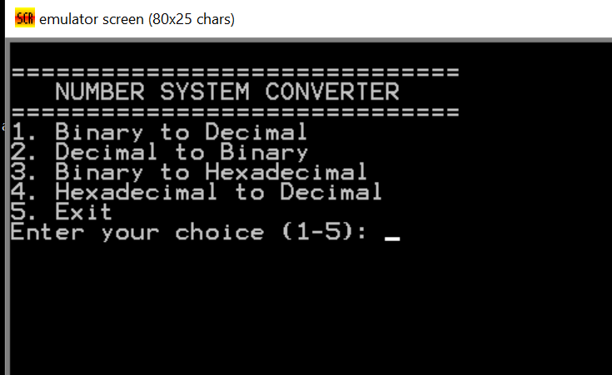
Figure 1

IF WE ENTER 1

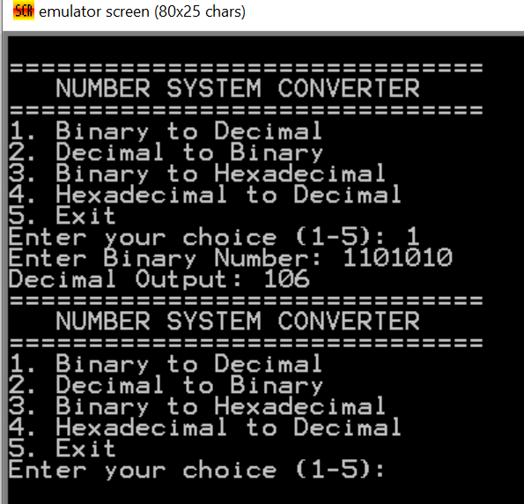
Figure 2

IF WE ENTER 2
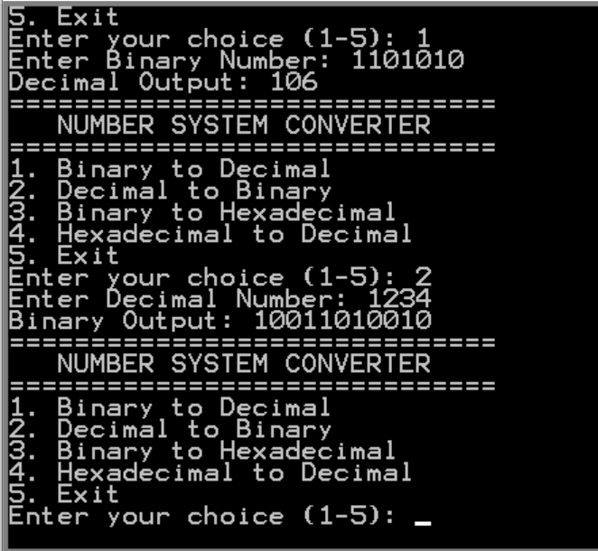

Figure 3

IF WE ENTER 3

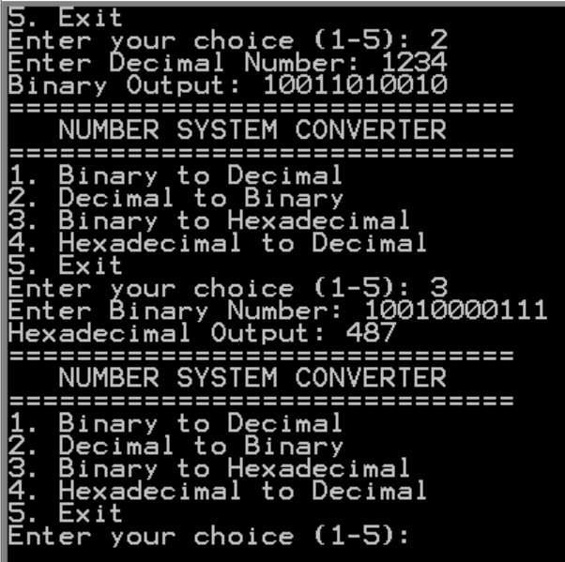
Figure 4

IF WE ENTER 4
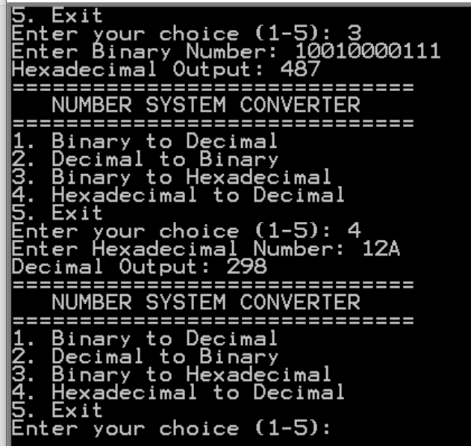
Figure 4
Figure 5

