离线测试demo说明：
运行HttpService.exe，接口即可测试对接，接收到的Json保存在程序目录下的Log文件夹内。
接口地址：http://localhost:9999/deviceApi/invokeSrv
Http Post提交数据：示例用户名a，密码b。
Content-Type：application/json; charset=UTF-8
Authorization=”Basic “+base64(用户名+":"+密码)
其中base64(用户名+":"+密码)值为YTpi。

测试OK的json：
{
"reqCode": "12345678999",
"reqTime": "2019-10-10 12:11:05",
"clientCode": "",
"tokenCode": "123",
"interfaceName": "devStatus",
"deviceCode": "D001",
"workTime": "2019-10-10 12:11:05",
"status": "stop",
"extend1": "测试"
}
返回：{"reqCode":"12345678999","result":"OK","message":"","extend1":"","extend2":"","extend3":""}

测试NG的json:reqCode改为reqCodea。
{
"reqCodea": "12345678999",
"reqTime": "2019-10-10 12:11:05",
"clientCode": "",
"tokenCode": "123",
"interfaceName": "devStatus",
"deviceCode": "D001",
"workTime": "2019-10-10 12:11:05",
"status": "stop",
"extend1": "测试"
}
返回：message=“获取Json的reqCode值失败”。
{"reqCode":"","result":"NG","message":"\u83B7\u53D6Json\u7684reqCode\u503C\u5931\u8D25","extend1":"","extend2":"","extend3":""}

以下为PostMan工具调用截图。
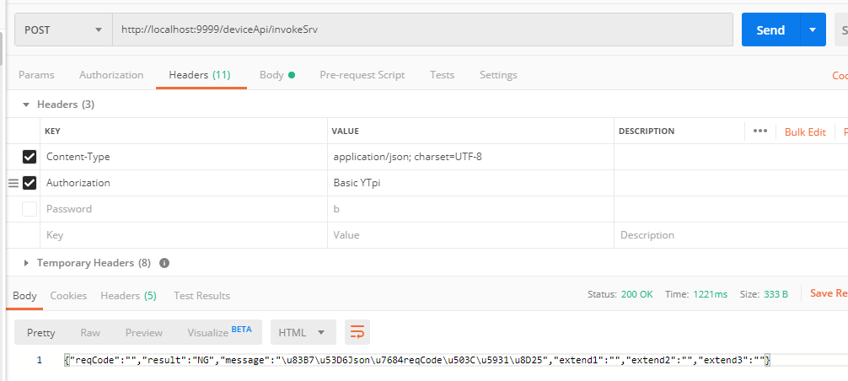

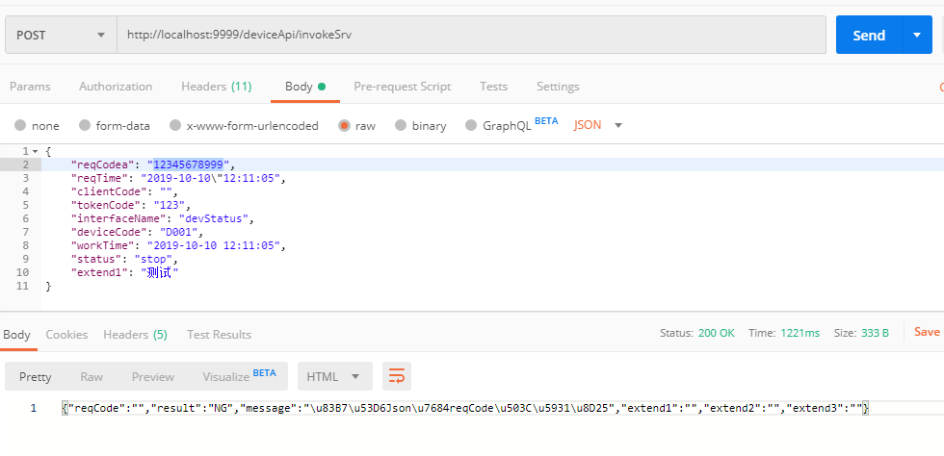
C#调用代码
HttpWebRequest httpWebRequest = WebRequest.Create(edtAddress.Text) as HttpWebRequest;
httpWebRequest.Method = "POST";
httpWebRequest.ContentType = "application/json";
//httpWebRequest.UserAgent = HttpHelper.DefaultUserAgent;
string userName = edtUserName.Text;//a
string password = edtPassword.Text;//b
string encoded = Convert.ToBase64String(Encoding.GetEncoding("ISO-8859-1").GetBytes(userName + ":" + password));
httpWebRequest.Headers.Add("Authorization", "Basic " + encoded);
httpWebRequest.Headers.Add("charset", "UTF-8");
using (var streamWriter = new StreamWriter(httpWebRequest.GetRequestStream()))
{
streamWriter.Write(richTextBox1.Text);
streamWriter.Flush();
streamWriter.Close();
}
var httpResponse = (HttpWebResponse)httpWebRequest.GetResponse();
using (var streamReader = new StreamReader(httpResponse.GetResponseStream()))
{
richTextBox2.Text = streamReader.ReadToEnd();
}
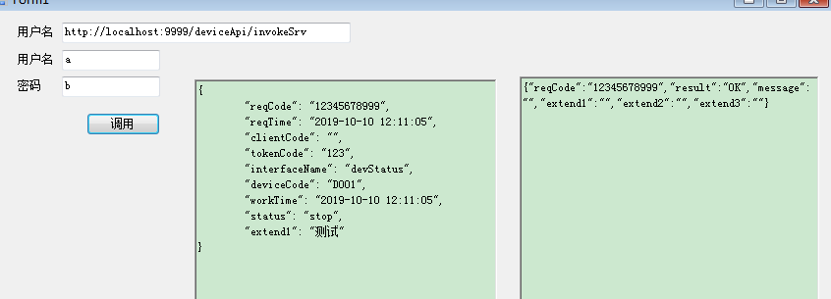
Delphi调用代码
var
RequestStream: TStringStream;
ResponseStr: string;
IDHttpMES: TIdHTTP;
jJson: TJSONObject;
begin
RequestStream := nil;
IDHttpMES := nil;
jJson := nil;
try
IDHttpMES := TIdHTTP.Create(nil);
IDHttpMES.Request.Connection := 'Keep-Alive';
IDHttpMES.Request.Charset := 'UTF-8';
IDHttpMES.Request.ContentType := 'application/json';
IDHttpMES.request.Method := 'POST';
IDHttpMES.request.ContentLength := 0;
IDHttpMES.Request.CustomHeaders.Values['Authorization']:=
'Basic '+EncdDecd.EncodeString(edtUserName.Text+':'+edtPassWord.Text);

jJson := TJSONObject.ParseJSONValue(memo1.lines.text) as TJSONObject;
RequestStream := TStringStream.Create(jJson.ToString, TEncoding.GetEncoding(65001));
ResponseStr := IDHttpMES.Post(edtAddress.Text, RequestStream);
Memo2.Lines.Add('返回数据:'+ResponseStr);
finally
IDHttpMES.Free;
RequestStream.Free;
jJson.Free;
end;
end;

