Unified Platform for Student Organization Engagement and Membership Opportunities at PUP Main Campus Sta.Mesa Manila.

Prepared for:
Institute of Technology

Prepared By:
Group 2
Abarca, Jerome
Balana, Clifford Josh
Caballero, Janna Mae
Caculba, Ashanti Louise
Calimag, Alyson Bryan
Lacano, Jusphine
Malgapo, Rica Mae
ACKNOWLEDGMENT
This research becomes a reality with the kind support of many individuals. The researchers would like to extend their sincere thanks to all of them.
Foremost, the researchers want to offer this endeavor to our GOD Almighty for the wisdom bestowed upon the researchers, the strength, peace of mind and good health in order to finish this research
The researchers would like to express their gratitude towards their family for the encouragement which helped the researchers in completion of this paper.
The researchers are highly indebted to Polytechnic University of the Philippines Institute of Technology for their guidance and constant supervision as well as for providing necessary information regarding this research & also for their support in completing this endeavor
The researchers would like to express their special gratitude and thanks to their adviser, Sir Fernando Lipardo Jr. for imparting his knowledge and expertise in this study.
Thanks to Sir John Michael Legaspi, Ma’am Jonnalyn Apsay, Sir Roel Malubay and Sir Mark Bautista and for sharing their knowledge and validating the researcher’s paper
The researchers would also like to express their thanks to all the respondents for their honest and cooperative response to all the questions solicited in this study
Thank you and appreciations to the people who have willingly helped the researchers out with their abilities
CERTIFICATION OF ORIGINALITY
This is to certify that the project titled Unified Platform for Student Organization Engagement and Membership Opportunities at PUP Main Campus Sta.Mesa Manila., submitted by Dit 31, Group 2 , is the result of our original effort, research, and creativity. The content, ideas, analyses, and materials presented in this work have been independently developed by us, and all sources and references consulted have been properly acknowledged and cited in accordance with academic and ethical standards.
We affirm that this project has not been previously submitted to any institution or organization for academic, professional, or personal purposes.
We understand the consequences of academic dishonesty and plagiarism and hereby take full responsibility for the authenticity and originality of this work. This certification is provided as a testament to the integrity, originality, and validity of the work we have submitted.
Name Of Researchers:
Abarca, Jerome
Balana, Clifford Josh
Caballero, Janna Mae
Caculba, Ashanti Louise
Calimag, Alyson Bryan
Lacano, Jusphine
Malgapo, Rica Mae

ABSTRACT
This study seeks to provide a uniform digital platform to overcome communication gaps and inefficiencies in student organization involvement at the Polytechnic University of the Philippines (PUP) Main Campus. The platform aims to simplify membership administration, event promotion, and interaction between student organizations, resulting in a more inclusive and engaged campus community. This research uses systems theory to highlight that we must unite all parties including students, organizations, and administrators to advance engagement levels and organizational development. This study uses two types of analysis to find that both students and organizations must deal with limited resources and inadequate exposure to suitable opportunities. The results show the need for building two key features, a platform for organizing events by type and a service for event promotion based on interest-specific categories. The suggested platform aims to create a more cohesive and welcoming campus community by removing these obstacles. It seeks to increase student involvement while simultaneously fostering organizational development, establishing an environment where everyone may flourish and enjoy their time on campus.

TABLE OF CONTENTS
Chapter 1: The Problem and Its Background
1.1 Background of the Study
1.2 Theoretical Framework
1.3 Research Paradigm
1.4 Statement of the Problem
1.5 Scope and Limitations
1.6 Significance of the Study
1.7 Definition of Terms

Chapter 2: Review of Related Literature
2.1 Local Literature
2.2 Foreign Literature
2.3 Local Studies
2.4 Foreign Studies
2.5 Synthesis of the Literature

Chapter 3: Research Methodology
3.1 Research Design
3.2 Research Locale
3.3 Participants and Sampling
3.4 Data Collection Procedures
3.5 Data Analysis Techniques
3.6 Ethical Considerations
3.7 Project Architecture

CHAPTER 1
THE PROBLEM AND ITS BACKGROUND
This chapter includes the background of the study, theoretical framework, research paradigm, statement of the problem, scope, and limitation, significance of the study, and the definition of terms used.

BACKGROUND OF THE STUDY
At some universities, students, and organizations struggle to establish long-term partnerships. Some students are unable to locate organizations that are relevant to their interests, and many organizations struggle to recruit new members and communicate opportunities according to DeSawal (2007). The lack of a consistent system for engagement and membership management has resulted in fragmented messaging, missed opportunities, and decreased involvement. These are only a few of the issues that highlight the importance of a centralized platform for reducing inefficiencies and encouraging genuine connections among campus community members.

Student organizations are vital because they assist students develop their personal, professional, and engagement skills. However, many students are unable to discover relevant organizations, and organizations struggle to recruit members and communicate opportunities. UniScholars (2021) states that student organizations give students the ability to connect, share interests, and lead. However, due to communication discrepancies or a lack of understanding, students are unable to take advantage of these chances.

Additionally, CampusGroups (2021) emphasizes the importance of effective communication tactics in attracting and retaining members, as well as having proper engagement tools. Furthermore, KEG News emphasizes the importance of student organizations in developing an atmosphere of belonging and integration in the academic environment. Communication breakdowns among students and organizations have come from a lack of interaction with effective and centralized services.

In this study, the independent variable is the creation of a centralized platform, whereas the dependent variables are student involvement, membership opportunities, and organizational communication. This study seeks to determine how communication gaps can be bridged by creating a web-based platform for membership, organizational management, and student participation.

This study aims to show how a centralized platform can provide a streamlined, user-friendly solution that improves communication, promotes organizational growth, and allows students to engage in opportunities that align with their interests and skills.

THEORETICAL FRAMEWORK
The framework is based in Systems Theory, which emphasizes the interconnectedness of different components within an organization. The platform acts as a system that integrates stakeholders, enabling seamless communication and collaboration among them.

CONCEPTUAL FRAMEWORK
This study follows the Agile Scrum framework to develop a centralized platform that addresses student and organizational challenges. The process follows an iterative cycle to ensure continuous improvement and efficient development.
The Backlog phase involves gathering requirements, including student skills, interests, organization profiles, and membership opportunities. These serve as the foundation for system development.
During Sprint Planning, tasks are prioritized, and goals for the sprint are set. This includes designing features such as a searchable directory, a matching tool, and an announcement board.
The Execution phase focuses on developing and testing these features, ensuring the system meets user needs. Developers continuously refine and implement functionalities based on feedback.

Once features are completed, the Deployment phase ensures the platform is fully functional and accessible to users. Updates are implemented in increments to maintain stability.
Finally, the Review and Retrospective phase evaluates the sprint’s success, collects user feedback, and identifies areas for improvement before the next cycle begins.
This iterative approach ensures that the platform continuously evolves, enhancing student engagement, streamlining student-organization matches, and improving communication within the campus community.
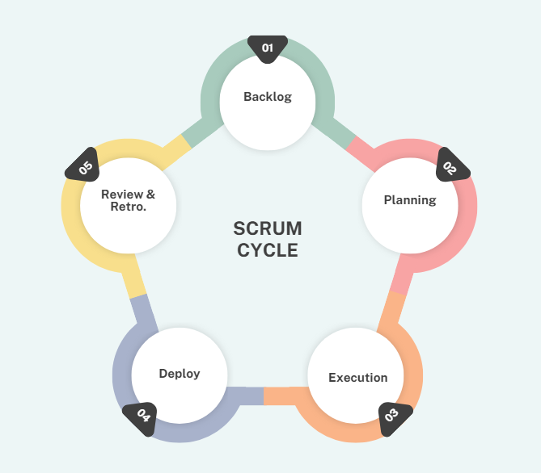

STATEMENT OF THE PROBLEM
This study investigates the challenges faced by students and organizations in managing organizational activities and fostering engagement within the university. The research aims to address issues related to recruitment, communication, and resource management by designing a centralized platform—Unified SOEMO. Specifically, the study seeks to answer the following questions:
- What are the challenges encountered by the respondents on the current student organization matters?
1.1 Recruitment issues and barriers
1.2 Lack of a unified platform for announcements and communication
1.3 Limited resources for managing and promoting organizations
1.4 Ineffective communication between organizations and students
1.5 Missed opportunities for student engagement and participation
- How to design the UNIFIED SOEMO in terms of
2.1 User Creation/Management
2.2 Events
2.3 Organizations
2.4 UI/UX
2.5 Feedback Mechanism
2.6 Notification System
2.7 Resource Sharing
3. How effective is the implementation of UNIFIED SOEMO in addressing student organization needs?
3.1 Does the platform increase student participation in organizations and events?
3.2 How does it enhance the efficiency of communication between students and organizations?
3.3 How well does it optimize the management and allocation of organizational resources?
3.4 Does it provide a seamless and user-friendly experience for both students and organization administrators?
3.5 How does the feedback mechanism contribute to continuous improvements in the platform?

SCOPE AND DELIMITATIONS
This study focuses on developing and implementing a Unified Platform for Student Organization Engagement and Membership Opportunities at the Polytechnic University of the Philippines (PUP) Main Campus in Sta. Mesa, Manila. The platform aims to enhance student engagement and streamline organizational processes by providing a centralized and accessible digital solution.

This platform will cater primarily to the students and organizations within PUP Main Campus, aiming to create a more engaged, connected, and organized campus community. The platform’s coverage is limited to PUP Main Campus only

SIGNIFICANCE OF THE STUDY
The implementation of Sustainable Development Goals (SDGs) in school organizations demonstrates a commitment to creating a comprehensive and impactful educational environment. This study focuses on the importance of a proposed centralized platform for student organization engagement in promoting the following SDGs:

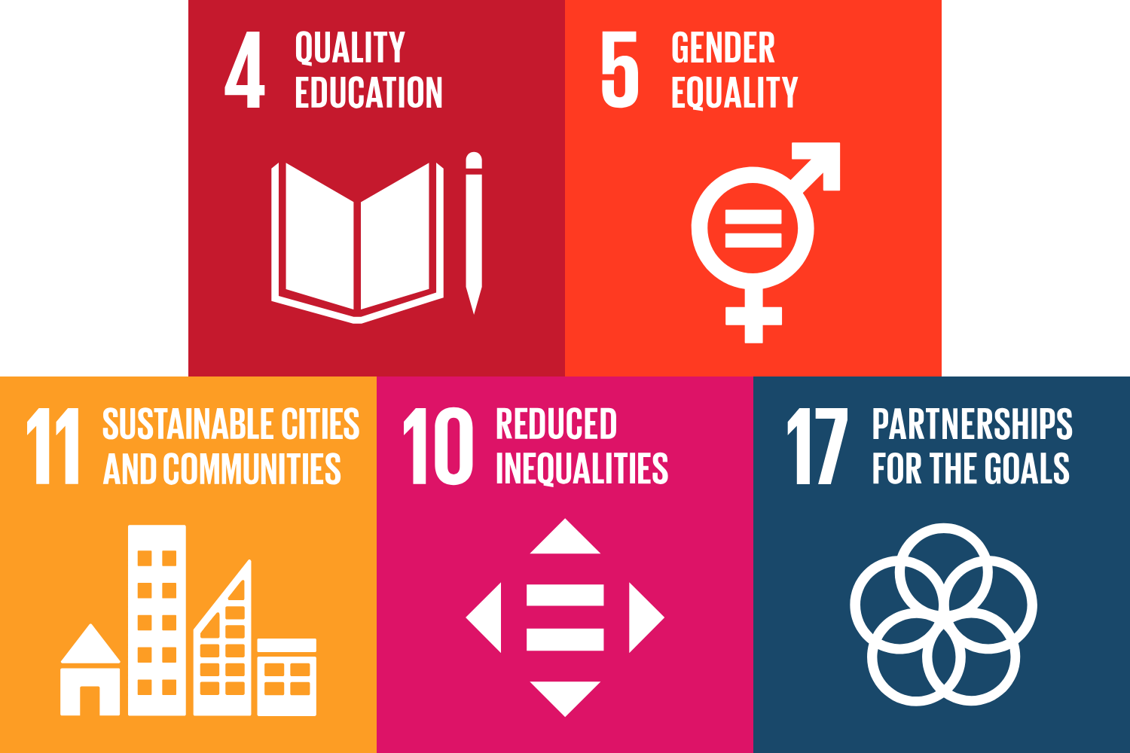

SDG 5 - Gender Equality
The proposed platform contributes to gender equality by ensuring equal access to information and opportunities for all students, regardless of gender. By providing a centralized platform, it helps eliminate barriers that might disproportionately affect certain groups, fostering an inclusive environment where everyone can participate equally in student organizations.

SDG 10 - Reduced Inequality
This study addresses inequality by bridging communication gaps and providing equal opportunities for all students to engage with organizations that match their interests. The platform helps reduce social and economic disparities by ensuring that all students have access to the same resources and opportunities, promoting a more equitable campus community.

SDG 11 - Sustainable Cities and Communities
The platform supports sustainable development within the campus community by enhancing connectivity and collaboration among students, organizations, and administrators. It fosters a sustainable environment by promoting resource sharing, efficient event management, and streamlined communication, which are crucial for building resilient and sustainable communities.

SDG 4 - Quality Education
Quality education is important as a foundational element of student success. The proposed centralized platform addresses the challenges students face in finding and engaging with organizations and enhances the overall educational experience. By fostering a culture of involvement and connection, the study highlights that quality education extends beyond academics to include the rich experiences that student organizations provide, ultimately contributing to the holistic development and experience of students. This approach reinforces the idea that education is a multi-faceted journey that thrives on collaboration and community engagement.
SDG 17 - Partnerships for the Goals
Draws emphasize the necessity of cross-sector and cross-level collaboration and partnerships to address complex global challenges. emphasizing the importance of partnerships and collaborative efforts to achieve sustainable development goals, which directly align with the objectives of the proposed platform. This aim highlights the collaborative nature of attaining the SDGs and the importance of stakeholder accountability and assistance in building a sustainable future for all.

DEFINITION OF TERMS
Centralized: Organized into a single, unified system for better communication and accessibility.
Platform: A web-based system designed to connect students, organizations, and administrators for communication and engagement.
Unified: Combined, integrated, or brought together as a single system or entity to create efficiency and cohesion.
Systems Theory: A conceptual framework emphasizing interconnections between components within an organization.

CHAPTER 2
REVIEW OF RELATED LITERATURE AND STUDIES
This chapter reviews the relevant literature and studies on the development of a Unified Platform for Student Organization Engagement and Membership Opportunities at PUP Main Campus, Sta. Mesa, Manila. The review focuses on the issues that students and student organizations confront, the significance of digital tools in increasing student engagement, and the factors that influence student participation and leadership development. The purpose of this chapter is to provide a contextual framework for understanding the necessity for such a platform and its potential benefits to students, organizations, and the university as a whole.

LOCAL LITERATURE
The studies collectively explore various aspects of student engagement, leadership development, and the role of digital tools in educational settings. Bajaj (2024) examines how digital learning platforms enhance student engagement, showing their potential to foster interaction among students. However, the study lacks a deeper analysis of the long-term effects of these platforms on student academic performance. Additionally, the study doesn't account for the varying effectiveness of these platforms based on different academic disciplines or student demographics, which could impact their overall utility and inclusivity.
Dedicatoria et al. (2023) focus on student leadership and the reasons students join organizations, linking this involvement to personal and academic growth. However, the study does not explore how participation in these organizations influences students' future career prospects. There is also a gap in investigating how the leadership roles within these organizations can be used as a tool for career development, such as by providing networking opportunities or skill development that directly align with industry needs.
Haines (2019) highlights student perspectives on joining organizations, emphasizing personal and professional development, but it overlooks the necessary institutional or faculty support for the success of student organizations. The study also does not address how institutional culture or faculty involvement might hinder or promote student participation in organizations, particularly in the context of underfunded or less-recognized groups.
Maglipas (2019) discusses the empowerment of student organization advisers in the Philippines and their impact on student leadership development, yet it does not address the influence of external factors such as government policies on these organizations. Moreover, the study does not explore how these advisers can be equipped with the tools and resources necessary to better guide students, including ongoing professional development for advisers themselves.
Mgweba (2024) explores the use of competitive intelligence for student recruitment in public universities, highlighting how it helps institutions attract students. The research gap here lies in the lack of investigation into how these strategies differ across regions or types of universities. Furthermore, the study fails to consider how competitive intelligence can also be used for retaining students once they are enrolled, such as by identifying at-risk groups and tailoring engagement efforts to retain them.
Singh (2024) delves into the impact of technology integration on student engagement and academic performance, focusing on its effects beyond the classroom. While the study highlights positive outcomes, it fails to consider the accessibility and equity of technology among diverse student populations. There is also a gap in examining how the infrastructure and digital literacy levels at different institutions affect the effectiveness of technology in enhancing engagement, especially in lower-resource settings.
Sumague (2023) examines the influence of involvement in clubs on leadership development, showing a clear link between engagement and skill-building. However, it does not address the emotional or psychological impacts of participation in these organizations. The study could also explore how the time commitment required for involvement in clubs affects students' mental well-being, as well as how to balance extracurricular involvement with academic pressures.
Modern Campus Involve (2021), formerly known as Presence, is a student engagement platform designed to enhance participation in student organizations through event management, membership tracking, and communication tools. Acquired by Modern Campus in June 2021, it provides universities with a centralized system for managing student involvement and offers data-driven insights to improve engagement and retention. The platform supports both in-person and virtual events, making it adaptable to modern campus needs. However, a key gap in Modern Campus Involve is that it is a generalized platform designed for multiple universities, which may not fully address the unique needs of individual institutions. Its implementation often requires significant funding and administrative support, which can be a barrier for some schools. Additionally, while it provides a structured approach to student engagement, it may lack customization features that cater to the specific organizational structures and student dynamics of certain universities.

Anderson (2024) discusses digital tools for facilitating in-person college student connections, focusing on the role of technology in maintaining relationships. However, the study does not explore how these tools affect the quality of relationships between students. There is also a gap in addressing how digital tools impact the depth of these connections—whether they enhance meaningful interactions or merely foster superficial relationships.
Lastly, the Unibuddy (2023) article highlights a student engagement platform but lacks data on its effectiveness or impact on student satisfaction. Furthermore, the study doesn't examine how such platforms can be continuously improved based on feedback and user experience, leaving a gap in how to measure long-term success and user retention.
The studies collectively point to the growing role of technology in enhancing student engagement. However, they often fail to address its long-term impact or inclusivity across diverse student groups. Moreover, many studies do not explore how these technologies can be further tailored to specific student needs, demographics, or regions. Additionally, there is a lack of exploration into how these technologies and strategies can be adapted to foster long-term sustainability and scalability in various educational contexts.

FOREIGN LITERATURE
LOCAL STUDIES
Diaz (2019) investigated student leadership at Nueva Ecija University of Science and Technology (NEUST), emphasizing the cognitive and interpersonal benefits of organizational participation. Peer influence and belonging were identified as primary motivators. The findings highlight barriers such as limited awareness of student organizations—an issue the proposed PUP platform seeks to address by centralizing organizational opportunities and fostering collaboration between academic and non-academic sectors.
Ravelas et al. (2023) examined student participation at Laguna University’s College of Education, finding a positive correlation between expanded organizational opportunities and student engagement. Their research supports the necessity of a centralized system, like the PUP platform, to enhance student connectivity and program participation, thereby strengthening academic and social development.

FOREIGN STUDIES
Philip and Aguilar (2021) conducted research to understand how students view leadership competency usage during digital transformation. Student leadership depends heavily on three important factors as shown by the research: digital literacy together with flexibility and effective communication abilities. According to research by the authors technological leadership strategies represent the fundamental approach needed for both academic and professional environments to achieve success. This aligns with our findings because utilizing a centralized digital platform at PUP will not only be a functional online space for student administration management but could also provide integrated digital tools that engage in student organization engagement and leadership development and prepare students for what is required of them in the current professional climate.
In Cheng's study (2023), it was analyzed how social media could facilitate the engagement of students from Shandong University of Traditional Chinese Medicine Student Organizations. The results show that consistent using of social media and higher levels of student involvement in group activities are positively correlated. Social media sites were found to be useful resources for member recruitment, event marketing and communication. This supports the findings of our study because the proposed Unified Platform intends to incorporate comparable digital communication tools to streamline recruiting, event advertising, and engagement processes, thereby increasing PUP student involvement in groups.
Hermoso et al. (2023) examined the challenges faced by leaders of student organizations concerning online management and their transition to digital competence. These included inadequate communication, low engagement, time limitations, and technology issues. Even with these challenges, student leaders adopted new strategies, such as engaging in social media, holding virtual meetings, and utilizing other online collaboration platforms. The research observed that while digital leadership requires transformation, it also enhances the effectiveness and reach of an organization. This study is in accordance with Unified Platform for Student Organization Engagement and Membership Opportunities at PUP because it calls for a single multifunctional digital platform that aids student organization leaders. The platform will be able to provide structured leadership tools, direct communication, and event management systems which will aid in addressing the issues associated with digital organizational leadership.
Koranteng et al. (2019) examined how social networking sites (SNS) demonstrates effects on higher education student involvement. The study demonstrates that regular social networking expands academic and extracurricular use which increases student participation in university programs and team collaboration and sharing of information. They suggested integrating digital platforms to support student engagement. Koranteng et al. (2019) support the development of a Unified Platform at PUP by showing that digital tools boost engagement. Features like discussion boards and event promotion can foster student participation and a more connected campus community.
Hong et al. (2019) examined the roles of academic engagement and digital readiness in students’ achievements in university e-learning environments based on their levels of digital readiness as well as engagement in learning activities. They found that students who are more engaged and comfortable with digital tools tend to perform better. The research demonstration that effective learning outcomes should include digital tools integration because they boost student engagement. According to this study, students that exhibit high levels of engagement and digital readiness do better academically. Our research of unified platform at PUP would achieve higher digital readiness when we create a single platform that provides essential resources for student organization participation thus fostering better student achievement.
Turkalj et al. (2020) examined that how student organizations use digital marketing to improve visibility and engagement. Research showed that organizations achieving member growth and boosted participation levels through website utilization and social media platforms (Facebook, Instagram, LinkedIn, YouTube) together with electronic promotions. The research demonstrated that organizations need competent digital marketing strategies to maintain student involvement and grow their membership base. This study supports our research of Unified Platform for Student Organization Engagement at PUP by highlighting the role of digital tools in boosting student involvement. The platform will include event promotion, targeted outreach, and automated announcements to help organizations improve communication and increase membership.
Smist (2020) examined how human actions, organizational contexts and institutional factors affect student leadership development. Active student organization engagement enables students to develop better leadership skills together with higher self-efficacy and lead with greater motivation. It stressed how participation in structured student organizations allows for decision-making, teamwork, and personal growth. This study supports the Unified Platform for Student Organization Engagement at PUP by showing how student involvement contributes to leadership development. By providing easy access to organizations, leadership opportunities, and structured activities, the platform can help students enhance their leadership potential and engagement.
Lan et al. (2023) investigated that the effects of social media-based peer learning networks have on student involvement. FPT University in Danang, Vietnam used students as research participants to find social media platforms enhanced team collaboration and academic knowledge distribution. The research identified both information exhaustion as well as disruptions among participants. The research findings validate our platform investigation at PUP that focuses on student organization social media engagement enhancement. The platform develops student organization communication by combining discussion features and collaborative elements with structured engagement tools that lead to productive and efficient communication practices.

SYNTHESIS OF THE LITERATURE
The analyzed studies highlight the significance of student organizations in developing leadership abilities, personal development, and academic performance. Local and foreign literature show that student engagement is closely related to improved communication, teamwork, and career readiness. However, current constraints such as inadequate recruitment techniques, a lack of unified communication and limited digital capabilities, prevent student organizations from reaching their full potential.
Several foreign studies stress the impact of digital transformation on student engagement. Philip and Aguilar (2021) and Hermoso et al. (2023) suggest that digital literacy and online leadership skills are crucial for effective student organization management. Cheng (2023) and Koranteng et al. (2019) shows social media platforms increase student involvement and mobilization. Meanwhile, Lan et al. (2023) and Turkalj et al. (2020) argue digital marketing strategies increase organization visibility as well as engagement. Active engagement within student organizations leads to further conclusions or the notion of promoting student leaders' development Smist (2020) and self-efficacy Sumague (2023).
Local research support similar conclusions, Diaz (2019) and Ravelas et al. (2023) uncovered how centralizing organizational opportunities through a digital platform can bridge engagement gaps and improve student participation. Furthermore, research by Garcia and Bay (2010) and Friales (2021) highlights that mentorship and faculty involvement significantly contribute to leadership development. Additionally, Bajaj (2024), Dedicatoria et al. (2023), and Singh (2024) focus on how technology-driven platforms improve student engagement and learning experiences.
Other studies, such as Modern Campus (2021) and Unibuddy (2023), emphasize the use of digital platforms in student organization management. Anderson (2024) and Haines (2019) look at how digital tools help students network and participate. Maglipas (2019), Mgweba (2024), and Hong et al. (2019) demonstrate how competitive intelligence, technology integration, and academic engagement promote student involvement.
The reviewed literature collectively supports the need for a centralized digital platform to address challenges in student organization engagement. A unified system at PUP could enhance communication, streamline recruitment, and promote leadership development. By integrating digital tools, such as event promotion features and automated notifications, the proposed platform aims to create a more connected and dynamic student community.

CHAPTER 3
RESEARCH METHODOLOGY
RESEARCH DESIGN
This research considered a qualitative research approach to gain the proper understanding of the perceptions, experiences, and challenges faced by students and organizations regarding engagement and membership opportunities. Qualitative research is the justification of exploration and comprehension of real-world data. The ability to understand and clarify human behavioral patterns that are challenging to quantify (Tenny et al., 2022.).

RESEARCH LOCALE
This study was conducted on Polytechnic University of the Philippines (PUP) Main Campus located in Sta. Mesa, Manila where the chosen respondents include individuals with the university’s organizations and personnel, as well as those not part of the organizations.

PARTICIPANTS AND SAMPLING
The participants of this research are individuals who are directly involved in or whose activities are influenced by the varied dynamics of student organizations at the Polytechnic University of the Philippines (PUP) Main Campus in Sta. Mesa, Manila. It is essential to select participants who can provide comprehensive insights into the engagement, opportunities, and challenges associated with student organizations within the university. The identified groups of participants are as follows:

PUP Students
- Current Members of Student Organizations: These are students who receive or apply for facilities in officially accredited student organizations within the university. They are included to gain the raw experiences, difficulties, and advantages of belonging to a student organization.

- Non-Members: These are those students who are not yet in any student organization but who showed some interest in participation in such organizations. Thus, their views will be valuable in pinpointing constraints to membership and elements that may expand organizational scope and access. This group will also give an opposing view to those present.
Faculty Members
Student Organization Advisers and Faculty Involved in Student Organizations: This group includes faculty members who work as advisers, mentors, or coordinators for student organizations. Their inclusion will provide an academic and administrative viewpoint on student organizations, such as their significance in student growth, organizational issues, and the impact of faculty leadership.
RESEARCH INSTRUMENT
This study employed an interview guide and a structured survey questionnaire, both developed by the researchers. The interview began with open-ended questions, prompting participants to share their experiences and perceptions regarding student organization involvement. Follow-up probing questions were utilized to delve deeper into the participants' insights. Surveys complemented interviews by collecting quantitative data on participation rates and organizational dynamics.

SAMPLING METHOD AND SIZE
This study will use convenience sampling to recruit participants from widely accessible groups on campus. This strategy was designed to acquire varied opinions from key academic community members efficiently. The sample will include at least 50 current student organization members, 30 students who are not members, and one official from each recognized student group. To ensure faculty representation, the study will involve at least 5 faculty members who work as advisers, mentors, or coordinators for student organizations. This section offers a balanced view of the role and influence of student organizations at the university. The study uses convenience sampling to enhance involvement from those who are readily available and willing to contribute. This strategy assures that both students and faculty members gain vital insights into the experiences, challenges, and benefits of being involved in student organizations.

DATA COLLECTION PROCEDURES
A list of participants will be compiled based on the sampling strategy, for interviewing the organization officers a semistructured interview schedule will be developed, and to gather data, a structured questionnaire will be constructed, for students. To have a clear view of the examined research issue questionnaires and interviews as the data collection tools will be utilized. To achieve primary data, different sources can be used such as experiments, surveys, interviews, and questionnaires (Taherdoost, 2021). Also, to enhance the convenience and availability of the surveys, online administration will be used through tools like Google Forms, students who will not be able to respond through the online platforms will also be given paper surveys. Depending on the participants' preferences and availability, semi-structured interviews will be either in-person or online using tools like Zoom or MS Teams. Additionally, to safeguard the participants' rights and welfare, the study will follow ethical research guidelines. A consent document must be signed before they can take part in surveys or interviews.
Software Development Life Cycle
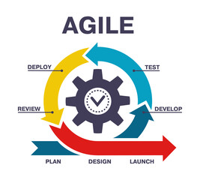
Agile SDLC is the methodology that the researchers will use. The process begins with the planning and requirement gathering phase, where user needs are continuously collected and analyzed through regular feedback loops. Next is the design phase, where system architecture and user interface prototypes are created based on evolving requirements. The development phase follows, where programmers build and modify the application in small, iterative cycles (sprints), ensuring continuous integration and rapid feature deployment. During the testing phase, each iteration undergoes rigorous testing to identify and resolve errors, ensuring that the software aligns with user expectations. Once features are stable, the software moves to the deployment phase, where updates are released incrementally to a live environment, ensuring minimal disruption. Review comes after deployment; it's a continuous monitoring, and improvements based on user feedback and evolving requirements. Finally, the launch phase involves releasing the application not just for selected users but for global release. The iterative nature of Agile allows modifications at any stage, ensuring flexibility and responsiveness to changes.
DATA ANALYSIS TECHNIQUES
This study employs descriptive statistics and thematic analysis to analyze the collected data.
1. Descriptive Statistics – Quantitative data from surveys and questionnaires will be analyzed using descriptive statistics, including frequencies, percentages, and mean scores. This method will help summarize respondents' engagement levels, challenges faced in student organizations, and the perceived effectiveness of the proposed platform.
2. Thematic Analysis – Qualitative responses from open-ended survey questions and feedback will be examined using thematic analysis. This approach will identify common themes and patterns related to communication barriers, recruitment challenges, and organizational management, providing deeper insights into the user experience and platform expectations.
By combining these methods, the study aims to present a comprehensive understanding of the current challenges in student organization engagement and assess the potential impact of the proposed Unified SOEMO platform.
ETHICAL CONSIDERATIONS
Survey participants will be thoroughly informed about the objectives and how their responses will be used. Their privacy will be safeguarded, with all comments remaining anonymous and no identifying information disclosed. The survey data will be carefully recorded and evaluated without alteration, ensuring that the results accurately represent the genuine responses of participants. Additionally, the objectives and limitations of the survey will be clearly articulated to ensure the results are understood within the appropriate context.
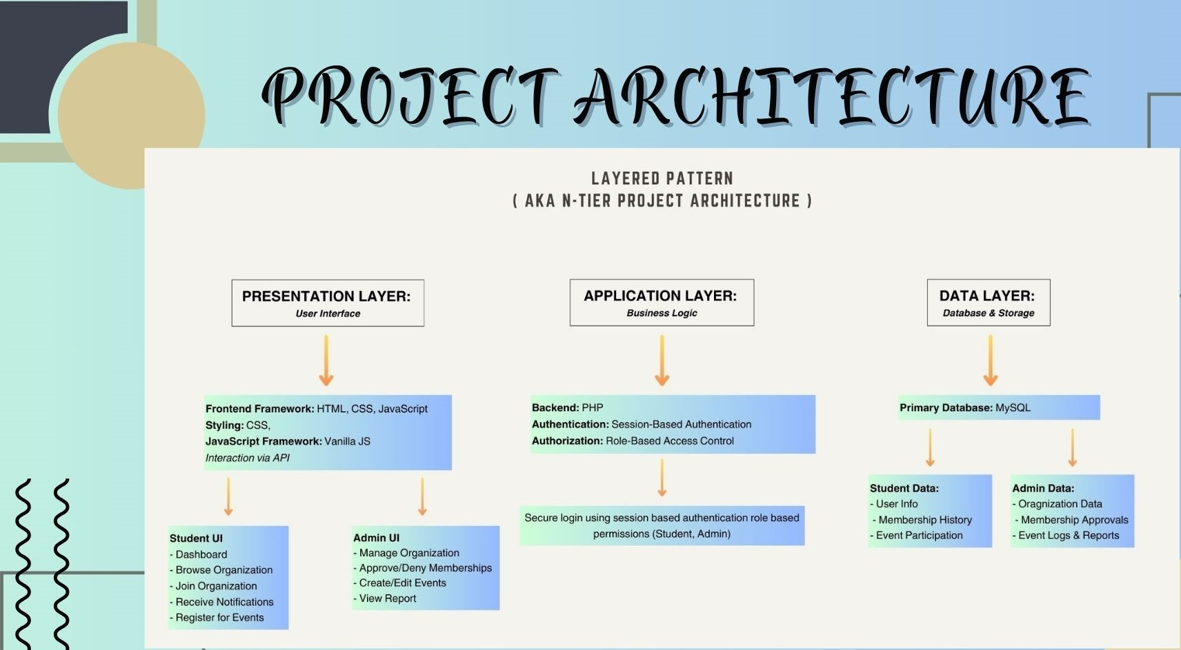
PROJECT ARCHITECTURE
s

The system's Layered Pattern structure consists of three basic layers: Presentation, Application, and Data. The Presentation Layer is where users interact; it uses HTML, CSS, and JavaScript (particularly Vanilla JS) for the interface, CSS for the appearance, and API calls for interactions. This layer has two interfaces: the Student UI, which allows users to explore and join groups, receive notifications, register for events, and access dashboards, and the Admin UI, which allows administrators to manage organizations, review membership requests, set up events, and examine reports. PHP was utilized on the backend to create the business logic that appears in the Application Layer. Session-based authentication is utilized to allow logged-in users, and authorization is managed using role differences to distinguish between students and administrators. The Data Layer uses a MySQL database to store and manage data within the system. Student Data includes user data, membership information, and event attendance; Admin Data includes organization details, approved members, and [records of] event actions or logs. Because of this architecture, systems are adaptable, updatable, and simple to maintain, and each layer serves its purpose without causing conflict.

UI/UX
References
Keg. (n.d.). The role of student associations. (2022, August 30). https://www.keg.com/news/the-role-of-student-associations-university
Lucie-Kay Desthuis-Francis. (2021, September 28). CampusGroup. https://blog.campusgroups.com/campusgroups/2021/9/28/student-organizations-how-to-attract-and-retain-members
UniScholars. (n.d.). Purpose of a student organization. (2023, May 29). https://unischolars.com/blog/purpose-of-a-student-organization/
Ethical Research: Best practices for responsible Studies | Prolific. (n.d.). Prolific. https://www.prolific.com/resources/ethical-considerations-in-research-best-practices-and-examples
Tenny, S., Brannan, J. M., & Brannan, G. D. (2022, September 18). Qualitative study. StatPearls [Internet]. https://www.ncbi.nlm.nih.gov/books/NBK470395/
Taherdoost, H. (2021, September 22). Data collection Methods and Tools for Research; A Step-by-Step Guide to choose data collection technique for academic and business research projects. https://hal.science/Hal-03741847/
View of research population and sampling in quantitative study. (n.d.). https://ejournal.unimap.edu.my/index.php/ijbt/article/view/263/218
Diaz, R. A. (2019). The Perspective of the CMBT Officers in Joining the Student Organizations in NEUST San Isidro Campus. [Research paper, Nueva Ecija University of Science and Technology]. IRJET, 2(3), 53–57.
https://www.irjweb.com/The%20Perspective%20of%20the%20CMBT%20Officers%20in%20Joining%20the%20Student%20Organizations%20in%20NEUST%20San%20Isidro%20Campus.pdf

Ravelas, M. S. A., Capongga, D. B., Fugaban, E. H., Glomar, M. S., Ihapon, N. T. P., Planillo, D. C., & Santos, V. D. R. (2024). The Relationship of Organization Opportunities and Engagement of COED Students in Fostering Cognitive Comprehensive Skills. [Research paper, Laguna University]. IJRP, 146(1), 271–297. https://ijrp.org/paper-detail/6206
Philip, J., & Gavrilova Aguilar, M. (2021). Student perceptions of leadership skills necessary for digital transformation. Journal of Education for Business, 97(2), 86–98. https://doi.org/10.1080/08832323.2021.1890540

Cheng, Y. (2023). Social media as a catalyst among student organizations in a selected university in China. Pacific International Journal, 6(4), 66–70. https://doi.org/10.55014/pij.v6i4.477​

Hermoso, Ritchel & Hernando, Mary & Gimarangan, Rommel & Tobes, Suzette & Alob, Jester & Geonzon, Charlene. (2023). Online Leadership: Experiences of Student Body Organization Officers. Journal of Humanities and Social Sciences Studies. 5. 39-59.
https://doi.org/10.32996/jhsss.2023.5.12.5

Koranteng, F. N., Wiafe, I., & Kuada, E. (2019). An Empirical Study of the Relationship Between Social Networking Sites and Students’ Engagement in Higher Education. Journal of Educational Computing Research, 57(5), 1131-1159. https://doi.org/10.1177/0735633118787528

Kim, H.J., Hong, A.J. & Song, HD (2019). The roles of academic engagement and digital readiness in students’ achievements in university e-learning environments. Int J Educ Technol High Educ 16, 21. https://doi.org/10.1186/s41239-019-0152-3

Turkalj, Davorin & Štimac, Helena & Helajz, Valentina. (2020). Role Of Digital Marketing On Student Organizations' Online Presence And Activities. https://www.researchgate.net/publication/365274538_ROLE_OF_DIGITAL_MARKETING_ON_STUDENT_ORGANIZATIONS'_ONLINE_PRESENCE_AND_ACTIVITIES

Smist, J. A. (2020). Contributions of student organization experiences on leader capacity development (Doctoral dissertation). University of Illinois at Urbana-Champaign. https://www.ideals.illinois.edu/items/115722

Duong Hoai Lan, Tran Minh Tung, & Vo Thi Kim Oanh. (2023). Student Engagement in Informal Social Media Based Peer Learning Communities in the Digital Age Motivation and Challenges. Kurdish Studies, 11(2), 2703–2717. https://kurdishstudies.net/menu-script/index.php/KS/article/view/836

Bajaj, M. (2024). The role of digital learning platforms in enhancing student engagement. International Journal of Humanities and Arts, 6(1), 23-28. https://doi.org/10.25215/819818984X.01
Dedicatoria, A., Dionela, M., Climaco, C., & Balangon, W. (2023). The role of student leadership and their reason for joining student organizations at Polytechnic College of Botolan. Psychology and Education: A Multidisciplinary Journal, 12(6), 1-11. https://ejournals.ph/article.php?id=21694
Haines, K. (2019). Student perspectives on joining student organizations. Northeastern University. ProQuest LLC. https://www.proquest.com/dissertations-theses/student-perspectives-on-joining-organizations/docview/2209696378/se-2
Maglipas, M. O. (2019). Empowering the campus student organization advisers in the Philippines: A case study. Journal of BIMP-EAGA Regional Development, 5(1), 74–82. https://jurcon.ums.edu.my/ojums/index.php/BIMP-EAGA/article/view/3262
Mgweba, C. (2024). The use of competitive intelligence as a strategic tool for student recruitment in public universities. International Journal of Business Ecosystem & Strategy, 6(3), 196-203. https://doi.org/10.36096/ijbes.v6i3.523
Singh, M. (2024). Beyond the classroom walls: Unveiling the impact of technology integration on student engagement and academic performance. International Journal of Humanities and Arts, 6(1), 23–28. https://doi.org/10.33545/26647699.2024.v6.i1a.58
Sumague, R. P. (2023). Influence of involvement in clubs and organizations on the leadership development of students. World Journal of Advanced Research and Reviews, 17(2), 404–407. https://doi.org/10.30574/wjarr.2023.17.2.0228
Modern Campus. (2021, June 24). Modern Campus acquires Presence, leading campus engagement and learning platform. Retrieved from https://www.prweb.com/releases/modern-campus-acquires-presence-leading-campus-engagement-and-learning-platform-866255061.html
Anderson, N. (2024, December 4). Digital tools for in-person college student connections. Inside Higher Ed. https://www.insidehighered.com/news/student-success/college-experience/2024/12/04/digital-tools-person-college-student-connections
Unibuddy: A Student Engagement Platform. (2023). Unibuddy. Retrieved from https://en.wikipedia.org/wiki/Unibuddy

