**Standards Based Grading**

Alyssa Weber

July 3, 2022

The education world is flooded by new initiatives and teaching best practices every year. Examples of this are student-led learning, academic pods instead of classrooms, Social Emotional Learning (SEL), and Advancement Via Individual Determination (AVID) just to name a few. One conversation that is gaining interest since I first joined the teaching profession in 2015 is that of standards-based grading. I am interested in finding out where it was first introduced, which states are currently using standards-based grading, and if standards-based grading in secondary education benefits a student’s experience. I want to investigate if standards-based grading impacts outcomes such as rigor, graduation rates, and post-secondary acceptance.

**Overview**

**Traditional Grading Pros and Cons**

Conversations around grading can get heated. Those in favor of the traditional system list benefits including that it is recognizable, simple, streamlined and provides a clear pass/fail cutoff (Hobden, 2021). I argue that the restricted benefit is that grades in school are the top factor in college admissions (Clinedinst, 2019). Shown below are the results of the National Association for College Admission Counseling (NACAC) Admission Trends Survey from 2018-2019. The top three factors related to college admission are “Grades in all Courses,” “Grades in College Prep Courses,” and “Strength of Curriculum.”

(Clinedinst, 2019)

I have been using a traditional grading scale since 2015, but the format has looked different each year based on colleague and administration input. In 2015 my students were graded with a 60% assessment and 40% “formative” split. Included in the formative section were penalties for late work, participation scores, and extra credit. This was standard practice for the mathematics department, but if you asked a student in 2015 if their other teachers used the same framework, you would find that most departments formatted their gradebooks differently. Taking up to seven classes a day, students had to navigate around different expectations for each course that averaged points to generate a letter grade. Often these letter grades were not reflective of what a student knew or could do and included implicit biases. The meaning of an “A” varied from class to class. By 2021, my administration required all teachers to use an 80% summative and 20% formative split. Only artifacts related to standards or objectives were allowed as inputs and the meaning of each letter grade was defined school wide.

**Standards-based Grading Origin**

By quick google search, it was surprisingly difficult to find an origin of standards-based grading. The closest I could find to a start date was not in fact for standards-based grading policies, but for standards-based education. Education reform with common standards at the front and center began in the 1980’s after *A Nation at Risk* was published (Kannapel, 2000). Google trends does not have data to support that far back, but it does show that even up until 2004, standards-based education, in red, was a topic of interest. In 2011, google trends shows a switch in searches to standards-based grading in blue.

2004 – present Standards-Based Education vs Standards-Based Grading (Google Trends, n.d.-a)

Not surprising to me, the highest search results for standards-based grading was at the end of 2019 before showing a steep decline in early 2020 at the start of the Covid-19 pandemic. It was my experience as a teacher in these times that there was a dramatic shift from grading practices to social-emotional support.

**Early and Current Usage of Standards-based Grading**

Based on the earliest available google trend data, Wisconsin was the most curious in their searches regarding standards-based grading. You can see from the following maps that within five years the number of states with substantial search data for standards-based grading more than quadrupled.

2006 standard-based grading searches (Google Trends, n.d.-b)

2011 standard-based grading searches (Google Trends, n.d.-c)

An interesting find is that in 2011, other related searches included “what is standards-based grading?” (Google trends, n.d.-c), while in 2021 the related searches dealt more with specifics about the 1- 4 grading scale (Google trends, n.d.-d) implying that there was a shift in that timeframe from curiosity to implementation. Something else that caught my attention as I was looking through different entities was that in the metro category, Minneapolis-St. Paul, where I am from, has the highest all time search rate for standards-based grading. This confirms for me that my area is in fact having conversations about this practice and not so ironically, here I am authoring a paper on it.

2004 – present Metro Data (Google Trends, n.d.-d)

**Standards-based Grading and Graduation Rates**

I also used Google Trends to look up how often people searched for “What do you need to graduate high school?” shown in red. A related query for this topic was “grading in education,” shown in blue. Naturally, I compared the two searches and Google Trends Generated the graph shown below.

2004 –Grading in Education vs Present How to Graduate High School (Google Trends, n.d.-e)

This graph shows another switch around the 2011 timeframe. This time though, it seems counterintuitive to the data in the origin section. In 2004, people were searching for standards-based education, but searches about how to graduate high school were low. In 2019 the searches for standards-based grading were rising and so was clarification on how to graduate high school.

**Analysis**

**Standard-Based Grading Schools in Minnesota**

To begin to explain the google trend above, I needed concrete examples of standards-based impacts. To generate a small pool of data I googled “Standards Based Grading Minnesota.” The first five schools to make Google’s listings were Westonka, Duluth, Windom, Hayfield, and Anoka which I have mapped out below.

(MapCustomizer, n.d.)

I was surprised to find a mix of both rural and suburban cities. My intuition predicted that these schools would have been closer to the Twin Cities Metro, however the rural locations, other than Duluth, appear to fit the map on pg. 6.

Next, I began searching the district websites for their annual reports to extract data. I stumbled upon a data tool created by the Minnesota Department of Education that retains data and generates personalized reports based on the categories depicted in the image to the right. The reports can be compared side by side filtering by schools and subcategories. The website generates up to three years of reports. The first report I ran was in the category “Are students mastering the standards?” I created a side-by-side view of the five standard-based schools that Google produced compared to the state-wide average for both math and reading. I anticipated that more than half of the standard-based schools would perform better than the statewide average, but instead the following data was delivered. Only one school, Westonka High School, scored above the statewide math average of 53.8%. It was 11.6 points above the mean. The other four schools averaged 17.2 points below the mean in the category of mathematics. There were three schools that scored above the statewide average of 58.3% in the reading category. The three schools that outscored the mean averaged 12.6 points above the norm while the underperforming schools averaged 10.7 points below the norm (Minnesota Department of Education, n.d.-b).

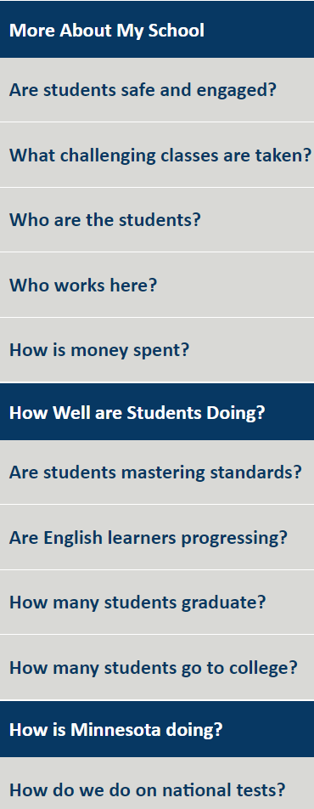

(Minnesota Department of Education, n.d.-a)

**Next Steps**

The preliminary results from the previous section only represent a small sampling of the schools in Minnesota and do not provide any comparisons to schools that are using traditional grading. The next steps would be to continue to collect data from statewide or schoolwide databases. It was very time consuming to manually generate and analyze just one report by hand. After collecting and storing data, I would want a program that could help me sift through data to spot trends more easily.

It would be beneficial to have a comprehensive list of schools and their grading systems nationwide. If schools had made a switch between grading practices, I would also want pre and post data as this would provide valuable insight into correlations between models. For each sampling of standards-based schools I would like a doppelganger school to use as a comparison since socioeconomic makeup, size, location, and course offerings all impact a student’s secondary experience.

**Conclusion**

Standards-based related searches have been present for more time than I had originally predicted. From the conversations that I am a part of in school it sounds like standards-based grading is in my near future given that our district just invested in new grading software to accommodate more flexible grading in the 2022-2023 school year. It is no longer surprising that district I work for is pushing for changes, seeing that the Twin Cities metro is one of the areas most interested in this topic. Contradicting my intuition, I predicted that standard-based grading would have high impact on students mastering standards. Rather, the first small sampling of data suggested otherwise. It will take a much larger scale of data and more analysis to see how grading systems truly impact rigor, graduation rates, and post-secondary acceptance.

**References**

Clinedinst, M. (2019). *State of college admission*. The State of College Admission Report. Retrieved July 3, 2022, from <https://www.nacacnet.org/globalassets/documents/publications/research/2018_soca/soca2019_all.pdf>

Google. (n.d.-a). [Google Trends Comparison of Standards-based Grading vs Standards-based Education all time]. Retrieved June 12, 2022, from <https://trends.google.com/trends/explore?date=all&geo=US&q=Standards%20Based%20Grading,Standards%20Based%20Education>

Google. (n.d.-b). [Google Trends Standards-based Grading 2006]. Retrieved June 12, 2022, from <https://trends.google.com/trends/explore?date=2006-01-01%202006-12-31&geo=US&q=Standards%20Based%20Grading,Standards%20Based%20Education>

Google. (n.d.-c). [Google Trends Standards-based Grading 2006]. Retrieved June 12, 2022, from <https://trends.google.com/trends/explore?date=2011-01-01%202011-12-31&geo=US&q=Standards%20Based%20Grading,Standards%20Based%20Education>

Google. (n.d.-d). [Google Trends Standards-based Grading 2021]. Retrieved June 12, 2022, from <https://trends.google.com/trends/explore?date=2021-01-01%202021-12-31&geo=US&q=Standards%20Based%20Grading,Standards%20Based%20Education>

Google. (n.d.-e). [Google Trends Grading in Education vs How Do You Graduate High School All-Time]. Retrieved June 12, 2022, from <https://trends.google.com/trends/explore?date=all&geo=US&q=grading%20in%20education,What%20do%20you%20need%20to%20graduate%20high%20school>

Hobden, H. (2021, February 4). *Traditional grading scale: Pros, cons & alternatives*. School Safety Platform - Kidio. Retrieved July 3, 2022, from <https://kid.io/traditional-grading-scale-pros-cons-alternatives/>

Kannapolis, P. J. (2000). Standards-Based Reform and Rural School Improvement: Finding the Middle Ground. *Journal of Research in Rural Education*, *16*. Retrieved June 12, 2022, from <https://jrre.psu.edu/sites/default/files/2019-08/16-3_5.pdf>.

MapCustomizer (n.d) [Standard-based grading schools: Mapcustomizer.com: Plot multiple locations on Google Maps. Create a map.] Retrieved July 3, 2022, from <https://www.mapcustomizer.com/map/Standard-Based%20Grading%20Schools>

Minnesota Department of Education. (n.d.-a). Minnesota Report Card. Retrieved July 3, 2022, from <https://rc.education.mn.gov/#mySchool/p--3>

Minnesota Department of Education. (n.d.-b). Minnesota Report Card. Retrieved July 3, 2022, from <https://rc.education.mn.gov/#northStarAchievement/orgId--10277062000__year--2019__nscomparisonline--FOC_NONE__p--3/orgId--10709215000__year--2019__nscomparisonline--FOC_NONE__p--3/orgId--10709220000__year--2019__nscomparisonline--FOC_NONE__p--3/orgId--10203001000__year--2019__nscomparisonline--FOC_NONE__p--3/orgId--10011001000__year--2019__nscomparisonline--FOC_NONE__p--3>