How to use.

Start the program (MstarGUI.exe).

You will see :

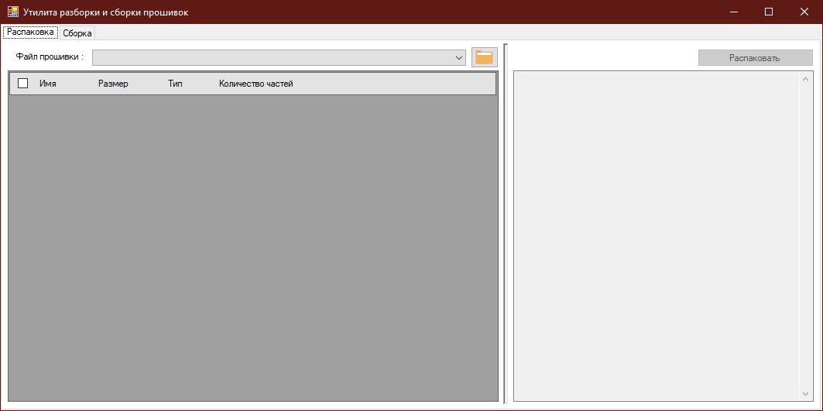
Choose the work folder (the button with a folder).
After this you can choose any file from the drop-down list (there are files from the work folder).

You will see, for example:

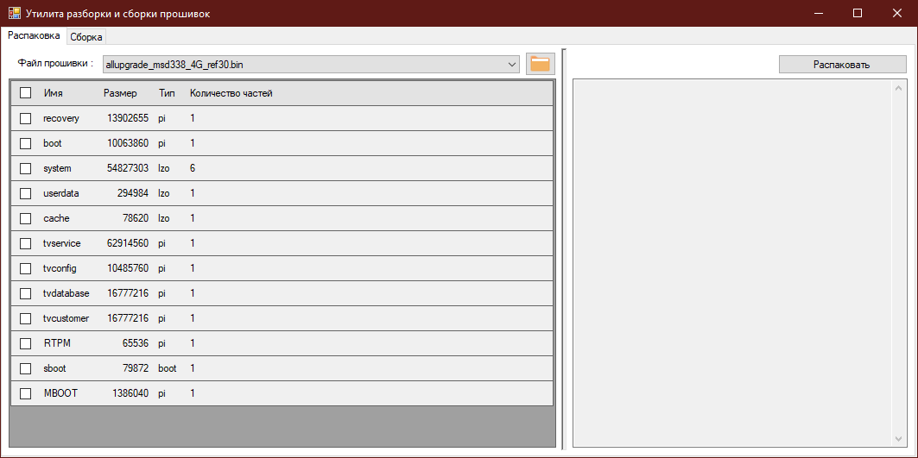

Choose parts of the file which you wish to unpack:

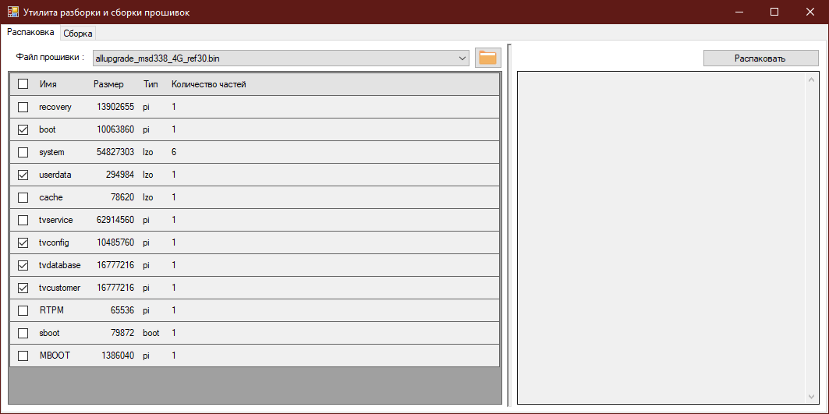
And press the button “Распаковать”. You will see an unpack log:

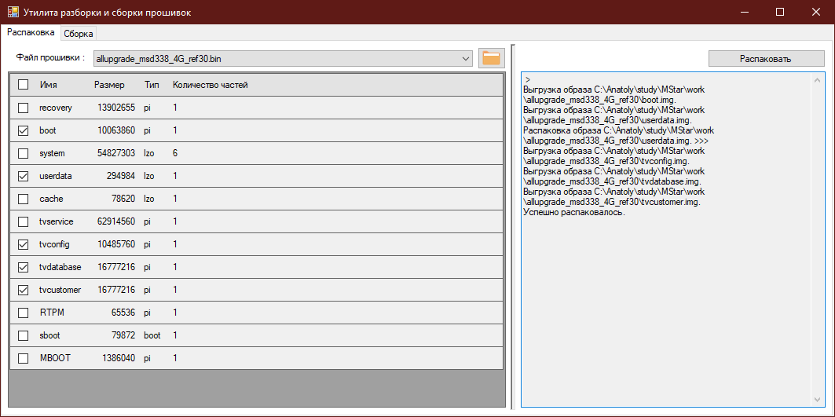
In the work directory will be created a subfolder with the your file name without an extension.
For my file it will be “allupgrade_msd338_4G_ref30”.

You can modify any img file in the subfolder of your file and then you can pack you firmware in tab “Сборка”.

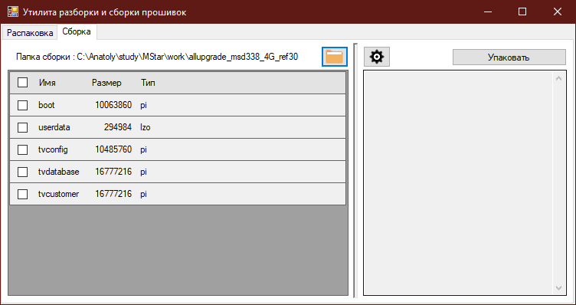
Choose all parts of the firmware which want to be packed:

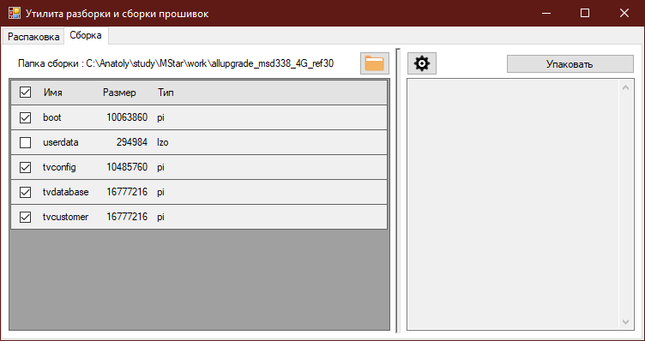

And press the button “Упаковать”.

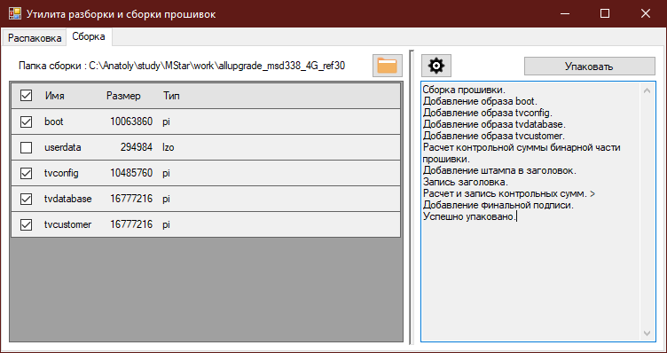
You will see the log of the packing process.

“Успешно упаковано” - it means “Well done, all parts was successfully packed.”

You firmware will be in the work folder with name new_<oldname>.
For example, my the file of my firmware is new_allupgrade_msd338_4G_ref30.bin.

That is all.

