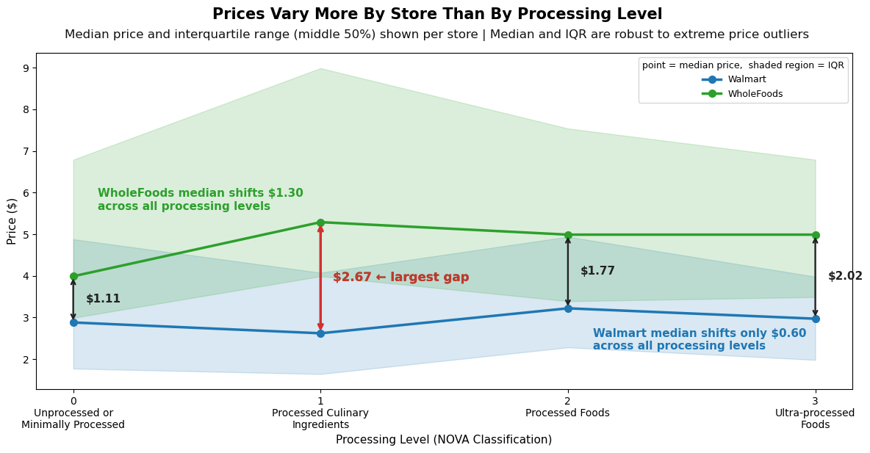

The main story I wanted to tell with my visualization was debunking the myth that the level of processing food undergoes heavily influences its price. In reality, as the visualization showcases, the store you choose to buy your food influences its price significantly more than its processing level. I wanted to understand whether more processed foods were cheaper than less processed foods and found that was only true in some cases. For example, as the visualization shows, in the case of Walmart, the price of foods varied minimally across processing levels while with Whole Foods, the price of more processed foods was at least $1 more than those that were unprocessed or minimally processed.
Regarding the data, I made minimal changes to it in order to allow the plot to display as much information as possible. First, I decided to represent the center of the data using the median rather than the mean in order to prevent skew from outliers in the visualization. I chose to include the interquartile range to provide further evidence about the variability of the distribution so that the reader would not be making a decision solely using one piece of data from each store and processing category. This meant I did not need to filter out extreme price outliers, since the median and IQR are robust to them by design. I removed any rows that didn't include a processing level class (FPro_class) or price, which removed just over 4,000 entries. While this was a large removal, it only accounted for about 15% of the entire dataset and was largely associated with null data for price per calorie, which I would not have been able to utilize for my analysis.
Notably, the largest removal of data I chose was excluding all data from Target from the visualization. While Target also somewhat displayed this trend, it sat as more of an intermediary between Walmart and Whole Foods in terms of price level, and I felt the contrast between the two extremes would tell a clearer and more compelling story. I attempted visualizations including Target and found that its inclusion made the overlapping IQR shaded regions significantly harder to read and draw conclusions from. To further mitigate the difficulty of reading overlapping regions, I made the shaded areas intentionally light and included various annotations to help readers understand the differences between medians without needing to carefully read the y-axis.
For the visual encoding, I assigned blue to Walmart and green to Whole Foods, which are colors that are visually distinct and already associated to the branding of the respective stores. Critically, I used the same colors for the store annotations on the plot itself, so a reader can immediately match each label to its corresponding line without cross-referencing the legend. I simplified the legend to show only store names, moving the explanation of the median and IQR encoding into the legend title ("point = median price, shaded region = IQR") to reduce clutter while keeping the information accessible. I also chose a line plot rather than a bar chart because the x-axis represents ordered NOVA categories, and a line naturally implies trend across an ordered sequence. Finally, I included clarifying x-axis labels for each NOVA processing level and defined the interquartile range in the subtitle so that a reader without a statistics background could still interpret the plot. The gap annotations with dollar amounts, especially the bolded dark red $2.67 largest gap label and the store-level shift annotations, were included to make the central comparison quantitative and immediately legible without requiring the reader to estimate from the y-axis.

