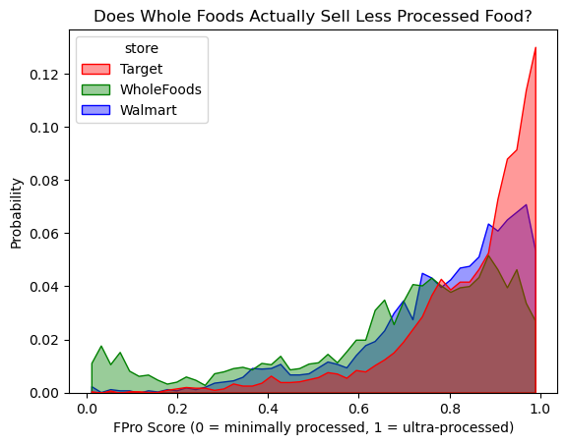
One of the features that contributes to the effectiveness of my plot is the color, which helps visually distinguish between the stores without needing to focus on the legend, which contributes to pre-attentive processing. However, due to the large amount of ultra-processed food sold at all stores, there is heavy overlapping in the colors after the 0.7 FPro Score point. This can either help or muddy the interpretation about Whole Foods actually selling less processed food than the other stores depending on how well the viewer is able to distinguish the green color/layer from the blue and red. This contributes to the idea of selective attention.

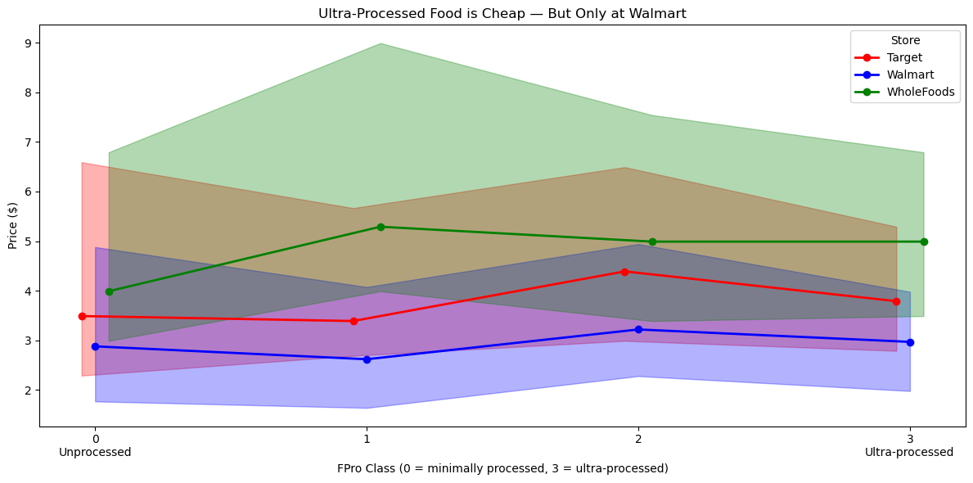
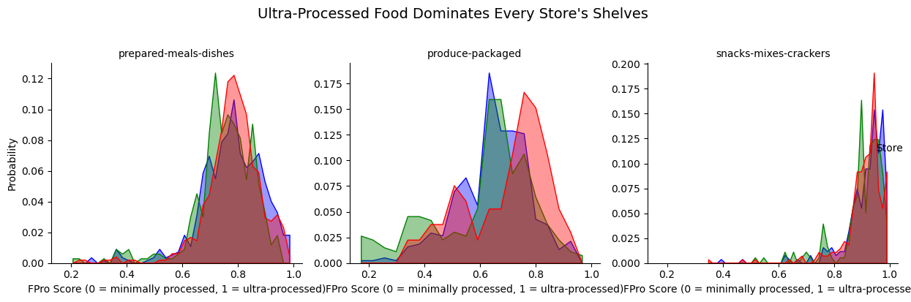
I prefer the second plot because it clearly highlights one of the key insights I found in the data: how food prices vary across processing levels and stores. I was particularly interested in understanding whether more processed foods are cheaper, and how this relationship differs between stores. This plot focuses on price across the different FPro classes, making it easier to compare trends directly. I chose to display medians as lines and interquartile ranges as shaded regions so that the viewer can quickly understand both the central tendency and the variability of prices. The line plot effectively shows overall trends, while the shaded regions provide additional context and prevent overreliance on the median alone. One important takeaway is that Whole Foods and Walmart show little overlap in their price ranges across most processing levels, suggesting that price is influenced more by the store itself than by how processed the food is.

