INFORMED CONSENT FORM
Title of Study: Testing Groupthink in Human-AI Teams
Investigators: Alita Regi, Dr. Thomas C. Eskridge
You have been invited to participate in a research study. This document contains pertinent details to help you make an informed decision about whether you would like to participate, so please review it closely. Participation in research studies is purely voluntary, and you reserve the right to STOP your participation at any point in time. Before making your decision, please feel free to direct any inquiries you may have regarding the study or this document to the project staff.
Purpose of the Study
The purpose of this study is to examine how groupthink affects decision-making under high-pressure conditions. This research uses a scenario to simulate high-stakes situations that require rapid moral and strategic decisions made collaboratively within a group.The goup here is defined by the human (you) and your AI teammate.

Eligibility to Participate
You may participate in this study if you meet all of the following criteria:
- You are 18 years of age or older.
- You should NOT participate if you are sensitive to intense horror, depictions of violence, injury, death, or psychological distress, or if you experience anxiety in high-pressure or suspenseful environments.
- You are comfortable participating in group discussions and completing short questionnaires.
- If at any point you feel uncomfortable, anxious, distressed, or overwhelmed, you are strongly instructed to stop participation and leave the experiment immediately. You do not need to provide a reason.

Study Procedures
If you agree to participate, you will take part in a session lasting approximately 10 minutes.
This includes :

Participants will be exposed to suspenseful, emotionally intense scenarios that require rapid group decision-making and may affect character survival. Please see sample images from the game below:
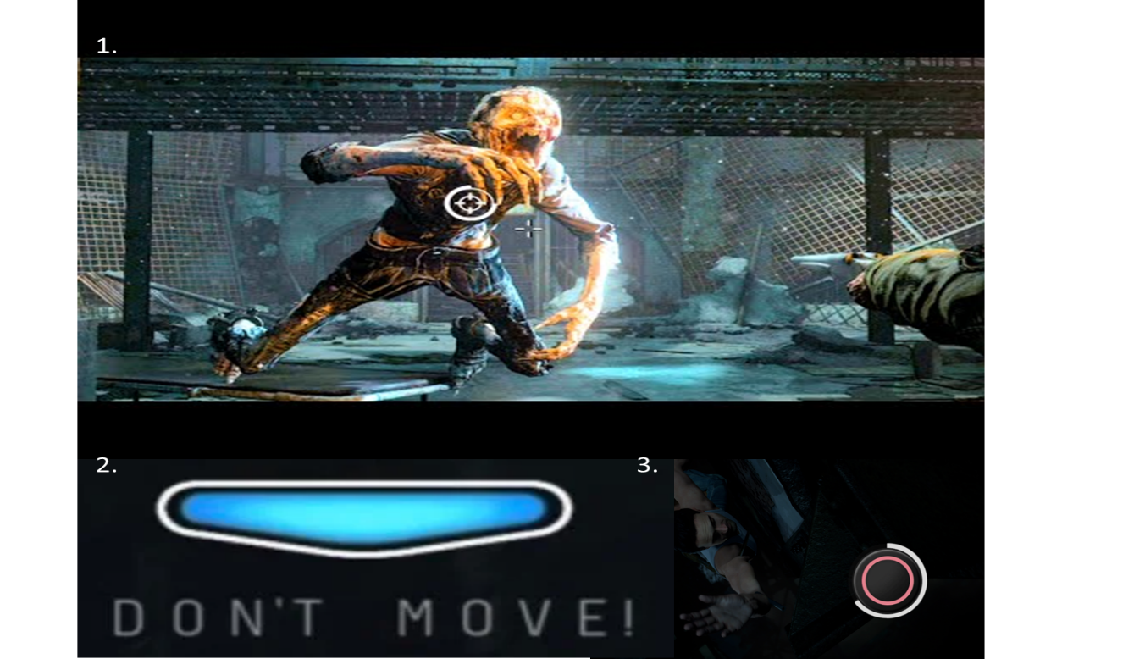
Figure 1 Wendigo


Figure 2 Psycho

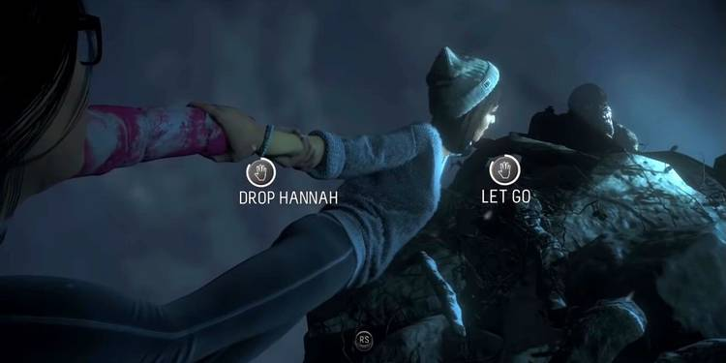
Figure 3 Types of decisions

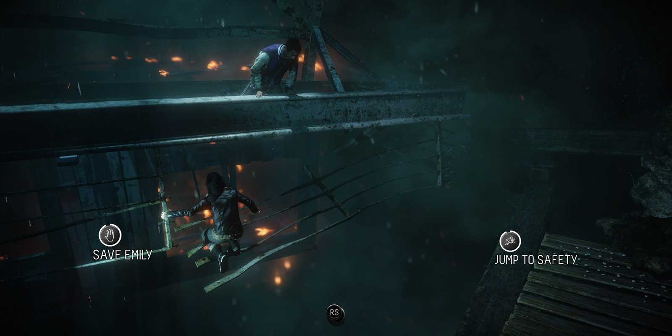
Figure 4 Types of Decisions Contd
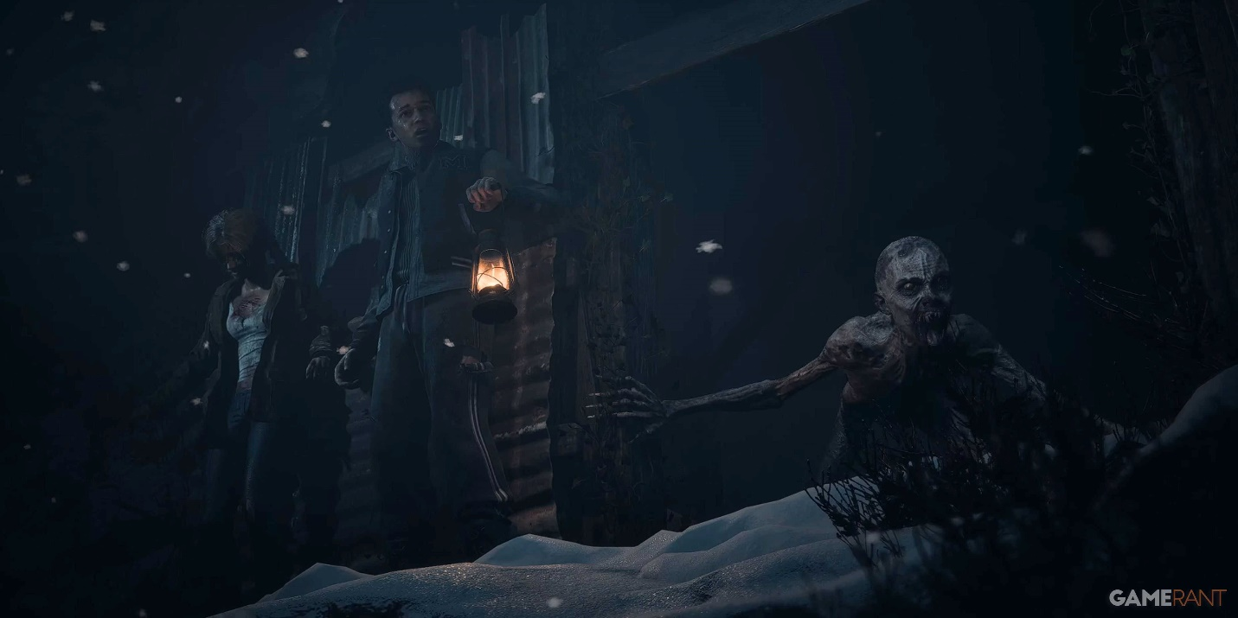
Figure 5 Gameplay

The session will include the following components:
- Pre-Survey (approximately 5 minutes)
You will complete a short questionnaire assessing baseline attitudes, decision-making preferences, comfort with group interaction, and familiarity with AI agents.
- Gameplay Session (approximately 30–45 minutes)
You will participate in a small group playing selected chapters of the interactive video game Until Dawn. Until Dawn is a narrative-based decision-making game in which players collectively guide characters through a suspenseful storyline involving survival, moral dilemmas, and time-pressured choices. The group must discuss options and reach decisions that shape the story's outcome. The game contains horror themes, suspense, and depictions of danger.
- Post-Survey and Group Debrief (approximately 10 minutes)
You will complete a short post-survey followed by a brief group discussion reflecting on the decision-making process and group interactions during gameplay.

AI Teammate Clarification
During gameplay, you may interact with or receive input from an AI teammate (IRIS). The AI teammate is a programmed system and not a human participant. Its responses are generated as part of the study design, which:

- Provides suggestions or opinions during decision-making
- May agree or disagree with group members
- Is part of the experimental design to study human-AI interaction and group influence

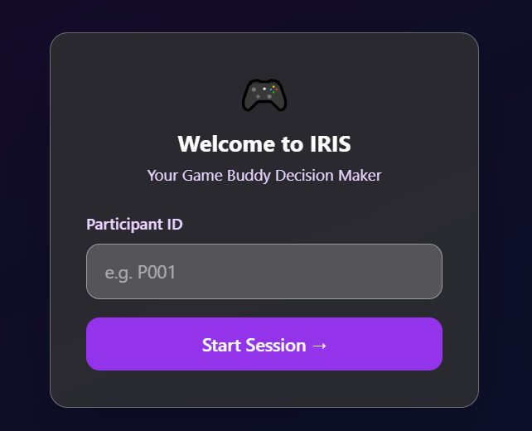
Figure 6 AI Teammate

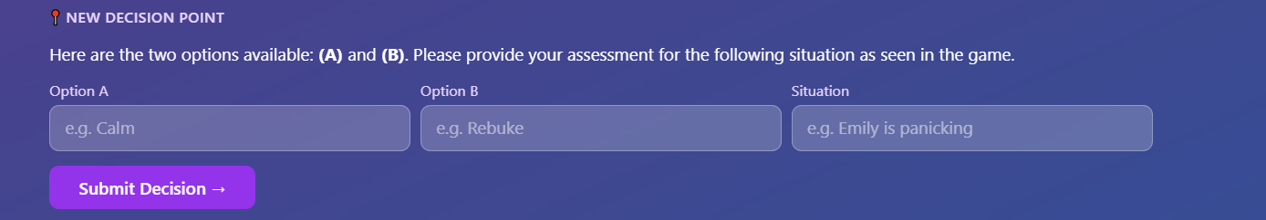
Figure 7 AI Teammate Decision Input Screen

Visual Disclosure
Participants will be shown example screenshots/images from the game before participation (figures 1-7) to better understand the type and intensity of the content.

Audio and Video Recording
This study will include audio and video recording.
- Group discussions during gameplay and the debrief session will be audio-recorded.
- The gameplay session will be video recorded to capture group interactions and decision-making behaviors.
- Recordings are used solely for research and analysis purposes related to group dynamics and decision-making.
- Recordings will be stored securely, accessible only to the research team, and will not be used for public presentation without additional consent.
All recordings will be handled in accordance with Florida Institute of Technology's Audio and Video Recording Policy.

Risks and Discomforts
Potential risks include moderate emotional or psychological distress, including:
- Exposure to intense horror, violence, and death-related content
- Experiencing fear, anxiety, or stress from suspenseful situations
- Reactions to jump scares or sudden loud sounds
- Discomfort from group pressure or moral decision-making under time constraints
- You may take breaks, skip questions, or withdraw from the study at any time without penalty.

If you experience any discomfort, anxiety, fear, or distress, you are strongly instructed to stop immediately and leave the study.

Benefits
There are no direct personal benefits to you for participating in this study. However, your participation may contribute to a better understanding of group decision-making in high-stakes environments, which may inform future research in human factors and team performance.

Confidentiality
All research records will be kept confidential, and your data will be de-identified before reporting or analysis. Only the research team and authorized Florida Institute of Technology personnel responsible for research oversight (PI and Co-PIs) may access study records. Audio and video recordings will be used solely for research purposes and will not be shared publicly. Confidentiality may be broken if required by law, such as in cases involving imminent risk of harm or mandatory reporting requirements.

Voluntary Participation and Withdrawal
Your participation is voluntary. However, if you feel uncomfortable, anxious, or distressed, you are expected to stop participation immediately rather than continue. If you choose to withdraw before the session is complete, all data collected from you will be deleted immediately.

If you have any inquiries regarding questions about this study or about the rights of research participants, please do not hesitate to contact us
- Alita Regi at aregi2017@fit.edu
- Dr. Thomas C. Eskridge at teskridge@fit.edu.

By signing this document, you are agreeing to participate in this study, and you confirm that:
- You understand the study involves intense horror content, including violence, death, and psychological stressors
- You understand you may stop immediately if you feel uncomfortable
- You voluntarily agree to participate

I am 18 years of age or over and agree to take part in this study.

Participant's Name (printed)

Participant's Signature Date

