Experiment Script
Hello, and welcome! Thank you for participating in our study. I will be your facilitator, and this is IRIS, your AI teammate. IRIS is a programmed system (not a human participant) that provides suggestions during decision-making. You are not required to follow its recommendations, and all final decisions should be made by your team.
Once again, I would like to express my gratitude for being here and for participating in this research.
Before we begin, I want to highlight some important information about this study.
This study involves exposure to intense horror content, including scenes of violence, injury, death, psychological distress, sudden jump scares, and loud sounds.
If at any point you feel uncomfortable, anxious, or distressed, you are strongly instructed to stop immediately and leave the experiment. You do not need to provide a reason, and there is no penalty for doing so. Please scan the QR code to review the informed consent form carefully. It includes detailed descriptions and images of the game content. Once you have read and signed it, please let me know.
Team Formation & Pre-Survey (Facilitator speaking)
For all conditions:
- One participant will be assigned as the controller operator, while the rest of the team collaborates to make group decisions at key moments.
- Your team ID is …………… (refer to sticky note)
- Now that you have your team ID, please scan the next QR code and complete the 'Pre-Experiment Survey.'
- When you start the experiment, a prompt will pop up on the laptop screen asking you to enter your team ID (refer to the sticky note for your team ID).
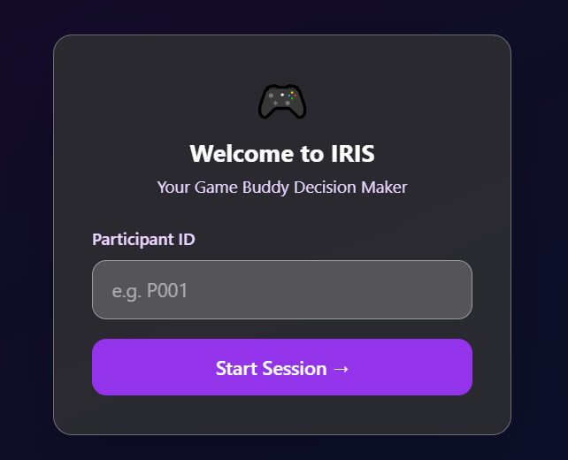
Figure 1
After which, you will get access to a chatbot! The chatbot looks like this when you are at a decision point in the game and want your AI teammate's feedback.
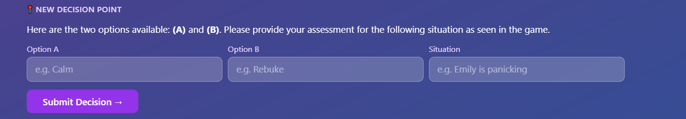
Figure 2

- After you get a response to your input, you will be asked to respond to the quick check-in below. Answer as you feel, as a team, to these questions.
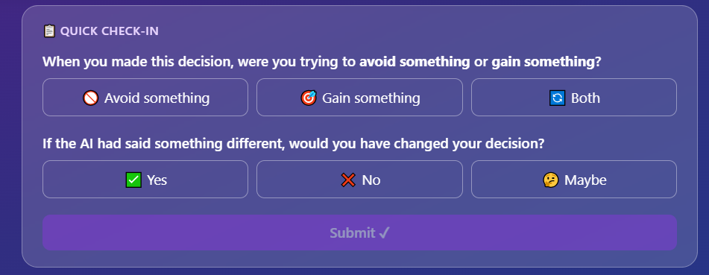
Figure 3
- Let's say you have an additional question, you get to ask 5 follow-up questions to your AI teammate. The chat looks like the one shown below. When you are done with your follow-up questions, hit Finish.
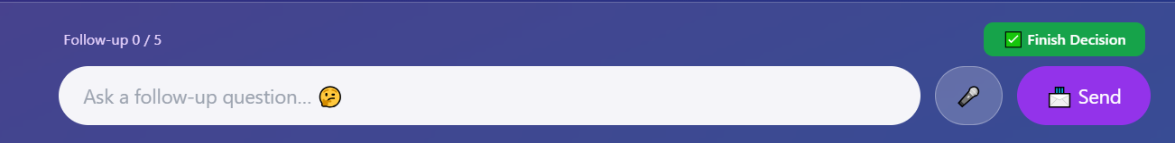
Figure 4

- Repeat these for all the decisions you encounter during the game!
For control condition:
- One participant will be assigned as the controller operator, while the rest of the team collaborates to make group decisions at key moments.
- Your team ID is ……………
- Now that you have your team ID, please scan the next QR code and complete the 'Pre-Experiment Survey.'
- When you start the experiment, a prompt will pop up on the screen asking you to enter your team ID (refer to the sticky note for your team ID).
Figure 5
- After which, you will get access to the game controller! Make sure you input every decision you come across in the game to your game controller.
Figure 6

- Once you submit your decision, you will get a quick check-in, as shown below. Answer these questions as you feel, as a team.
Figure 7
- Repeat these for all the decisions you encounter during the game!

Game Overview
You will now begin the gameplay portion of the experiment. Before we begin gameplay, I want to remind you again:
- This study includes intense and potentially distressing content. If at any time you feel uncomfortable, anxious, or distressed, you should stop immediately and leave the experiment.
You may also request a pause at any time.

- You will play a curated segment (Chapter 6) of the interactive decision-making game Until Dawn.
- The story follows a group of American friends (see the list on your left) who attended the same high school and who annually visit the Washington Estate on Blackwood Mountain in Alberta, Canada, for a getaway of partying and general good times. The team will assume all the protagonist roles listed on the right and follow them on their journey through the night.
Important: All decisions must be made within 60 seconds or less as a team. Time pressure is part of the experiment.
In-Game Procedure
Here's what you'll do during gameplay:
- When a major decision prompt appears on-screen, if there is no timer, your team has 60 seconds to discuss and agree on your choice.
- After making the choice, immediately press the PlayStation button () on the controller to pause the game.
- Once all participants have decided their responses, press' X' to re-enter the game and select 'Resume' to continue.
- You can also press the PlayStation button () on the controller to pause the game if you need a break.
- Remember to look at items in the game environments that shine as they contain clues to assist with the story.
These decisions do not include Quick Time Events (QTEs).
QTEs include:
- Button mash prompts (e.g., Triangle, Square, or Circle)
- 'Don't Move' moments
Use the on-screen timer to help your team make a decision. Figure 1 below shows examples of QTEs you will encounter in the game. Remember, the QTEs are just for your enjoyment of the game.

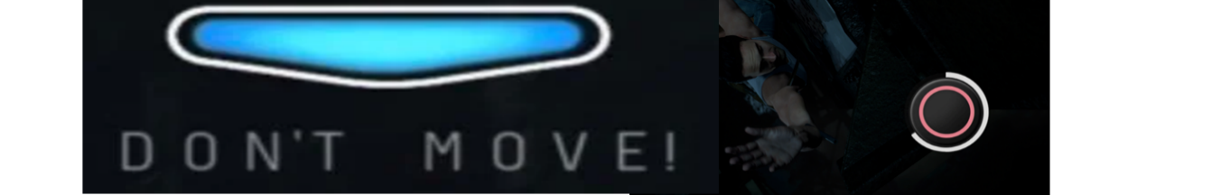

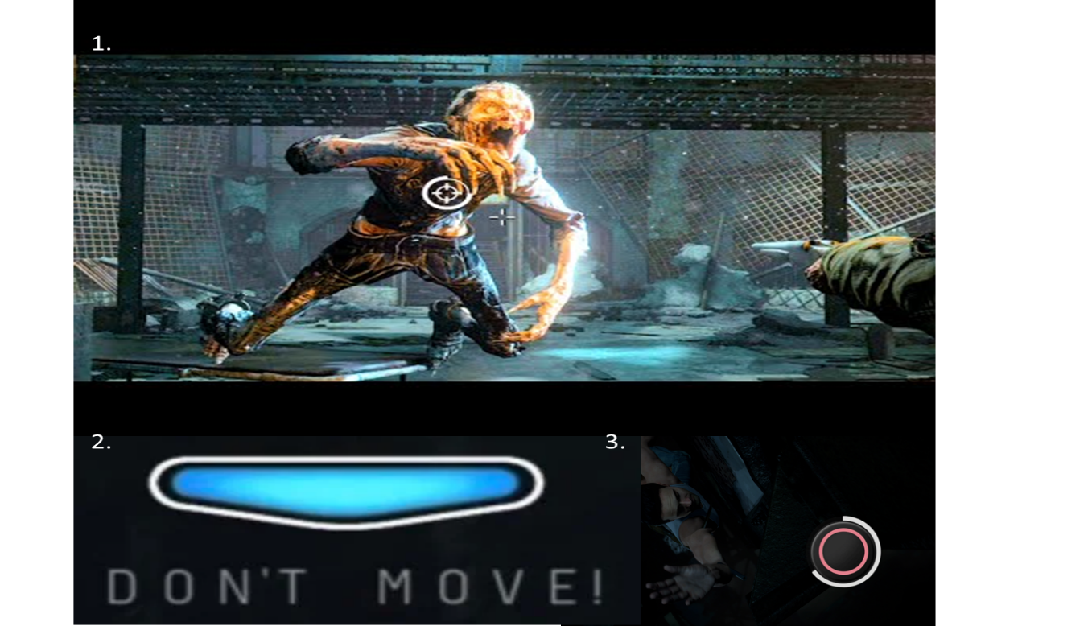
Figure 8 Sample QTEs
If you get uncomfortable or anxious please stop the experiement and leave. We want you have good experince. (add to informed consent)
Types of Decisions You Will Reflect On
You'll only pause and reflect on decisions like:
- Choosing between two actions (e.g., save vs. abandon a character)
- Dialogue or trust-based decisions
- Moral or ambiguous dilemmas
See Figure 9 for an example of an in-game team decision screen.
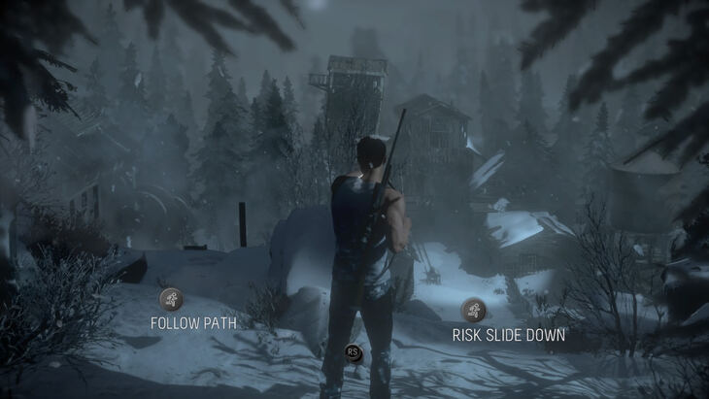
Figure 9 Example of the decision they are going to make as a team
Goal: Keep as many players alive as possible!
Post-Experiment Survey
Once you have made your last decision in the game, please scan the final QR code to complete the Post-Experiment Survey.
Debrief & Contact
Thank you for your participation. Your input is crucial to understanding team dynamics and the influence of AI in high-pressure decision-making.
If you have any questions or concerns or wish to withdraw your data, please contact:
- Alita Regi: aregi2017@fit.edu
- Dr. Thomas C. Eskridge: teskridge@fit.edu

