Introduction :
RLE with HTML file

Coding of RLE using C++:

int main() {
RLE_Compression();
RLE_Decompression();
return 0;
}

void RLE_Compression(){
string s;
int count;
ifstream input("html.txt");
ofstream output ("compressed.txt");

while(!input.eof()){

getline(input,s); //takes line by line from the input file

for(int i=0;i<(int)s.length();++i){
count=1;
while(s[i]==s[i+1]){
count++;
i++;
}
if(count<=3){
while(count>0){
output<<s[i];
count--;
}// undo compression if the num of char less than or equal 3

}
else
output<<"@"<<count <<s[i]; //compress

}
output<<endl;

}
input.close();
output.close();

}

void RLE_Decompression(){
string s ;
ifstream input("compressed.txt") ;
ofstream output("extended.txt") ;

if (!input.is_open())
input.open("compressed.txt", ios::in);

while(!input.eof()){
while(getline(input ,s)){
for(int i=0 ;i<(int)s.length();i++){ //loop the string char by char
if(s[i]=='@'){
int x = s[i+1]-'0';
///take the number followed in position i+1 as an integer for(int j=i ; j <(i+x);j++){
///loop from your current position for a x iterations to repeat the target char in position i+2
if (!output.is_open())
output.open("extended.txt", ios::out);
output<<s[i+2];
///print the char in the output file
}
i+=2; /// to skip the num and char we repeated
}

else{
if (!output.is_open())
output.open("extinted.txt", ios::out);
output<<s[i];
}
}
output<<endl;
}
}
input.close();
output.close();
}

Flowchart :
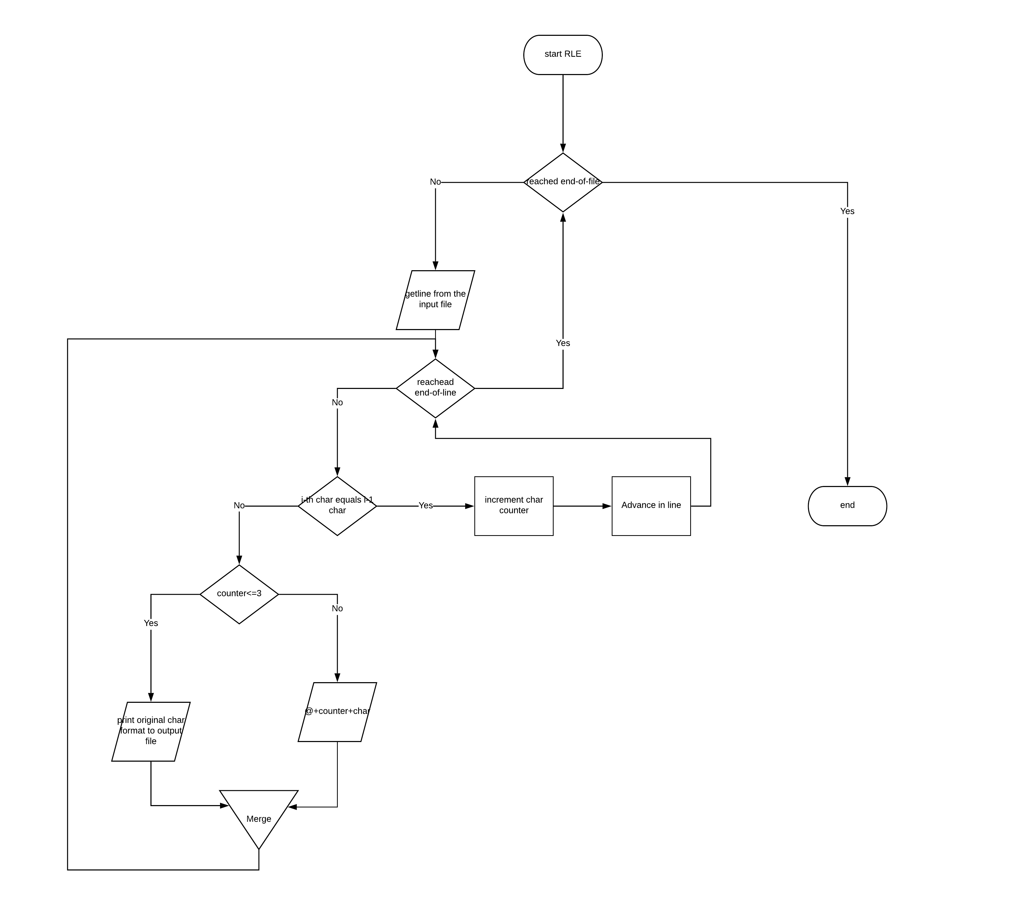

Conclusion :
compression ratio= 0.973
This method is not suitable for HTML files

Names:
1- salma sayed
2- alzahraa ahmed
3- alaa khaled
sec:1

