Full name:

Immatriculation Number:

**Day 2: Using Cross-References to Retrieve Structural Data from the Protein Data Bank (PDB)**

As we learned yesterday, KNIME can be handy to query databases in an automated fashion via API requests. UNIPROT contains a multitude of useful information about a given protein. Today we will learn how to interconnect different databases by using cross-references. More specifically, we will use UNIPROT IDs to retrieve and analyze available 3D protein structures from the PDB.

**2.1 Example Workflow**

UNIPROT provides cross-references to the PDB in the form of PDB IDs for a given UNIPROT entry (e.g, 3o7q, 4zw9, 3wdo). PDB cross-references are integrated in XML files as <dbReference> elements. However, there are multiple <dbReference> elements which provide cross-references to different databases, such as:

<dbReference type="PubMed" id="12730500"/>

<dbReference type="GO" id="GO:0039579">

<dbReference type="InterPro" id="IPR036333">

<dbReference type="Pfam" id="PF06478">

<dbReference type="PDB" id="6NUR">

The question arises how to enforce KNIME to only keep XML elements which do possess the ‘PDB’ attribute. We can to this by a proper definition of the Xpath query. We will use a similar syntax like in the previous exercise where we extracted the length of the protein sequence. However, we have to generalize the query in a way that it solely retrieves all ‘id’ values which correspond to the ‘type=”PDB”’ attribute. A correct definition to achieve this operation is shown in the following screenshot:

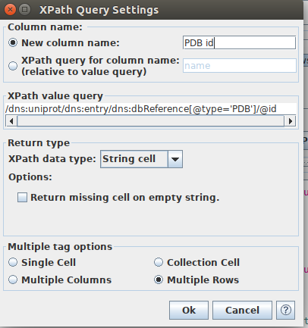

Please note that there can be multiple PDB IDs per single UNIPROT entry available. Therefore, we select the option ‘Multiple Rows’ in ‘Multiple tag options’ to list all unique PDB IDs into a separate row in table. The output table will look as follows:

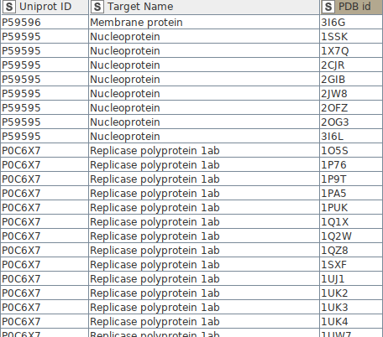

In the given example, there is only a single PDB ID (3I6G) for ‘Membrane protein’, while there are eight PDB IDs for ‘Nucleoprotein’, and so on.

After retrieving PDB codes per target from UniProt, we use the ‘PDB id’ column to create an API request to extract useful information about the protein structures from PDB. We use the ‘String Manipulation’ node to create the API calls as follows:

https://files.rcsb.org/view/3I6G.pdb

Since specialized PDB nodes are an integral part of KNIME, we can use them to load PDB files via API calls (‘PDB Loader’ node) and extract different structural properties (‘PDB Property Extractor’ node) directly:

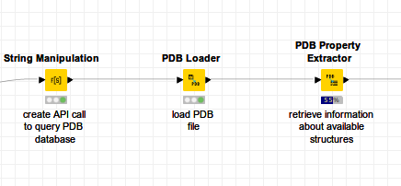

The PDB webservices provide many diverse utilities. For example, we can specify an API call to request detailed information about co-resolved ligands. An example of such an API call is provided below:

https://www.rcsb.org/pdb/rest/ligandInfo?structureId=3I6G

After fetching co-resolved ligands with KNIME, our aim will be to examine ligand properties in greater detail:

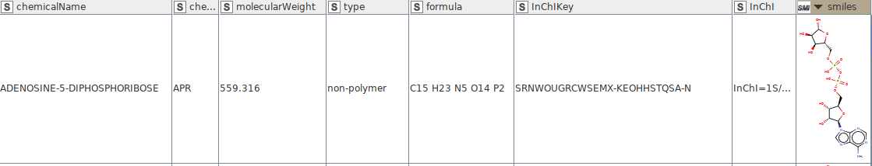

**2.2 Questions & Challenges**

1. In the example workflow we learned how to link UNIPROT entries to the available PDB structures. After retrieval of available PDB structures use appropriate nodes to calculate the number of unique PDB IDs per UNIPROT entry and fill in the table below:

|  |  |
| --- | --- |
| **Uniprot ID** | **Number of Unique PDB IDs** |
| P0C6X7 |  |
| P0C6U8 |  |
| P59594 |  |
| Q9BYF1 |  |
| O15393 |  |
| P50052 |  |
| A0A220F1P8 |  |

2. After execution of the PDB nodes in your workflow, you should get a list of PDB IDs with their structural properties. Your task is to create a list of available experimental methods (‘Experimental Method’ column) and calculate the number of unique PDB IDs which were resolved by the respective methods.

|  |  |
| --- | --- |
| **Experimental Method** | **Number of Unique PDB IDs** |
|  |  |
|  |  |
|  |  |
|  |  |

3. Which KNIME nodes would you use to calculate basic statistics, such as mininum, maximimum, mean, and median values? Name at least two different nodes:

4. In case of the PDB structures resolved via X-Ray diffraction, use any available KNIME node to calculate the mininum, maximimum, mean, and median values of crystal resolution [Å].

|  |  |
| --- | --- |
| **Statistic Value Type** | **Crystal resolution [Å]** |
| Minimum |  |
| Maximum |  |
| Mean |  |
| Median |  |

5. After retrieval of co-resolved ligands, look at different ligand properties. What is the minimum, maximum, and median molecular weight for those ligands?

|  |  |
| --- | --- |
| **Statistic Value Type** | **Molecular Weight** |
| Minimum |  |
| Maximum |  |
| Mean |  |
| Median |  |

6. Calculate the number of unique ligands per protein target and fill in the table.

|  |  |
| --- | --- |
| **Uniprot ID** | **Number of Unique ligands** |
| P0C6X7 |  |
| P0C6U8 |  |
| P59594 |  |
| Q9BYF1 |  |
| O15393 |  |
| P50052 |  |
| A0A220F1P8 |  |

7. Provide additional ligand properties by calculating RDKit descriptors for the ligands. First, convert the SMILES string format into a molecular type (‘Molecule Type Cast’ node) format. Now you can visually inspect the ligand structure in a table. As a next step, remove all rows with missing molecular type (‘Row Filter’ node) and keep only unique ligands (‘GroupBy’ node using ligand molecular type as a group). Afterwards, convert smiles columns with visualized structures into the RDKit format (‘RDKit from Molecule’). Then, calculate RDKit descriptors by using the ‘RDKit descriptor calculation’ node. Below you can see the visual depiction of such a workflow:

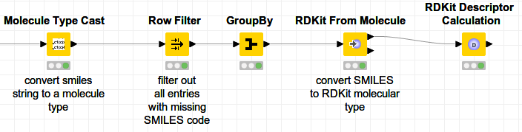

Finally, use any KNIME node of your choice to calculate different statistical measures for the respective RDKit descriptors (table below):

|  |  |  |  |  |  |  |
| --- | --- | --- | --- | --- | --- | --- |
|  | **Rdkit descriptor** | | | | | |
| Statistic Value Type | SlogP | SMR | TPSA | Number of Heteroatoms | Number of Rotatable Bonds | Number of Aromatic  Rings |
| **Minimum** |  |  |  |  |  |  |
| **Maximum** |  |  |  |  |  |  |
| **Mean** |  |  |  |  |  |  |
| **Median** |  |  |  |  |  |  |