**Tugas PHP**

Tulislah jawaban dalam google docs.

berikut ini instruksi tugas

* buat nama domain sendiri dan screenshoot konfigurasinya

/etc/hosts

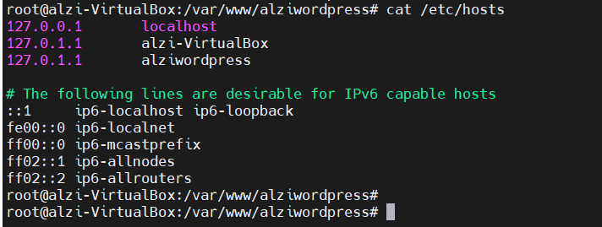

/var/www/alziwordpress/index.html

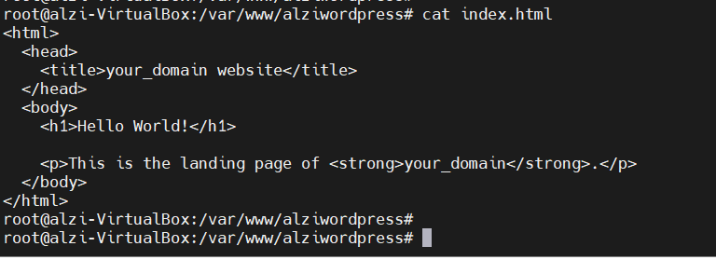

* Screenshot domain/info.php

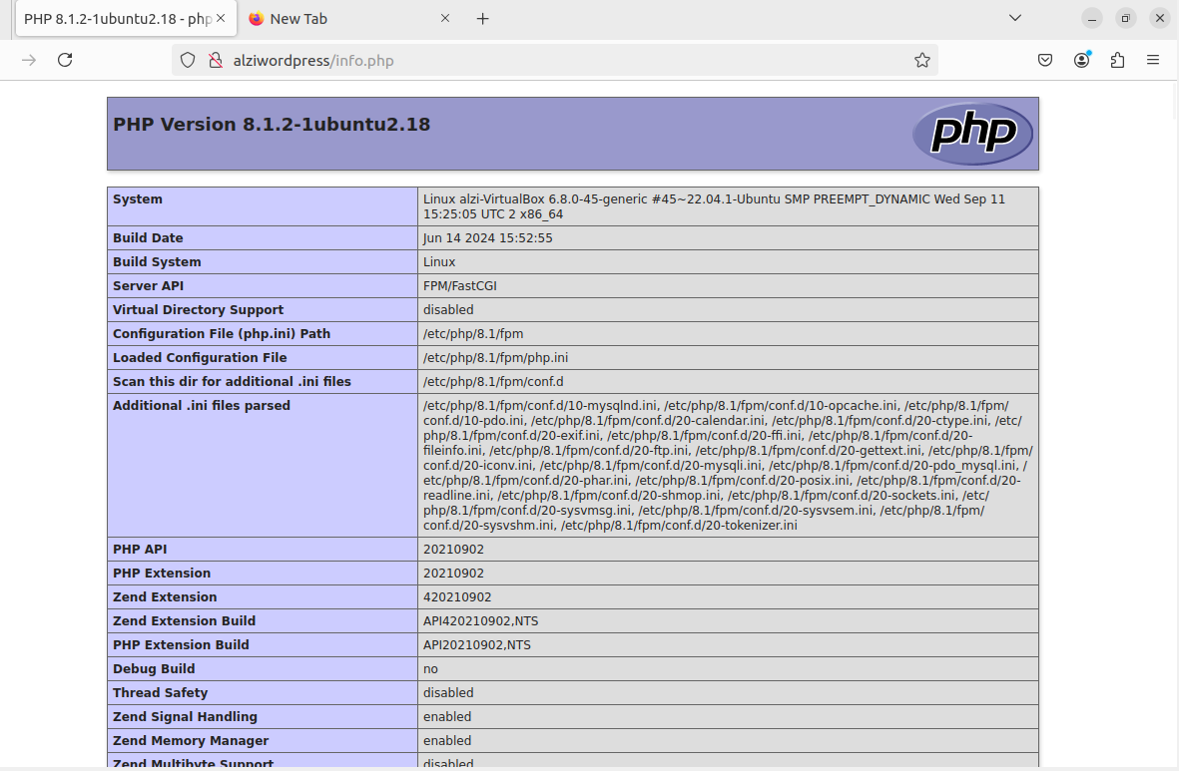

* buatlah lists categories yang didapatkan dari database pada tugas mysql munculkan pada file categories.php, screenshot kode php dan hasil domain/categories.php

Koneksi.php

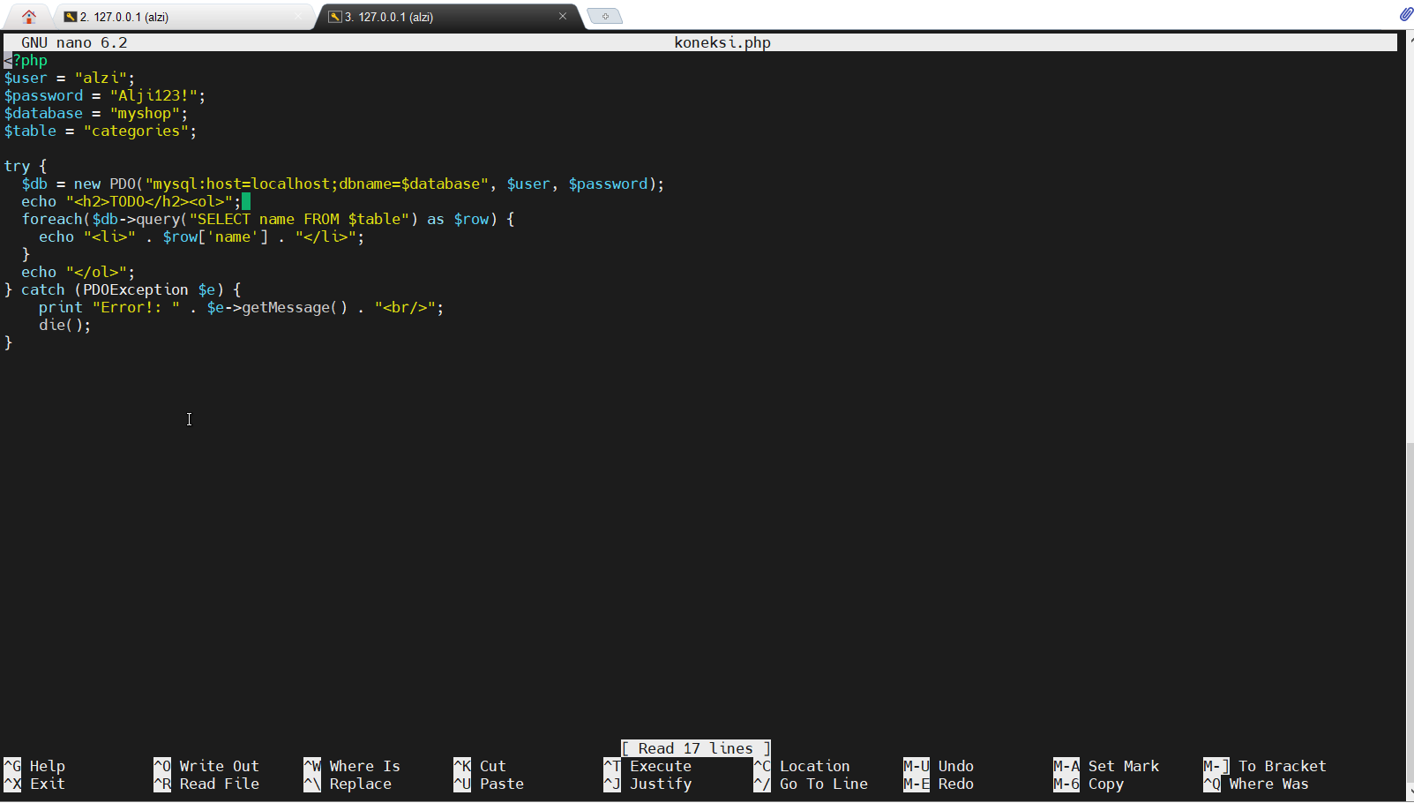

alziwordpress/koneksi.php

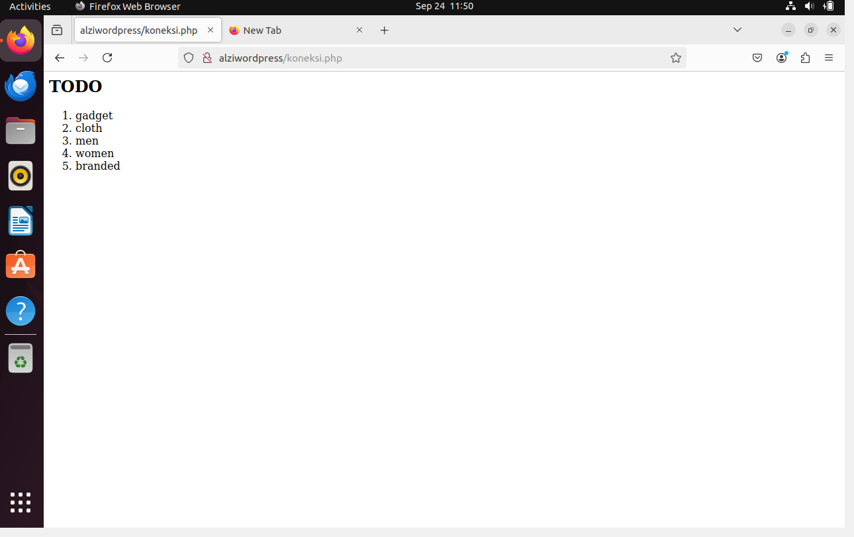

**Tugas Wordpress**

kerjakan dalam google docs yang sama dengan tugas php.

berikut ini instruksi tugas wordpress:

* install wordpress dari awal sampai selesai (dari konfigurasi nginx, download wordpress dst.) screenshoot step by step

Create User DB untuk Wordpress

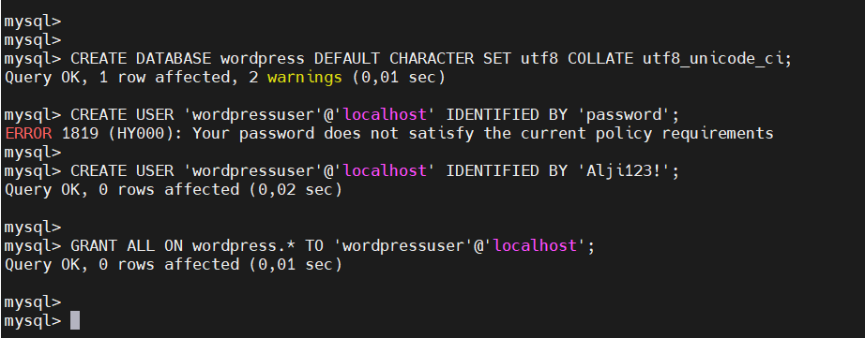

Install Additional PHP Extention

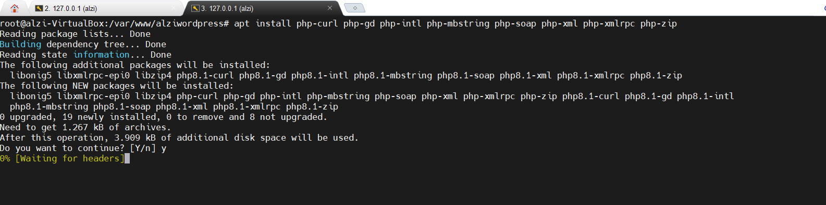

Download Wordpress

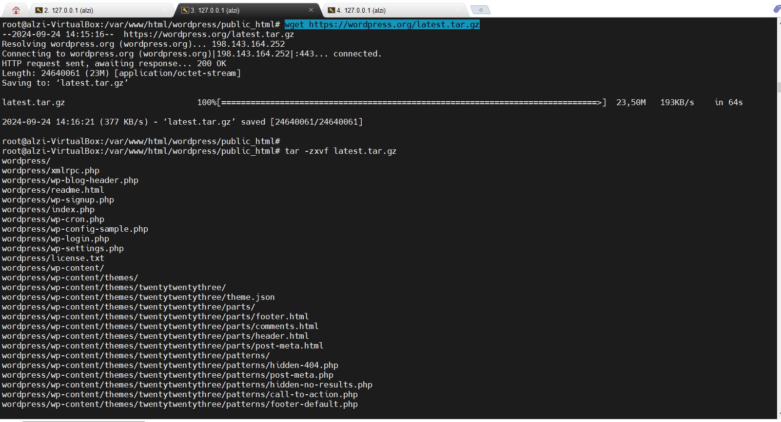

Extract Wordpress

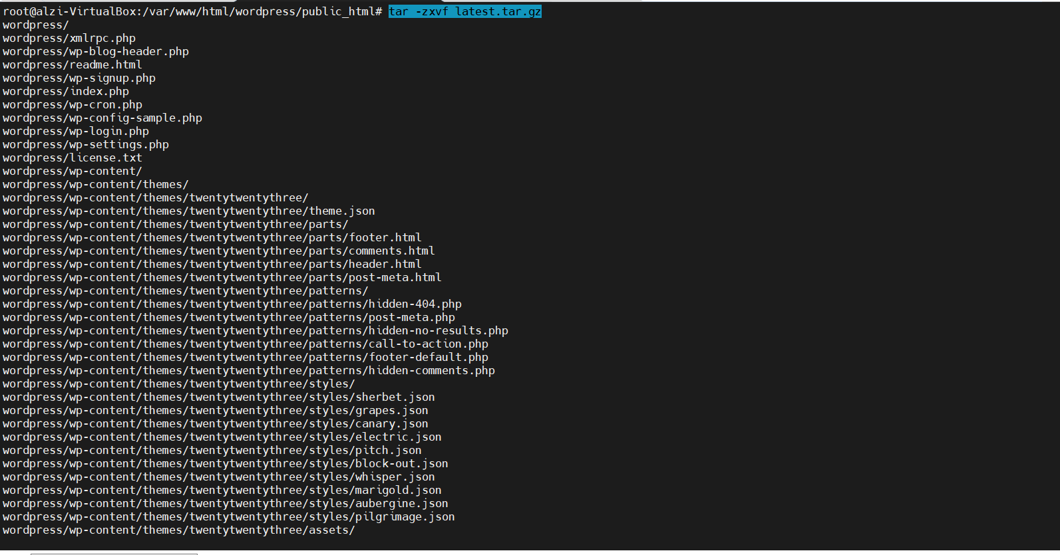

* # mv wordpress/* .
* # rm -rf wordpress
* # chown -R www-data:www-data *
* # chmod -R 755 *

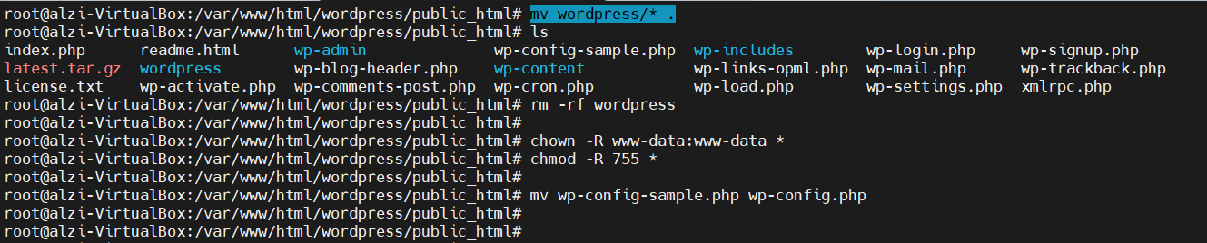

* screenshot nginx configuration

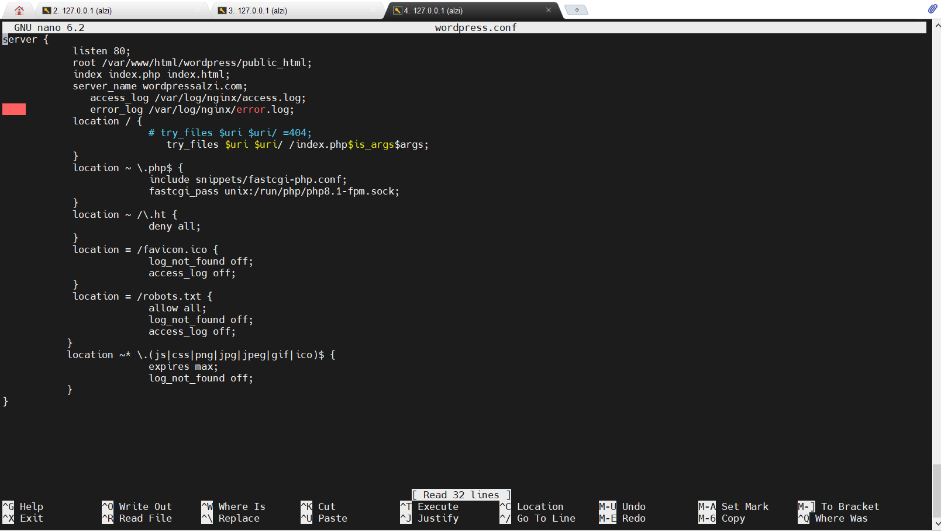

* screenshot wp-config.php

| root@alzi-VirtualBox:/var/www/html/wordpress/public_html# cat wp-config.php  <?php  /**  * The base configuration for WordPress  *  * The wp-config.php creation script uses this file during the installation.  * You don't have to use the website, you can copy this file to "wp-config.php"  * and fill in the values.  *  * This file contains the following configurations:  *  * * Database settings  * * Secret keys  * * Database table prefix  * * ABSPATH  *  * @link https://developer.wordpress.org/advanced-administration/wordpress/wp-config/  *  * @package WordPress  */  // ** Database settings - You can get this info from your web host ** //  /** The name of the database for WordPress */  define( 'DB_NAME', 'wordpress' );  /** Database username */  define( 'DB_USER', 'wordpressuser' );  /** Database password */  define( 'DB_PASSWORD', 'Alji123!' );  /** Database hostname */  define( 'DB_HOST', 'localhost' );  /** Database charset to use in creating database tables. */  define( 'DB_CHARSET', 'utf8' );  /** The database collate type. Don't change this if in doubt. */  define( 'DB_COLLATE', '' );  /**#@+  * Authentication unique keys and salts.  *  * Change these to different unique phrases! You can generate these using  * the {@link https://api.wordpress.org/secret-key/1.1/salt/ WordPress.org secret-key service}.  *  * You can change these at any point in time to invalidate all existing cookies.  * This will force all users to have to log in again.  *  * @since 2.6.0  */  define('AUTH_KEY', '^1z,2./EZw6*2q.pQDuG ~rb5wSyBD]pt8`C[9M. At+xr8jg+vPi5&[^N?c5Xto');  define('SECURE_AUTH_KEY', 'X}0@Wa$6mPLUSaD]O+|gGun$V-6!|Iht]PC!HyAY`aO}}8?*h>G+R8s^B4Rdrvl0');  define('LOGGED_IN_KEY', 'zVnz{[TJ0cgqKo09e9?*PD-Z^-o<<qh+Wx@J-XFt.%Fi@oR%iOuQTZ*iBZR(#-|x');  define('NONCE_KEY', '3-8X.u#t;c+wJ$`].SbIk>S4xlw#m})jZx^| d*+A:U*U`no=cW||rBR&n(SKC@p');  define('AUTH_SALT', 'A$u,j:5j6D(|K-~CMLBjwQTAh-BwR.,`S|-DU{V7e^y+|7p]vc6D+8NjZt?&j(&=');  define('SECURE_AUTH_SALT', '^}@c`Q*s-ZCh(s-|b|pKAfv kcQ%-iAIdf6Vg}#VM`mLQ%RSb,l|AGw:j~KL:VI+');  define('LOGGED_IN_SALT', 'qn}@v+zT*x6zmzIP,LCw}9O8nk:n~+;k:%;+*hY?[.;DLt?(~&9<z:=`,l_o7#IS');  define('NONCE_SALT', 'luW*{kXbZQfy3^IBp+HkkI>-TJ5KES-`!V@g9Ho9RSM++fV=S^OJ6lhMNJ7Nop+!');  /**#@-*/  /**  * WordPress database table prefix.  *  * You can have multiple installations in one database if you give each  * a unique prefix. Only numbers, letters, and underscores please!  */  $table_prefix = 'wp_';  /**  * For developers: WordPress debugging mode.  *  * Change this to true to enable the display of notices during development.  * It is strongly recommended that plugin and theme developers use WP_DEBUG  * in their development environments.  *  * For information on other constants that can be used for debugging,  * visit the documentation.  *  * @link https://developer.wordpress.org/advanced-administration/debug/debug-wordpress/  */  define( 'WP_DEBUG', false );  /* Add any custom values between this line and the "stop editing" line. */  /* That's all, stop editing! Happy publishing. */  /** Absolute path to the WordPress directory. */  if ( ! defined( 'ABSPATH' ) ) {  define( 'ABSPATH', __DIR__ . '/' );  }  /** Sets up WordPress vars and included files. */  require_once ABSPATH . 'wp-settings.php'; |
| --- |

* Screenshot website wordpress

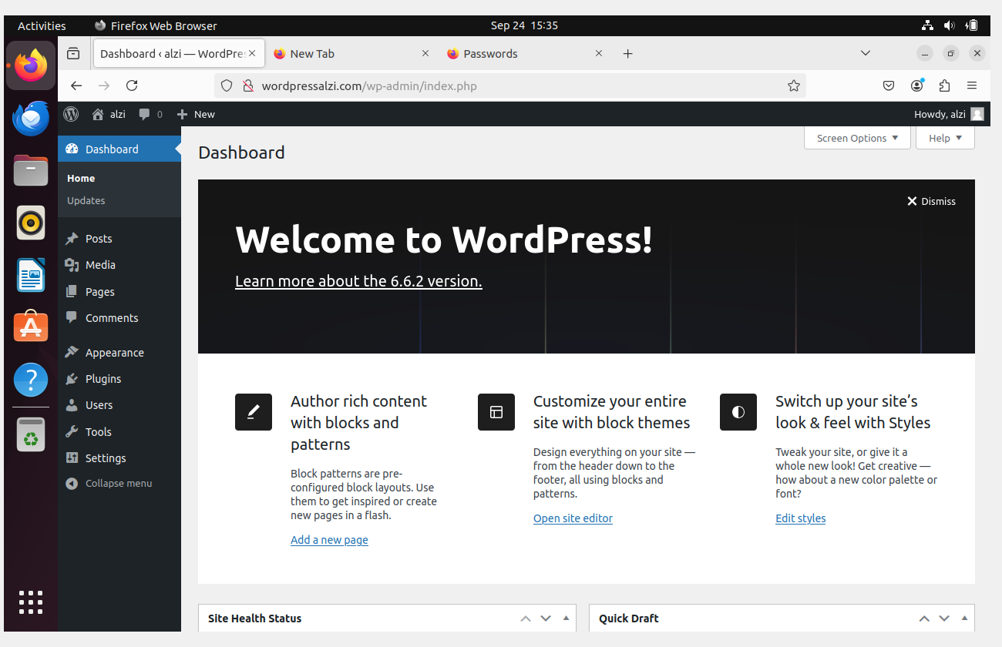

* buat video website wordpress

[Video Website Wordpress](https://drive.google.com/file/d/1SmjNce58WFAU5ACzNi5DhtCpZU-qqNxj/view?usp=sharing)