1. Intsall Docker



1. List all running containers

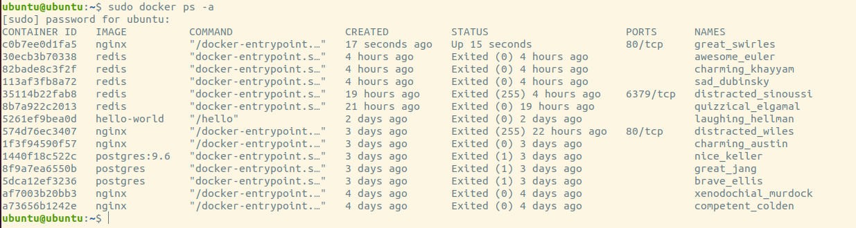

1. List all containers in your system

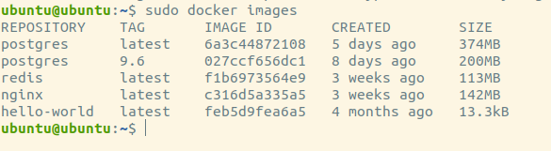

1. List all images in your system

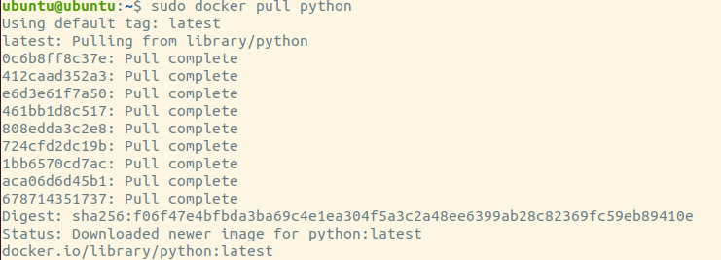

1. Pull nginx image

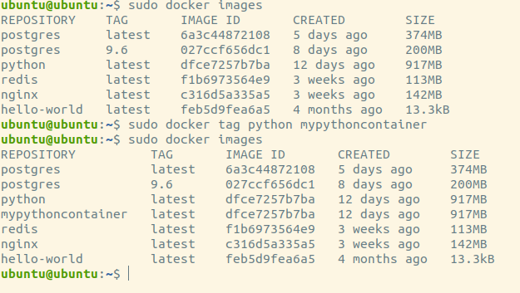

1. Try to run nginx

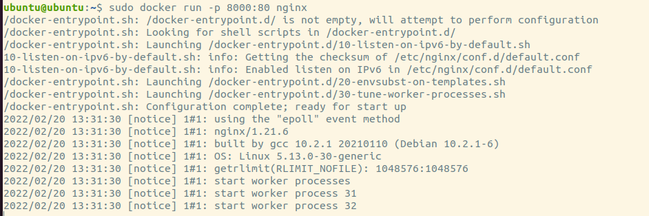

1. Watch container Logs

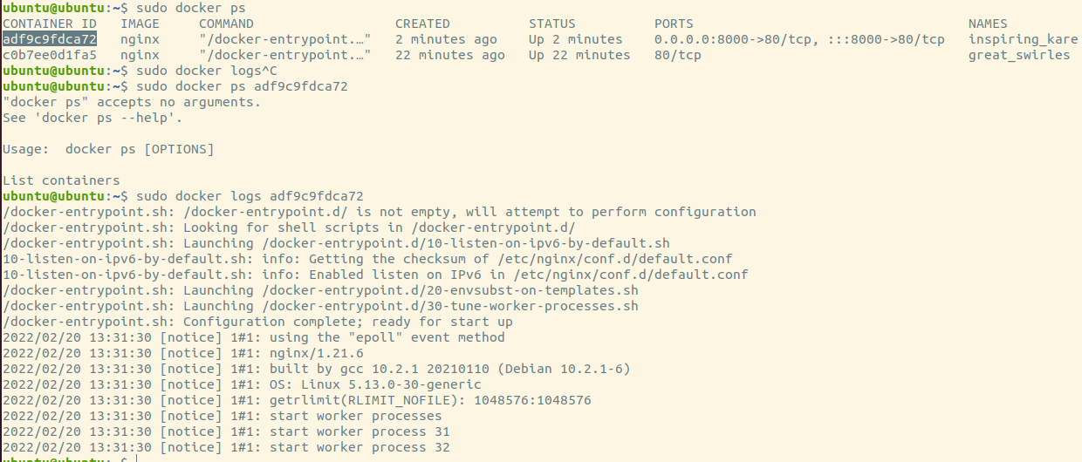

1. Inspect container IP

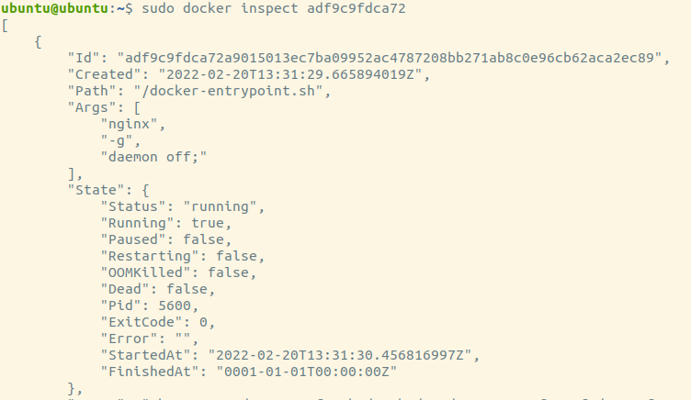

1. Try to execute inside nginx Container

9D

1. Try to remove nginx Image 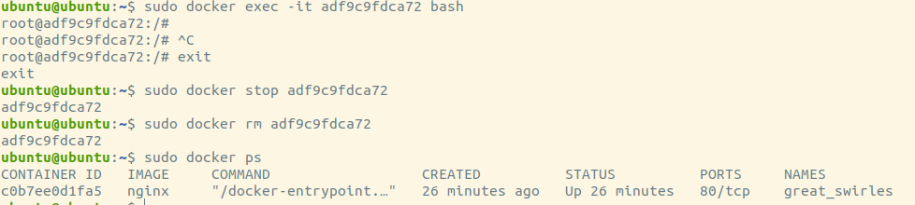
2. Try to run ubuntu container
3. Create a file Inside it
4. Exit the container

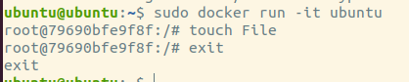

1. Try to start it again , Did you find the file ? NO