Vehicle Smart Grid based on a Multi-Agent System

Miguel Trinca

Nr: 86490

miguel.trinca@tecnico.ulisboa.pt

João Tiago Aparício

Nr: 97155

joao.aparicio@tecnico.ulisboa.pt

Daniel Castro

Nr: 87644

danieldmcastro@tecnico.ulisboa.pt

**ABSTRACT**

In this document we propose a multi-agent-based solution, to solve the problem of electric vehicle allocation on the electric grid chargers.

**Keywords**

smart grid, reinforcement learning, agent-based systems, multiagent systems, sustainability, electric fleet, charging stations, power management, energy efficiency, negotiation, auction

# INTRODUCTION

In the context of distributing energy to an electric vehicle fleet, some optimization problems can arise. In this way, it is essential to manage the cost of changing stations and minimize the number of unused stations. As well as minimize the waiting time of the vehicles to charge and to manage the power being delivered to the whole system. Managing the energy in the system is important because sometimes, in a time of crisis, it is critical to reduce energy provided to the system. And so, how the system adapts itself to optimize the delivery of energy to the vehicles. For example, in Lisbon it is estimated that there are 12 cars per charging station [1].

Defining solutions to this problem is relevant since it affects the overall power consumption and sustainability of maintaining a smart grid. Minimizing power consumption of systems is increasingly meaningful in a society where the number of electric devices is ever crescent.

In the scope of this project, we are doing a virtual simulation of a multi-agent-based solution to solve this problem. This simulation aims to produce a meaningful solution for the problem described earlier. The artifact proposed has the following characteristics.

# MULTI-AGENT SYSTEM

Our project will implement an environment and four unique agents. These agents will have different characteristics and goals, as well as different behaviors and interaction among themselves. These agents are:

**Driver Assistant** (DA): This agent's purpose is to evaluate the usage and consumption of the vehicle’s energy.

**Charger Handler** (CH): This agent's purpose is to evaluate the usage and consumption of the charging stations

**Power Operative** (PO): This agent's purpose is to evaluate and distribute power to the charging stations

**Energy Broker** (EB): This agent's purpose is to simulate a black box energy system that provides energy not only to our system but also the other systems such as hospitals, houses, etc.

In this project we are going to evaluate multiple solutions for the agents. The multiplicity of the agents - having multiple CHs, or only one, for example - is something that is going to be tested along the project to see which is the best option for our system.

# ASSUMPTIONS

It’s important to note some assumptions for the development of this project. First one is that we’re assuming that there are already in place charging stations in the city. Thus, we’re not focused on optimizing their location.

Moreover, we’re also assuming that our fleet of vehicles have a well-established optimized route for their vehicles, that minimizes time and consumption. Therefore, we’re not focusing on optimizing this area as well.

# SYSTEM PROPERTIES

## Environment

### Representation

A weighted bi-directional graph represented graphically by a grid.

### Properties

**Accessible**: All the agents can obtain complete, accurate, up-to-date data about the smart grid.  
**Non-deterministic**: An action has no single guaranteed effect such as traffic.  
**Dynamic**: The world changes while the agent is deliberating.  
**Discrete**: We have a finite amount of actions.  
**Non-episodic**: Events have a direct correlation to other events.   
**Random**: Environment has random events, such as crises.   
**Cost**: Agents have a cost of energy/money for each iteration.

## Agents

### Driver Assistant (DA)

* **Architecture**: Hybrid and Emotional
* **Sensors**:
  + Grid
    - Traffic level (per road/edge)
    - Position
  + Battery level
* **Actuators**:
  + Move randomly (Move right, left, up, down)
  + Charge
  + Stop
  + Choose Station
  + Move to next edge to chosen station
  + Consume Energy
  + Communication with CHs
    - Message give me stations
    - Negotiation with CHs
  + Negotiate with DAs - who is first?
* **Intern state**:
  + Chosen station
  + Priority level
  + Battery size
  + Battery level
  + Reinforcement Learning Markov network (States and Transition matrixes)
* **Events**:
  + Low energy

### Charger Handler (CH)

* **Architecture**: Deliberative
* **Sensors**:
  + Grid
  + Inside stations
  + Energy consumption per station
  + Energy usage per station
  + Stations being used
  + Vehicles waiting
* **Actuators**:
  + Give energy to station
  + Turn On/Off charging station
  + Calculate earnings
  + Communicate with DA
    - Message DA about the station
  + Communicate with PO
    - Message PO that needs more Units of Energy
    - Message PO the amount of energy spent
  + Communicate with CH
    - Message other CHs of waiting time
* **Intern state**:
  + Number of stations
  + List of stations (each station has)
    - On/Off
    - Charging?
    - Priority Queue
  + Provider price per units of energy
  + Consumer price units of energy
  + Charge time
* **Events**:
  + Report best station to DA

### Power Operative (PO)

* **Architecture**: Hybrid (deliberative because it negotiates with CH and reactive in the rest)
* **Sensors**:
  + Communication with CH
  + Total amount of energy in the network (Worst case all energy given by EB)
  + Energy level of each CH (Max 300 Units, for example)
  + Flux of Energy (Units per day per CH, for example)
  + Energy Storage Unit
* **Actuators**:
  + Negotiation with CH
  + Give energy to CH
  + Receive energy from EB
  + Store energy
* **Intern state**:
  + Available energy

### Energy Broker (EB)

* **Architecture**: Reactive
* **Sensors**:
  + Initial input of Units of energy
* **Actuators**:
  + Give energy to PO
* **Intern state**:
  + Total amount of energy
* **Events**:
  + Power outage
  + Power redistribution (high fluctuation)

# INTERACTION/NEGOTIATION

## DA vs DA

Negotiation to decide who gets to charge first based on priority level and other factors

## CH vs DA

Case: There is a station that is not being used, CH negotiates with DA so that he passes there to use it. Goal of CH is to have a car charging, but the goal of the DA is to have the most efficient route.

## CH vs PO

Conflicting Goals: CH needs more power to charge, but the PO wants to minimize the power delivered to the system.

Align Goals: CH has an inactive station tells the PO to lower energy production. The energy needed might be forecasted.

# METRICS

Several different architectures will be tested. To analyze the best system architecture for each case the following metrics will be used:

* Profit margin: cost of maintaining stations vs money made on total simulation;
* Number of inactive stations for more than *x* time;
* Energy units spent per energy units provided;
* Time to charge (time waiting) along time (in Tics of time);
* Number of communications between DA, PO and CH;

These metrics change according to the following parameters:

* Number of vehicles and stations;
* Number of natural disasters (power failures and decreased flow of energy supplied to the system) and
* Number of priority vehicles;

The following system architectures will be tested (N denotes several of):

*1* x DA; *N* x CH; *1* x PO; *1* x EB;

*N* x DA; *N* x CH; *1* x PO; *1* x EB;

*1* x DA; *1* x CH; *1* x PO; *1* x EB;

*N* x DA; *1* x CH; *1* x PO; *1* x EB;

# SOLUTION

## Environment representation

As this project is supposed to simulate a fairly realistic scenario, we used a network representation (i.e. on nodes and edges) based on real maps that can be fetched in real-time. We can adjust the size of the area of the simulation and the central point. For the tests we used the geographic coordinates of Instituto Superior Técnico as a central point and a radius of 1km. For this we used the OSMNX library that used NetworkX to represent the actual network.

Furthermore, we implemented a GUI from scratch to help on the perception of what is actually happening on the simulation, as can be seen in the Image 1. To ensure every member could run everything smoothly we implemented an anaconda environment and managed the packages accordingly

[INSERT GUI IMAGE]

## Driver Assistant - Movement, Negotiation and Deliberation

The

## Charger Handler - Offers and Negotiation

The

## Power Operative - Negotiation

The

## Energy Broker - Fluctuations

To simulate a realistic scenario where the source of energy can be fairly unstable, we opted to simulate 2 kinds of problems, power outages and power redistributions, one proves no energy to the system and the other provides a diminished amount. For instance, to power the ventilators on a hospital, which can have a higher priority than power the network on this simulation. An example of such fluctuations can be seen in the graph of Figure 2.

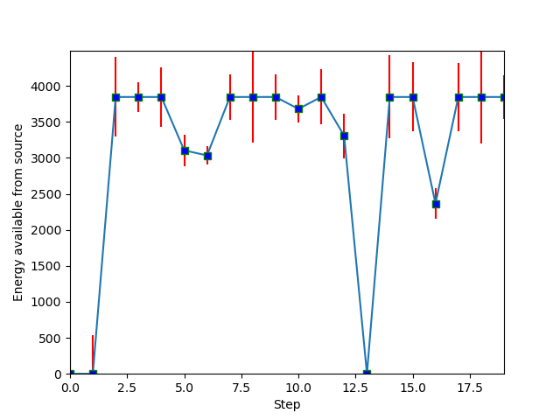

Figure 1. Power fluctuation from source during simulation

.

# 

# RESULTS

The

## Default values for simulation

The

## Profit margin

The

## Number of inactive stations

The

## Number of units spent per energy provided

The

## Time to charge

The

## Number of communications between agents

The

# CONCLUSIONS

The

## Future work

The

## Related work

The

# REFERENCES

1. https://www.portugalms.com/en/portugal-is-leading-the-sales-of-electric-cars-but-there-are-not-enough-charging-stations/
2. OSMNX: Python library for fetching maps from Open Street Maps. https://osmnx.readthedocs.io/en/stable/.
3. NetworkX: Python software for complex networks. https://networkx.github.io/.
4. mathplotlib: Python software for representing graphs. https://matplotlib.org/users/index.html.
5. Pierce, Donald: Traffic simulator mini project for route optimization. https://github.com/donjpierce/traffic
6. Wooldridge, M. (2009). An introduction to multiagent systems. John Wiley & Sons.
7. Anaconda: Software to manage Python packages and environments. https://docs.anaconda.com.