What after installing python

Now you have installed python on your operating system you can see an icon labeled IDLE on your desktop. If you don't find the icon on desktop, you can search for IDLE(Python GUI) from the installed applications .

Double click the icon and you should see something like this,

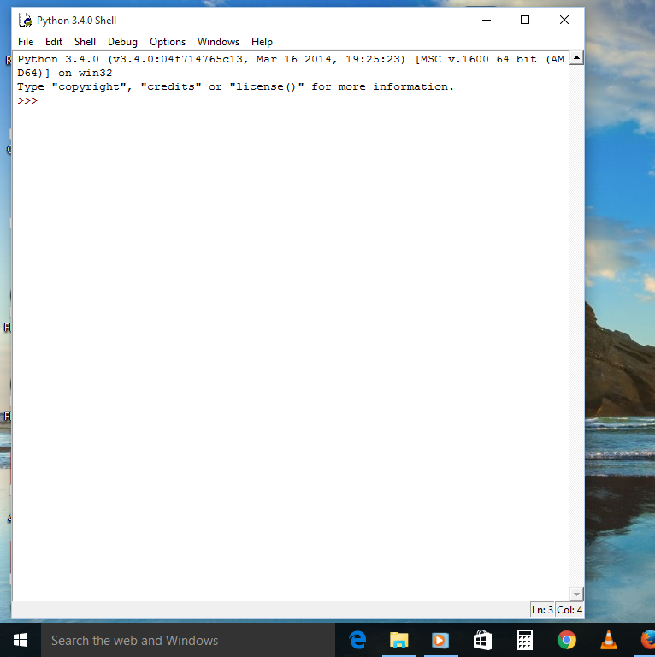

This is the Python shell, which is part of Python’s integrated
development environment. The three greater-than signs (>>>) are
called the prompt.

Lets enter some command at the prompt

>>>print(“Hello world”)

and press Enter and you would notice something like this down the line

>>>print(“Hello world”)
Hello world
>>>

Voila! That was your first program.

The word print is a type of Python command called a function, and it prints out whatever is inside the parentheses to the screen. In essence, you have given the computer an instruction to display the words “Hello World”—an instruction that both you and the computer can understand.

How do you feel? Isn't it interesting.
Well I suppose your answer would be like this : Hell Yeah! :D
So why waiting, let's explore python more....

Saving your python programs

Python is an interpreted language, which can save you considerable time during program development because no compilation and linking is necessary. The interpreter can be used interactively, which makes it easy to experiment with features of the language, to write throw-away programs, or to test functions during bottom-up program development. It is also a handy desk calculator.

But If you want to save your program without loosing the track of what you are doing in your program then you can do that by following some these simple steps;

Open IDLE ,then click on File -> New file

Write your code in the opened window.

Save the file in a folder different from your python installation folder.

If you want to run this file just double-click on the file icon and you could see Python command-line console (similar to Python shell) starting up like this

