EEG Pain Scale Project
Empirical acute-pain EEG benchmark reanalysis
Evidence audit • reproducible statistics • validation boundary
Critical status: This report reanalyzes actual numerical results printed in a published EEG paper. It does not claim that the project’s proposed 0–10 pain-intensity formulae were fitted to raw EEG, because the raw files and paired trial-level features could not be retrieved into this runtime.

1. Source dataset and analysis scope
Sun et al. (2020) describe an EEG study of acute pain-signal detection. The first dataset analysis used 50 healthy participants from a dataset that originally recruited 51 people. A second dataset comprised two people with chronic back pain who received painful pinprick and non-painful monofilament stimulation at the hand and back. The published work used source-localized EEG, time-frequency features, and two detection approaches: an unsupervised state-space model (SSM) and a linear support-vector machine (SVM).
The reproducible numeric reanalysis uses the 16 rounded train/test configurations in Table 2 of the paper. These are not 16 independent participants: they are repeated cross-subject/cross-modality configurations from two patients. The raw figures are recorded in published_table2_performance_rows.csv. Pain-rating summaries from the same paper are recorded in published_patient_nrs_summary.csv.
Primary source: https://pmc.ncbi.nlm.nih.gov/articles/PMC7744433/ . The first-cohort public dataset cited by the paper is https://osf.io/bsv86/ .

2. Reanalysis of the 16 published benchmark rows
Reported metric | Mean | SD | Median | Range
SSM unsupervised AUC | 0.711 | 0.068 | 0.710 | 0.60 to 0.81
SVM supervised peak AUC | 0.614 | 0.120 | 0.590 | 0.43 to 0.83
SVM peak accuracy | 0.602 | 0.069 | 0.605 | 0.50 to 0.73
Paired AUC difference (SSM − SVM) | 0.096 | 0.124 | 0.115 | -0.18 to 0.28

SSM AUC was higher than SVM AUC in 13/16 table rows; SVM AUC was higher in 3/16 rows, with no ties. The mean paired difference on the rounded printed values was 0.096 AUC. Leave-one-row-out diagnostics kept the mean difference positive (0.084–0.115); this is a descriptive sensitivity check, not an independent replication.
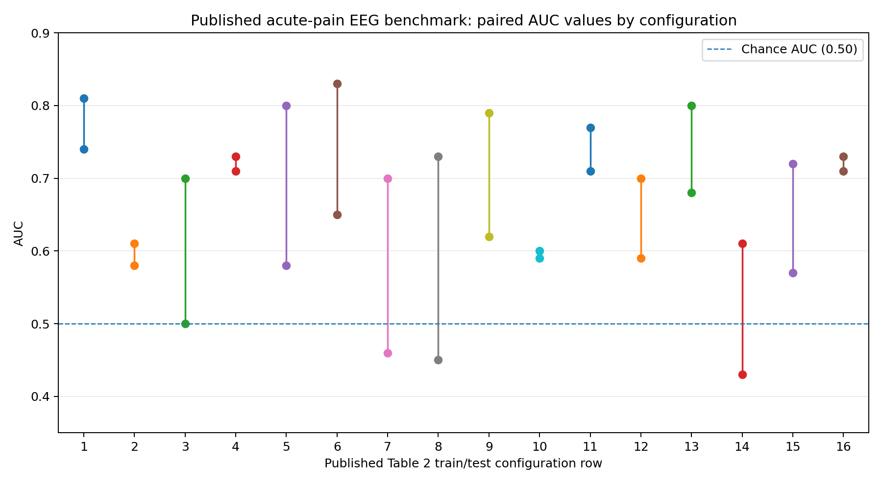
Figure 1. Each vertical segment links the reported SVM AUC and SSM AUC for one published configuration. Values are the paper’s rounded aggregate performance numbers, not EEG-derived estimates newly fit here.

3. Paired statistical sensitivity checks
Test | Statistic | Nominal p | Interpretation limit
Paired t-test, SSM vs SVM AUC | t=3.115, df=15 | 0.0071 | Exploratory; repeated configurations violate independent-unit assumption
Wilcoxon signed-rank, two-sided | W=18.5 | 0.0105 | Similar to paper’s reported p=0.0113; tiny difference expected from rounding/method
Exact sign test, two-sided | 13 wins / 3 losses | 0.0213 | Direction consistency only; same dependent configurations
Exact sign test, SSM greater | 13 wins / 3 losses | 0.0106 | One-sided sensitivity check, not a confirmatory population test
Pearson correlation of method AUCs | r=0.233 | 0.3859 | Descriptive cross-row association only
Spearman correlation of method AUCs | rho=0.252 | 0.3467 | Descriptive cross-row association only

A nominal paired-t 95% interval for the mean AUC difference from these 16 rows is [0.030, 0.162]. It is not a valid population-level confidence interval because the table rows are dependent and originate from only two participants. The paper reports a signed-rank p-value of 0.0113 for this comparison; this reanalysis of rounded table entries yielded a two-sided approximate p-value of 0.0105.
AUC-vs-chance checks and accuracy-vs-0.5 checks were also computed in the JSON output. They are not treated as inferential evidence because the row dependencies remain, and because AUC and accuracy are detection metrics—not calibrated pain intensity.

4. Actual patient pain-rating summaries
Subject | Site | Stimulus | NRS median | Reported IQR
Subject #1 | Hand | Painful pinprick | 1 | 1–1
Subject #1 | Hand | Non-painful monofilament | 1 | 1–1
Subject #1 | Back | Painful pinprick | 1.5 | 1–2
Subject #1 | Back | Non-painful monofilament | 1 | 1–1
Subject #2 | Hand | Painful pinprick | 3 | 2–4
Subject #2 | Hand | Non-painful monofilament | 2 | 1–2
Subject #2 | Back | Painful pinprick | 4 | 3–5
Subject #2 | Back | Non-painful monofilament | 2 | 2–3

The painful-minus-non-painful median differences across the four subject/site comparisons were 0, 0.5, 1, and 2 NRS points. These are differences between published medians, not trial-level paired differences; no inferential p-value can be justified from this summary table. In particular, Subject 1’s hand medians were both 1, and the back summaries overlapped. This cautions against equating stimulus category with experienced pain intensity.

5. Findings from the original authors (reported, not independently recalculated)
- In the 50-person main analysis, 32 participants had clear source-localized evoked potentials and 18 did not. The paper reports a group difference in AUC at rank-sum p = 1.9 × 10⁻⁵, indicating material heterogeneity in signal detectability.
- Median detection latency was 180 ms for high-intensity trials and 202 ms for low-intensity trials (rank-sum p = 1.5 × 10⁻⁵). Detection latency and reaction time had a weak, non-significant association (Spearman rho = 0.29, p = 0.06).
- The authors report mean cross-subject SSM AUC of 0.62, best single-subject SSM AUC of 0.79 and best supervised SVM AUC of 0.95. The best values are best-case outcomes and should not be interpreted as typical subject-level performance.
- The SVM used spectral power in 4–12 Hz, 12–45 Hz and 60–100 Hz bands. The SSM used time-averaged 1–100 Hz EEG amplitude in 100 ms bins and baseline z-scoring. These are literature-backed detector benchmarks, not 0–10 intensity equations.

6. Formula coverage and status
The candidate registry now contains 17 families: alpha sigmoid, ordinal regression, ridge, elastic net, GAM, EEG interactions, N2/P2 ERP, spatiotemporal EEG, random forest, gradient boosting, within-person calibration, EWMA smoothing, quantile/rank calibration, artifact-aware QC, mixed-effects regression, state-space change-point detection, and spectral linear SVM.
The last two are literature-informed benchmarks for event detection/classification. They do not produce calibrated 0–10 scores without additional supervised calibration. None of the proposed 0–10 intensity formulas have been fitted or applied to raw trial-level EEG in this runtime; the paper’s Table 2 contains AUC and accuracy summaries, not individual EEG predictors and matched per-trial pain-intensity predictions.

7. Test ledger: what has and has not been established
Test or work item | Status | Evidence / boundary
Recompute published Table 2 descriptive means/ranges | PASS | Actual printed paper values; reproducible by script
Paired t, Wilcoxon and exact sign tests on published rows | PASS (exploratory) | Dependent configuration rows; no population inference
Leave-one-row-out sensitivity | PASS (descriptive) | Mean advantage remained positive; not an independent validation
Summarize published patient NRS medians/IQRs | PASS | Aggregate summaries only; cannot test trial-level differences
Project software boundary/property tests | PASS in earlier run | Score-bound, sigmoid-bound, EWMA recurrence, zero-MAD and input guard checks; synthetic software fixtures only
Extract features from raw participant EEG here | BLOCKED | The runtime cannot resolve raw.githubusercontent.com, api.github.com or openneuro.org; no raw EEG files are present locally
Fit/evaluate proposed 0–10 pain intensity equations on actual trial rows | NOT RUN | Would require trial-level EEG and paired rating labels
Clinical patient generalization | NOT ESTABLISHED | Published second dataset contains two chronic-back-pain patients receiving test stimuli; it is not a clinical validation cohort for acute injury/postoperative pain

8. Next empirical gate
To finish the requested formula validation, the analysis must have actual participant EEG or source signals with trial identifiers and matching NRS ratings. The intended analysis then requires group-wise held-out evaluation, trial-level predictions, subject-cluster bootstrap confidence intervals, participant-preserving permutation tests, temporal holdout, external dataset validation and pre-specified multiplicity control. Until this is executed, no winner, coefficient, calibration claim or clinical readiness claim is warranted.
Source/data links:
- Sun et al. full text: https://pmc.ncbi.nlm.nih.gov/articles/PMC7744433/
- Public acute-pain EEG dataset cited by the study: https://osf.io/bsv86/
- Large-scale laser-evoked EEG collection (678 healthy participants): https://pmc.ncbi.nlm.nih.gov/articles/PMC12405539/

