Expanded EEG-only Pain Prediction Research Report
Version 0.2 | 16 October 2026
Evidence status: literature synthesis and pre-specified analysis protocol. No new raw EEG model was fitted in this session.

Executive conclusion
EEG contains pain-related information, especially in stimulus-evoked responses and some multivariate connectivity patterns, but it is not yet a reliable stand-alone, universally calibrated pain meter. Published chronic-pain analyses show weak generalization for several commonly used EEG features and modest out-of-sample performance for connectivity models. A formula is valid only to the extent that it predicts ratings on held-out people and independent datasets.
Critical limitation: raw EEG could not be downloaded in this execution environment because the data-analysis runtime has no network/DNS access. This package therefore does not claim new fitted coefficients, p-values, AUC, MAE, or confidence intervals for candidate formulas. The figures below show results reported by published papers, not new analyses.
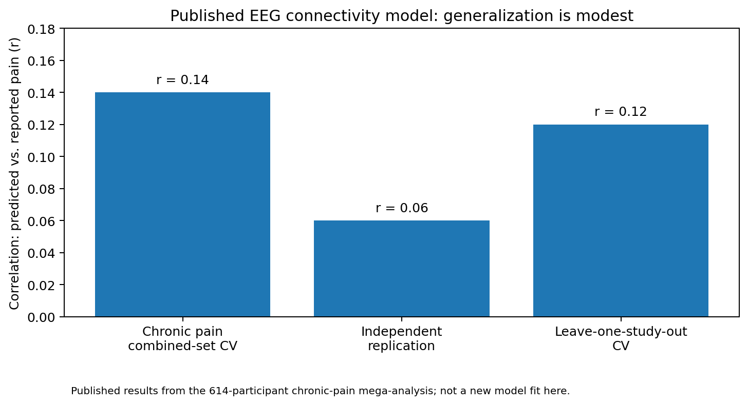
Figure 1. Published chronic-pain connectivity-model correlations. The independent replication correlation (r = 0.06) is especially important: a measurable association can still be too weak for individual pain estimation.
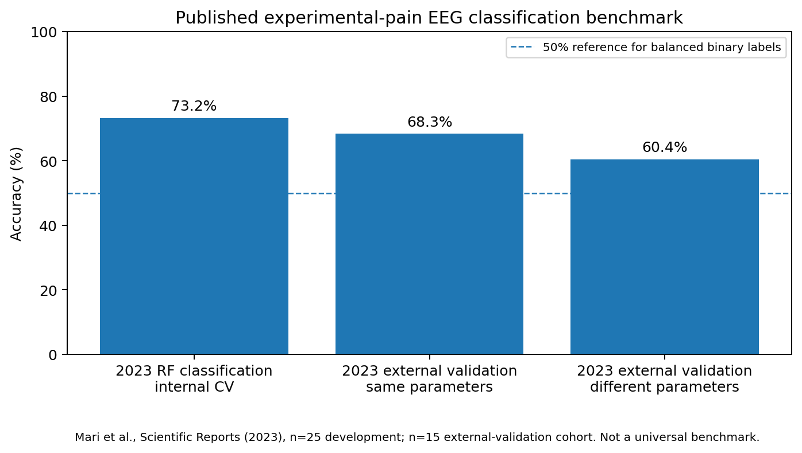
Figure 2. Published experimental pain classification accuracies. Results depend on the task and stimulation protocol; these are not universal performance estimates.

1. Candidate formula families

F1 — Single-feature baselines
EEG variables: log band power; PAF; N2-P2; entropy; aperiodic exponent. Candidate: Regression per feature. Validity guardrail: Baseline; no universal direction.

F2 — ERP multivariate
EEG variables: N2, P2, N2-P2 amplitude, N2/P2 latency. Candidate: Linear/ridge regression. Validity guardrail: Fixed windows; artifact and latency checks.

F3 — Event-related spectral response
EEG variables: Post-stimulus minus baseline log power in theta/alpha/beta/gamma. Candidate: Ridge/elastic net. Validity guardrail: Pre/post windows fixed; gamma EMG check.

F4 — Alpha suppression
EEG variables: -log((alpha_post+eps)/(alpha_baseline+eps)). Candidate: Univariate then multivariate. Validity guardrail: Only comparable pre/post trials.

F5 — Multiband power + PAF
EEG variables: log theta/alpha/beta/gamma; PAF. Candidate: Ridge/elastic net. Validity guardrail: Learn signs in training folds.

F6 — Nonlinear spectral model
EEG variables: Pre-registered spectral feature vector. Candidate: Random forest / boosting. Validity guardrail: Nested grouped CV; no feature selection on test.

F7 — Connectivity
EEG variables: Theta/alpha/beta wPLI or imaginary coherence; network summaries. Candidate: Regularized regression. Validity guardrail: Volume conduction and reference confounds.

F8 — Alpha envelope dynamics
EEG variables: Mean, variance, autocorrelation time, burst rate. Candidate: Ridge / nonlinear benchmark. Validity guardrail: Test incremental value over mean power.

F9 — Entropy
EEG variables: Spectral entropy and/or permutation entropy. Candidate: Ridge / elastic net. Validity guardrail: Estimator and epoch length fixed.

F10 — Aperiodic 1/f
EEG variables: Aperiodic exponent and offset. Candidate: Ridge / univariate association. Validity guardrail: Published evidence against simple intensity link.

F11 — PAC
EEG variables: Surrogate-normalized phase-amplitude coupling. Candidate: Regularized model. Validity guardrail: Pre-register bands/regions; multiple testing.

F12 — EEG-derived habituation
EEG variables: Slope of ERP/power response across repeated trials. Candidate: Mixed model / regression. Validity guardrail: Trial-order effects; no split leakage.

F13 — Multi-view fusion
EEG variables: ERP + spectra + connectivity + entropy + aperiodic features. Candidate: Elastic net / PLS. Validity guardrail: Ablation and grouped CV.

F14 — Ordinal classes
EEG variables: EEG features mapped to pre-registered ordered pain categories. Candidate: Ordinal/logistic classifier. Validity guardrail: Report macro-F1, balanced accuracy, calibration.

F15 — Personal baseline index
EEG variables: Within-person z-score change of EEG features. Candidate: Personalized calibrated model. Validity guardrail: Relative index only; not universal 0–10 scale.

Mathematical specifications

F2 — ERP multivariate
ŷ = β₀ + β₁·A(N2-P2) + β₂·A(N2) + β₃·A(P2) + β₄·L(N2) + β₅·L(P2).

F3 — event-related spectral response
ŷ = β₀ + Σᵦ βᵦ Δlog(Pᵦ), where Δlog(Pᵦ) = log(Ppost,ᵦ) − log(Pbaseline,ᵦ).

F4 — alpha suppression
Sα = −log[(Pα,post + ε)/(Pα,baseline + ε)]. This is a reactivity feature, not an absolute pain scale.

F5 — multiband regularized
ŷ = β₀ + βA·z(log Pα) + βT·z(log Pθ) + βB·z(log Pβ) + βG·z(log Pγ) + βF·z(PAF).

F12 — temporal/habituation
Model EEG-derived response slope over repeated trials; do not let adjacent trials from the same participant leak between training and test.

F15 — personal baseline change
Iᵢₜ = Σₖ wₖ [fᵢₜₖ − μᵢ,baseline,k] / σᵢ,baseline,k. Relative change only; NRS calibration requires supervised validation.
Other candidates are specified in the workbook and Markdown report: single-feature baselines, nonlinear spectral models, connectivity summaries, envelope dynamics, entropy, aperiodic exponent/offset, phase-amplitude coupling, multiview fusion, and ordinal classification. Signs and weights must be learned inside training folds, not selected after inspecting test performance.

2. Statistical validation protocol
- Use participant-grouped outer cross-validation; never randomly split trials when claiming generalization to new people.
- Use nested grouped cross-validation for model/hyperparameter selection. Fit scaling, imputation, feature selection, dimension reduction and calibration inside training folds only.
- Compare against a training-fold mean baseline, single-feature EEG baselines, and—where known—a stimulus-only baseline. The EEG model must add value beyond the stimulus cue.
- Regression: report MAE, RMSE, test R², Spearman correlation and calibration slope/intercept. Report participant-cluster bootstrap 95% intervals.
- Classification: pre-register class cutoffs. Report balanced accuracy, macro-F1, per-class recall, confusion matrix, AUROC/AUPRC and probability calibration.
- Use participant-level permutation tests and control multiplicity for exploratory feature screens. Do not treat hundreds of trials from a few participants as independent people.
- Run leave-one-dataset-out or locked external validation. Keep acute experimental pain and chronic clinical pain as separate targets.
- Check artifacts, EMG contamination for gamma, volume conduction for connectivity, stimulus-intensity confounding, participant identity leakage, and stability to preprocessing choices.

3. Public datasets and published evidence

ds005293 / on005293
Acute laser pain. Healthy; 4 levels NRS 2/4/6/8; 80 trials/person. Label information: Trial-wise pain rating described.
https://nemar.org/dataset/on005293
Use note: High priority; inspect version/labels before use

ds005285 / on005285
Acute laser pain. Low/high stimuli; 160 trials/person; NRS 0-10. Label information: Rating described.
https://nemar.org/dataset/on005285
Use note: High priority; participant-wise split

Nine-dataset LEP resource
Acute laser pain. 678 participants across nine experiments. Label information: Single-trial ratings reported in data descriptor; verify each experiment.
https://www.nature.com/articles/s41597-025-05900-1
Use note: Potential large-scale benchmark; harmonization required

OSF uqt9z
Experimental pressure pain. Independent experiments; healthy volunteers. Label information: Pain categories / high-low labels.
https://osf.io/uqt9z/
Use note: Useful external validation benchmark

Chronic pain EEG mega-analysis
Chronic pain. 614 participants, eight datasets. Label information: Average pain NRS over preceding 1-4 weeks.
https://pmc.ncbi.nlm.nih.gov/articles/PMC12517086/
Use note: Strong evidence source; public access differs by contributing dataset

Aperiodic chronic pain study
Chronic pain and controls. 149 chronic pain + 115 controls. Label information: Pain intensity within chronic-pain cohort.
https://elifesciences.org/articles/101727
Use note: Published null finding for aperiodic exponent

4. Interpretation and limitations
The evidence supports investigating multimodal EEG feature families, especially single-trial evoked responses and carefully controlled connectivity features, but it does not support treating a hand-weighted EEG index as a universal 0–10 pain scale. The aperiodic exponent is included as a falsifiable candidate, not a presumed biomarker; a published 149-chronic-pain/115-control study found no reliable relation with pain intensity. A 2026 external-validation study reported that continuous EEG pain-regression models did not beat the mean-value baseline, although low/high classification showed AUC around 0.62–0.68.

5. Work completed vs. not completed
Completed: broad literature search, formula expansion, dataset inventory, validation plan, literature-benchmark figures, workbook, and a grouped-CV analysis script designed for a genuine feature CSV.
Not completed: raw EEG download, signal preprocessing, feature extraction, new model fitting, permutation tests, new confidence intervals, or external validation of new coefficients. No synthetic EEG or pain-rating data were created. The Python script will not run without a supplied real feature table.

References
- Zhao et al. (2025). A comprehensive EEG dataset of laser-evoked potentials for pain research. Scientific Data. https://doi.org/10.1038/s41597-025-05900-1
- Exploring electroencephalographic chronic pain biomarkers: a mega-analysis (2025). eBioMedicine. https://doi.org/10.1016/j.ebiom.2025.105955
- Mari et al. (2023). External validation of binary machine learning models for pain intensity perception classification from EEG in healthy individuals. Scientific Reports. https://doi.org/10.1038/s41598-022-27298-1
- External validation of EEG-based machine learning models for continuous pain prediction (2026). Journal of Pain. https://doi.org/10.1016/j.jpain.2026.106416
- Assessing the balance between excitation and inhibition in chronic pain through the aperiodic component of EEG (2025). eLife. https://doi.org/10.7554/eLife.101727
- Huang et al. (2018). Magnitude and Temporal Variability of Inter-stimulus EEG Modulate the Linear Relationship Between Laser-Evoked Potentials and Fast-Pain Perception. Frontiers in Neuroscience. https://doi.org/10.3389/fnins.2018.00340

