EEG Pain Measurement by Explicit Formulae
Revised research analysis | 16 October 2026
Scope: mathematically interpretable EEG formulas and statistical evidence. No random forest, boosting, neural network, or synthetic observations are used.

Executive finding
The strongest direct formula-based published evidence located is Bai et al. (2016), which tested single-trial pain-evoked EEG magnitude equations. Spontaneous-EEG-normalized RMS improved reported continuous prediction MAE (1.838 to 1.625 NRS points on predicted high-pain trials, p=.002; 1.235 to 1.173 on true high-pain trials, p=.003). Low/high classification accuracy changed from 68.95% to 70.36%, which was not significant (p=.092). These are published analyses of real data, not a fresh reanalysis of raw EEG in this package.
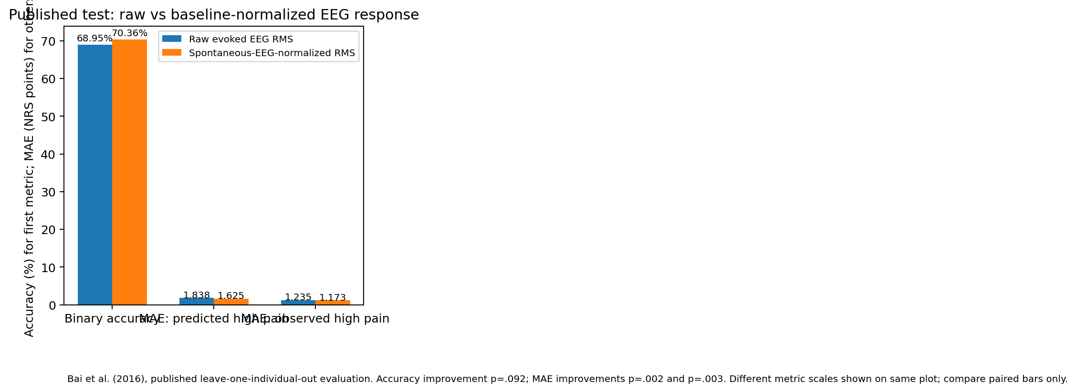
Figure 1. Published formula-based test of raw versus spontaneous-EEG-normalized RMS. The metrics have different units/scales; only paired bars of the same metric should be compared.

Formulae

F1 — Evoked response RMS
RMS_P(i) = sqrt[(1/K) Σ x(i,k)²]
Amplitude of a pre-specified post-stimulus epoch; not pain itself.

F2 — Spontaneous-normalized RMS
nRMS_P(i) = [RMS_P(i) − μ(RMS_S)] / σ(RMS_S)
Baseline normalization within a participant.

F3 — Linear calibration
NRS_hat = a·RMS_P + c
Fit a and c on training participants only.

F4 — Normalized linear calibration
NRS_hat = a·nRMS_P + c
Test whether normalization improves held-out MAE.

F5 — Piecewise calibration
ŷ = β0 + β1x + β2 max(0, x−τ)
Can represent nonlinearity; τ must be pre-specified and available from EEG at prediction time.

F6 — N2–P2 amplitude
A_N2P2 = V_P2 − V_N2; NRS_hat = a·A_N2P2 + c
Fixed electrodes/time windows; control attention, salience, stimulus and artifact.

F7 — Alpha suppression
Sα = −ln[(Pα,post+ε)/(Pα,base+ε)]
Within-trial spectral change; exploratory.

F8 — Band response
ΔP_b = ln(P_b,post+ε) − ln(P_b,base+ε)
Use fixed bands/epochs; check gamma EMG.

F9 — Connectivity equation
NRS_hat = β0 + Σ β_(b,r,s) C_(b,r,s)
Promising theta connectivity findings, but not a validated fixed coefficient set.

F10 — Personal baseline index
I = Σ w_k (f_k − μ_base,k)/σ_base,k
Relative index, not universal NRS without separate calibration.

Published statistical evidence
Outcome | Raw RMS | Normalized RMS | p-value
Low/high accuracy | 68.95% ± 12.91 | 70.36% ± 14.18 | 0.092
MAE, predicted high pain | 1.838 ± 0.602 | 1.625 ± 0.446 | 0.002
MAE, true high pain | 1.235 ± 0.278 | 1.173 ± 0.278 | 0.003
Bai et al. (2016), https://doi.org/10.3389/fncom.2016.00031. Binary accuracy change is not significant at 0.05. MAE reductions are statistically significant in the reported analysis but modest in NRS units.

Statistical validity protocol
- Pre-register one primary equation and limit secondary feature screens.
- Use participant-level held-out validation; never split trials from the same participant across train and test.
- Report MAE, RMSE, test R², calibration slope/intercept, and participant-cluster confidence intervals.
- Test within-person slopes with mixed-effects methods or participant-level Fisher-z summaries.
- Compare with a training-mean baseline and stimulus-only baseline where stimulus intensity is known.
- Use participant-aware permutation tests, multiplicity correction, and locked external validation.
- Keep acute experimental pain and chronic clinical pain as separate targets.

Important limitation
Raw EEG could not be downloaded in this execution environment. Therefore, no new coefficients, p-values, confidence intervals, or performance metrics from a fresh raw-data analysis are claimed. The supplied Python script is for genuine feature tables and fits only interpretable ordinary least-squares equations, not AI models.

References
- Bai et al. (2016). https://doi.org/10.3389/fncom.2016.00031
- Huang et al. (2018). https://doi.org/10.3389/fnins.2018.00340
- Bott et al. (2025). https://doi.org/10.1016/j.ebiom.2025.105955
- Mari et al. (2023). https://doi.org/10.1038/s41598-022-27298-1

