EEG-only Formula Monte Carlo Benchmark
Synthetic stress test only. No raw EEG data or clinical pain labels were analyzed. Formula inputs are EEG-derived metrics only.

Objective and limitation
Compare combinations of EEG metrics as scalar outputs and evaluate mathematical separation under simulated assumptions. Simulated classes are not validated pain profiles. No subjective pain score, demographic factor, or personalization variable is a formula input.

Metrics and combinations
- Sensorimotor alpha suppression (alpha_suppression) — Spectral; Core candidate.
- Beta power change (beta_change) — Spectral; Core candidate.
- Theta power change (theta_change) — Spectral; Core candidate.
- Gamma power change (gamma_change) — Spectral; EMG-sensitive candidate.
- Peak alpha frequency (peak_alpha_freq) — Spectral; Exploratory.
- Frontal alpha asymmetry (frontal_alpha_asymmetry) — Spatial/spectral; Exploratory.
- Spatially defined midline theta (midline_theta) — Spatial/spectral; Exploratory.
- Predefined theta connectivity summary (theta_connectivity) — Connectivity; Exploratory.
- Predefined alpha connectivity summary (alpha_connectivity) — Connectivity; Exploratory.
- Normalized spectral entropy (spectral_entropy) — Complexity; Candidate.
- Aperiodic spectral exponent (aperiodic_exponent) — Aperiodic; Exploratory.
- Alpha-envelope autocorrelation (alpha_envelope_autocorr) — Temporal; Exploratory.
- Alpha burst rate (alpha_burst_rate) — Temporal; Exploratory.
- Stimulus-locked N2–P2 amplitude (erp_n2p2) — ERP; Discrete stimuli only.
- ERP trial-to-trial variability (erp_trial_variability) — Temporal/ERP; Exploratory.
- ERP habituation slope (erp_habituation_slope) — Temporal/ERP; Exploratory.
- F01_alpha_only (1 features): alpha_suppression.
- F02_alpha_beta_theta (3 features): alpha_suppression, beta_change, theta_change.
- F03_spectral (5 features): alpha_suppression, beta_change, theta_change, gamma_change, peak_alpha_freq.
- F04_spectral_entropy (4 features): alpha_suppression, beta_change, theta_change, spectral_entropy.
- F05_connectivity (3 features): theta_connectivity, alpha_connectivity, midline_theta.
- F06_temporal (4 features): alpha_envelope_autocorr, alpha_burst_rate, erp_trial_variability, erp_habituation_slope.
- F07_ERP (3 features): erp_n2p2, erp_trial_variability, erp_habituation_slope.
- F08_spectral_connectivity (5 features): alpha_suppression, beta_change, theta_change, theta_connectivity, alpha_connectivity.
- F09_spectral_complexity (6 features): alpha_suppression, beta_change, theta_change, gamma_change, spectral_entropy, aperiodic_exponent.
- F10_multidomain (6 features): alpha_suppression, beta_change, theta_change, spectral_entropy, theta_connectivity, erp_trial_variability.
- F11_all_EEG_features (16 features): alpha_suppression, beta_change, theta_change, gamma_change, peak_alpha_freq, frontal_alpha_asymmetry, midline_theta, theta_connectivity, alpha_connectivity, spectral_entropy, aperiodic_exponent, alpha_envelope_autocorr, alpha_burst_rate, erp_n2p2, erp_trial_variability, erp_habituation_slope.
- F12_reduced_multidomain (6 features): alpha_suppression, theta_change, spectral_entropy, theta_connectivity, alpha_envelope_autocorr, erp_n2p2.

Simulation design
200 independent datasets; 70 simulated observations per class; three assumed feature-pattern classes; 16 EEG metrics; correlated residual noise; PC1 scalar; eta-squared, pairwise standardized separation and Kruskal–Wallis tests. Additional noise/signal stress tests and shuffled-label null checks.

Results
Top by mean simulated eta-squared: F07_ERP, eta²=0.099 (SD 0.035).
Top by pairwise standardized separation: F07_ERP, mean separation=0.503.
These results are conditional on assumed simulated class means, feature loadings and noise. They do not validate a clinical pain classifier.
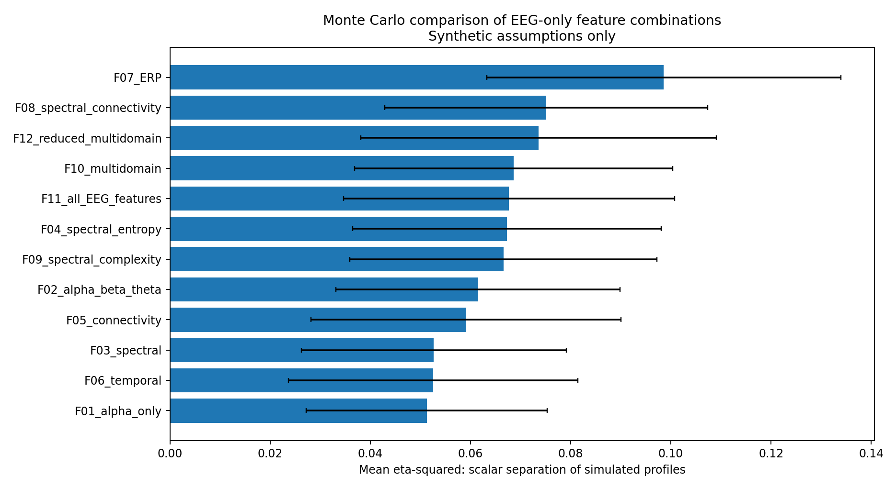
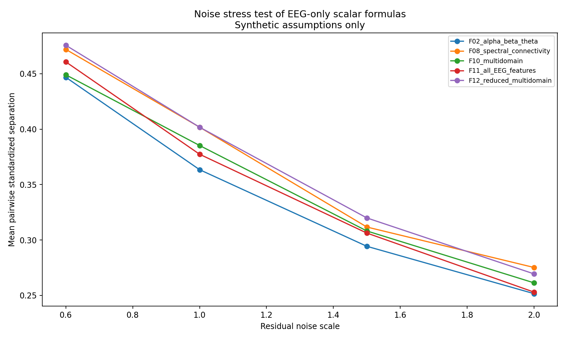
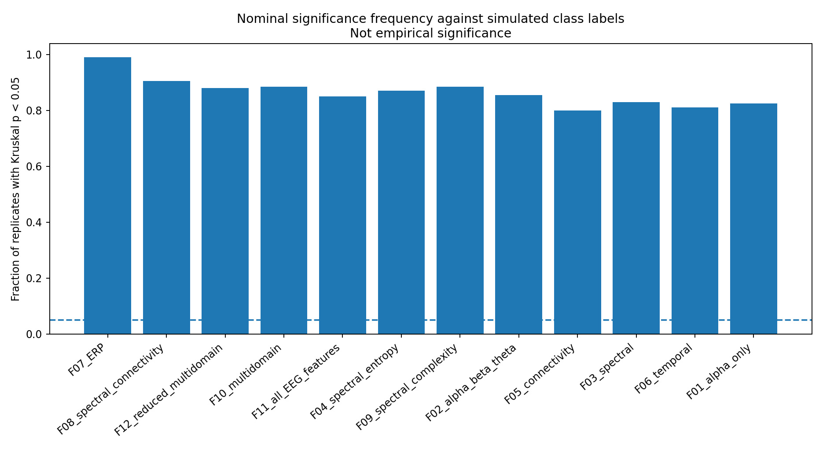

Interpretation and next steps
- PC1 provides a scalar but maximizes variance rather than pain relevance.
- Standardize features before combination and estimate weights using training participants only.
- Control EMG contamination for gamma; predefine connectivity estimator, electrodes, frequency band and reference.
- Only use N2–P2 and habituation terms in suitable stimulus-locked protocols.
- Use independent clinical labels, subject-wise nested cross-validation and external validation to test real pain-profile classification.
- Report bootstrap confidence intervals, permutation tests, multiplicity correction, calibration, test–retest reliability and baseline comparisons.
- If independent clinical labels are absent, report EEG-pattern phenotypes rather than pain profiles.

