EEG-only Pain Scoring
Formula development, pain-level labels, and validation
23 October 2026 • Public clinical/experimental EEG feature dataset
IMPORTANT: Research prototype only. The continuous score modestly predicts four-week average pain in participant-held-out testing, but diagnosis-held-out generalization and severity labels remain weak. Do not use for diagnosis, triage, or treatment decisions.

Executive conclusion
The most useful path was not another large search over trial-level nonlinear equations. After correcting trial/epoch alignment, the best current candidate predicts the participant’s reported average pain over the prior four weeks from the mean and variability of five log EEG band-power measures. Its out-of-fold MAE was 1.43 NRS points versus 1.65 for a training-mean baseline (n=80 chronic-pain participants).
The score is promising as a research hypothesis, not a validated patient grading tool. The model did not transport consistently to an entirely held-out diagnosis group, and categorical labels remained error-prone—especially high/severe pain. The package includes the exact equation, fit parameters, out-of-fold scores and an inference script, with these limits made explicit.
Target | N | EEG formula MAE | Mean baseline MAE | R² | Pearson r
Average pain, previous 4 weeks (primary) | 80 | 1.430 | 1.650 | 0.233 | 0.482
Current pain (`NRS_now) | 80 | 1.873 | 1.848 | -0.116 | 0.150
Maximum pain, previous 4 weeks | 80 | 1.698 | 1.704 | -0.009 | 0.190

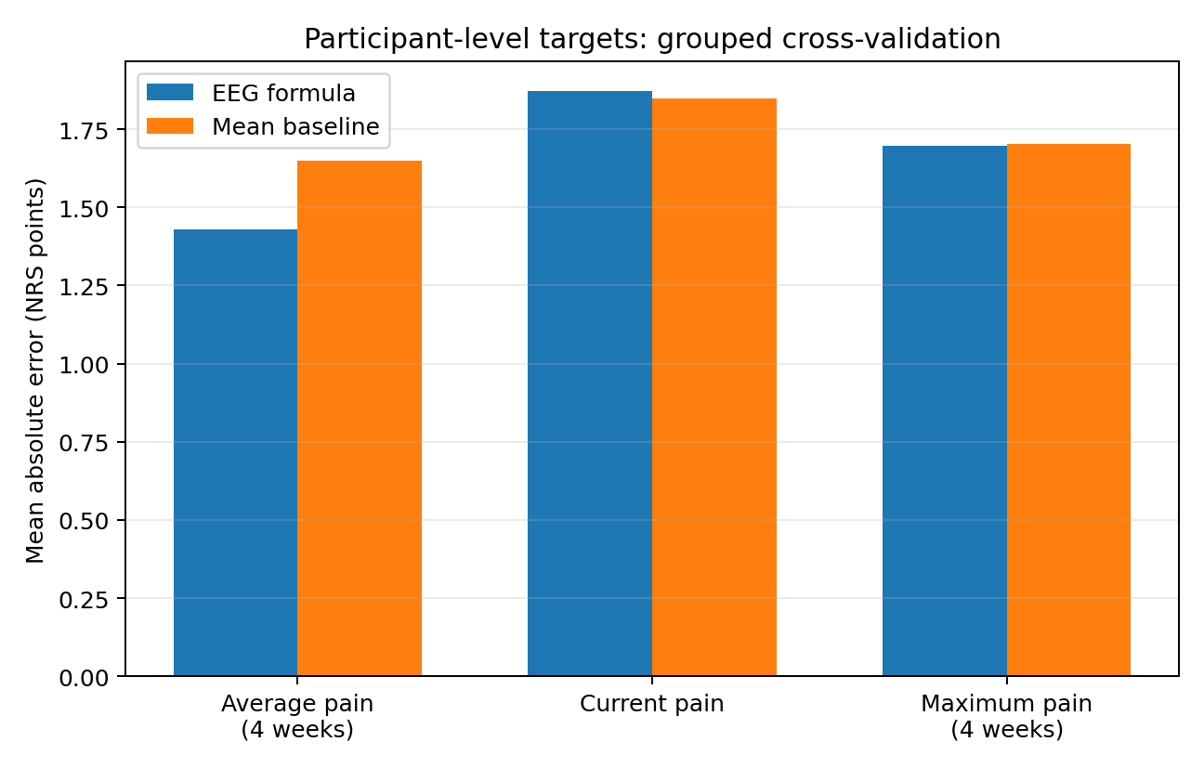

1. Dataset and alignment correction
Source: Gozzi et al. (2024), “Unravelling the physiological and psychosocial signatures of pain by machine learning,” public Zenodo record 10.5281/zenodo.12570277. The archive contains `Trials.pkl` (physiological EEG/skin-conductance-derived features), `Subjects.csv` (demographic, clinical and questionnaire fields), and `SubjectAreas.csv` (pain-area / quantitative sensory testing features). The source repository distinguishes the pain-versus-baseline classification task from the regression task for subjective NRS.
Local data audit: 22,428 feature rows, 117 participant IDs, and 11,214 unique `(id, Area, B, iTrial)` keys. Each key appears twice with the same NRS but a different binary `pain` flag and materially different EEG features. To avoid attaching a future pain rating to baseline activity, trial-level NRS estimation uses only `pain==1` response epochs. The flag is an epoch filter only, never a model predictor. That leaves 11,214 pain-response feature rows.
For the patient-level task, each chronic-pain participant’s pain-response EEG features were aggregated over trials and linked to `NRS_avg4wk` as the target. Only 80 participants in CRPS, low-back-pain or SCI-neuropathic-pain cohorts had this clinical target available. Healthy controls were excluded from the patient-intensity model to avoid making the task mostly “healthy zero versus patient nonzero.” No demographic, cohort or questionnaire variable was used as a predictor.

2. Formula families and validation design
At trial level, 13 coefficient-based EEG-only formula families were evaluated: log band powers; relative band powers; log ratios/balances; log bands plus spectral-shape and moment features; a composite interpretable set; degree-2 and degree-3 polynomial expansions; additive splines; signed fractional-power transforms; clipped exponentials; tanh saturation; and Yeo–Johnson power transforms. Ridge shrinkage was used to keep the score an explicit equation rather than a black-box tree model.
Outer validation used five folds grouped by participant; three inner participant-grouped folds selected the formula family. All imputation/scaling and fitted transformations were learned inside training folds. The Ridge penalty was fixed at 10 for the exhaustive family search. Patient-level models were similarly chosen inside grouped training folds. The continuous target was clipped to [0,10] only after prediction.

3. Trial-level intensity score did not validate
Metric | Nested EEG formula | Training-fold mean baseline
MAE (NRS points) | 2.189 | 2.210
RMSE | 2.631 | 2.634
R² | -0.009 | -0.011
Pearson correlation | 0.084 | —
Spearman correlation | 0.071 | —

Participant-weighted MAE difference (formula minus baseline) was -0.022, with participant-cluster bootstrap 95% CI [-0.059, 0.014]. Because the interval includes zero, the apparent improvement is not reliable. Trial-level 3-class labels had balanced accuracy 0.342 and macro-F1 0.292. Individual trial pain grades should not be used from this model.
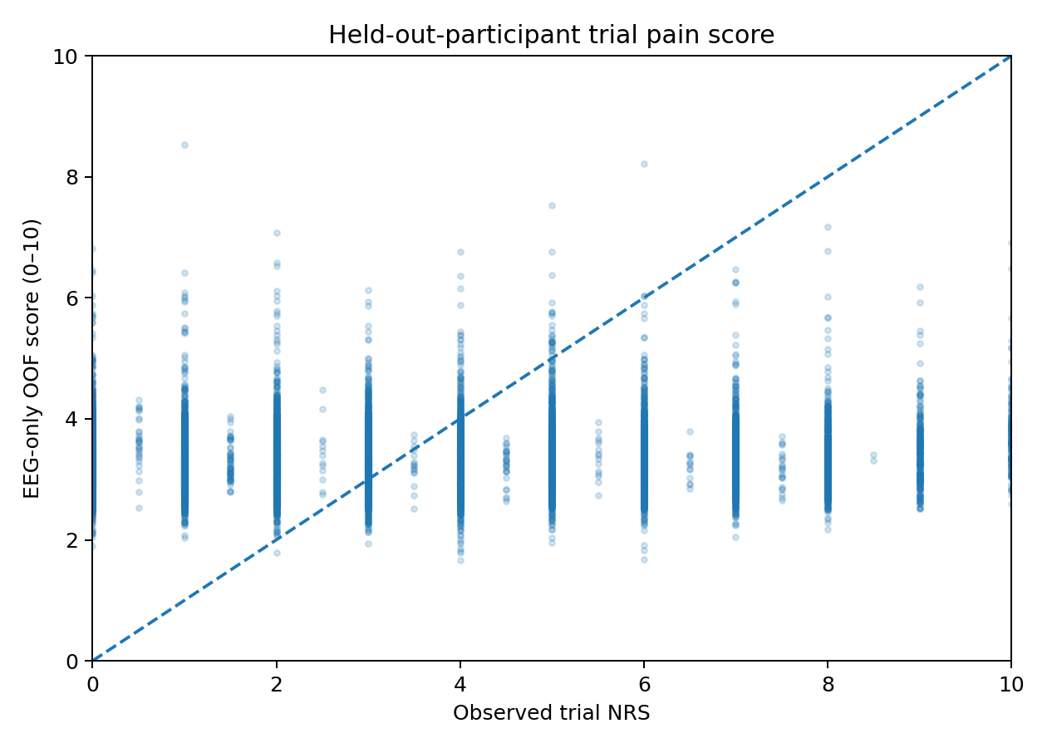

4. Patient-level average-pain equation
For each participant and each band b in delta, theta, alpha, beta and gamma, calculate across that participant’s pain-response trials:
m_b = mean(log(P_b + 1e−6)) and s_b = sample SD(log(P_b + 1e−6))
Standardize each of the ten variables using its training reference mean and standard deviation from `patient_score_formula_parameters.csv`: z_j = (x_j − mean_j) / SD_j. Then calculate the score below and clip it to [0,10]. The coefficient values and normalization values are also exported as machine-readable CSV files.
score = clip(4.337500
+ 0.037217 z(log_delta_mean)
+ 0.090567 z(log_theta_mean)
- 0.000313 z(log_alpha_mean)
+ 0.262936 z(log_beta_mean)
- 0.259798 z(log_gamma_mean)
- 0.167156 z(log_delta_sd)
+ 0.267647 z(log_theta_sd)
+ 0.672448 z(log_alpha_sd)
+ 0.264137 z(log_beta_sd)
+ 0.131118 z(log_gamma_sd), 0, 10)
Five-fold participant-held-out results: MAE 1.430 vs 1.650 baseline, RMSE 1.762 vs 2.025, R² 0.233, Pearson r 0.482, Spearman rho 0.408, calibration slope 0.998. Paired patient bootstrap 95% CI for MAE difference was [-0.411, -0.036]. The empirical 90th percentile absolute held-out error was 2.89 NRS points, so individual scores can still be off by several points.
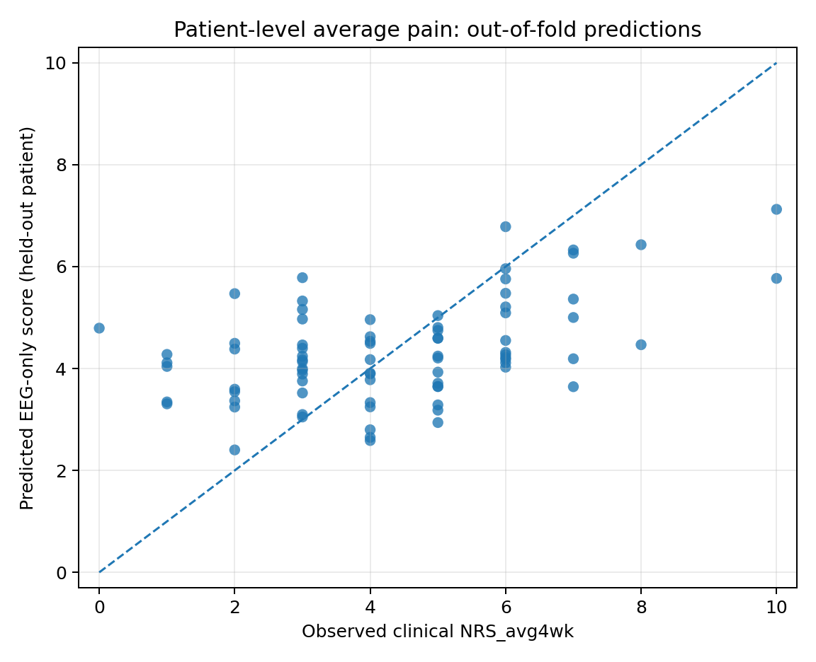

5. Severity labels are not reliable enough for clinical use
For descriptive comparisons, the continuous prediction was mapped into low/mild (<4), moderate (4 to <7), and high/severe (>=7). These are operational research bins, not treatment thresholds. A separate linear multinomial formula predicts the three classes directly from the same ten EEG-only features.
Thresholding the continuous score: accuracy 0.500, balanced accuracy 0.397, macro-F1 0.403. The direct multinomial formula: accuracy 0.400, balanced accuracy 0.433, macro-F1 0.390. The majority-label baseline has accuracy 0.500, balanced accuracy 0.333 and macro-F1 0.222.
The direct formula correctly identifies 5/10 high/severe cases in held-out predictions, but only 5/19 patients predicted high/severe actually belong to that category (precision 0.263). Its class probabilities are not calibrated. This level of performance is not adequate for clinical classification.
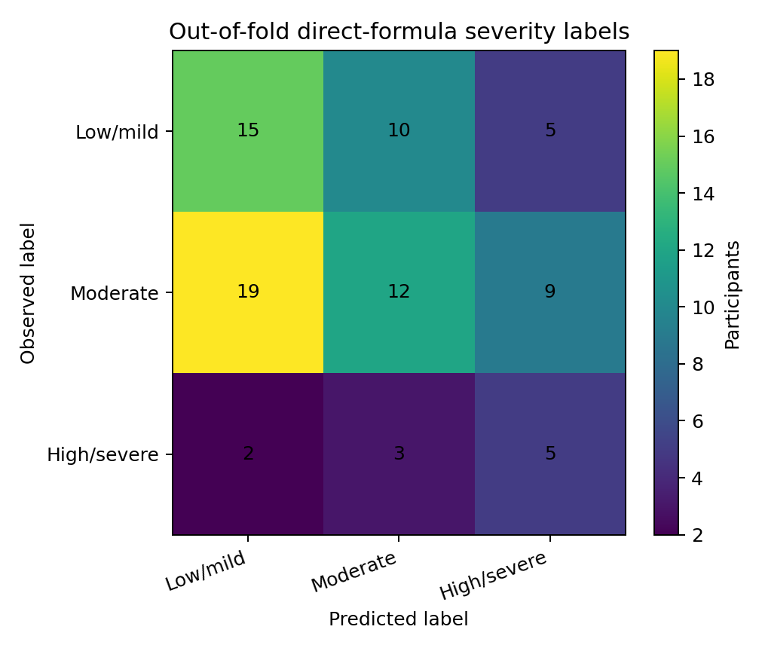

6. Cross-diagnosis validation failed to establish transportability
Entire cohort held out | n | EEG MAE | Baseline MAE | R²
CRPS | 19 | 1.982 | 2.311 | 0.056
LBP | 51 | 1.691 | 1.791 | -0.479
SCI_NP | 10 | 1.445 | 1.146 | -0.612

The formula improved MAE for CRPS and LBP by small margins but was worse than the mean baseline for SCI_NP; R² was negative in LBP and SCI_NP. Therefore random participant-fold performance does not establish that the equation generalizes to a new diagnostic cohort. Current NRS and maximum 4-week NRS also failed to outperform baseline reliably.

7. How to run the prototype
`score_patient_csv.py` accepts a CSV with participant ID, EEG_delta, EEG_theta, EEG_alpha, EEG_beta and EEG_gamma for pain-response trial epochs. If a `pain` column exists, it filters to pain==1. It computes the ten patient-level features, produces the continuous average-pain score and a direct-formula class label with uncalibrated probabilities. Features must be created with preprocessing and band definitions consistent with the development data. Participant ID is used only to group trials, never as a predictor.
Example command:
python score_patient_csv.py --input patient_trials.csv --output patient_score.csv
A sample input and sample scored output are in the package. The continuous and classification model files are `EEG_patient_average_pain_score_prototype.joblib` and `EEG_patient_severity_label_formula_prototype.joblib`.

8. Recommendation
Use the continuous EEG-derived NRS_avg4wk estimate as the primary research candidate for follow-up, not the trial-level NRS score. Treat categories as provisional only. The decisive next step is a frozen validation on an independent clinical cohort with compatible EEG processing, aligned clinical NRS_avg4wk outcomes, and preregistered score/label thresholds. A robust clinical pain scale should not be claimed until external performance, calibration, high-pain sensitivity/precision, and cross-diagnosis transport are satisfactory.

Sources
- Gozzi N, Preatoni G, Ciotti F, Hubli M, Schweinhardt P, Curt A, Raspopovic S. “Unravelling the physiological and psychosocial signatures of pain by machine learning.” Med (2024). https://doi.org/10.1016/j.medj.2024.07.016
- Data archive: Zenodo 10.5281/zenodo.12570277 — https://doi.org/10.5281/zenodo.12570277
- Authors’ code and task documentation: https://github.com/neuroenglab/multidimensional_pain
- Three-level NRS grouping example in contemporary EEG pain classification: IEEE TNSRE 2026, https://doi.org/10.1109/TNSRE.2026.3692232

