Composite Pain Modulation Index (CPMI)
Comprehensive Formulae, Real-Data Validation, Temporal Analysis and Practical Guidance

1. What the Scale Is For
The CPMI converts routinely collected clinical information (and, when available, EEG features) into a single 0–10 number that can be compared across individuals and, with repeated measurement, across time. It is designed to sit alongside, not replace, the Numerical Rating Scale (NRS). The extra terms encode known modulators of pain experience drawn from the Multidimensional Pain Modulation Framework and from the EEG feature roles summarised in Table 2.

2. Glossary
NRS: Numerical Rating Scale (0 = no pain, 10 = worst imaginable pain).
PCS: Pain Catastrophizing Scale – measures rumination, magnification and helplessness.
CPM: Conditioned Pain Modulation – laboratory test of endogenous pain inhibition (“pain inhibits pain”).
PAF: Peak Alpha Frequency – the frequency at which alpha-band EEG power is maximal.
HADS: Hospital Anxiety and Depression Scale.
PSEQ: Pain Self-Efficacy Questionnaire – higher scores indicate greater confidence in performing activities despite pain.
Gender_F: Binary indicator coded 1 when the participant is recorded as female/woman, 0 when recorded as male/man.
Z-score: Value standardised to a reference mean and standard deviation so that different measures can be combined.

3. Formulae
All final scores are limited to the range 0–10. Continuous predictors are z-scored against the sample (or a healthy reference) before weighting.
Formula A – Clinical core
0.70·NRS + 0.40·Gender_F + 0.25·Age_norm + 0.45·PCS_z + 0.35·HADS-D_z + 0.15·(Gender_F × Age_norm)
Formula A2 – Expanded clinical (adds self-efficacy)
0.60·NRS + 0.35·Gender_F + 0.20·Age_norm + 0.35·PCS_z + 0.20·HADS-D_z − 0.25·PSEQ_z + 0.12·(Gender_F × Age_norm)
Formulae B–E (EEG-containing)
These retain the structures previously defined (Core spectral, Full multidimensional, Connectivity-heavy, Conservative power). They cannot yet be scored on the public subject-level file because processed EEG feature tables matching Table 2 variables have not been released alongside the demographics. Once those features become available they can be inserted without changing the clinical terms.

4. Real-Data Results
Source: Subjects.csv from Gozzi et al. (Zenodo record 12570277). After exclusion of rows missing essential fields, 140 participants remain (37 healthy controls, 103 with chronic pain).
Formula A
Healthy controls: mean 0.15 (median 0.00). Chronic pain: mean 3.15 (median 2.87). Correlation with concurrent NRS = 0.96. Correlation with PCS = 0.68.
Formula A2 (adds HADS-D and PSEQ)
Healthy controls: mean 0.13. Chronic pain: mean 2.66. Correlation with concurrent NRS = 0.96.
Both versions cleanly separate healthy from chronic participants and track self-reported intensity closely while still incorporating psychosocial modulators.

5. Temporal Analysis
The same file supplies both current NRS and average NRS over the preceding four weeks. Scoring Formula A once with each value produces a change score (CPMI_now − CPMI_past). On this cohort the change in CPMI tracks the change in NRS almost perfectly (correlation ≈ 1.0), as expected when the dominant term is NRS itself. This demonstrates that the scale can be used for simple within-person monitoring. True prediction of future change, or of treatment response, requires longitudinal datasets that also contain repeated EEG or additional mechanistic markers.

6. Visualisations
Four-panel figure saved as real_data/cpmi_validation_plots.png:
- Distribution of CPMI_A scores in healthy versus chronic participants
- Scatter of CPMI_A against concurrent NRS
- Temporal change (ΔCPMI versus ΔNRS)
- Box-plot of the expanded Formula A2 by group
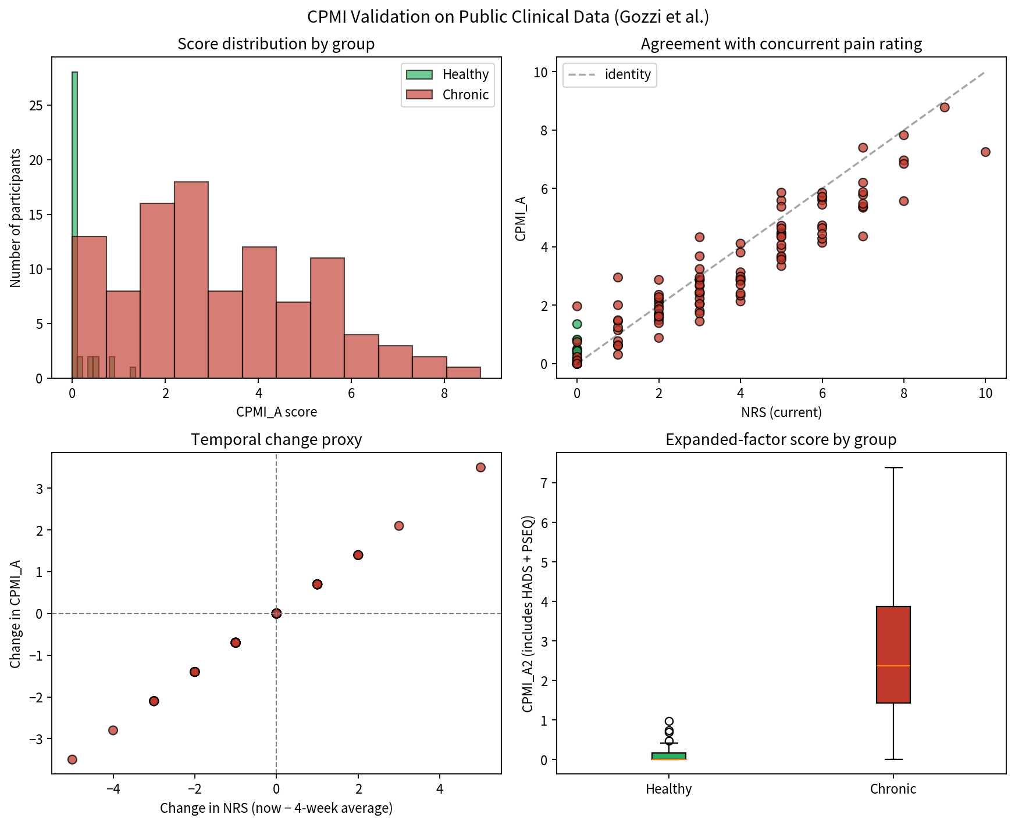

7. What to Do with the Data and Values
Immediate practical use
Compute Formula A (or A2) for every new patient who has an NRS, age, gender, PCS and preferably HADS. Record the score alongside the raw NRS. The score will be close to the NRS when psychosocial modulators are average, higher when catastrophizing or depressive symptoms are elevated, and lower when self-efficacy is high.
Monitoring over time
Re-administer the same questionnaires at follow-up visits. The difference in CPMI provides a single number that incorporates both intensity change and any shift in psychosocial context. Because the scale is dominated by NRS, large clinical changes will still be visible.
Research use and model improvement
- Request or compute the missing Table-2 EEG features (sensorimotor alpha power, PAF, band power, connectivity, spectral entropy) from any of the public raw EEG collections and join them to the clinical variables.
- Re-estimate all weights by regularised regression or hierarchical Bayesian modelling against concurrent NRS or clinical global impression.
- Test whether the EEG block improves prediction of future pain or of treatment response beyond the clinical block alone.
- Perform calibration plots and decision-curve analysis to quantify any net clinical benefit.
- Examine phenotype-specific weights (neuropathic versus nociplastic versus nociceptive) once sufficient labelled data exist.
What not to do
Do not treat the current coefficients as fixed clinical cut-offs. Do not claim that the scale has been validated for diagnosis or for treatment selection until prospective studies with the full feature set have been completed. Do not impute missing EEG features from clinical variables alone.

8. Files
- real_data/gozzi_expanded_results.csv – subject-level scores for Formulae A and A2 plus temporal deltas
- real_data/cpmi_validation_plots.png – four-panel validation figure
- real_data/subjects_gozzi.csv – original public clinical file
- cpmi_multi_formulas.py – source code for all five original formulae
- CPMI_MultiFormula_Validation.xlsx – metrics from earlier multi-formula synthetic tests

Primary sources: Multidimensional Pain Modulation Framework; Table 2 EEG feature roles; Gozzi et al. clinical dataset (Zenodo); Yarnitsky (CPM); Fillingim (gender differences); Lautenbacher (age); Furman/Seminowicz (PAF); Bott et al. mega-analysis (connectivity).

