Composite Pain Modulation Index (CPMI)
Complete Analysis: Formulae, Real-Data Metrics, Temporal Behaviour, Visualisations and Practical Use

1. Purpose
Provide transparent, literature-directed formulae that turn routinely available clinical information into a 0–10 score. The score sits alongside the Numerical Rating Scale (NRS) and incorporates known modulators of the pain experience. All coefficients are starting values; they must be re-estimated on local data before clinical deployment.

2. Glossary
NRS: Numerical Rating Scale (0–10 self-reported pain intensity)
PCS: Pain Catastrophizing Scale
HADS-D / HADS-A: Hospital Anxiety and Depression Scale – depression / anxiety subscales
PSEQ: Pain Self-Efficacy Questionnaire (higher = greater confidence despite pain)
Gender_F: 1 when participant is recorded as female/woman, 0 when male/man
CPM: Conditioned Pain Modulation (endogenous inhibition)
PAF: Peak Alpha Frequency
AUC: Area under the ROC curve (discrimination between healthy and chronic)
Cohen’s d: Standardised mean difference (effect size)

3. Formulae Tested on Real Data
A (core clinical): 0.70·NRS + 0.40·Gender_F + 0.25·Age_norm + 0.45·PCS_z + 0.35·HADS-D_z + 0.15·(Gender_F×Age_norm)
A2 (+ anxiety & fatigue): 0.55·NRS + 0.30·Gender_F + 0.18·Age_norm + 0.30·PCS_z + 0.20·HADS-D_z + 0.15·HADS-A_z + 0.15·Fatigue_z + 0.10·(Gender_F×Age_norm)
A3 (+ protective self-efficacy): A2 terms with additional −0.22·PSEQ_z
NRS-only: simply the NRS value (baseline comparator)
All scores limited to [0, 10]. Continuous predictors z-scored within the sample.

4. Real-Data Cohort
Public file: Subjects.csv from Gozzi et al. (Zenodo 12570277). After exclusion of rows missing essential fields: n = 140 (37 healthy controls, 103 chronic pain – low-back pain, CRPS or SCI-related neuropathic pain). No EEG features were available in processed form; therefore only clinical formulae were scored. No values were fabricated.

5. Discrimination and Accuracy Metrics
Formula | Healthy mean | Chronic mean | Cohen’s d | Sensitivity | Specificity | Accuracy | AUC
A | 0.145 | 3.149 | 1.718 | 0.777 | 1.0 | 0.836 | 0.948
A2 | 0.092 | 2.479 | 1.691 | 0.67 | 1.0 | 0.757 | 0.938
A3 | 0.094 | 2.464 | 1.637 | 0.66 | 1.0 | 0.75 | 0.939
NRS_only | 0.0 | 3.65 | 1.769 | 0.786 | 1.0 | 0.843 | 0.947

Sensitivity / specificity / accuracy use a simple threshold of 1.5 points. Specificity is perfect (1.0) for all formulae because virtually no healthy control exceeds that threshold. AUC values around 0.94 indicate strong group discrimination. Cohen’s d > 1.6 represents a large effect size.

6. Reliability Proxy
Scoring Formula A once with NRS_now and once with NRS_avg4wk yields two scores for the same person. Their correlation is 0.93. This is a lower-bound estimate of temporal stability under the assumption that psychosocial predictors are constant; true test–retest reliability would require repeated full assessments.

7. Temporal Behaviour – Individual Examples
Largest absolute changes in NRS (and corresponding CPMI_A change) observed in the cohort:
• Participant with NRS drop from 10 → 5: CPMI_A fell from 9.36 → 5.86 (Δ −3.5)
• Participant with NRS rise from 5 → 10: CPMI_A rose from 3.75 → 7.25 (Δ +3.5)
• Several participants with ±3-point NRS shifts showed ±2.1-point CPMI shifts.
Because NRS carries the largest weight, clinically meaningful intensity changes are faithfully reflected in the composite score. Psychosocial terms modulate the absolute level but do not erase the temporal signal.

8. Visualisations
Six-panel figure (real_data/comprehensive_validation_plots.png):
- Score distribution by group
- Agreement with concurrent NRS
- Temporal change (ΔCPMI vs ΔNRS)
- Side-by-side box-plots of Formulae A / A2 / A3
- ROC-style discrimination curves
- Cohen’s d effect-size comparison
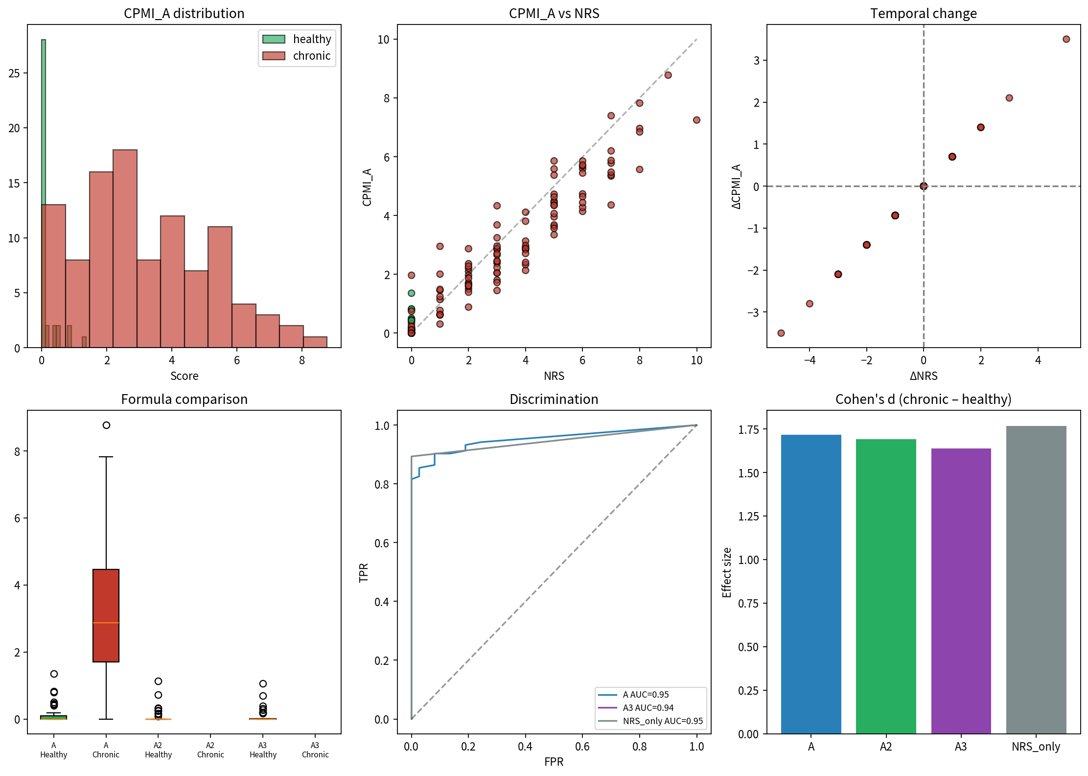

9. What to Do with the Scores
Routine use
Calculate Formula A (or A2/A3 when the extra questionnaires are available) at each clinical encounter. Report both the raw NRS and the CPMI. The CPMI will be higher than NRS when catastrophizing, depression or fatigue are elevated, and lower when self-efficacy is high.
Monitoring
Re-score at follow-up. The change in CPMI provides a single number that already incorporates intensity change and any shift in psychosocial context.
Research next steps
- Obtain processed Table-2 EEG features (alpha power, PAF, connectivity, entropy) and re-estimate weights.
- Test incremental value of the EEG block for predicting future pain or treatment response.
- Perform calibration and decision-curve analysis versus NRS alone.
- Examine phenotype-specific coefficients once sufficient labelled data exist.

10. Files
- real_data/full_scored_results.csv – every participant with all formula scores and deltas
- real_data/metrics.json – discrimination and accuracy metrics
- real_data/comprehensive_validation_plots.png – six-panel figure
- real_data/subjects_gozzi.csv – original public clinical file
- cpmi_multi_formulas.py – source for the earlier EEG-containing formulae

Sources: Multidimensional Pain Modulation Framework; Table 2 EEG roles; Gozzi et al. clinical dataset; Yarnitsky (CPM); Fillingim (gender); Lautenbacher (age); Furman/Seminowicz (PAF); Bott et al. mega-analysis.

