

Design Plan Adventurehub

By Arenco Meevissen



13 september 2022

**Revision Table**

|  |  |  |  |
| --- | --- | --- | --- |
| Version | Date | Author | change(s) |
| 1.0 | 13/9/2022 | Arenco Meevissen | Initial document |
| 1.1 | 7/10/2022 | Arenco Meevissen | Added context to c4 and added High level architecture |
| 1.2 | 2/11/2022 | Arenco Meevissen | Added C4 level 4 and context to level 3 and 4. Added Class Diagrams till now implemented |
| 1.2.1 | 4/11/2022 | Arenco Meevissen | Changed title to include project name |

Contents

1 Introduction 3

2 Class Diagram 4

3 C4 Diagram 5

5.1 C4 level 1 system context (system, users, dependencies) 5

5.2 C4 level 2 Containers (overall shape technologies choices) 5

5.3 C4 level 3 Components (components and their interaction) 6

5.4 C4 level 4 Code (Implementation details) 6

References 7

# 1 Introduction

This document shows the designs for the structure of the Class diagram, entity diagram for the database and the expected web designs for this project

# 2 Class Diagram

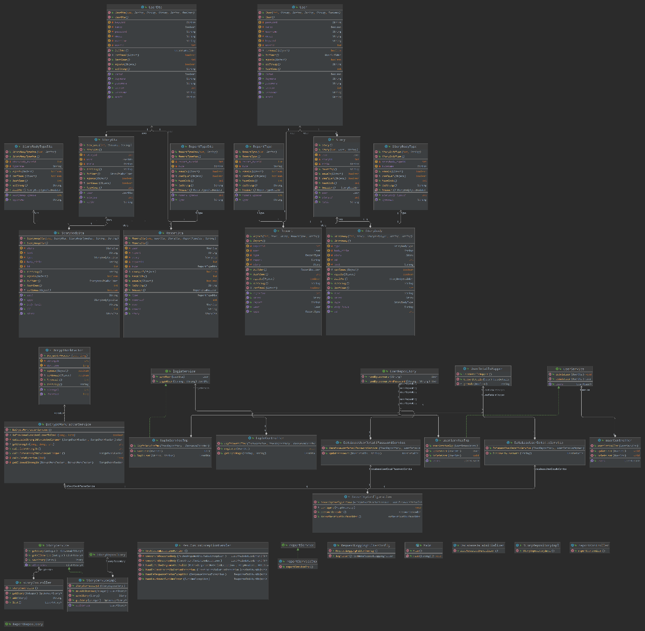

# 3 C4 Diagram

The use of Java is because of its cross-platform support and Type safety (Hartman, 2022) that java enforcers which helps with prevention of illegal operations and memory safety. (Wikipedia contributors, 2022), (Srivastava, 2022)  
The spring boot is used because it provides powerful batch processing capabilities compared to Spring MVC, it also has an auto-configuration feature that some others lack like Spring MVC. (Difference Between Spring MVC and Spring Boot, 2022)  
  
React is used for its code reusability, the fast community that it has and the huge number of libraries that it has. It also is more flexible compared to Vue.js (which is also a JavaScript framework). (Patel, 2022 and Yusov, 2020)  
  
The MySQL Database I chose because of the data model that it uses which is a relational database, the support of SQL and that Java is one of its supported languages and its simple syntax. It also works well with systems like Windows, Linux, MacOS land others. (Editor, 2019), (Wikipedia contributors, 2022b), (MySQL System Properties, n.d.)

## 5.1 C4 level 1 system context (system, users, dependencies)

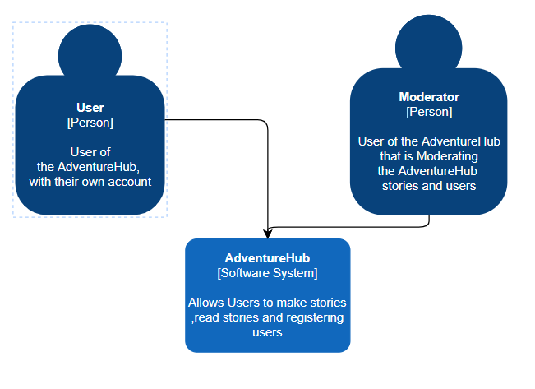

## 5.2 C4 level 2 Containers (overall shape technologies choices)

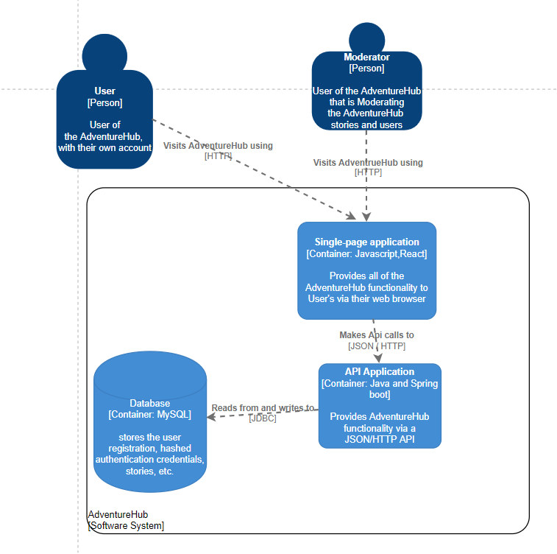

## 5.3 C4 level 3 Components (components and their interaction)

I use Spring boot to connect to everything and it has powerful batch processing capabilities that Spring MVC doesn’t have.  
for the Repository I use the JPA repository so that less time is used to produce the individual query components to the database and the basic validation to the database is used.  
For the security I use spring security because this incorporates finely with Spring boot and instead of Apache Shiro the security is more separate from the business logic and it also has a general more community support. (Wagde, 2022)

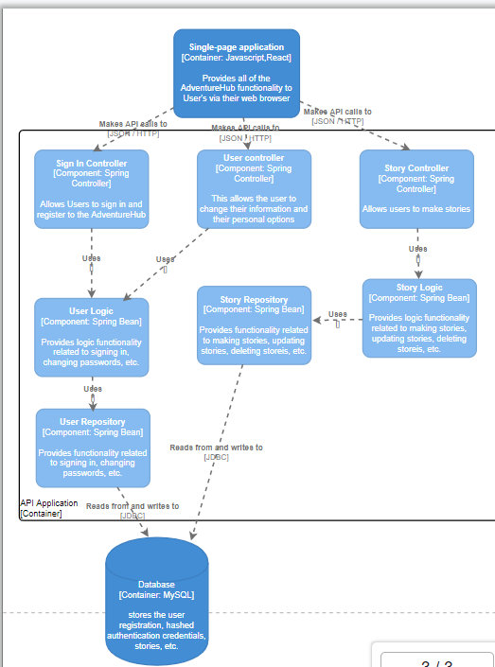

## 5.4 C4 level 4 Code (Implementation details)

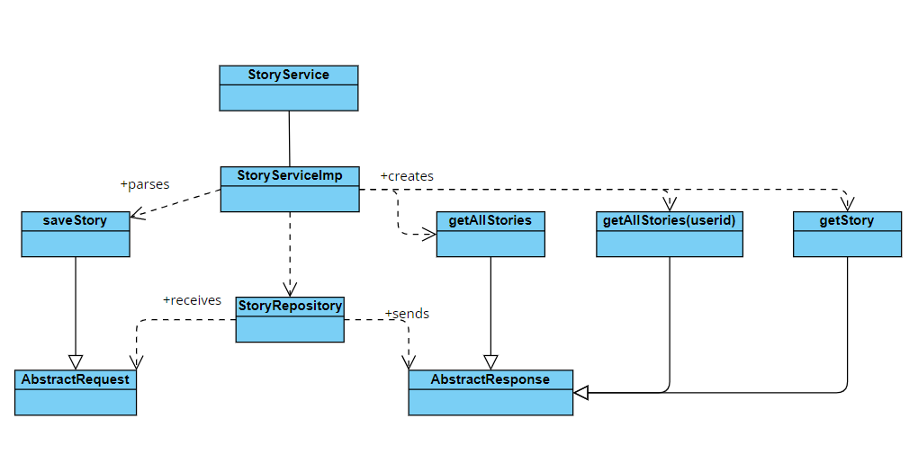

(Class diagram & explanation)

# 6.Ci /CD diagram

The diagram shows how when a Gitlab runner is triggered by a developer how it will execute it.

We start at 1 where the developer commits their work on their version branch and does it till satisfied. Then at 2 comes when the developer pushes their commits to Gitlab so others can see and get the commits that the developer did at number 1. At 3 the Gitlab runner is triggered this can be done by keywords or the branch. Inside of the Gitlab runner we have the following categories Build, test, SonarQube. At build the backend is tested if it can build. When build is successful (4) test will be triggered to start this test if all tests that are defined are successful. The moment that test is successfully done (5) then SonarQube will start, and this has a dependency on the application SonarQube which needs to be running

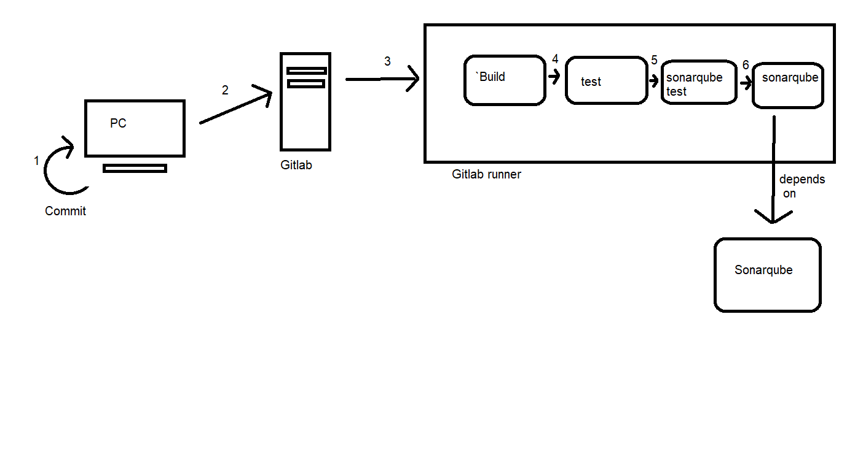

# References

Hartman, J. (2022, August 30). *Java vs C# – Difference Between Them*. Guru99. Retrieved October 7, 2022, from https://www.guru99.com/java-vs-c-sharp-key-difference.html

Wikipedia contributors. (2022, September 21). *Type safety*. Wikipedia. Retrieved October 7, 2022, from https://en.wikipedia.org/wiki/Type_safety

Srivastava, V. (2022, January 19). *C# vs. Java: What Are Its Main Differences*. DistantJob - Remote Recruitment Agency. Retrieved October 7, 2022, from  
https://distantjob.com/blog/c-vs-java/

Patel, A. (2022, September 28). *React Vs Vue: A Battle of Two Most Popular Front-end JS Frameworks*. Mindinventory. Retrieved October 7, 2022, from https://www.mindinventory.com/blog/reactjs-vs-vuejs/

Yusov, K. (2020, December 21). *Vue vs. React: Performance, Speed, Use Cases*. Jelvix. Retrieved October 7, 2022, from https://jelvix.com/blog/js-frameworks-is-vuejs-better-than-react

*Difference Between Spring MVC and Spring Boot*. (2022, September 1). InterviewBit. Retrieved October 7, 2022, from https://www.interviewbit.com/blog/difference-between-spring-mvc-and-spring-boot/

Editor. (2019, October 15). *Comparing Database Management Systems: MySQL, PostgreSQL, MSSQL Server, MongoDB, Elasticsearch and others*. AltexSoft. Retrieved October 7, 2022, from https://www.altexsoft.com/blog/business/comparing-database-management-systems-mysql-postgresql-mssql-server-mongodb-elasticsearch-and-others/

Wikipedia contributors. (2022b, September 27). *Comparison of relational database management systems*. Wikipedia. Retrieved October 7, 2022, from https://en.wikipedia.org/wiki/Comparison_of_relational_database_management_systems

*MySQL System Properties*. (n.d.). Retrieved October 7, 2022, from https://db-engines.com/en/system/MySQL

Wagde, S. (2022, August 20). *Spring Security vs Apache Shiro*. Baeldung. https://www.baeldung.com/spring-security-vs-apache-shiro