Ideation documentation

* GIT Repository link.
* Short description of web application (e.g., what is its purpose, what will be the *<content>*, etc.);
* Sitemap with all pages.
* Some example wireframes of pages (e.g., landing/home-page, <content>-page, etc.).

# Git repository

<https://git.fhict.nl/I479450/s2-cb02_library.git>

# Description

In this project I want to make an application for a library where you can rent movies and books but also If the library doesn't need the book anymore it can be bought by somebody.

# Sitemap

Website used/ view

<https://octopus.do/st3jm8txx9f> (used a different email to save this)

<https://www.gloomaps.com/abxXGrsfhe> (will hold for 28 days till reloaded and then 28 days again)

Extra notes:

* For toddlers, children, youth, adults, and seniors they use the same pages just with different titles and there will be different things that will be shown. Also, the book page uses the same page “info book” and the “reservation” page of it. It’s the same with movies.
* In work for us I have employment and volunteers the pages under employment is also used for the volunteers
* At management Employment, employees and volunteers use the same pages but with different content that will be shown.
* Workshops and events are 2 separate pages because I think a library can have events of a different nature and if somebody is only interested in the workshops then I think it’s more user friendly to make it separate

# Wireframes

Homepage:

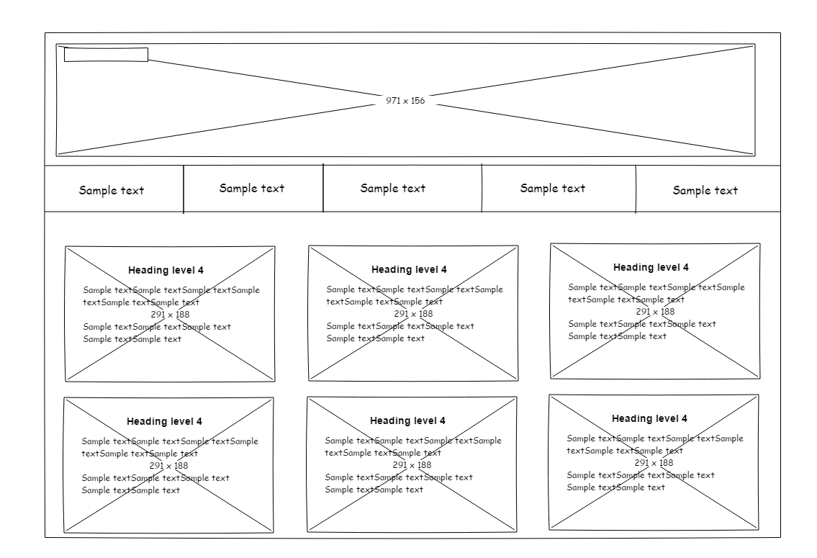

Book info page

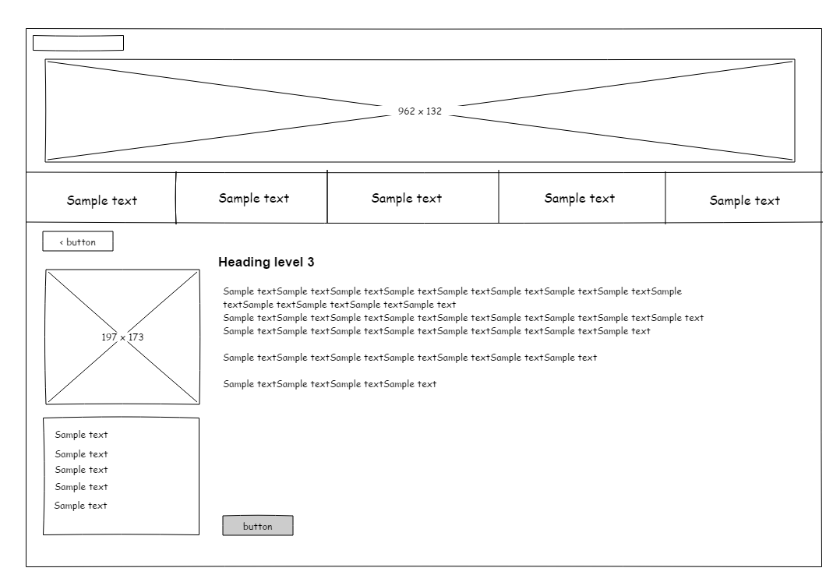

Movies page

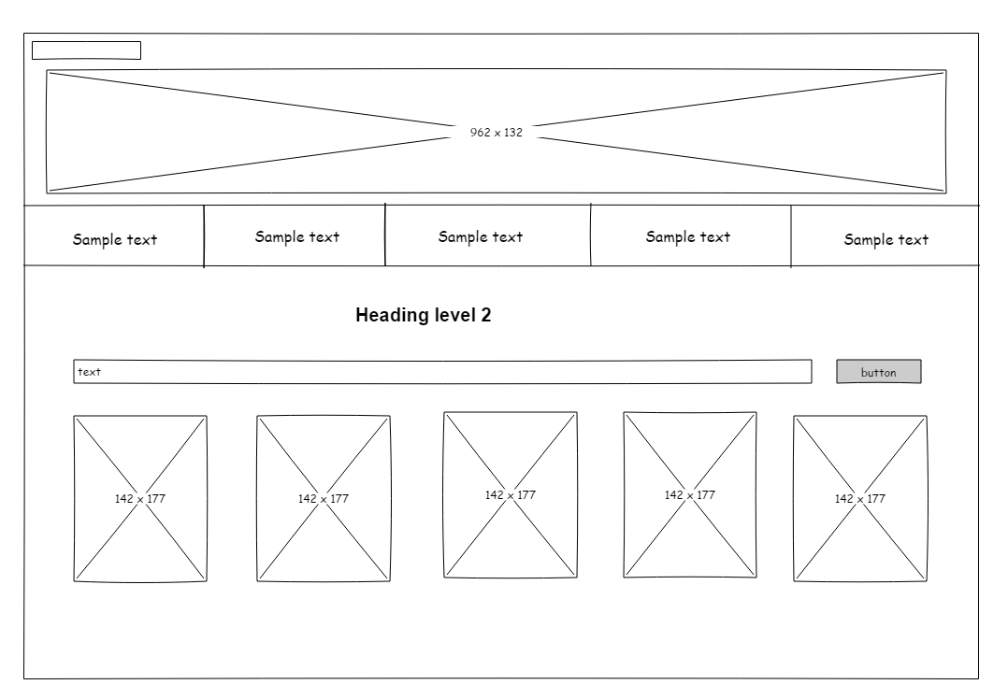

Adding Employee

Account info

Agenda page

