Information Engineering and Technology Faculty

German University in Cairo



NETW-903: Network&Services

|  |
| --- |
| January 3  2022 |

Project Report (Yummy Recipes)

|  |  |
| --- | --- |
| **Submitted by:** | Abdelrahman Gelnay 43-17100  Mohamed Abdelmaksoud 43-16710  Mohamed Diaa 43-12821 |
| **Supervised by:** | Dr. Minar El-Aasser |

Contents

Introduction to Web Services 3

RESTful Web Services 3

Web Services API 4

Features of Web Services API 4

Implementations 5

Implementations-About App 5

General overview 5

App specs 5

Libraries 5

Implementations-Methods 6

Search recipes operation 6

Post instructions operation 7

Get instructions operation 8

Conclusion 9

Demo Video Link 9

References 10

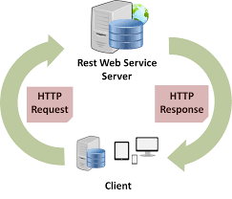

**What are RESTful Web Services?**

**RESTful web services** are designed to be used on the internet. REST is an architectural style that sets limitations, such as the consistent interface, that when applied to a web service result in desired features, such as performance, scalability, and modifiability, that allow services to run optimally on the Web. Data and functionality are considered resources in the REST architectural style, and they are accessible via **Uniform Resource Identifiers (URIs)**, which are often links on the Web. A collection of straightforward, well-defined operations are used to act on the resources. The REST architectural style restricts an architecture to a client/server model and is intended to employ a stateless communication protocol, such as HTTP. Clients and servers exchange representations of resources using a standardised interface and protocol in the REST architectural style.

One of the main advantages of REST is that it allows you a lot of flexibility. REST can accommodate many sorts of calls, return diverse data formats, and even change fundamentally with the right implementation of hypermedia since data is not linked to resources or functions. This flexibility allows developers to create an API that fulfills both your demands and the needs of a wide range of consumers.

­

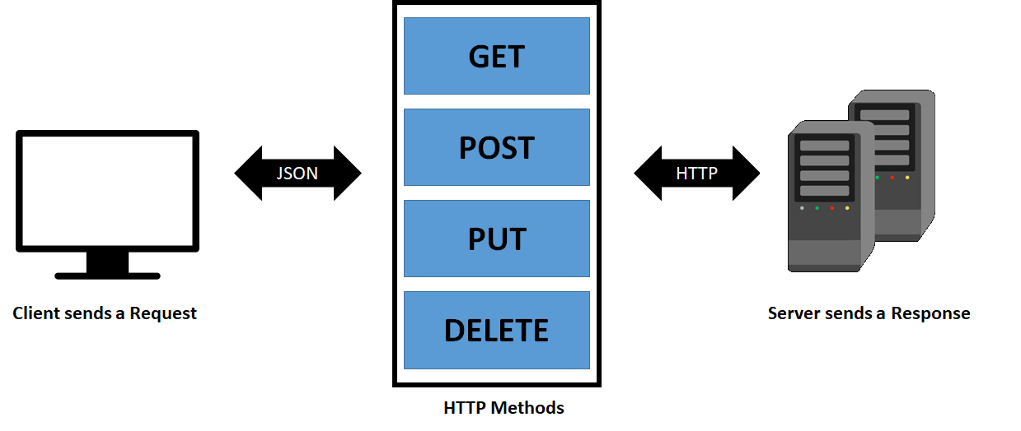

**Features of Web API**

* **API** allows you to provide data from a service to a browser.
* Because it works with HTTP verbs GET, PUT, POST, and DELETE, API provides typical CRUD (Create Read Update Delete) activities.
* It is built on HTTP, which is simple to design and expose in a RESTful manner.

**What is a Web API?**

**Application Programming Interface (API)** is the abbreviation for Application Programming Interface. This interface allows users to extend the functionality and data of another programme. They may be seen as as building bricks that can be used to develop nearly anything, as they can be found in places like Spotify and Yahoo Finance.

APIs, in a nutshell, assist sites in communicating on the web and understanding information (independent of programming languages) in order to speed up procedures. Data may be sent and received using HTTP protocol requests. The only limitation is that each API must be thoroughly tested on a regular basis to ensure consistent performance.

**Implementations**

**About the application**

* **General overview**

This is a desktop application that makes use of web services with RESTful APIs. Python was chosen as the coding language for this app.

The concept is that too many people look for meal recipes online, and some of them have hidden secrets for making the food taste better, while others are looking for specific instructions that other people add to their recipes, thus our App is a simple tool for performing these chores.

* **App specs**

We have three main features:

* + - Search for a recipe.
    - Add instructions.
    - Get instructions.

We mainly used two HTTP verbs:

* + - **POST** for posting the new instructions.
    - **GET** for getting the recipes and the instructions.

The API that was used for this app from rapidapi.com under the food umbrella

Specifically: rapidapi.com/spoonacular/api/recipe-food-nutrition/

Two main libraries were used in this app:

* + - Requests, for the API requests
    - Pyqt5, for using the Qt GUI framework from Python.

# Implementation

**application Methods**

**Search recipes operation:**

In this method, the user enters his desired search terms, and we return a recipe useful aspects. A NOT FOUND message will be given if no match can be found.

The API URL for this task is https://spoonacular-recipe-food-nutrition-v1.p.rapidapi.com/recipes/search, and we utilise the GET HTTP verb. We just use the request method from the request library to transmit the user's query terms in a GET request.

Output the recipes recipe

Start searching

Exists?

Not found

Entering the data

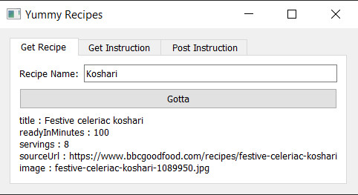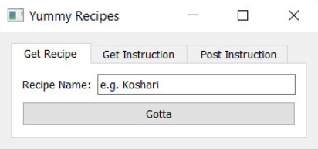

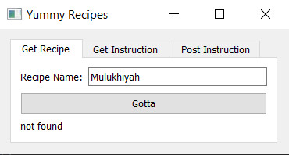

# Implementation

**Post instructions operation:**

In this method, the user posts his own instructions for future use by other users, and a notification message appears after a successful action.

This job is accomplished using the POST HTTP verb, and the API URL is https://spoonacular-recipe-food-nutrition-v1.p.rapidapi.com/recipes/analyzeInstructions. Using the request method from the request library, we publish the data that the user provides as a payload in the POST request.

Start posting

Entering the data

Message pops up

End

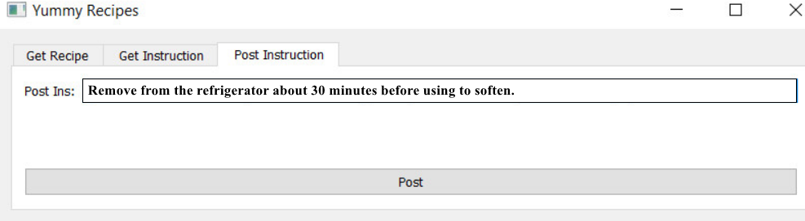



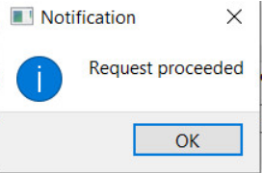

# Implementation

**Get instructions operation:**

The user will obtain all instructions written by other users using this method.

The API URL for this work is https://spoonacular-recipe-food-nutrition-v1.p.rapidapi.com/recipes/324694/analyzedInstructions, and we utilise the GET HTTP verb. We just use the request function from the request library to create a GET request.

Output the instructions

Start

Getting instruction

Exists?

Not found

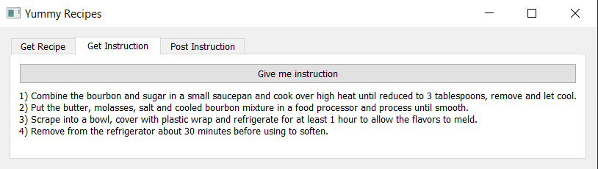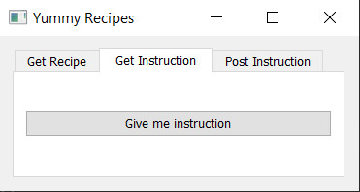

# Conclusion

* Restful web services are simple to integrate into applications.
* HTTP formats are used by restful APIs.
* It ensures that the frontend, backend, and database are all in sync.

# Demo video

* https://drive.google.com/drive/folders/13LnP7b44h9-mEOcz8z4hUtHVesG0L9zn?usp=sharing

# References

1. Lecture slides of Dr. Minar El-Aasser.
2. “The next generation API platform,” RapidAPI, 08-Dec-2021. [Online]. Available: http://www.rapidapi.com/. [Accessed: 23-Dec-2021].
3. Web services - summary. [Online]. Available: https://www.tutorialspoint.com/webservices/web_services_summary.htm. [Accessed: 23-Dec-2021].
4. Ethan Cerami. \Web Services Essentials", O'Reilly, 2002.
5. “Spoonacular® Recipe, food, nutrition API,” RapidAPI. [Online]. Available: https://rapidapi.com/spoonacular/api/recipe-food-nutrition. [Accessed: 23-Dec-2021].