Analysis and system design

User requirements

The Treasure Hunting game developed by the iMe team consists in an application-supported quest, assisted by a Raspberry Pi. The main advantage of this smart integration is the possibility to let the software organize checkpoints and riddles to solve in order to pursue the final goal but nevertheless is allowed the chance to completely customize the game to the creator, for example adding conundrums for reaching a determined checkpoints or adding checkpoints themselves. In this first version of the application the game can be deployed outdoor with the only strict requirement consisting in a common Internet network provided to the players and the Raspberry Pi, which works as central computer for supporting the application. As an Android device for every gamer is given, with GPS localization working as checkpoints detector, you'll only need to download the application. After that, one of your group will have to check some simple settings for the creation of the game, and once the game's ID will be assigned and communicated to the other participants , start the hunt. For indoor gaming the software-application part works along a hardware part, consisting in the displacement by the creator of the game of a set o USB-to-Bluetooth dongles as checkpoint detectors; in this case the creator won't be allowed to participate to the quest.

System Requirements

Server-side and hardware

The server developed for supporting the application mainly accomplish two functions: storage of games' data and transmission of this data to the players.
To play Treasure Hunting is necessary to set the server to work to trasmit files from and to user devices.

Client-side and application

In the following page we can see what the app looks like thanks to its flowing chart. Every single aspect of an AmI is located in the app itself, thanks to random-like algorithms to create games and clues for the checkpoints.
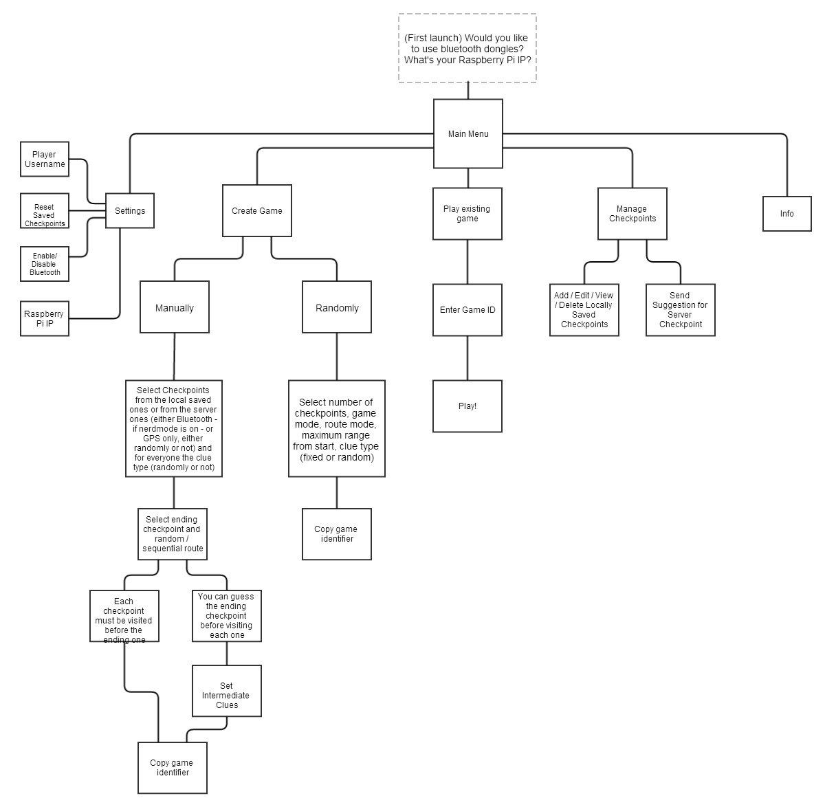
The game is so set: a checkpoint is shown with its riddle, and as the player solves it he must go to that checkpoint and confirm his location. The GPS coordinates or the Bluetooth key reveal if he's close enough to that checkpoint, if so another checkpoint is shown. This going on until the ending checkpoint is touched. The game creator can choose if the path to follow between checkpoints must be the same for everyone (something like pen-and-paper treasure hunts) of everyone gets every time a random checkpoint from the game's list to complete (making an exception for the last one, of course). He can also choose between two game modes: one in which every checkpoint must be visited before the last one (something like pen-and-paper treasure hunts) or one in which once you complete any checkpoint you are also given a clue for the last checkpoint, and if you get it you can rush to it as soon as possible to secure the win.

