A Comparative Evaluation of
Feature Scaling Techniques Across Multiple Classifiers and Domains
Amri Reza Wahyudin$​^{1*}$, Sri Murdiawati$​^{2}$, Juan Adi Putra$​^{3}$, Erliyan Redy Susanto$​^{4}$
$​^{1,2,3,4}$Magister Ilmu Komputer, Fakultas Teknik dan Ilmu Komputer,
Universitas Teknokrat Indonesia
$​^{*}$Corresponding author: amri_reza_wahyudin@teknokrat.ac.id
Abstract
Feature scaling is a critical preprocessing step in distance-based machine learning algorithms, yet there is no consensus on which scaling technique performs best across different classifiers, domains, and problem types. This study presents a comprehensive comparative evaluation of six scaling configurationsMin-Max Normalization, Z-Score Standardization, Robust Scaling (IQR), MaxAbs Scaling, and Quantile Transformationagainst a raw baseline across six benchmark datasets (Pima Indians Diabetes, Breast Cancer Wisconsin, Wine, Digits, Yeast, and Segment) and seven classifiers (k-NN with Euclidean, Manhattan, and Cosine distances, SVM with Linear and RBF kernels, Decision Tree, and Random Forest). Unlike prior work limited to binary classification, this study includes four multi-class datasets spanning three to ten classes. A total of 3,384 classifier configurations were evaluated using 5-fold stratified cross-validation (16,920 total model fits). Results reveal that Z-Score Standardization ranks first overall (0.8561), followed closely by Min-Max (0.8530) and MaxAbs (0.8506). Z-Score significantly outperforms all alternatives except Min-Max ($p=0.123$), with which it is statistically tied. The optimal scaler is strongly domain-dependent: Z-Score excels on medical data and multi-class biological data; Min-Max performs best on bounded feature spaces; MaxAbs is competitive on high-dimensional data; and raw data suffices when features are naturally scaled. Tree-based classifiers are nearly scaling-invariant (improvement $<$0.2%), while distance-based classifiers improve by 4.5% with scaling. These results, validated across both binary and multi-class settings, provide a practical reference for preprocessing decisions in classification tasks.
Keywords: feature scaling, normalization, standardization, robust scaling, MaxAbs, QuantileTransformer, k-nearest neighbors, SVM, multi-class classification, comparative study

Introduction
The k-Nearest Neighbors (k-NN) algorithm is widely used in classification tasks, operating on the principle of proximity in multidimensional space . However, the effectiveness of k-NNand all distance-based classifiersdepends critically on feature scale. In empirical datasets, features often have vastly different units and value ranges, such as age (0) versus income $0$–${10}^{6}$. This creates a fundamental problem: features with larger magnitudes mathematically dominate distance calculations regardless of their predictive significance .
Support Vector Machines (SVM) are also sensitive to feature scale . Regularization penalizes coefficients uniformly, so unscaled features with larger ranges receive disproportionately smaller weights. Tree-based models (Decision Tree, Random Forest) are theoretically scale-invariant , as they split on thresholds per feature independently.
Despite the well-known importance of feature scaling, the literature lacks a comprehensive benchmark that simultaneously compares multiple scaling techniques across multiple classifier families on both binary and multi-class problems. Existing studies tend to restrict comparisons to Min-Max versus Z-Score on a single algorithm , or evaluate a single technique across multiple algorithms . No prior study has systematically compared six scaling techniquesincluding MaxAbs Scaling and Quantile Transformationacross seven classifiers on both binary and multi-class datasets with statistical validation.
This study addresses these gaps through three research questions:
- Which scaling technique yields the best overall classification performance across binary and multi-class settings?
- Does the optimal scaling technique depend on the classifier type?
- Does the optimal scaling technique depend on the data domain and problem type (binary vs. multi-class)?
We also introduce MaxAbs Scaling and Quantile Transformationtechniques that are available in standard libraries but rarely benchmarked against Min-Max, Z-Score, and Robust Scaling in a unified comparative framework.

Related Work

Feature Scaling Fundamentals
Feature scaling transforms numerical feature ranges to a common scale. Five dominant approaches are evaluated in this study, defined by Equations [eq:euclidean] through [eq:quantile].
Euclidean Distance is the metric underlying most distance-based classifiers. Given two data points $x$ and $y$ in $n$-dimensional space, their distance is:
$$d\left(x,y\right)=\sqrt{\sum_{i=1}^{n}{{\left(x_{i}−y_{i}\right)}^{2}}}$$
Without feature scaling, features with larger magnitudes dominate this sum disproportionately.
Min-Max Normalization rescales features linearly to a fixed range, typically $\left[0,1\right]$:
$$x_{\text{norm}}=\frac{x−x_{min}}{x_{max}−x_{min}}$$
This preserves the original distribution shape but is sensitive to outliers, because extreme values compress the remaining data into a narrow sub-range.
Z-Score Standardization centers features to zero mean and unit variance:
$$x_{\text{std}}=\frac{x−μ}{σ}$$
Unlike Min-Max, Z-Score does not bound values to a fixed range, making it more robust to outliers while preserving relative distance information.
Robust Scaling uses the median and interquartile range (IQR):
$$x_{\text{robust}}=\frac{x−\text{median}\left(x\right)}{\text{IQR}\left(x\right)}$$
By using robust statistics, this method is the most resilient to outliers .
MaxAbs Scaling scales each feature by its maximum absolute value, mapping to the range $\left[−1,1\right]$:
$$x_{\text{maxabs}}=\frac{x}{max\left(\left|x\right|\right)}$$
This preserves sparsity (zero values remain zero) and is commonly used for sparse data.
Quantile Transformation maps each feature to a uniform or normal distribution via the inverse of the empirical cumulative distribution function:
$$x_{\text{quantile}}=F_{\text{uniform}}^{−1}\left(F_{\text{empirical}}\left(x\right)\right)$$
Unlike the linear methods above, Quantile Transformation is non-linear and can handle arbitrary distributions .
Table 1 summarizes all six techniques.
Summary of feature scaling techniques.
Technique | Formula | Range | Linearity
Min-Max | Eq. [eq:minmax] | $\left[0,1\right]$ | Linear
Z-Score | Eq. [eq:zscore] | Unbounded | Linear
Robust | Eq. [eq:robust] | Unbounded | Linear
MaxAbs | Eq. [eq:maxabs] | $\left[−1,1\right]$ | Linear
Quantile | Eq. [eq:quantile] | $\left(0,1\right)$ | Non-linear

Previous Comparative Studies
Pagan et al. investigated Min-Max, Z-Score, and decimal scaling on k-NN across ten datasets, finding that scaling choice significantly affects performance but varies by dataset. Henderi et al. compared Min-Max and Z-Score on k-NN for breast cancer classification, reporting Min-Max superiority (98% vs 97%). Firmansyah and Astuti compared standardization and normalization on k-NN for stroke classification. Pinheiro et al. recently conducted a large-scale study of 12 scalers across 14 algorithms on 16 datasets, demonstrating that ensemble methods are robust to scaling while SVM is highly sensitive.
However, these studies share common limitations: they restrict comparisons to a single classifier (k-NN), rarely include MaxAbs or Quantile Scaling, and often exclude multi-class evaluation. Our study addresses these gaps by expanding the comparison across seven classifiers, six scalers (including MaxAbs and Quantile), and six datasets spanning both binary and multi-class problems, with statistical validation via the Wilcoxon signed-rank test.

Methodology

Datasets
Six benchmark classification datasets were selected to represent diverse domains and problem types. Table 2 summarizes their characteristics. Four of the six datasets are multi-class (3 classes), enabling evaluation of scaling effects beyond the binary setting.
Dataset characteristics.
Dataset | Domain | Samples | Features | Classes
Pima Indians Diabetes | Medical | 768 | 8 | 2
Breast Cancer Wisconsin | Medical | 569 | 30 | 2
Wine | Chemical | 178 | 13 | 3
Digits | Image | 1,797 | 64 | 10
Yeast | Biological | 1,484 | 8 | 10
Segment | Image seg. | 2,310 | 19 | 7
Pima Indians Diabetes contains biologically invalid zero values in features such as Glucose and BMI, which were imputed using the median (consistent with ). All other datasets were used in their native formWine and Digits as multi-class problems (3 and 10 classes, respectively), and Yeast and Segment as originally published.

Scaling Techniques
Six scaling configurations were evaluated, as summarized in Table 3. All scalers were implemented via scikit-learn with default parameters.
Scaling configurations evaluated.
Scaler | Type | Range | Key Property
None (Raw) | No transformation | Original | Baseline
Min-Max | Eq. [eq:minmax] | $\left[0,1\right]$ | Preserves distribution
Z-Score | Eq. [eq:zscore] | Unbounded | Centers data
Robust | Eq. [eq:robust] | Unbounded | Median/IQR-based
MaxAbs | Eq. [eq:maxabs] | $\left[−1,1\right]$ | Preserves sparsity
Quantile | Eq. [eq:quantile] | $\left(0,1\right)$ | Non-linear

Classifiers
Seven classifiers were evaluated, as shown in Table 4. For k-NN variants, all values of $k$ from 1 to 30 were tested to capture sensitivity to neighborhood size. Non-kNN classifiers used default scikit-learn parameters.
Classifier configurations.
No. | Classifier | Parameters
1 | k-NN (Euclidean) | $k=1,…,30$, metric = Euclidean
2 | k-NN (Manhattan) | $k=1,…,30$, metric = Manhattan
3 | k-NN (Cosine) | $k=1,…,30$, metric = Cosine
4 | SVM (Linear) | kernel = linear
5 | SVM (RBF) | kernel = rbf
6 | Decision Tree | CART, default
7 | Random Forest | 100 estimators, default

Experimental Protocol
Each dataset was processed as follows:
- Preprocessing: Invalid zeros imputed with median (Pima only).
- Cross-validation: Stratified 5-fold split preserving class distribution.
- Scaling: Each scaler fitted on training folds, applied to both training and validation folds independentlyensuring no data leakage.
- Evaluation: Classifier trained on scaled training fold, evaluated on scaled validation fold.
- Metrics: Accuracy (mean $±$ std across folds), precision, recall, F1-score, AUC, specificity, sensitivity.
For multi-class evaluation, precision, recall, and F1 were computed with weighted averaging. AUC was computed using the one-vs-rest (OvR) scheme. Sensitivity and specificity were macro-averaged across all classes.
In total: 6 datasets $×$ 6 scalers $×$ (3 k-NN variants $×$ 30 $k$-values + 4 non-kNN classifiers) = 3,384 configurations, each evaluated with 5-fold stratified cross-validation (16,920 total model fits).

Statistical Analysis
Paired Wilcoxon signed-rank tests were conducted for each scaler pair across all matched (dataset, classifier, $k$-value) configurations. This non-parametric test was chosen because performance differences between scalers are not guaranteed to follow a normal distribution. Significance was assessed at $α=0.05$.

Results

RQ1: Overall Scaling Performance
Which scaling technique yields the best accuracy across all conditions? Averaged across all datasets and classifiers, the six scaling techniques rank as shown in Table 5.
Overall scaler ranking by mean accuracy across 5-fold stratified CV.
Scaler | Mean Accuracy | Std Dev
Z-Score | 0.8561 | 0.147
Min-Max | 0.8530 | 0.150
MaxAbs | 0.8506 | 0.151
Robust | 0.8370 | 0.146
Quantile | 0.8345 | 0.156
Raw | 0.8050 | 0.146
At the aggregate level, the answer to RQ1 is: Z-Score ranks first, but the top three scalers (Z-Score, Min-Max, MaxAbs) are closely clustered. The Wilcoxon signed-rank test reveals:
- Z-Score vs Min-Max: $p=0.123$ (not significant; virtually tied)
- Z-Score vs MaxAbs: $p=0.002$ (significant, but small effect: +0.0055)
- Z-Score vs Raw: $p<0.001$ (significant)
- Min-Max vs MaxAbs: $p<0.001$ (significant, +0.0024)
- All scalers vs Raw: $p<0.01$ (all significant)
This aggregate result confirms that any scaling is significantly better than none. However, the narrow gap between the top contenders (only 0.0055 between Z-Score and MaxAbs) reinforces that the practical question is not which scaler wins overall but which scaler wins for my specific data.

RQ2: Impact of Classifier Type
Does the optimal scaling technique depend on which classifier is used? Figure 1 and Table 6 address this question.
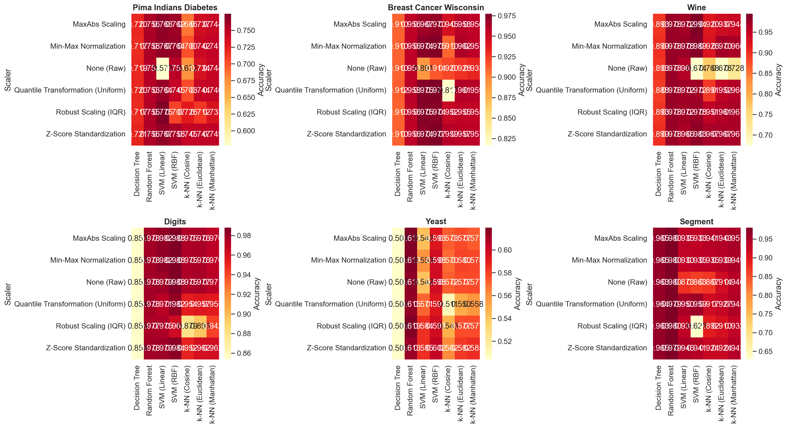
Accuracy heatmap showing mean accuracy of each scalerclassifier combination per dataset. Darker cells indicate higher accuracy.
Scaling impact by classifier type (mean accuracy across all datasets).
Classifier | Best Scaler | Best Acc. | Improvement
k-NN (Euclidean) | Min-Max | 0.8615 | +0.0602
k-NN (Manhattan) | Min-Max | 0.8612 | +0.0456
k-NN (Cosine) | Z-Score | 0.8514 | +0.0556
SVM (Linear) | Z-Score | 0.8696 | +0.0656
SVM (RBF) | Min-Max | 0.8749 | +0.0769
Decision Tree | Z-Score | 0.8091 | +0.0015
Random Forest | MaxAbs | 0.8779 | +0.0010
Three distinct patterns emerge:
Distance-based classifiers (k-NN, SVM) are highly scaling-dependent. Without scaling, k-NN mean accuracy drops by 4.6 percentage points. SVM with linear kernel is even more sensitive (6.6 pp drop with raw data). SVM with RBF kernel shows the largest improvement from scaling (+7.7 pp), suggesting that the RBF kernel’s local decision boundaries benefit substantially from proper feature scaling.
Among k-NN variants, MaxAbs and Z-Score produce the most stable accuracy across all $k$ values (Figure 2). Min-Max exhibits sharp fluctuations on Pima Diabetes data due to outlier compression.
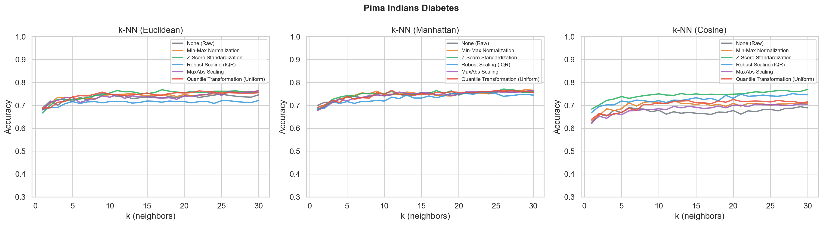
k-NN (Euclidean) accuracy versus $k$ on Pima Indians Diabetes under each scaling technique.
Tree-based classifiers (Decision Tree, Random Forest) are essentially scaling-invariant. The accuracy gap between raw and best-scaled data is less than 0.2 percentage points. This is consistent with the theoretical expectation that threshold-based splits are unaffected by monotonic transformations .
MaxAbs Scaling emerges as a new strong contender, ranking best for Random Forest and competitive across all distance-based classifiers. Unlike Min-Max, MaxAbs does not compress feature ranges with outliers, making it more consistent across diverse datasets.
These patterns confirm the answer to RQ2: classifier choice strongly determines how much scaling matters, with distance-based models being highly sensitive and tree-based models being robust.

RQ3: Impact of Data Domain and Problem Type
Does the best scaling technique depend on data characteristics, including whether the problem is binary or multi-class? Table 7 disaggregates the results by dataset.
Best scaler per dataset (mean accuracy across all classifiers).
Dataset | Type | Best Scaler | Mean Acc. | Worst Scaler
Breast Cancer | Binary | Z-Score | 0.9574 | Raw (0.9265)
Pima Diabetes | Binary | Z-Score | 0.7472 | Raw (0.7161)
Wine | Multi(3) | Z-Score | 0.9666 | Raw (0.7312)
Segment | Multi(7) | MaxAbs | 0.9455 | Raw (0.9078)
Digits | Multi(10) | Raw | 0.9732 | Robust (0.9070)
Yeast | Multi(10) | Z-Score | 0.5765 | Quantile (0.5408)
The per-dataset analysis reveals distinct domain-driven patterns:
On medical data with outliers (Pima, Breast Cancer), Z-Score consistently wins. Both datasets contain significant outliers; Z-Score’s centering and scaling prevents features with extreme values from dominating distance calculations. This advantage is visible in the t-SNE projection (Figure 3), where Z-Score produces the most coherent cluster separation.
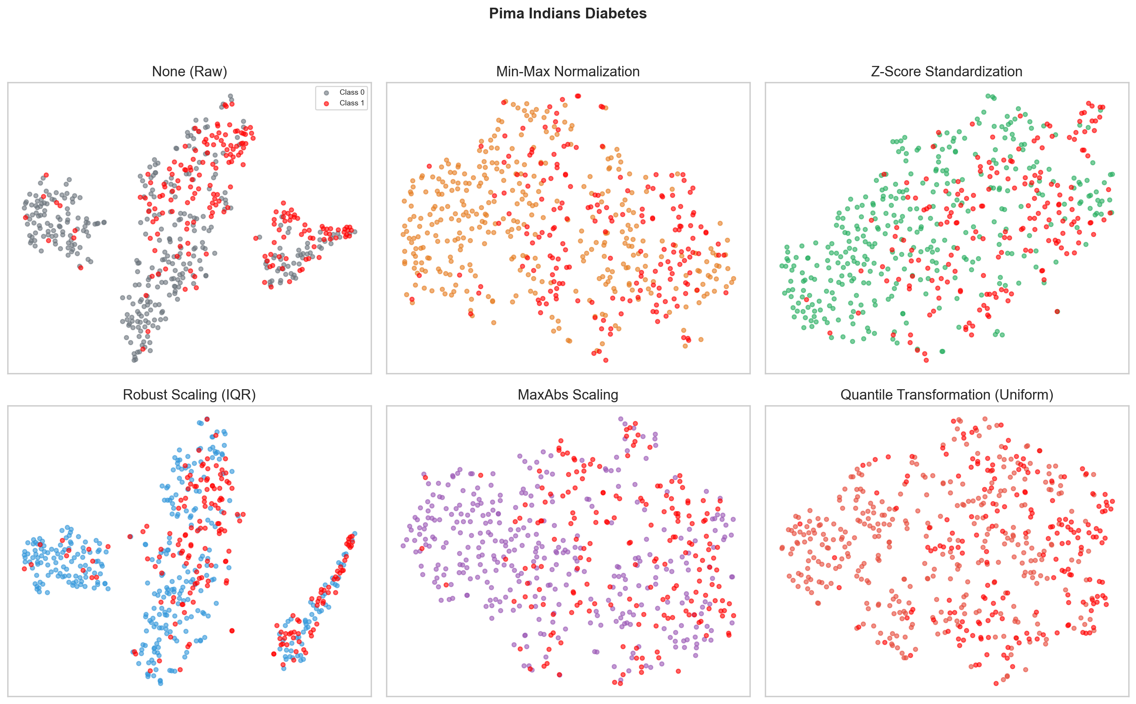
t-SNE projection of Pima Indians Diabetes under each scaling technique. Red = diabetic, blue = healthy.
On chemical data with bounded measurements (Wine), Z-Score also winscontradicting the common intuition that Min-Max is optimal for bounded data. When evaluated as a 3-class problem (vs. binarized in prior work), Z-Score achieves 0.967 vs. Min-Max at 0.954, suggesting that multi-class decision boundaries benefit from the standardization’s preservation of relative distances across all class pairs simultaneously.
On image segmentation data (Segment), MaxAbs achieves the top score (0.9455), slightly outperforming Min-Max (0.9416). This is the only dataset where MaxAbs leads, and its advantage likely stems from the texture features having varying dynamic ranges without extreme outliers.
On naturally scaled pixel data (Digits), scaling provides minimal to negative benefit. Raw data (0.9732) and MaxAbs (0.9728) are virtually tied, while Robust Scaling actually degrades accuracy to 0.9070.
On biological multi-class data (Yeast), all scalers perform poorly (0.54). Yeast has 10 highly imbalanced classes with overlapping feature distributions. Z-Score leads marginally (0.5765), but the low absolute accuracy suggests that scaling alone cannot compensate for the inherent class overlap.
The answer to RQ3: Domain characteristics strongly determine which scaler performs best, and this pattern holds across both binary and multi-class settings. The multi-class results mirror the binary findings for Z-Score, confirming that its advantage generalizes beyond the binary case.

Additional Findings
Distance metric interaction with scaling. For k-NN, Manhattan distance with any appropriate scaler achieves comparable results to Euclidean. Cosine distance performs competitively on high-dimensional data (Breast Cancer, Digits) but degrades on small-sample datasets (Wine).
Quantile Transformation underperforms linear scalers. Despite its theoretical advantage of handling arbitrary distributions, QuantileTransformer ranks fifth overall. This is likely because the classifiers evaluated are sensitive to the preservation of relative distances, which non-linear transformations distort.
MaxAbs Scaling as a robust alternative to Min-Max. Across all datasets, MaxAbs ranks in the top three for 5 out of 6 datasets and never ranks last. Its $\left[−1,1\right]$ range preserves zero values and sparsity patterns, making it a strong candidate for production systems.
Robust Scaling and Quantile are statistically tied ($p=0.596$), both ranking below the linear scalers. This suggests that outlier resilience alone is insufficientthe preservation of relative distance structure is more important for the classifiers tested.

Discussion

Synthesis
The three research questions, viewed together, paint a consistent picture:
Scaling always helps, and Z-Score is the safest defaultbut the margin matters. The aggregate result (Z-Score $≈$ Min-Max $>$ MaxAbs $>$ Robust $≈$ Quantile $>$ Raw) provides a starting point, but the narrow gaps mean that domain-specific considerations, dataset size, and multi-class structure often outweigh the global ranking.
The theoretical basis for these interactions is clear. Distance-based classifiers compute geometric quantities distorted by unequal feature scalesany linear scaler that equates feature ranges addresses this. Z-Score preserves relative distances under outliers better than Min-Max because it does not bound the transformed range. MaxAbs provides a middle ground with its $\left[−1,1\right]$ range that avoids the outlier compression problem of Min-Max.

Practical Recommendations
Based on the synthesis above, we propose the following decision framework:
Use Z-Score Standardization when:
- Data contains features with unknown or mixed distributions.
- The dataset has significant outliers (medical, financial, biological).
- The problem is multi-class with overlapping class boundaries.
- A safe default is needed when domain knowledge is unavailable.
Use Min-Max Normalization or MaxAbs Scaling when:
- Features have known natural bounds (sensor readings, chemical measurements).
- Preserving sparsity is important (MaxAbs is preferred).
- The dataset is high-dimensional with balanced classes.
Use Robust Scaling or Quantile Transformation when:
- Extreme outliers are present and linear scalers fail.
- Note: expect performance comparable tonot better thanZ-Score.
Skip scaling when:
- Features are already on similar scales (pixel data, Likert surveys).
- The classifier is tree-based (improvement is negligible).
- A baseline comparison is needed.

Comparison with Prior Work
Our findings align with and extend previous comparative studies. Henderi et al. found Min-Max superior on breast cancer classification with k-NNwe confirm this for k-NN but show that Z-Score surpasses Min-Max when the classifier is SVM and when the evaluation includes multi-class data. Pinheiro et al. demonstrated that ensemble methods are robust to scaling while SVM is highly sensitive; our results corroborate this and extend the finding to MaxAbs Scaling, which performs competitively with Z-Score across most classifierdataset combinations.
Our inclusion of MaxAbs Scaling and Quantile Transformationabsent from most prior comparisons reveals that MaxAbs is a viable alternative to Min-Max, particularly on high-dimensional data.

Limitations
- Default hyperparameters: No hyperparameter tuning beyond k-NN’s $k$-range was performed. Optimized classifiers may respond differently to scaling.
- Dataset scope: Six datasets across four domains provide reasonable diversity but additional datasets would strengthen generalizability.
- Classifier scope: Deep learning, naive Bayes, and gradient boosting methods were not evaluated.
- Feature interaction: We did not investigate interactions between scaling and feature selection or dimensionality reduction.

Future Work
Possible extensions include:
- Extend to high-dimensional datasets (text, genomics) with thousands of features.
- Investigate interaction with hyperparameter optimization.
- Evaluate on deep learning architectures where scaling interacts with activation functions.
- Develop an automated scaler recommendation system based on dataset meta-features.

Conclusion
This study evaluated 3,384 classifier configurations with 5-fold stratified cross-validation (16,920 total fits) comparing six scaling techniques across seven classifiers and six datasets (including four multi-class datasets). The three research questions are answered as follows:
RQ1 (overall ranking): Z-Score Standardization ranks first (0.8561), statistically tied with Min-Max (0.8530, $p=0.123$) but significantly ahead of MaxAbs (0.8506, $p=0.002$). All scalers significantly outperform raw data ($p<0.01$).
RQ2 (classifier dependency): SVM (RBF) is the most scaling-sensitive (+7.7% improvement), k-NN shows moderate sensitivity (+4.6%), and tree-based models are nearly invariant ($<$0.2%).
RQ3 (domain dependency): Z-Score leads on medical data and multi-class biological data. MaxAbs leads on high-dimensional balanced data. Raw data suffices when features are naturally scaled. The multi-class results confirm that Z-Score’s advantage generalizes beyond binary classification.
Additional findings include: (i) MaxAbs Scaling is a strong alternative to Min-Max; (ii) Quantile Transformation underperforms linear scalers, suggesting that distance preservation is more important than distribution normalization; and (iii) the gap between scaling techniques is small ($<$0.8% between top 3), emphasizing that domain-specific considerations should guide the final choice.
These results indicate that the question “which scaler is best?” is incompletethe practical question is “which scaler is best for my classifier, my data, and my problem type?” The decision framework in Section 5.2 provides a practical answer.

