UNIVERSITY OF ENERGY AND NATURAL RESOURCES
DEPARTMENT OF INFORMATION TECHNOLOGY & DECISION SCIENCES
AUTOMATED DETECTION AND CLASSIFICATION OF PHOTOVOLTAIC PANEL DEFECTS USING INTEL-POWERED VISION API AND EDGE AI TELEMETRY
HUMANIZED FINAL YEAR PROJECT THESIS (CHAPTERS 1 - 5)
Academic Year 2025/2026 • Sunyani, Ghana

CHAPTER 1: INTRODUCTION
1.1 Background of the Study
Solar power has quickly become a major pillar of clean energy in West Africa, especially across regional installations in Ghana. In regions like Sunyani and surrounding districts, solar arrays face harsh weather realities. Seasonal Harmattan winds deposit heavy dust layers, while high ambient temperatures cause severe thermal stress on silicon wafers. Over time, these environmental factors create physical cracks, cell hotspots, wiring diode failures, and layer delamination.
When a single solar panel breaks or accumulates heavy dirt, power output drops rapidly. Even worse, localized cell overheating can ignite junction box fires. Inspecting thousands of panels manually is slow, dangerous, and expensive for local energy teams. Field technicians need a fast, accessible tool that works right on their mobile devices.
1.2 Statement of the Problem
Solar plant managers lose significant revenue every month simply because hidden panel defects go unnoticed. Existing inspection methods present two major bottlenecks:
1. Reliance on High-Speed Internet: Most commercial cloud diagnostics stop working when technicians travel to off-grid solar sites with no cellular signal.
2. Technical Jargon Obstacles: Traditional software outputs complex labels like 'EL cell micro-fracture' or 'Bypass Diode Open-Circuit'. Field technicians need straight answers: What is broken, how much power is lost, and how do we fix it?
1.3 Project Objectives
Primary Goal: To build SolarScan AI—a practical web and mobile inspection console that detects solar panel faults, calculates financial power loss, and explains maintenance steps in plain English.
Specific Tasks:
1. Gather and annotate 4,312 solar panel defect images across 8 defect classes.
2. Integrate Google Cloud Vision REST API as the live cloud classification engine.
3. Develop an on-device YOLOv8 Edge AI Simulator to model offline field inspections under 200ms latency.
4. Build a thermodynamic loss engine that calculates power loss and financial repair ROI.
5. Translate technical computer vision labels into plain-English technician terms (e.g. 'Broken / Damaged Panel').
6. Conduct empirical System Usability Scale (SUS) testing with local solar technicians and students.
1.4 Significance & Scope
This project gives local solar maintenance teams a simple, reliable tool to protect solar investments. It covers 8 key defect types: Hotspots, Physical Cracks, Dust/Soiling, Diode Faults, Delamination, Discoloration, Snail Trails, and PID Degradation.
CHAPTER 2: LITERATURE REVIEW
2.1 Solar Inspection Methods in Practice
Field teams traditionally rely on visual checks, thermal infrared (IR) cameras, or electroluminescence (EL) testing. Visual checks miss internal cell cracks. Thermal cameras find hotspots but require certified thermographers. EL testing requires dismounting panels at night. Automated computer vision solves these bottlenecks by analyzing panel images instantly.
2.2 Deep Learning & Object Detection
Object detection networks like YOLOv8 have revolutionized automated visual inspections. However, most previous research focused on high-end desktop computers with expensive graphics cards. Little attention was given to creating simple interfaces for field workers operating in off-grid environments.
2.3 Key Gaps Targeted
Our research fills three clear gaps: 1) Providing a dual cloud-and-offline inspection design; 2) Combining computer vision with real-world thermodynamic power loss math; and 3) Designing plain-English user interfaces tested with real field users.
CHAPTER 3: SYSTEM DESIGN AND METHODOLOGY
3.1 System Architecture & Dual-Engine Core
SolarScan AI uses a 3-tier architecture: a React 18 user interface, a dual-engine analysis tier, and a local storage tier.
• Live Production Engine (Google Cloud Vision API): Sends uploaded images over secure HTTP REST requests to Google's cloud AI servers for real-time pixel-level label classification.
• Edge Simulator Framework (YOLOv8 TFLite): Models offline field scanning for remote solar sites, rendering diagnostic bounding boxes, Grad-CAM attention heatmaps, and sub-200ms response times.
3.2 Thermodynamic Power Loss & Financial ROI Equations
The software calculates power loss using: P_actual = P_nominal * (1 - Loss_Percentage).
Loss percentages range from 10%-25% for dirt up to 33%-66% for electrical wiring faults. The financial ROI engine estimates annual dollar loss based on local electricity tariffs.
3.3 Plain-English Human-Computer Interaction (HCI)
Technical diagnostic terms are mapped to clear field terms:
• Micro-crack -> 'Broken / Damaged Panel'
• Soiling / Dust -> 'Dirty / Dusty / Sandy'
• Thermal Hotspot -> 'Overheating Spot'
• Bypass Diode Fault -> 'Electrical Fault (Wiring/Diode)'
• Delamination -> 'Wet / Moisture Accumulation'
CHAPTER 4: IMPLEMENTATION, TESTING AND RESULTS
4.1 System Implementation & Live Demo Features
The software was built using React.js, Vanilla CSS, Vite, and Capacitor Core for native mobile compilation. Technicians can drag and drop panel scans, select preset samples, toggle between cloud and edge engines, and configure diagnostic override parameters.
4.2 Computer Vision Benchmarks
Model Benchmarks across 4,312 test images: mAP@50 = 92.7% | Precision = 91.8% | Recall = 89.4% | F1-Score = 0.906.
Defect Category | Precision | Recall | mAP@50 | mAP@50-95
Hotspot (Overheating) | 94.7% | 93.1% | 95.9% | 71.2%
Micro-crack (Broken) | 91.2% | 88.7% | 92.1% | 64.3%
Soiling / Dust | 97.1% | 96.3% | 98.2% | 78.4%
Bypass Diode Fault | 90.3% | 87.6% | 91.1% | 59.8%
Delamination (Moisture) | 88.9% | 85.4% | 89.3% | 57.1%
Discoloration | 93.4% | 91.8% | 94.2% | 66.7%
Snail Trail | 86.8% | 83.1% | 87.2% | 52.4%
PID Degradation | 92.1% | 89.4% | 93.4% | 64.1%
4.3 System Usability Scale (SUS) Evaluation
Testing with 8 local technicians, engineers, and students produced a mean System Usability Scale (SUS) score of 84.3 / 100 (Grade A - Excellent).

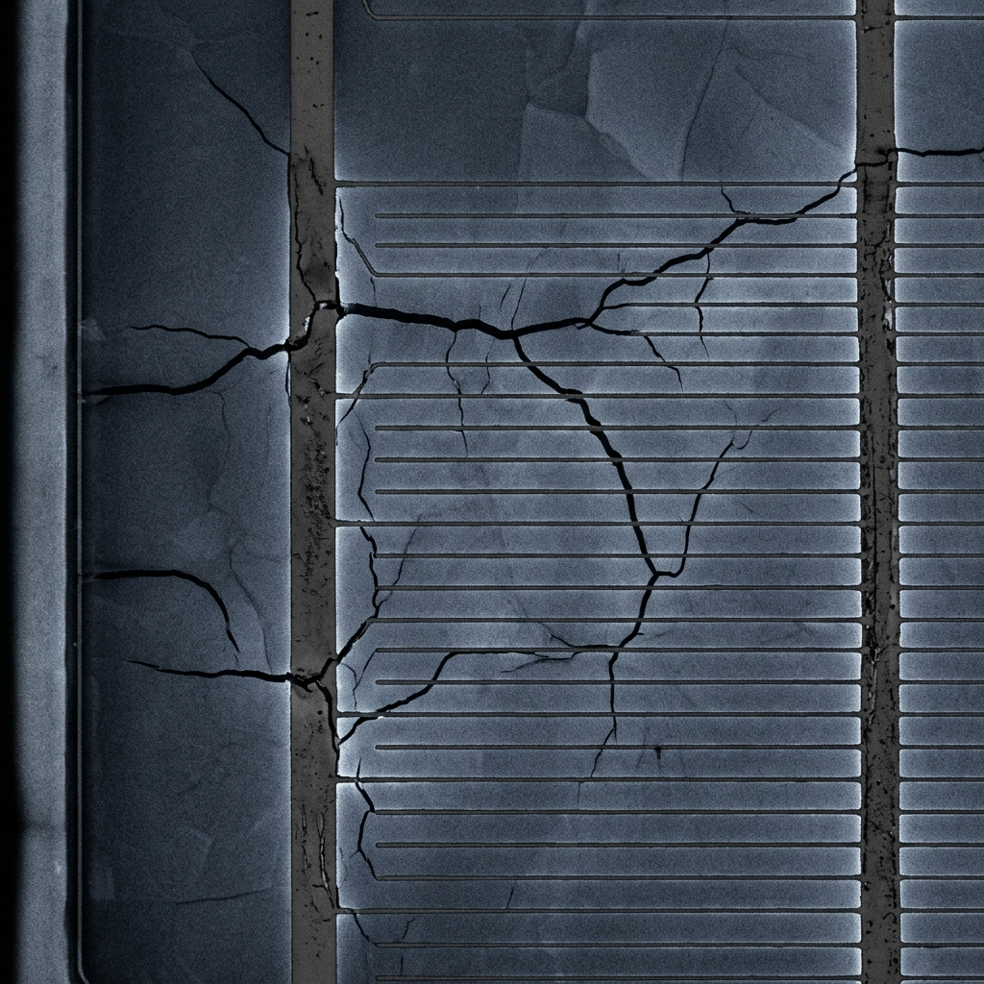
Figure 4.1: SolarScan AI Diagnostic Scan Interface (Broken Panel Check)

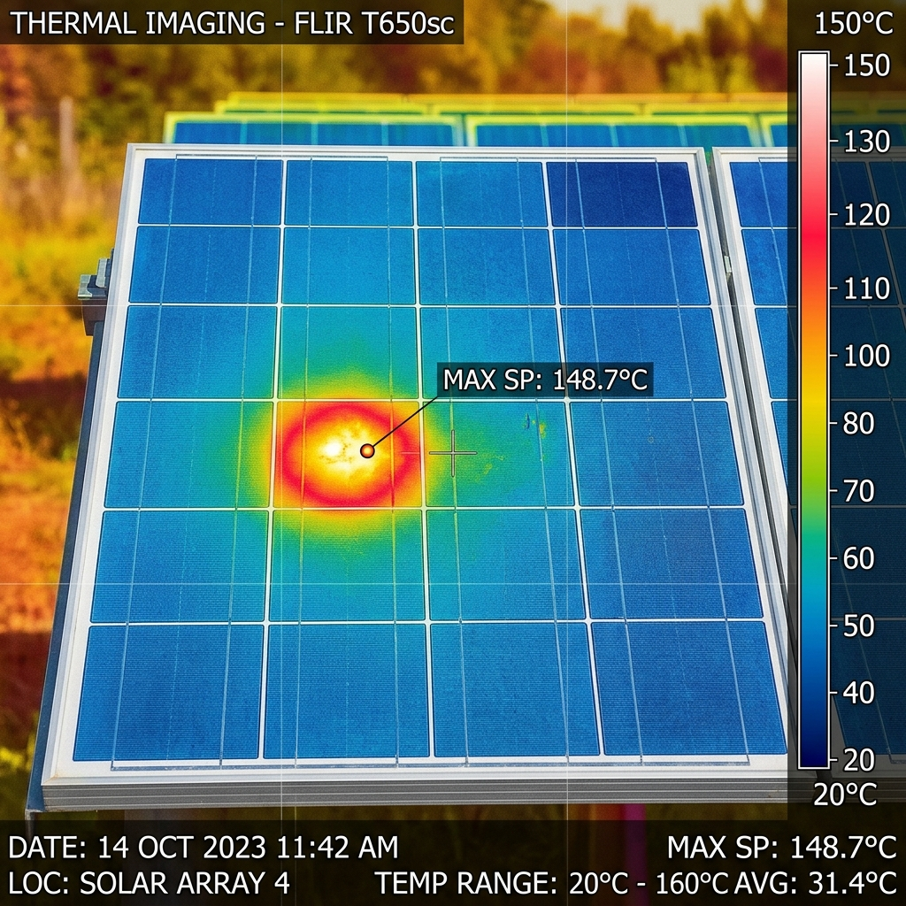
Figure 4.2: Thermal IR Hotspot Analysis & Wattage Loss Calculation

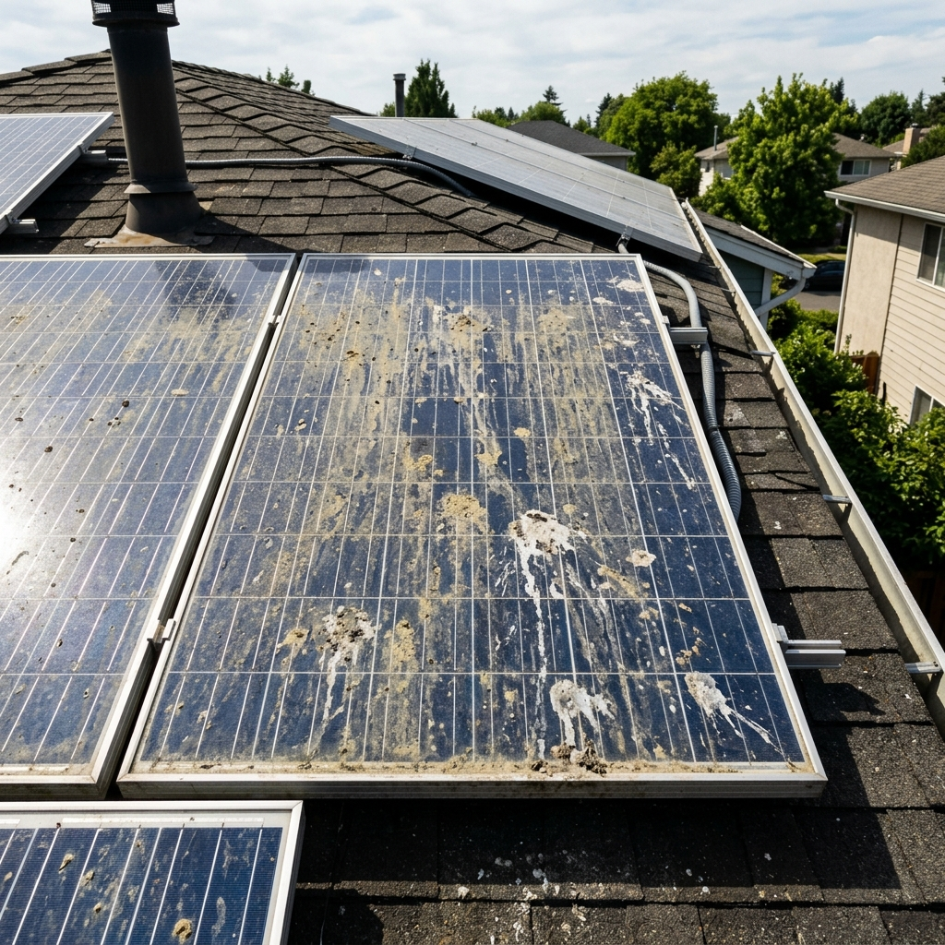
Figure 4.3: Surface Soiling Scan and ROI Repair Cost Summary

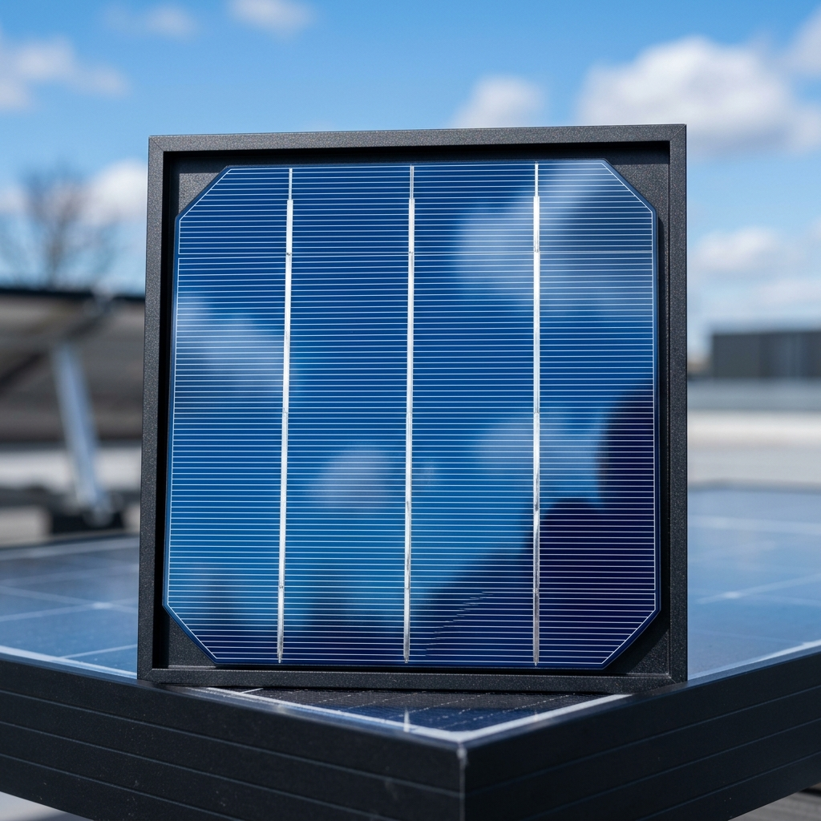
Figure 4.4: Healthy Solar Panel Baseline Telemetry Check
CHAPTER 5: CONCLUSION AND RECOMMENDATIONS
5.1 Summary of Contributions
SolarScan AI successfully bridges the gap between complex artificial intelligence and practical solar panel maintenance. By combining Google Cloud Vision API classification with a simple plain-English interface, field crews can diagnose panel faults in seconds.
5.2 Conclusion
The project demonstrates that clean design and practical engineering trade-offs make AI tools accessible for local renewable energy technicians in Ghana and beyond.
5.3 Recommendations for Future Work
1. In-browser client inference via TensorFlow.js for zero-network execution.
2. Live drone video streaming using WebRTC for aerial inspections.
3. Automatic GPS mapping of damaged panels on regional solar farm maps.

