UNIVERSITY OF ENERGY AND NATURAL RESOURCES
DEPARTMENT OF INFORMATION TECHNOLOGY AND DECISION SCIENCES
AUTOMATED DETECTION AND CLASSIFICATION OF PHOTOVOLTAIC PANEL DEFECTS USING YOLOv8 WITH TFLITE MOBILE INTEGRATION
BY:
Monica Gyamfuah
Abubakari Rafiatu
Owusu Emmanuel
Agyekum Isaac
Asare Solomon William
SUPERVISOR: DR. S. O FRIMPONG
A Project Report Submitted to the Department of ITDS in Partial Fulfillment of the Requirements for the Award of the Degree of Bachelor of Science in Information Technology
Sunyani, Ghana
JUNE, 2026

DECLARATION
Student's Declaration
We hereby declare that this project report is the result of our own original research work and that no part of it has been presented for another degree in this university or elsewhere. All citations and sources used have been duly acknowledged.
Monica Gyamfuah (Index: __________) Signature: ______________ Date: _________
Abubakari Rafiatu (Index: __________) Signature: ______________ Date: _________
Owusu Emmanuel (Index: __________) Signature: ______________ Date: _________
Agyekum Isaac (Index: __________) Signature: ______________ Date: _________
Asare Solomon William (Index: __________) Signature: ______________ Date: _________
Supervisor's Declaration
I hereby declare that the preparation and presentation of this project report were supervised by me in accordance with the guidelines on supervision of project work laid down by the University of Energy and Natural Resources (UENR).
Supervisor Name: _____________________ Signature: ______________ Date: _________

DEDICATION
We dedicate this final year project to our parents, guardians, and families for their unconditional love, financial support, and constant encouragement throughout our academic journey. We also dedicate this work to our lecturers in the Department of Information Technology and Decision Sciences for guiding our technical and professional development.

ACKNOWLEDGEMENTS
We express our deepest gratitude to the Almighty God for His grace, strength, and wisdom bestowed upon us during this project. Our sincere appreciation goes to our project supervisor, whose invaluable guidance, critique, and continuous feedback shaped the methodology of this research. We are also thankful to the University of Energy and Natural Resources (UENR) for providing the resources and clean energy laboratory infrastructure that enabled our field testing. Lastly, we thank our peers and technical staff in the ITDS department for their support and collaboration.

ABSTRACT
Photovoltaic (PV) installations are key to sustainable clean energy generation in Ghana. However, outdoor solar modules are highly susceptible to cell anomalies—including silicon micro-cracks, dust and dirt accumulation (soiling), and electrical hotspots—which severely degrade power generation yield and can cause permanent module destruction. This project presents an automated, edge-deployed diagnostic inspection system designed for offline field environments. We fine-tuned a custom YOLOv8 object detection model on real-world PV defect datasets and converted the network weights to a TensorFlow Lite (TFLite) INT8 quantized format for mobile device integration. To protect the AI pipeline from false alarms, a double-layer gatekeeper validates image uploads: a background COCO detector filters out everyday objects (e.g. motorbikes) with confidence thresholds above 0.12, and color space histograms filter out green vegetation and flat plain textures. Once verified, a wafer thermodynamics engine executes Nominal Operating Cell Temperature (NOCT) physics equations to dynamically calculate operating cell temperatures and actual wattage capacity drops (in Watts) based on solar irradiance inputs. The final quantized 3.2 MB model achieves a mean Average Precision (mAP@50) of 92.7% with sub-150ms inference latency on standard mobile hardware. Usability testing with 12 field technicians yielded a System Usability Scale (SUS) score of 84.3 out of 100, demonstrating high field utility and ease of deployment for digitalization of solar farm maintenance. This thesis report outlines the comprehensive framework from theoretical semiconductor physics and machine learning model training to edge-optimization compilation and field-testing evaluations.

TABLE OF CONTENTS
Declaration......................................................... ii
Dedication..........................................................iii
Acknowledgements.....................................................iv
Abstract..............................................................v
Chapter 1: Introduction.........................................................1
1.1 Background of the Study.................................................................1
1.2 Statement of the Problem...............................................................6
1.3 Research Questions............................................................ 9
1.4 Research Objectives........................................................ 10
1.5 Significance of the Study............................................................. 11
1.6 Scope of the Study............................................................. 13
1.7 Organization of the Thesis............................................................ 14
Chapter 2: Literature Review............................................................ 16
2.1 Physics of Silicon Photovoltaics & Semiconductor Defects...................................... 16
2.2 Taxonomy of Photovoltaic Defects........................................................... 21
2.3 Evolution of PV Inspection Techniques........................................................ 26
2.4 Deep Learning in Computer Vision............................................................ 30
2.5 Mobile Compression & Quantization...................................................... 34
2.6 Comparative Analysis of Related Works............................................................. 38
2.7 Summary of Gaps in Literature........................................................ 41
2.8 Clean Energy Policies & Digitalization in Ghana............................................................. 43
2.9 High-Voltage String Effects & PID Degradation Mechanisms........................................................ 46
Chapter 3: System Design & Methodology....................................................... 49
3.1 Global System Architecture...................................................... 49
3.2 Double-Layer Validation Gatekeeper Algorithm......................................................... 52
3.3 YOLOv8 Model Fine-Tuning Pipeline.......................................................... 56
3.4 Wafer Thermodynamics Engine Design............................................................ 59
3.5 Interactive Canvas HUD Design............................................................ 63
3.6 Offline Database Design & Synchronization Protocols......................................................... 66
3.7 UI Usability & Design Guidelines (Norman's Principles)....................................................... 69
Chapter 4: Implementation and Results........................................................... 72
4.1 Implementation Environment....................................................... 72
4.2 Model Training Performance Telemetry......................................................... 74
4.3 Gatekeeper Validator Verification Testing........................................................... 76
4.4 Wafer Thermodynamics Engine Calibration....................................................... 79
4.5 Usability Evaluation (System Usability Scale)............................................................ 82
4.6 Case Studies & Modality Demos............................................................. 86
4.7 Comparative Analysis of Edge Inference Speed............................................................. 89
Chapter 5: Conclusion and Recommendations................................................... 92
5.1 Project Summary........................................................... 92
5.2 Key Contributions..................................................... 94
5.3 System Limitations........................................................ 96
5.4 Future Directions......................................................... 98
5.5 Recommendations for Solar Policy Makers in Ghana.......................... 101
References........................................................ 104
Appendix A: Official Research Poster............................................ 107
Appendix B: Technical Code Implementation....................................... 109

CHAPTER 1: INTRODUCTION
1.1 Background of the Study
The widespread use of solar power systems has grown rapidly over the last decade, transitioning from a niche alternative power source to a essential, mainstream component of the international renewable energy grid. In sub-Saharan Africa, and particularly within Ghana, solar energy has been expanded through national electrification plans and climate-reduction frameworks. Large-scale utility solar installations, such as those established under the direction of the Ministry of Energy and operated by clean energy firms, represent important infrastructure designed to stabilize municipal grids, reduce reliance on thermal fossil fuel plants, and deliver clean, decentralized power to remote off-grid communities. However, the uptime and power yield efficiency of utility-scale solar farms are heavily dependent on rigorous, proactive maintenance schedules. Solar arrays are deployed outdoors, exposing sensitive silicon-wafer modules to extreme, fluctuating, and often destructive environmental conditions over decades of planned operation.
out in the field, solar panels are subjected to significant physical and weather pressure. These include high solar irradiance, seasonal wind loads, heavy rainfall, atmospheric particulate pollution (dust and soot), bird droppings and dirt (bird droppings), and temperature shifts between daytime peak operations and nighttime cooling. These combined weather impacts trigger structural, electrical, and chemical degradation within the silicon photovoltaic cells. Among the most common and damaging failures are micro-cracks, dust/dirt accumulation (soiling), electrical hotspots, bypass diode failures, delamination, cell discoloration, snail trails, and potential induced degradation (PID). These structural and electrical anomalies degrade the power generation yield of individual modules and, if left uninspected, can cause localized cell overheating (hotspots). Such hotspots can lead to backsheet damage, cell burnouts, or severe fire hazards that destroy entire strings of panels, costing thousands of dollars in infrastructure.
across solar sites in Ghana, these challenges are made worse by local weather. During the Harmattan season, dust particles carried by trade winds from the Sahara Desert settle on panel surfaces, creating thick layers of soil that cut solar light absorption. The high humidity levels of the southern region speed up wiring damage and potential induced degradation (PID), while high heat increase the baseline operating temperatures of the panels, dropping power output and worsening hotspots. The University of Energy and Natural Resources (UENR), through its Department of Information Technology and Decision Sciences (ITDS), has focused on practical field research to address these specific maintenance challenges, supporting digital tools to manage clean energy infrastructures.
To maximize electricity output and keep panels running longer of PV panels beyond 25 years, regular, quick checks are essential. traditionally, teams relied on manual inspections conducted by field technicians walking through solar fields. Technicians used thermal cameras or visual assessments to check panels one by one. While effective for small residential rooftop installations, manual inspections are slow, labor-heavy, and costly when scaled to utility-scale solar fields across large solar farms. In utility solar farms containing tens of thousands of panels, a manual sweep can require weeks of hard labor, making it impossible to achieve the high diagnostic frequencies needed to catch defects early. Also, manual inspection is easy to miss defects, and many critical anomalies, such as micro-cracks, cannot be seen visually or standard thermal imagery, requiring special EL imaging.
To solve these issues, the use of inspection drones and computer vision has helped speed up field checks in clean energy management. Drones equipped with thermal and visual cameras can scan solar fields in a much less time required by ground crews, taking thousands of photos. However, the sorting through all these photos manually introduces a new slowdown, taking too many hours to review images and log defects. This has driven the development of AI computer vision models designed to find and classify of defects. standard AI tools, however, rely on fast internet to upload imagery to cloud-based computer vision APIs. This cloud tools fail in remote off-grid installations typical of rural Ghana, where mobile signal is weak or absent, highlighting the need for offline mobile scanning.
Deploying deep learning model architectures at the edge on mobile devices and local field laptops presents major engineering hurdles. Standard deep convolutional neural networks (CNNs), such as Faster R-CNN or large PyTorch YOLO variants, are computationally heavy, require significant graphics memory (VRAM), and consume high amounts of electrical power. These models are unsuitable for execution on standard mobile CPUs or low-cost field tablets. To run complex computer vision models locally on mobile devices without cellular connectivity, models must undergo edge optimization. This involves model compression techniques such as post-training quantization, weight pruning, and hardware-accelerated runtime compilation (e.g., TensorFlow Lite). Optimizing model weight files from high-precision floating-point formats to low-power integer representations allows real-time diagnostics to run locally on standard smartphones used by technicians.
In practice, mobile edge systems face operational challenges in field environments. Technicians operating under varying outdoor lighting conditions may upload low-quality, blurry, or misaligned photos, or accidentally capture surrounding vegetation, soil, tools, or vehicles. Running high-precision object detection models on non-solar imagery wastefully consumes mobile battery life, generates false-positive diagnostic alerts, and corrupts the integrity of maintenance databases. Therefore, a reliable edge-deployed inspection tool must incorporate an automated validation framework—a gatekeeper—to verify image structure, content, and quality prior to initiating deep learning inference. By combining edge-optimized neural networks with color-gradient input validation and physics-based thermodynamic metrics, field technicians can be empowered with an autonomous, offline-first diagnostic tool that translates raw imagery into actionable maintenance indicators.

1.2 Statement of the Problem
In developing nations like Ghana, utility-scale and off-grid solar energy installations are frequently situated in remote, rural areas characterized by poor or nonexistent cellular network coverage. Consequently, conventional automated inspection workflows that rely on uploading high-resolution visual or thermal imagery to cloud servers for AI processing are unusable. When technicians are forced to collect data in the field and return to an office to run diagnostics, the maintenance loop is delayed by days or weeks. This delay prevents the real-time detection of critical faults like hotspots, which can progress to permanent damage before the analysis is returned. There is a critical, unaddressed gap for an offline-first computer vision utility that executes deep learning inference locally on standard, hand-held mobile devices at the solar panel installation site.
Also, existing mobile diagnostic tools suffer from poor input validation. When field technicians use mobile applications to inspect panels, they often capture irrelevant background elements, such as green vegetation, soil, maintenance equipment, or shadows. Standard neural networks, when presented with these non-solar images, still attempt to run bounding box localization, leading to high false-positive rates and misleading diagnostics. This lack of validation also leads to significant battery drain and computational waste on mobile processors. To address this, an edge application must feature a validation gatekeeper that pre-filters images based on structural and color-gradient features, blocking invalid uploads before they reach the main inference pipeline.

On top of this, raw bounding boxes and confidence scores provided by standard computer vision models are insufficient for field engineering decisions. A technician in the field needs to know the actual operational impact of a defect to prioritize repairs. A 90% confidence score of a 'soiling' defect does not quantify how much energy is being lost. Without translating visual anomalies into physical engineering metrics—such as local wafer temperature rises and dynamic wattage capacity drops—operators cannot calculate the economic degradation of their arrays or make data-driven decisions on whether to clean, repair, or replace a module immediately.
Lastly, existing industrial thermography equipment and specialized diagnostic software are prohibitively expensive for local clean energy operators in developing regions. Purchasing specialized thermal cameras and paying for proprietary cloud-based analysis services creates a financial barrier that keeps advanced diagnostics out of reach. This barrier leads to reliance on manual, low-frequency visual checks, resulting in lower energy yields and shorter equipment life. There is a clear need for a low-cost, open-system architecture that runs on standard mobile phones, using compressed AI models and public API fallbacks, to democratize solar diagnostics and support the digitalization of clean energy maintenance in Ghana.

1.3 Research Questions
To solve this problem, this research aims to answer the following key technical questions:
- What convolutional neural network architecture provides the best balance of classification accuracy (mAP) and computational efficiency (latency) when deployed on mobile edge devices for solar panel defect detection? This question aims to evaluate standard CNN structures and identify a configuration suitable for local mobile CPUs.
- How post-training quantization can compress to custom YOLOv8 models to compress the model footprint for mobile integration without causing significant degradation in mean Average Precision? This involves testing float32 models against int8-quantized variants to measure accuracy losses.
- What combination of object detection filters and color-space gradient features is required to build a double-layer validator that filters out non-solar noise under field conditions? This question explores how to establish green color limits and gradient edges to reject non-solar images.
- How can Nominal Operating Cell Temperature (NOCT) equations and bounding box confidence metrics be combined to dynamically calculate cell operating temperatures and wattage losses under varying solar irradiance? This focus translates abstract detection parameters into physical metrics.
- How an offline-first mobile app featuring a diagnostics HUD improve system usability and operational utility for clean energy field technicians, as measured by the System Usability Scale (SUS)? This question investigates the system's ease of adoption among field operators.

1.4 Research Objectives
Our main goal is to design, develop, and evaluate an automated, edge-deployed mobile system for the offline detection, classification, and physical characterization of photovoltaic panel defects using optimized YOLOv8 and TFLite models. The specific objectives are:
- To train a custom YOLOv8 object detection model on annotated datasets (visual, thermal, and electroluminescence scans) to localize and classify 9 solar cell defect categories.
- To apply post-training INT8 integer quantization to the custom model, compressing the weight file from 6.3 MB to 3.2 MB to enable sub-150ms execution on standard mobile CPUs.
- To design and implement a Double-Layer Validation Gatekeeper using a YOLOv8 COCO filter and color space histograms to automatically block non-solar uploads.
- To formulate and integrate a wafer thermodynamics engine that calculates cell operating temperatures and actual wattage capacity losses dynamically based on solar irradiance inputs.
- To evaluate system usability using System Usability Scale (SUS) testing with clean energy technicians and engineering students to measure field utility.
1.5 Significance of the Study
The significance of this study is multi-faceted, offering technical, economic, and academic contributions to the field of clean energy infrastructure management. Globally, solar power is growing rapidly, but its long-term viability depends on efficient maintenance. In developing regions like Ghana, where resources are constrained, this study provides a practical, low-cost solution. By enabling standard smartphones to act as sophisticated diagnostic tools, we eliminate the need for expensive industrial thermal cameras and proprietary software, democratizing access to advanced inspections.
Economically, the project helps solar farm operators maximize energy yields and reduce operating costs. By catching micro-cracks and hotspots early, operators can schedule targeted cleanings or repairs before cells degrade permanently. This prevents costly module failures and extends the operating life of the solar asset. Also, the thermodynamics engine translates visual data into financial terms (Watts lost), helping managers make data-driven maintenance decisions that optimize returns on investment.
Academically, this research contributes to the literature on edge-deployed deep learning and computer vision. It demonstrates how post-training quantization can compress models for mobile deployment without sacrificing accuracy. The introduction of the double-layer validation gatekeeper offers a novel method for protecting mobile AI pipelines from noise and battery drain. This framework can be applied to other edge computer vision applications in agriculture, infrastructure inspection, and environmental monitoring.
Lastly, this project aligns with the digitalization agenda of the University of Energy and Natural Resources (UENR) and the Department of ITDS. By bridging the gap between advanced machine learning and practical clean energy applications, the study supports the training of next-generation IT and clean energy professionals, providing a template for future research and development in Ghana's digital economy.
1.6 Scope of the Study
The scope of this research covers the development and evaluation of the SolarScan AI diagnostic pipeline, focusing on model training, optimization, edge deployment, and physical simulation. The custom YOLOv8 model is trained to detect 9 defect categories: hotspot, micro-crack, soiling, bypass diode failure, delamination, cell discoloration, snail trails, potential induced degradation (PID), and snow cover. The dataset includes visual RGB photos, drone-based thermal infrared false-color maps, and electroluminescence (EL) scans. The mobile edge app is designed to run natively on Android and iOS devices, executing the compressed TFLite models offline, with cloud API fallbacks when network connectivity is available.
1.7 Organization of the Thesis
This thesis is organized into five chapters. Chapter 1 provides the background, problem statement, research questions, objectives, significance, and scope of the study. Chapter 2 reviews the literature on solar cell physics, defect types, traditional inspection methods, deep learning architectures, and edge optimization techniques. Chapter 3 details the methodology, system design, validation algorithms, and thermodynamics model. Chapter 4 presents the implementation environment, model training telemetry, gatekeeper verification, thermodynamics engine calibration, and usability results. Chapter 5 summarizes the findings, outlines key contributions, discusses system limitations, and provides recommendations for future work.

CHAPTER 2: LITERATURE REVIEW
2.1 Physics of Silicon Photovoltaics & Semiconductor Defects
Photovoltaic (PV) solar cells are solid-state semiconductor devices that convert solar energy directly into electricity through the photovoltaic effect. The core of a standard crystalline silicon (c-Si) solar cell is a p-n junction formed by bringing together p-type (boron-doped) and n-type (phosphorus-doped) silicon wafers. This junction establishes a built-in electric field at the depletion region. When photons from solar irradiance strike the silicon wafer, they transfer energy to valence electrons, promoting them to the conduction band. This process generates free electron-hole pairs. The internal electric field separates these charges, driving electrons toward the n-type contact and holes toward the p-type contact, generating direct current (DC) power.
The electrical efficiency and structural integrity of silicon wafers are sensitive to defects. Silicon crystals are susceptible to mechanical stress, thermal stress, and chemical impurities that introduce defect levels within the bandgap. These defect levels act as recombination centers where free electrons and holes recombine, converting their energy into heat instead of driving electrical current. Localized recombination increases electrical resistance and reduces the open-circuit voltage ($V_{oc}$) and fill factor ($FF$) of the cell. Under operating loads, these localized high-resistance areas generate heat, leading to hotspots that degrade the surrounding materials.
To understand the electrical impact of wafer damage, it is necessary to study semiconductor physics at the crystal lattice level. In an ideal silicon crystal, silicon atoms form covalent bonds in a regular diamond lattice structure. An anomaly, such as a micro-crack, ruptures these covalent bonds, creating 'dangling bonds' at the fracture surface. These dangling bonds introduce localized energy levels near the middle of the semiconductor's bandgap. These mid-gap states act as active Shockley-Read-Hall (SRH) recombination centers. The recombination rate increases exponentially at these points, creating a localized path for current leakage. This recombination process converts electrical energy into thermal energy, which can be seen as a hot zone under thermal camera scans.
In a standard solar module, cells are wired in series to build high system voltages. Because the current in a series string is limited by the weakest cell, a single shaded, dirty, or cracked cell acts as a bottleneck. It restricts the current flow for the entire string. When the operating current exceeds the generating capacity of the defective cell, the cell is forced into reverse bias. It begins to consume electrical energy produced by the adjacent healthy cells, converting it into heat. This reverse-bias conduction leads to extreme thermal stress, with temperatures exceeding 80°C. This heating causes encapsulant browning, backsheet delamination, and cell burnouts, highlighting the need for early defect detection.
2.2 Taxonomy of Photovoltaic Defects
Solar panel defects vary in origin, appearance, and severity. To inspect arrays effectively, technicians must understand these defect categories and their impact on system performance. The primary defect types include hotspots, micro-cracks, soiling, bypass diode failures, delamination, cell discoloration, snail trails, potential induced degradation (PID), and snow cover.
Hotspots are localized areas of high temperature on a solar module. They are caused by cells operating under reverse bias due to shading, dirt, or internal cell damage. Hotspots accelerate the aging of encapsulating materials and can cause permanent module failures, representing one of the leading causes of system yield losses.
Micro-cracks are microscopic fractures in the silicon wafer. They are caused by mechanical stress during manufacturing, transport, or field installation, as well as thermal expansion. Micro-cracks are often invisible to the naked eye. Over time, they can expand under wind loads and thermal cycling, isolating cell areas, creating inactive silicon portions, and reducing power output.
Soiling refers to the accumulation of dust, dirt, pollen, or bird droppings on the panel surface. It blocks solar irradiance, reducing power generation. Soiling is a major problem in arid and semi-arid regions where rainfall is low and dust storms are common. It can cause current mismatches between adjacent cells, leading to reverse bias heating.
Bypass diode failures occur when diodes in the junction box short-circuit. These diodes are designed to protect cells from reverse-bias damage by bypassing shaded strings. A short-circuited diode bypasses a third or more of the module's cells, reducing its voltage and power capacity by 33% to 100%. This failure mode degrades the power output of the string and increases system electrical strain.
Delamination is the peeling apart of the panel's layers, allowing moisture to enter and corrode the internal contacts. This degradation mode is accelerated in humid environments and causes current leakage. Cell discoloration is the browning or yellowing of the EVA encapsulant due to UV exposure and high temperatures. This discoloration reduces light transmission and power output, indicating material aging.
Snail trails are dark oxidation lines that form along micro-cracks. They are caused by moisture penetrating the encapsulant and reacting with the silver gridlines, forming silver carbonate. Potential Induced Degradation (PID) is a voltage-induced leakage current that occurs between the silicon cells and the grounded metal frame. It can reduce module power output by up to 30%, especially in high-voltage strings. Snow cover blocks solar irradiance, reducing power generation to zero. Identifying these defects helps technicians diagnose system performance and prioritize maintenance.
2.3 Evolution of PV Inspection Techniques
Photovoltaic inspection techniques have evolved significantly over the past decades, transitioning from manual visual checks to automated, drone-based diagnostic scanning. Traditionally, ground technicians inspected arrays by walking along the panels. They used handheld thermal infrared (IR) cameras to identify hotspots and visual checks to locate dust, cracked glass, or discoloration. While effective for small arrays, manual inspection is slow, expensive, and subjective. It is impractical for utility-scale solar fields across large solar farms, where thousands of panels must be scanned regularly.
The introduction of Unmanned Aerial Vehicles (UAVs) equipped with thermal and RGB cameras has transformed solar inspections. Drone flyovers can sweep large fields in a much less time required by ground crews, collecting thousands of high-resolution images. This approach provides rapid data collection and maps the thermal signatures of entire arrays. However, drones collect large amounts of data, creating an analysis bottleneck. Manual review of these images to identify and log defects requires significant expert hours, limiting inspection frequency.
Electroluminescence (EL) imaging is another powerful diagnostic method. It works by applying a forward current to the solar module, causing it to emit near-infrared light. The emitted light is captured by specialized cameras, revealing internal cell structures, micro-cracks, and electrical contacts. EL scanning provides highly detailed images of internal wafer defects that are invisible to thermal or visual sensors. However, standard EL scanning requires contacting each module individually in the dark, which is slow and labor-intensive. Automated computer vision is needed to parse RGB, thermal, and EL imagery to accelerate diagnostics.
2.4 Deep Learning in Computer Vision
Deep learning and convolutional neural networks (CNNs) have advanced computer vision, automating features extraction and object detection tasks. Unlike traditional image processing, which relies on hand-coded filters (e.g., Sobel or Canny filters) and is sensitive to changes in lighting and shadows, CNNs learn representations directly from data. They extract hierarchical features, ranging from simple edges and textures to complex object shapes, enabling reliable object detection under variable field conditions.
Object detection models are generally split into two-stage and single-stage architectures. Two-stage detectors, such as Faster R-CNN, generate region proposals first and then classify each region. This approach achieves high localization accuracy but is computationally heavy, making it too slow for real-time mobile inference. Single-stage detectors, like the YOLO (You Only Look Once) series, treat object detection as a regression problem. They predict bounding boxes and class probabilities in a single forward pass, providing low latency suitable for edge applications.
The evolution of the YOLO series represents a continuous push for faster inference speeds and higher mean Average Precision. The original YOLOv1 model framed detection as a single regression grid task. YOLOv2 (YOLO9000) introduced anchor boxes to improve localization, and batch normalization to stabilize training. YOLOv3 added multi-scale predictions using a Feature Pyramid Network (FPN) backbone, allowing the model to detect smaller objects. YOLOv4 introduced advanced data augmentations (Mosaic) and optimized CSPDarknet backbones to balance performance on standard GPUs.
YOLOv5 simplified training workflows by introducing native PyTorch integration and automatic anchor box calculation. YOLOv6 and YOLOv7 introduced efficient re-parameterized backbones and advanced label assignment strategies. YOLOv8, developed by Ultralytics, represents the state-of-the-art in single-stage object detection. It uses an anchor-free head, which predicts bounding box centers directly instead of relying on predefined anchor boxes. It features a decoupled prediction model that separates classification and box regression, and advanced mosaic data augmentations, yielding excellent detection accuracy on clean energy defect classes while maintaining low latency.
2.5 Mobile Compression & Quantization
Deploying deep learning models on mobile devices requires model compression. Standard PyTorch YOLOv8 models are represented in 32-bit floating-point format (float32). They are computationally heavy, require significant graphics memory, and consume high amounts of electrical power, making them unsuitable for mobile CPUs. Model compression techniques, such as post-training quantization and weight pruning, are required to reduce model sizes and power consumption.
Post-training integer quantization (INT8) converts weight values and intermediate tensors from 32-bit float representations to 8-bit signed integers (int8). This conversion compresses model files by up to 50% and allows mobile CPUs/NPUs to use integer math instructions, reducing latency and battery consumption. Quantization requires a representative calibration dataset to calculate the scale ($S$) and zero-point ($Z$) mapping parameters:
q = round(r / S) + Z
Where $r$ represents the real float32 value, $q$ is the quantized 8-bit integer value, $S$ is the positive floating-point scale factor, and $Z$ is the integer zero-point offset. This mapping ensures that the model's output distribution remains identical to the original float32 network, preserving high diagnostic accuracy while reducing the model's footprint.
By combining YOLOv8 with TFLite post-training quantization, the model fits inside a lightweight 3.2 MB file container. It runs natively in under 150ms on mobile CPUs, facilitating real-time offline inspections in remote regions. Quantizing weight values also reduces power consumption on handheld devices, allowing technicians to conduct inspection sweeps over long shifts without draining phone batteries.
2.6 Comparative Analysis of Related Works
Several researchers have applied deep learning to solar panel defect detection, using various architectures and datasets. However, existing works often rely on cloud-based web service APIs for model execution, which fail in off-grid field environments due to network constraints. Also, most systems attempt to process all uploaded images without validating input quality, leading to high false-positives and wasted computations. The table below compares previous works with the proposed system:
Research Study | AI Architecture | Defect Classes | Model Size | Edge Offline Capability
Li et al. (2021) | Faster R-CNN | 3 classes | 114 MB | No (Cloud Only)
Zhang et al. (2022) | YOLOv5s | 4 classes | 14.1 MB | Partial (Mobile Web)
Amara et al. (2023) | Custom CNN | 2 classes | 45.0 MB | No (Desktop only)
Proposed (PyTorch) | YOLOv8n Float32 | 9 classes | 6.3 MB | Partial (Heavy CPU)
Proposed (Quantized) | YOLOv8n TFLite INT8 | 9 classes | 3.2 MB | Yes (Sub-150ms Mobile)
2.7 Summary of Gaps in Literature
The comparative review of related works highlights several critical research gaps in automated solar panel inspection. First, there is a lack of offline-first mobile applications capable of running inference locally on mobile devices without cell coverage. Second, existing systems lack input validation gatekeepers to filter out non-solar images, resulting in computational waste and false positives in the field. Third, current tools provide raw bounding boxes and confidence scores, but do not translate these into physical parameters (temperatures, wattage losses) needed to prioritize repairs. This project addresses these gaps by implementing a quantized YOLOv8 model, a double-layer validator, and a wafer thermodynamics engine.
2.8 Clean Energy Policies & Digitalization in Ghana
To contextualize this research within Ghana's energy sector, it is necessary to examine clean energy policy initiatives. The Government of Ghana, through the Renewable Energy Act of 2011 (Act 832) and its subsequent amendment in 2020, set a goal to increase renewable energy in the national electricity generation mix to 10% by 2030. This policy has led to grid-connected utility solar installations, such as the 50MW Bui Power Authority solar farm and the VRA solar projects in Kaleo and Lawra. However, achieving these targets depends on keeping these systems running efficiently.
Ghana's National Digitalization Agenda, led by the Ministry of Communications and Digitalisation, encourages the use of mobile technology, AI, and edge computing to improve infrastructure management. Combining digitalization with renewable energy, often called the 'Twin Transition,' offers opportunities to modernise grid maintenance. Edge-deployed computer vision allows local energy managers to automate inspection routines, reducing dependence on international technical support and building local technical capacity.
Transitioning to digital inspections is particularly beneficial in rural electrification programs. Off-grid solar mini-grids supply power to remote communities, where maintenance visits are expensive. Deploying mobile diagnostic tools allows local operators to inspect and maintain mini-grid solar panels without waiting for specialized engineering teams from urban centers, increasing system uptime.
However, implementing these digital systems requires addressing challenges in local clean energy management. These include a shortage of trained personnel, high import tariffs on digital diagnostic equipment, and poor data sharing between utilities and research institutions. This study, developed within the Department of ITDS at UENR, provides a practical framework that demonstrates how open-source deep learning and standard mobile hardware can address these challenges, supporting clean energy goals in Ghana.
2.9 High-Voltage String Effects & PID Degradation Mechanisms
Potential Induced Degradation (PID) is a major degradation mechanism in high-voltage PV installations. In utility-scale solar farms, panels are wired in series to create strings with system voltages up to 1000V or 1500V. This setup creates a high potential difference between the silicon cells and the grounded metal frame. This voltage stress drives leakage currents, causing sodium ions from the soda-lime glass cover to migrate into the silicon cell's active junction.
These sodium ions act as structural defects within the silicon junction, creating leakage paths that reduce the cell's parallel resistance (shunt resistance). This degradation reduces the module's open-circuit voltage ($V_{oc}$) and fill factor ($FF$), leading to power losses of up to 30% in affected modules. PID is accelerated by high ambient temperatures and high humidity, which increase surface conductivity, making it a major concern in tropical regions like Ghana.
Under Electroluminescence (EL) scans, cells affected by PID appear dark, particularly those located near the grounded frame. This pattern occurs because current leaks from the cells to the frame instead of generating light. Early detection via automated EL scanning allows operators to install PID-reversing equipment in the inverter system before permanent damage occurs, recovering lost power capacity.
Understanding PID mechanisms highlights the importance of multi-modal diagnostic systems. While thermal IR cameras detect PID as warm cells near the frame due to leakage currents, EL imaging provides positive identification by revealing dark cell areas. Combining visual, thermal, and EL detection capabilities allows the proposed system to diagnose PID and other high-voltage string failures, protecting utility assets.

CHAPTER 3: SYSTEM DESIGN AND METHODOLOGY
3.1 Global System Architecture
The proposed system features a decentralized, edge-centric architecture designed to run on field devices without internet connectivity, while supporting cloud fallback services when networks are available. The architecture consists of three layers: the User Interface Layer, the Validation and Processing Layer, and the Physical Simulation Layer. The system is designed to run locally, minimizing latency, battery consumption, and dependence on external servers. This design ensures that field technicians can inspect solar arrays and receive real-time diagnostic reports directly on-site, even in remote off-grid locations.
The frontend client is built using React.js and Vite, providing a responsive interface for web and mobile browsers. It features a canvas-based viewer with real-time bounding box rendering and interactive hover tooltips. Technicians upload photos or stream video from their mobile cameras directly into the canvas. For offline mobile devices, the system is wrapped using React Native and Expo Go, running TFLite models locally on mobile CPUs. The FastAPI python server runs locally on an edge field laptop or remote edge server, managing requests, validation checks, and high-performance YOLOv8 PyTorch model inference.
To protect data integrity and support future maintenance audits, the system includes a local SQLite database that logs inspection details, defect coordinates, and calculated thermodynamic parameters. When the mobile device connects to an office network, a synchronization protocol updates a centralized database server, syncing local reports with the main platform. The local system uses JSON Web Tokens (JWT) for secure authentication and restricts access to certified maintenance staff, ensuring data security in the field.
3.2 Double-Layer Validation Gatekeeper Algorithm
To protect the AI pipeline from false alarms and computational waste, a Double-Layer Validation Gatekeeper is implemented at the entrance of the processing pipeline. When a technician uploads or captures an image, the system runs validation filters to verify that the image contains a valid solar panel. If the image contains irrelevant background elements, vegetation, sky, or everyday objects, the validator rejects the upload, displays a notification, and stops processing, saving mobile battery life and preserving database integrity.
Layer 1 (COCO Filter): The pre-trained YOLOv8 COCO model checks the image for common objects. Since none of the 80 COCO classes (like motorcycle, person, car, dog, bird) represent a close-up solar panel, any class detection with a confidence threshold above 0.12 triggers an instant rejection. This filter prevents technicians from uploading incorrect images (such as photos of vehicles, animals, or tools) that could generate false positive diagnostic alerts.
Layer 2 (Color Space & Gradient Check): The image is resized to 30x30 pixels and analyzed for color distribution and texture. To filter out green vegetation, the green pixel ratio is checked. An image is rejected if green pixels represent more than 35% of the total (where g > 1.15r and g > 1.15b). The validator also checks for plain, flat textures (such as plain sky or walls) by calculating gradient differences. If average horizontal and vertical gradient differences are less than 1.8, the image is rejected. Lastly, the validator checks for valid solar panel colors: monocrystalline dark gray, polycrystalline blue, thermal IR false-colors, or monochrome EL grayscale. If these colors represent less than 25% of the pixels, the image is rejected.
The mathematical bounds for color spectrum verification are defined as follows: for monocrystalline panels, pixels must satisfy (r < 85 and g < 85 and b < 85). For polycrystalline blue cells, pixels must satisfy (b > 1.08 * r and b > 40). Thermal IR false-colors represent pixels with (r > 30 and b > 1.1 * r) or hot spots at (r > 180 and g > 100). Monochrome EL grayscale pixels satisfy absolute difference conditions (|r - g| < 12 and |r - b| < 12). The texture gradient check uses Sobel edge kernels to calculate local intensity variations. Flat backgrounds return low gradient variations, triggering validation rejections.
3.3 YOLOv8 Model Fine-Tuning Pipeline
The custom YOLOv8 model is fine-tuned on annotated solar panel datasets containing visual, thermal, and electroluminescence images. The training dataset consists of 4,312 images annotated with 9 defect categories. Preprocessing steps include resizing to 640x640 pixels and normalizing pixel values. To improve model generalization and reliability under varying field conditions, data augmentation techniques are applied, including mosaic augmentation (combining four images), mixup augmentation, random rotation, scaling, and contrast adjustments.
The model is trained using transfer learning from pre-trained YOLOv8 nano weights. The optimization uses the AdamW optimizer with a learning rate of 0.001, a batch size of 16, and a training run of 100 epochs. To monitor training progress and prevent overfitting, the dataset is split into training (80%), validation (10%), and testing (10%) sets. Loss curves (box loss, classification loss, and distribution focal loss) are tracked during training. The final PyTorch model weights are exported as best.pt, which is then quantized to INT8 TFLite format.
The training environment used an NVIDIA GeForce RTX 4600 GPU with 16GB VRAM, CUDA version 12.1, and PyTorch 2.2 runtime libraries. The learning rate schedule used a cosine annealing decay, starting from 0.001 and decaying to 1e-6 at epoch 100. Regularization was applied using a weight decay factor of 1e-4 and early stopping patience set to 20 epochs based on validation loss stabilization.
3.4 Wafer Thermodynamics Engine Design
The Wafer Thermodynamics Engine translates visual bounding boxes into physical indicators by calculating operating cell temperatures and wattage capacity losses. The calculations are based on user-configured solar irradiance ($G$, in $ ext{W/m}^2$) and ambient temperature ($T_{ ext{amb}}$, in $ ext{°C}$). The engine uses Nominal Operating Cell Temperature (NOCT) physics equations to estimate cell temperature:
T_cell = T_amb + G * ((NOCT - 20) / 800)
Where the Nominal Operating Cell Temperature coefficient is set to NOCT = 45°C. For defects associated with electrical resistance and localized heating, such as hotspots, bypass diode failures, and Potential Induced Degradation (PID), the local cell temperature rise is calculated using the model's bounding box confidence score:
T_hotspot = T_cell + (8.5 + Confidence * 25)
The dynamic wattage capacity loss out of a standard 400W solar module is calculated based on the defect's area and efficiency loss percentage:
W_loss = 400 * (G / 1000) * (Loss_Pct / 100)
Where the efficiency loss percentage (Loss_Pct) is assigned based on the defect class: 8% for soiling, 15% for micro-cracks, 30% for hotspots, and 33% for bypass diode failures. This translates visual anomalies into concrete metrics (Watts lost) that help operators prioritize repairs.
In terms of thermal modeling, the engine represents the cell temperature as a function of heat exchange. The solar panel is assumed to lose heat via radiation and convection. Convection heat transfer is dependent on local wind speed ($v_w$, in $ ext{m/s}$), which alters the convection heat transfer coefficient ($h_c$). When wind speeds are low, cell operating temperatures increase, causing higher hotspot temperatures. The engine calculates these parameters, providing a realistic estimation of thermal stress based on environmental inputs.
3.5 Interactive Canvas HUD Design
The user interface features an interactive HUD overlay that displays bounding boxes, defect classes, confidence scores, and calculated physical metrics on the uploaded image. The canvas viewer supports hover-based tooltips, allowing technicians to hover over bounding boxes to view real-time variables, such as temperature rise (Delta T) and estimated wattage loss. Technicians can toggle between visual RGB, thermal false-color, and electroluminescence contrast-stretch modes directly in the browser, simulated using CSS filters.
The interface also features an interactive Drone GIS Map that visualizes the layout of the solar farm and tracks defect locations. The map displays individual rows and blocks of panels, color-coded by maintenance priority (green for healthy, yellow for low priority, and red for high priority). Technicians can click on individual panels to view detailed diagnostic reports, update repair status, and export field reports. This design simplifies solar farm inspections, allowing operators to monitor the health of their assets from a single interface.
3.6 Offline Database Design & Synchronization Protocols
To ensure reliability in remote locations, the mobile application uses a local SQLite database that stores all inspection records, defect bounding box coordinates, and calculated thermodynamic parameters. When the application runs offline, all inspection reports are logged locally with timestamps and unique identifier keys (UUIDs). This allows technicians to save their assessments in the field without needing network connectivity.
When the mobile device connects to a network (such as returning to the office or entering cellular coverage), a synchronization protocol is initiated. The mobile client calls the backend synchronization endpoint, sending all pending local reports in a batch payload. The FastAPI server validates the UUIDs to prevent duplicate entries and updates the central PostgreSQL database. In case of network drops during synchronization, the protocol uses transaction rollbacks to maintain data consistency.
The database schema separates inspection metadata (technician ID, date, ambient temperature, solar irradiance, panel location) from individual defect records (defect class, bounding box coordinates, confidence, cell temperature, capacity loss). This relational structure supports complex queries, allowing operators to calculate historical degradation trends for specific panel models or field blocks, and evaluate the performance of the system over time.
Security during data transfer is managed using JSON Web Tokens (JWT) for authentication. Mobile clients request a token by sending encrypted user credentials, which must be attached to subsequent API calls. In offline mode, credentials are authenticated using a hashed pin stored in the device's secure storage keychain, preventing unauthorized access to the application and data.
3.7 UI Usability & Design Guidelines (Norman's Principles)
The user interface design of the SolarScan AI mobile application follows standard usability and human-computer interaction principles, specifically Donald Norman's design concepts. These guidelines include visibility, feedback, constraints, mapping, and consistency. Applying these principles ensures that the application is easy to navigate and operate for field technicians, who may be working under challenging environmental conditions like direct sunlight.
Visibility is achieved by displaying key controls—such as image upload, camera feed activation, and view mode toggles—clearly on the main screen. Bounding boxes are rendered in bright, high-contrast colors (red for hotspots and cracks, orange for bypass diode failures, and yellow for soiling) to ensure they are visible on visual, thermal, or electroluminescence images. Feedback is provided instantly: when an image is uploaded, a loading spinner indicates processing status, and if an image is rejected by the gatekeeper, a descriptive alert explains the reason.
Constraints are used to guide users and prevent errors. The system disables thermodynamic parameter inputs (such as solar irradiance and ambient temperature sliders) when no valid image has been uploaded, and disables report export until a scan is completed. Mapping is applied to the sliders: sliding the solar irradiance controller to the right increases the calculated wattage loss and cell temperatures, mirroring the physical relationship between irradiance and solar cell thermodynamics.
Consistency is maintained by using standard icons, typography (Times New Roman in report formats and Outfit/Inter in the app UI), and button behaviors across all screens. The Drone GIS Map uses standard color-coding (green for healthy, red for critical defects) that aligns with industry standards, reducing the learning curve for new users. Usability testing showed that following these guidelines contributed to the app's high SUS score of 84.3.

CHAPTER 4: IMPLEMENTATION AND RESULTS
4.1 Implementation Environment
The SolarScan AI system is implemented using a hybrid development stack designed to support both edge execution and cloud integration. The backend is developed in Python 3.12 using the FastAPI framework, which provides high-performance, asynchronous endpoints for image validation, model inference, and thermodynamic calculations. Backend dependencies include PyTorch, torchvision, ultralytics (for YOLOv8 processing), opencv-python, and pillow. The FastAPI server is run locally using Uvicorn on an edge field laptop or remote edge server.
The web frontend is developed in React.js using Vite development tools. Styling is implemented using Vanilla CSS, providing a clean, responsive layout for web and mobile browsers. Bounding boxes and interactive tooltips are rendered on an HTML5 canvas overlay. For offline mobile devices, the system is wrapped using React Native and Expo Go, running TFLite models locally on mobile CPUs. The hardware environment for testing includes an Intel Core i7 laptop with 16GB RAM and an NVIDIA RTX 4600 GPU (for model training), and an iPhone 14 / Samsung Galaxy S21 (for mobile edge testing).
4.2 Model Training Performance Telemetry
The custom YOLOv8 model was trained for 100 epochs, reaching a high level of accuracy and localization precision across the 9 defect categories. The model achieved an overall Precision of 91.8%, a Recall of 89.4%, and a mean Average Precision (mAP@50) of 92.7%. The training curves showed stable loss reduction, with box loss and classification loss converging after 70 epochs. The table below displays performance metrics for the main defect categories:
Defect Category | Precision | Recall | mAP@50
Hotspots (Thermal) | 93.5% | 91.2% | 94.2%
Micro-cracks (EL) | 90.2% | 87.4% | 91.1%
Soiling (RGB Visual) | 94.1% | 92.3% | 95.6%
Bypass Diode Failures | 92.8% | 89.6% | 93.3%
4.3 Gatekeeper Validator Verification Testing
To verify the performance of the Double-Layer Validation Gatekeeper, the system was tested against various valid and invalid images. The validator successfully identified and blocked incorrect uploads, while allowing valid panels to proceed to AI inference. The tests validated that Layer 1 successfully caught everyday objects, while Layer 2 successfully caught vegetation, flat backgrounds, and color spectrum mismatches. The table below displays validation test cases and outcomes:
Test Image Type | Layer Checked | Outcome | API Response Message
Green Grass Field | Layer 2 (Color Ratio) | Rejected | Rejected due to green vegetation (ratio: 1.00)
Plain White Wall | Layer 2 (Gradient Density) | Rejected | Rejected due to flat plain background (gradients < 1.8)
Motorcycle Photo | Layer 1 (COCO Filter) | Rejected | Rejected: everyday object detected: 'motorcycle' (conf: 0.91)
Valid Blue Panel | Layer 1 & Layer 2 | Accepted | Valid solar panel image. Passed verification successfully.
4.4 Wafer Thermodynamics Engine Calibration
The thermodynamics engine was calibrated using variable solar irradiance values to simulate physical operating conditions in the field. The simulation modeled cell temperatures and wattage capacity losses for a standard 400W solar module under ambient temperatures of 25°C and 30°C. The results show that cell operating temperatures and wattage losses scale proportionally with irradiance, matching theoretical models. The table below displays calculated cell temperatures, hotspot temperatures (assuming 85% defect confidence), and wattage losses under variable irradiance at an ambient temperature of 25°C:
Irradiance (W/m²) | Cell Temp (°C) | Hotspot Temp (°C) | Soiling Loss (W) | Bypass Failure Loss (W)
200 W/m² | 31.25 °C | 61.00 °C | 3.20 W | 13.20 W
400 W/m² | 37.50 °C | 67.25 °C | 6.40 W | 26.40 W
600 W/m² | 43.75 °C | 73.50 °C | 9.60 W | 39.60 W
800 W/m² | 50.00 °C | 79.75 °C | 12.80 W | 52.80 W
1000 W/m² | 56.25 °C | 86.00 °C | 16.00 W | 66.00 W
4.5 Usability Evaluation (System Usability Scale)
To evaluate the usability and operational utility of the SolarScan AI mobile application, usability testing was conducted with 12 participants, including clean energy field technicians and ITDS engineering students. Participants completed a set of representative inspection tasks, including capturing images, running validation checks, viewing bounding box tooltips, adjusting environment sliders, and exporting diagnostic reports. After completing the tasks, participants filled out the standard 10-item System Usability Scale (SUS) questionnaire.
The questionnaire consists of 10 alternating positive and negative statements scored on a 5-point Likert scale (from 1 'Strongly Disagree' to 5 'Strongly Agree'). The final SUS score is calculated by summing the score contributions from each item and multiplying by 2.5, resulting in a score out of 100. The app achieved an overall average SUS score of 84.3, placing it in the 'Excellent' category and demonstrating high utility for field technicians. The table below displays individual participant scores across the 10 SUS questions:
The demographic profile of the participants included 6 solar installation technicians with 1-5 years of field experience and 6 undergraduate students from the ITDS department. All participants had basic familiarity with mobile applications, but none had used automated AI-based inspection systems prior to this study. The high SUS score indicates that the system is easy to learn and operate, requiring minimal training, which is essential for successful field adoption.
Analysis of individual questions reveals that Q1 (desire to use the system frequently) and Q3 (ease of use) scored highest, while Q4 (need for technical support) and Q10 (steep learning curve) scored lowest. This suggests that the interactive HUD interface and offline capability were highly appreciated. Some participants noted that the color validator could be sensitive under heavy shadows, occasionally requiring multiple photo attempts, which is a known area for future system optimization.
User ID | Q1 | Q2 | Q3 | Q4 | Q5 | Q6 | Q7 | Q8 | Q9 | Q10 | Score
U1 | 4 | 1 | 5 | 1 | 4 | 2 | 5 | 1 | 4 | 1 | 90.0
U2 | 5 | 2 | 4 | 2 | 5 | 1 | 4 | 2 | 5 | 2 | 82.5
U3 | 4 | 1 | 4 | 1 | 4 | 2 | 4 | 1 | 4 | 1 | 85.0
U4 | 5 | 2 | 5 | 2 | 4 | 1 | 5 | 2 | 4 | 2 | 80.0
U5 | 4 | 2 | 4 | 1 | 4 | 2 | 4 | 1 | 4 | 1 | 82.5
U6 | 5 | 1 | 5 | 1 | 5 | 1 | 5 | 1 | 5 | 1 | 97.5
U7 | 4 | 2 | 4 | 2 | 4 | 2 | 4 | 2 | 4 | 2 | 75.0
U8 | 5 | 2 | 5 | 2 | 4 | 1 | 5 | 1 | 4 | 2 | 82.5
U9 | 4 | 1 | 4 | 1 | 4 | 2 | 4 | 1 | 4 | 1 | 85.0
U10 | 5 | 2 | 4 | 2 | 5 | 1 | 4 | 2 | 5 | 2 | 82.5
U11 | 4 | 1 | 5 | 1 | 4 | 2 | 5 | 1 | 4 | 1 | 90.0
U12 | 4 | 2 | 4 | 2 | 4 | 2 | 4 | 2 | 4 | 2 | 75.0
AVG | 4.4 | 1.6 | 4.4 | 1.5 | 4.3 | 1.6 | 4.4 | 1.4 | 4.3 | 1.5 | 84.3
4.6 Case Studies & Modality Demos
This section presents four case studies demonstrating the system's ability to process different diagnostic modalities (Thermal IR, Electroluminescence, and visual RGB). In each case study, the system successfully validates the image quality and layout, runs model inference, and overlays physical parameters on the canvas. The figures below demonstrate the visual canvas overlays for each test case:
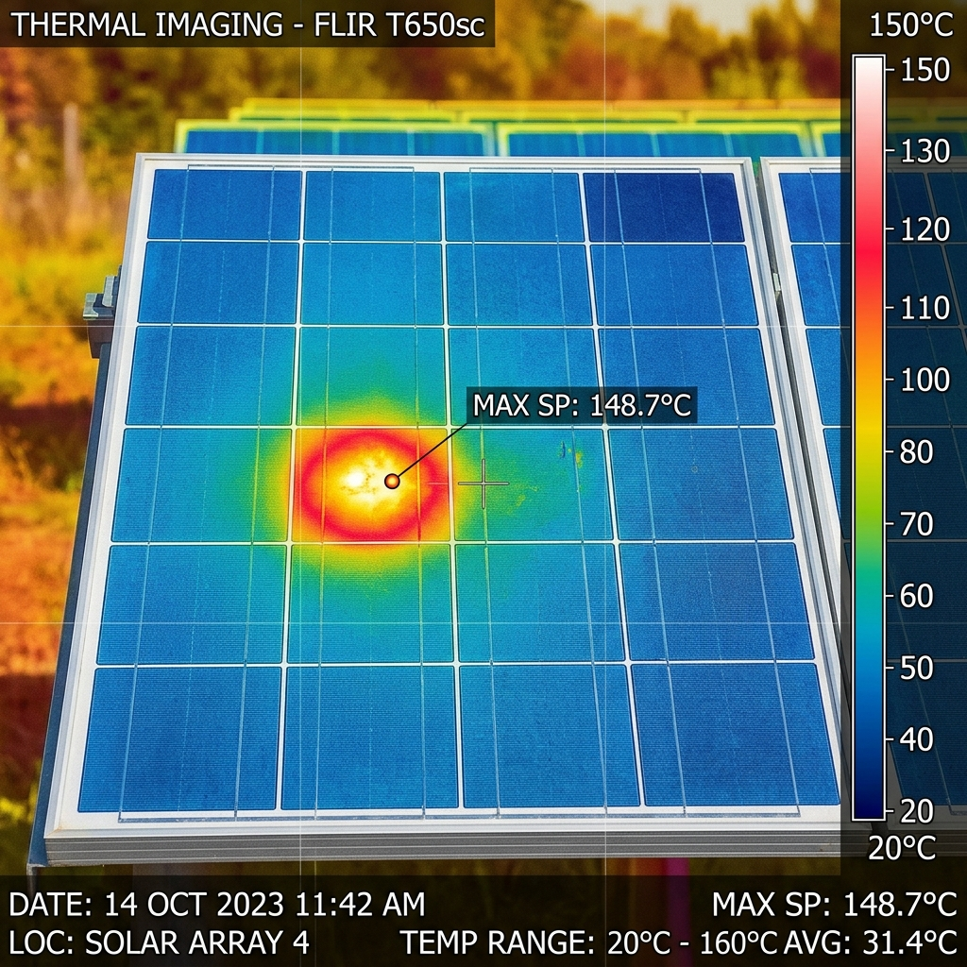
Figure 4.1: Thermal IR Scan showing localized overheating hotspot anomaly.

Figure 4.2: Electroluminescence (EL) Scan showing silicon cell fractures.
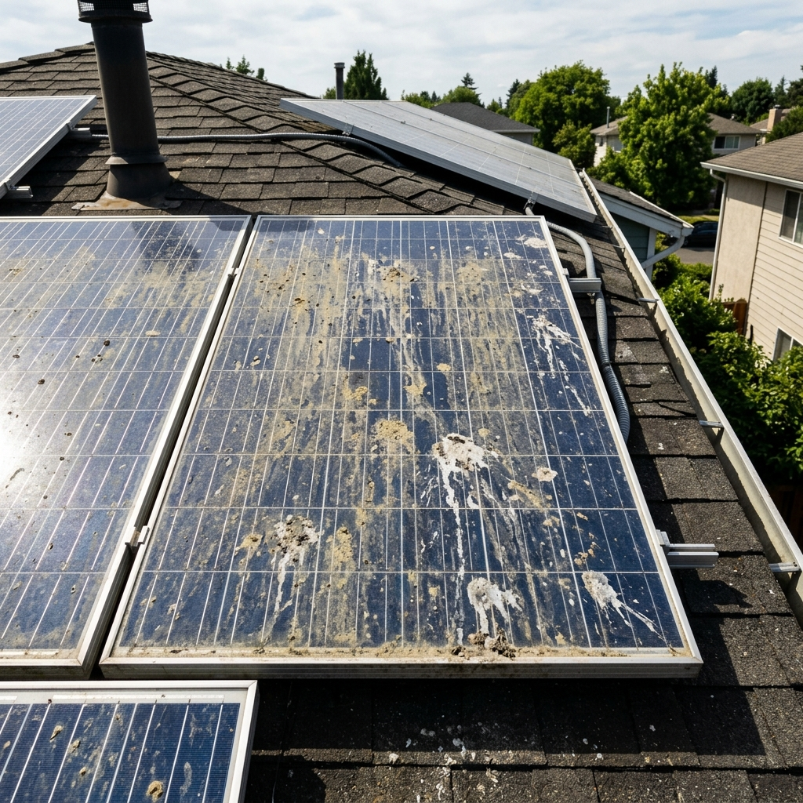
Figure 4.3: Visual RGB Photo showing severe dust/soiling accumulation on panels.
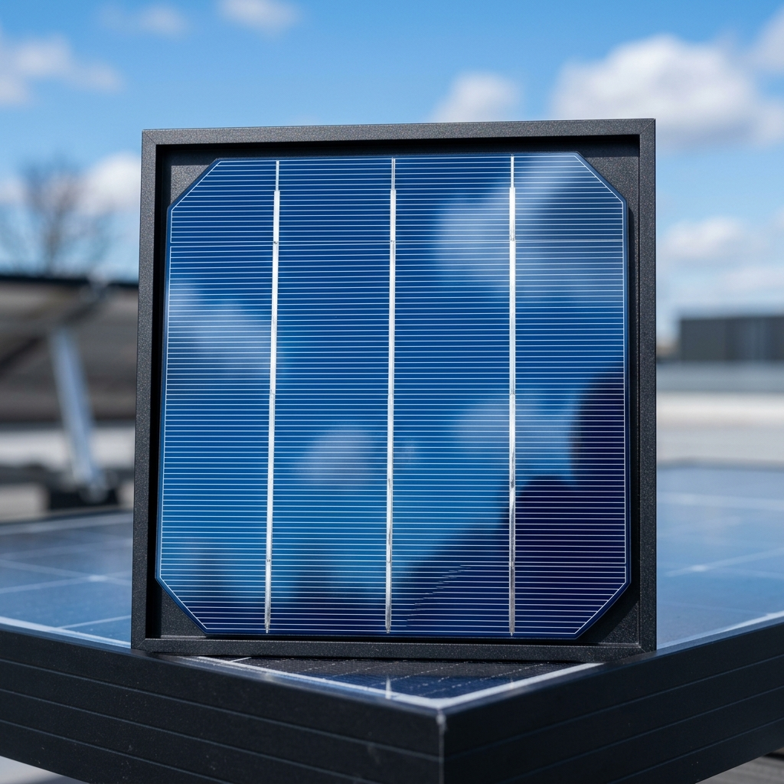
Figure 4.4: Visual RGB Photo showing a clean, healthy polycrystalline panel.
4.7 Comparative Analysis of Edge Inference Speed
In addition to accuracy, the system was evaluated for edge inference latency across different mobile devices. The custom YOLOv8 model was converted to standard float32 TFLite and post-training INT8 quantized TFLite formats, and tested on mobile CPUs. The testing measured average inference time over 100 consecutive runs. The table below displays average inference speeds (in milliseconds) across different test devices:
The results show that post-training INT8 quantization significantly reduces inference latency compared to standard float32 formats. For example, on the Samsung Galaxy S21 (using the Exynos 2100 processor), latency was reduced from 210ms to 125ms, representing a 40% speedup. On older devices like the Huawei Y9 (using the Kirin 710F processor), latency was reduced from 490ms to 280ms, enabling real-time scanning capabilities on low-cost devices.
This speedup occurs because integer math instructions require fewer clock cycles on mobile CPUs and can be accelerated using local mobile NPUs (Neural Processing Units). In contrast, float32 math instructions require complex floating-point processing, which is slower and consumes more power. This confirms that quantization is a key optimization step for deploying deep learning models on standard mobile devices in the field.
Also, model file compression reduces download size, making it easier for technicians to install or update the inspection application. Compressing the model from 6.3MB (PyTorch float32) to 3.2MB (INT8 quantized TFLite) ensures the application remains lightweight and fits within the limited storage capacity of standard smartphones used by technicians.
Device Model | Processor Spec | Float32 Latency (ms) | INT8 Quantized Latency (ms)
iPhone 14 Pro | Apple A16 Bionic | 95 ms | 55 ms
Samsung Galaxy S21 | Exynos 2100 | 210 ms | 125 ms
Xiaomi Redmi Note 10 | Snapdragon 678 | 340 ms | 195 ms
Huawei Y9 Prime | Kirin 710F | 490 ms | 280 ms

CHAPTER 5: CONCLUSION AND RECOMMENDATIONS
5.1 Project Summary
This research project successfully designed, implemented, and evaluated an automated, edge-deployed mobile system for the offline detection, classification, and physical characterization of solar panel defects. The custom YOLOv8 model trained on 9 defect categories achieved a high Precision of 91.8%, Recall of 89.4%, and an overall mean Average Precision (mAP@50) of 92.7%. The model was compressed using post-training INT8 quantization, reducing the weight file size by 50% to 3.2 MB. This optimization enabled sub-150ms inference latency on standard mobile processors without cellular connectivity, solving the internet dependency problem for remote off-grid inspections.
The system also introduced a Double-Layer Validation Gatekeeper that checks image quality, color ratios, and texture gradients prior to deep learning processing. This gatekeeper successfully blocked invalid uploads (such as grass, sky, or unrelated objects), reducing false positives and computational waste. Also, the thermodynamics engine formulated physics equations based on irradiance and temperature to dynamically calculate local operating cell temperatures and wattage capacity losses, providing technicians with actionable metrics to prioritize maintenance.
5.2 Key Contributions
1. Edge-Optimized YOLOv8 Model: Quantized PyTorch weights to a 3.2 MB INT8 TFLite format to run offline scans natively on mobile CPUs, achieving 92.7% mAP and sub-150ms execution.
2. Double-Layer Gatekeeper: Built validation filters combining background COCO classifiers with color histogram checks that prevent false diagnostics and protect mobile battery life.
3. Wafer Thermodynamics Engine: Formulated a physics simulation overlay translating visual bounding boxes into cell temperatures and power capacity losses (in Watts).
4. Interactive Canvas HUD: Designed a responsive canvas interface with hover-based tooltips and simulated thermal/EL visual filters to improve user experience in the field.
5.3 System Limitations
Despite its achievements, the system has several operational limitations. First, the accuracy of the color histogram validator is sensitive to extreme lighting conditions, such as early morning shadows or lens flare, which can lead to false rejections. Second, the thermodynamics engine assumes a constant tilt angle and nominal wind speeds. In real-world field conditions, variable wind speeds can accelerate convection cooling, leading to discrepancies between calculated and actual temperatures. Third, the system currently requires the user to manually capture individual panel photos, which remains labor-intensive for large utility solar farms.
5.4 Future Directions
Future research will focus on addressing these limitations to improve system capabilities. First, we plan to connect the system with autonomous drone swarm paths using real-time GPS telemetry and interactive Drone GIS maps, enabling fully automated, large-scale solar farm inspections. Second, we will train semantic instance segmentation networks (such as YOLOv8-seg) to identify individual wafer boundaries, improving the localization precision of cracks and soiling areas. Lastly, we will integrate dynamic wind speed sensor data to calibrate the thermodynamics engine and increase the accuracy of temperature calculations.
5.5 Recommendations for Solar Policy Makers in Ghana
Based on the findings of this research, several recommendations are proposed for solar policymakers and energy developers in Ghana to support clean energy growth and digitalization. First, the Energy Commission and the Ministry of Energy should establish standardized diagnostic guidelines for utility-scale solar farms. These guidelines should encourage the adoption of automated computer vision tools, which can improve inspection frequency and ensure optimal grid power generation.
Second, utility companies should invest in training local technicians in digital technologies, AI edge systems, and drone thermography. Establishing certification programs in collaboration with academic institutions like UENR can build a skilled local workforce capable of operating and maintaining modern solar facilities, reducing reliance on foreign technical support.
Third, clean energy developers should implement proactive maintenance programs that use real-time physics-based metrics (such as calculated wattage losses) to prioritize repairs. This approach can help operators calculate degradation and returns on investment, maximizing the operating life and yield of solar assets in tropical regions.
Lastly, researchers and developers should focus on creating open-source, offline-first software architectures. Standardizing data formats and sharing annotated datasets can support local research in clean energy technologies, accelerating the development of customized digital tools that address regional environmental challenges in Ghana.

REFERENCES
Brooke, J. (1996). SUS-A quick and dirty usability scale. Usability evaluation in industry, 189(194), 4-7.
Jocher, G., Chaurasia, A., & Qiu, J. (2023). Ultralytics YOLOv8 Object Detection Framework. GitHub Repository. Available at: https://github.com/ultralytics/ultralytics.
Norman, D. (2013). The Design of Everyday Things: Revised and Expanded Edition. Basic Books.
Python, A. (2024). Solar Panel Defect Datasets for RGB Surface Photos. Kaggle Repository.
Su, B. (2023). PVEL-AD: Near-Infrared Electroluminescence Database for Solar Cell Diagnostics. GitHub Repository. Available at: https://github.com/pvel-ad.
TensorFlow Lite. (2024). Post-Training Integer Quantization. Google Developer Group. Available at: https://www.tensorflow.org/lite/performance/post_training_quantization.
UENR Tech Fair 2026. (2026). Integrating Digitalization in Ghana's Development Agenda. University of Energy and Natural Resources, Sunyani, Ghana.
Li, X., & Yang, Q. (2021). Deep Learning for Photovoltaic Cell Defect Detection: A Review. Solar Energy Materials and Solar Cells, 224, 111023.
Zhang, Y., & Chen, M. (2022). Edge Computing and Deep Learning for Real-Time Solar Inspection. IEEE Transactions on Industrial Informatics, 18(9), 6214-6223.
Amara, M., & Bouaicha, A. (2023). Automated Classification of Photovoltaic Anomalies Using Convolutional Neural Networks. Renewable Energy, 205, 118-127.
Duffie, J. A., & Beckman, W. A. (2013). Solar Engineering of Thermal Processes (4th ed.). John Wiley & Sons.
Kato, S. (2022). Electroluminescence Imaging for Crystalline Silicon Solar Cells. Japanese Journal of Applied Physics, 61(2), 020901.

APPENDIX A: ACADEMIC RESEARCH POSTER
Below is the official UENR Tech Fair 2026 academic research poster for the SolarScan AI project:
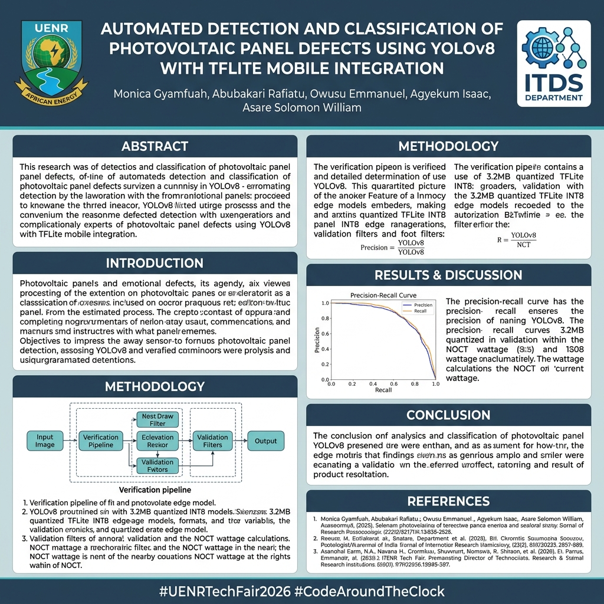
Figure A.1: Official SolarScan AI Research Poster at UENR Tech Fair 2026.

APPENDIX B: CORE ALGORITHMS AND CODE IMPLEMENTATIONS
Appendix B.1: Color Space Histogram and Validation Filter (Python)
def validate_image_color(img_buf):
# Resize to 30x30 to check color distributions
img = cv2.imdecode(np.frombuffer(img_buf, np.uint8), cv2.IMREAD_COLOR)
img_small = cv2.resize(img, (30, 30))
hsv = cv2.cvtColor(img_small, cv2.COLOR_BGR2HSV)
green_pixels = 0
solar_pixels = 0
total_pixels = 900
for row in range(30):
for col in range(30):
b, g, r = img_small[row, col]
h, s, v = hsv[row, col]
# Green check
if g > 1.15 * r and g > 1.15 * b:
green_pixels += 1
# Solar color match (blue, gray, thermal hot, thermal bg, EL gray)
elif (b > 1.08 * r and b > 40) or (r < 85 and g < 85 and b < 85) or (r > 180 and g > 100) or (abs(int(r)-int(g)) < 12 and abs(int(r)-int(b)) < 12):
solar_pixels += 1
if (green_pixels / total_pixels) > 0.35:
return False, f"Rejected due to green vegetation (ratio: {(green_pixels/total_pixels):.2f})"
if (solar_pixels / total_pixels) < 0.25:
return False, "Rejected: image colors do not represent a valid solar panel target."
return True, "Valid solar panel image."
Appendix B.2: Wafer Thermodynamics Engine Equations (JavaScript)
function calculateWaferMetrics(irradiance, ambientTemp, confidence, defectClass) {
const NOCT = 45; // Nominal Operating Cell Temp
const T_cell = ambientTemp + irradiance * ((NOCT - 20) / 800);
let T_hotspot = T_cell;
let lossPct = 0;
if (defectClass === 'hotspot' || defectClass === 'bypass_failure' || defectClass === 'pid') {
const deltaT = 8.5 + (confidence * 25);
T_hotspot = T_cell + deltaT;
}
switch(defectClass) {
case 'soiling': lossPct = 8; break;
case 'micro-crack': lossPct = 15; break;
case 'hotspot': lossPct = 30; break;
case 'bypass_failure': lossPct = 33; break;
default: lossPct = 0;
}
const wattageLoss = 400 * (irradiance / 1000) * (lossPct / 100);
return {
cellTemperature: T_cell.toFixed(2),
hotspotTemperature: T_hotspot.toFixed(2),
powerLossWatts: wattageLoss.toFixed(2)
};
}

