UNIVERSITY OF ENERGY AND NATURAL RESOURCES, SUNYANI
SCHOOL OF SCIENCES
DEPARTMENT OF INFORMATION TECHNOLOGY AND DECISION SCIENCES
AUTOMATED DETECTION AND CLASSIFICATION OF PHOTOVOLTAIC PANEL DEFECTS USING YOLOV8 WITH TFLITE MOBILE INTEGRATION
BY:
MONICA GYAMFUAH UEB32
ABUBAKARI RAFIATU UEB32
OWUSU EMMANUEL UEB32
AGYEKUM ISAAC UEB32
ASARE SOLOMON WILLIAM UEB3259122
SUPERVISED BY: DR. SAMUEL O. FRIMPONG
A PROJECT SUBMITTED TO THE DEPARTMENT OF INFORMATION TECHNOLOGY AND DECISION SCIENCES, IN PARTIAL FULFILLMENT OF THE REQUIREMENTS FOR THE AWARD OF THE DEGREE OF BACHELOR OF SCIENCE IN INFORMATION TECHNOLOGY
SUNYANI, GHANA JUNE, 2026

DECLARATION
Student's Declaration
We hereby declare that this project report titled "AUTOMATED DETECTION AND CLASSIFICATION OF PHOTOVOLTAIC PANEL DEFECTS USING YOLOV8 WITH TFLITE MOBILE INTEGRATION" is the result of our own original investigation and development under the supervision of Dr. Samuel O. Frimpong. It has not been presented in part or whole for any degree, diploma, or certificate in this or any other tertiary institution. All sources consulted, scholarly references, software libraries, and data repositories have been duly acknowledged with full citations in accordance with the academic regulations of the University of Energy and Natural Resources (UENR).
MONICA GYAMFUAH (UEB32)
Signature: ...................................................... Date: ...................................
ABUBAKARI RAFIATU (UEB32)
Signature: ...................................................... Date: ...................................
OWUSU EMMANUEL (UEB32)
Signature: ...................................................... Date: ...................................
AGYEKUM ISAAC (UEB32)
Signature: ...................................................... Date: ...................................
ASARE SOLOMON WILLIAM (UEB3259122)
Signature: ...................................................... Date: ...................................
Supervisor's Declaration
I hereby declare that the preparation, software design, and presentation of this project report were supervised by me in accordance with the guidelines on supervision of project reports laid down by the Department of Information Technology and Decision Sciences, University of Energy and Natural Resources (UENR), Sunyani, Ghana.
Dr. Samuel O. Frimpong (Supervisor)
Signature: ...................................................... Date: ...................................
Dr. Anokye Acheampong Amponsah (Head of Department)
Signature: ...................................................... Date: ...................................

DEDICATION
This project is dedicated to the Almighty God whose divine wisdom, boundless grace, and unfailing strength sustained us throughout this academic journey. It is also dedicated to our beloved parents, guardians, and families whose endless financial sacrifices, moral encouragement, and prayers laid the foundation of our education. Finally, we dedicate this work to all renewable energy technicians, software engineers, and researchers striving to accelerate clean and dependable energy access across Ghana and Sub-Saharan Africa.

ACKNOWLEDGEMENT
First and foremost, we give glory and thanksgiving to the Almighty God for providing us with good health, intellectual insight, and resilience to complete this capstone endeavor successfully. We express our profound gratitude to our project supervisor, Dr. Samuel O. Frimpong, whose scholarly guidance, constructive critique, and technical direction were pivotal in refining our computer vision models, architectural diagrams, and research methodology. We also extend our sincere appreciation to the Head of Department, Dr. Anokye Acheampong Amponsah, and all faculty and academic staff of the Department of Information Technology and Decision Sciences for their mentorship and rigorous instruction throughout our undergraduate curriculum. Special appreciation is due to the solar maintenance engineers and field operators in Sunyani and the Bono Region who participated in our preliminary requirement interviews and user acceptance testing sessions. Lastly, we thank our colleagues, friends, and families for their unwavering solidarity, patience, and encouragement throughout this intensive research and development project.

ABSTRACT
The rapid expansion of utility-scale and distributed solar photovoltaic (PV) installations across Ghana has introduced severe maintenance bottlenecks. Existing operations rely predominantly on periodic manual physical audits and paper-based logbooks. This conventional methodology suffers from high operational latency, inter-inspector inconsistency, dangerous delays in detecting thermal hotspots, physical cracks, and heavy soiling, and the absence of real-time communication between field technicians and central plant managers. These undetected anomalies degrade annual power yield by 15% to 35% and present acute fire and electrical breakdown hazards. To resolve these systemic failures, this study designed, implemented, and evaluated "SolarScan AI"—an end-to-end automated photovoltaic defect detection, classification, and maintenance tracking system tailored to the operational realities of Sub-Saharan Africa. The system incorporates a three-tier edge-to-cloud architecture utilizing an optimized YOLOv8 deep learning model quantized via TensorFlow Lite (TFLite INT8/FP16) for real-time mobile on-device inference (<25 ms per frame), a high-performance FastAPI backend, and a responsive React progressive web application with offline-first caching capabilities. Photovoltaic anomalies are classified into four primary operational categories (Cracks, Hotspots, Heavy Soiling, and Healthy Modules) and mapped directly to international standard IEC 62446-3 severity thresholds. Upon defect verification, the system automatically generates geospatial maintenance work orders and dispatches instant SMS and email alerts to field technicians. Following an Applied Developmental Research Model (ADRM) and Spiral SDLC, the system underwent rigorous automated testing and a comprehensive User Acceptance Testing (UAT) evaluation involving 12 professional solar operators and maintenance engineers. SolarScan AI achieved a 91.7% task completion success rate, an overall system usability satisfaction score of 4.3 out of 5.0, and an 85% reduction in inspection turnaround time, confirming that mobile edge computer vision combined with automated work order workflows significantly elevates solar asset reliability, data integrity, and operational decision-making.
Keywords: Photovoltaic Defect Detection, Computer Vision, YOLOv8, TensorFlow Lite, Edge Computing, DeLone & McLean Model, IEC 62446-3, Maintenance Tracking System, Solar Energy Ghana.

TABLE OF CONTENTS
DECLARATION ......................................................................... i
DEDICATION ......................................................................... ii
ACKNOWLEDGEMENT ................................................................... iii
ABSTRACT ........................................................................... iv
TABLE OF CONTENTS ................................................................... v
LIST OF TABLES .................................................................... vii
LIST OF FIGURES .................................................................. viii
LIST OF ABBREVIATIONS ............................................................... x
CHAPTER ONE: INTRODUCTION ........................................................... 1
1.1 Background of the Study ...................................................... 1
1.2 Problem Statement ............................................................ 3
1.3 Objectives ................................................................... 4
1.3.1 Aim ..................................................................... 4
1.3.2 Specific Objectives ..................................................... 4
1.4 Significance of the Study .................................................... 5
1.5 Scope of the Study ........................................................... 7
1.6 Limitations of the Study ..................................................... 8
1.7 Organization of the Study .................................................... 8
CHAPTER TWO: LITERATURE REVIEW ..................................................... 10
2.1 Introduction ................................................................ 10
2.2 Solar Photovoltaic Systems as an Operational Mandate ........................ 10
2.3 Systemic Failures of Paper-Based Logbook Management ......................... 12
2.4 Theoretical Framework: DeLone and McLean IS Success Model ................... 14
2.5 Web and Edge Mobile Systems in Ghanaian Renewable Energy .................... 17
2.6 Web Application Frameworks and Security in Critical Energy Systems .......... 19
2.7 Automated Communication and Notification Systems in Operational Contexts .... 22
2.8 Review of Existing Systems .................................................. 24
2.9 Comparative Analysis and Rationale for the Proposed System .................. 32
2.10 Research Gap ............................................................... 36
CHAPTER THREE: METHODOLOGY ......................................................... 38
3.1 Introduction ................................................................ 38
3.2 Research Design: Applied Developmental Research Model ....................... 38
3.3 System Methodology: The Spiral SDLC Model ................................... 39
3.4 Data Collection Methods ..................................................... 41
3.5 System Requirements Specification ........................................... 43
3.5.1 Functional Requirements (FR-01 to FR-22) ............................... 43
3.5.2 Non-Functional Requirements ............................................ 47
3.6 System Architecture: 3-Tier Edge-to-Cloud AI Architecture ................... 49
3.7 Technician and Solar Farm Onboarding Workflow ............................... 52
3.8 Field Inspection, Defect Diagnosis, and Work Order Workflow ................. 53
3.9 Technology Stack Summary .................................................... 55
3.10 System Testing Strategy .................................................... 56
3.11 System Design Diagrams ..................................................... 58
3.12 Chapter Summary ............................................................ 64
CHAPTER FOUR: SYSTEM IMPLEMENTATION AND RESULTS .................................... 65
4.1 Introduction ................................................................ 65
4.2 System Implementation Overview .............................................. 65
4.3 Module-by-Module Implementation (Figures 4.1 to 4.15) ....................... 66
4.4 Functional Requirements Verification Matrix ................................. 82
4.5 System Testing Results ...................................................... 86
4.5.1 Automated Unit and Integration Testing ................................. 86
4.5.2 User Acceptance Testing (UAT) Evaluation ............................... 88
4.6 Evaluation Against the DeLone and McLean IS Success Model ................... 92
4.7 Chapter Summary ............................................................. 95
CHAPTER FIVE: SUMMARY, CONCLUSION, AND RECOMMENDATIONS ............................. 96
5.1 Summary of the Study ........................................................ 96
5.2 Conclusion .................................................................. 98
5.3 Recommendations for Future Development ...................................... 99
REFERENCES ........................................................................ 101
APPENDIX A: SELECTED SOURCE CODE LISTINGS ......................................... 107
APPENDIX B: GITHUB REPOSITORY LINK & ACCESS INFORMATION ........................... 112

LIST OF TABLES
Table 2.1: DeLone and McLean Information Systems Success Model Dimensions ....... 16
Table 2.2: Comparison of Existing Solar Monitoring Systems vs SolarScan AI ...... 34
Table 3.1: System Functional Requirements Specification (FR-01 to FR-22) ........ 44
Table 3.2: Comprehensive Technology Stack Summary and Architectural Rationale ... 55
Table 4.1: Functional Requirements Verification Matrix (FR-01 to FR-22) ......... 83
Table 4.2: Empirical Evaluation Against the DeLone and McLean IS Success Model ... 93

LIST OF FIGURES
Figure 3.1: Spiral Software Development Life Cycle Model for SolarScan AI ....... 40
Figure 3.2: Theoretical Framework: DeLone & McLean IS Success Model Adaptation ... 48
Figure 3.3: UML Use Case Diagram for SolarScan AI System Actors and Interactions ... 58
Figure 3.4: Entity Relationship Diagram (ERD) of SolarScan AI Relational Schema ... 60
Figure 3.5: SolarScan AI End-to-End Operational System Flowchart ................ 62
Figure 3.6: Three-Tier Edge-to-Cloud System Architecture Diagram ................ 63
Figure 4.1: Authentication & Role-Based Access Control (Login / Register Modal) ... 67
Figure 4.2: Real-time Analytics & Executive Solar Farm Dashboard ................ 68
Figure 4.3: Edge Mobile Camera Live Feed & TFLite Inference Viewport ............ 69
Figure 4.4: Multi-Class Defect Bounding Box Visualization & Confidence Gauges ... 70
Figure 4.5: Defect Diagnostics: Crack, Hotspot, and Soiling Detection Modes ..... 72
Figure 4.6: IEC 62446-3 Severity Classification & Thermal Delta-T Evaluation .... 73
Figure 4.7: Solar Farm Geospatial Asset & Inverter String Layout Map ............ 74
Figure 4.8: Automated Maintenance Work Order Generation & Priority Assignment ... 75
Figure 4.9: Field Technician Dispatch & Work Order Task Execution Interface ..... 76
Figure 4.10: Field Remediation & Audit Evidence Hub Interface ................... 77
Figure 4.11: Historical Inspection Log & Trend Analytics Dashboard .............. 78
Figure 4.12: Role-Based Clearance Guard & System Security Enforcement ........... 79
Figure 4.13: Edge Model Synchronization & Continuous Retraining Pipeline ........ 80
Figure 4.14: Mobile Deployment & Instant Field Access (QR Code Connect) ......... 81
Figure 4.15: Offline-First Progressive Web App (PWA) Execution Viewport ......... 82

LIST OF ABBREVIATIONS
ACID : Atomicity, Consistency, Isolation, Durability
ADRM : Applied Developmental Research Model
AI : Artificial Intelligence
API : Application Programming Interface
AUC : Area Under the Curve
BSc : Bachelor of Science
CNN : Convolutional Neural Network
CPU : Central Processing Unit
CSV : Comma-Separated Values
CV : Computer Vision
DFD : Data Flow Diagram
DL : Deep Learning
ERD : Entity Relationship Diagram
FPS : Frames Per Second
GPU : Graphics Processing Unit
GPS : Global Positioning System
HTTP : Hypertext Transfer Protocol
HTTPS : Hypertext Transfer Protocol Secure
ICT : Information and Communication Technology
IEC : International Electrotechnical Commission
IoU : Intersection over Union
IT : Information Technology
ITDS : Information Technology and Decision Sciences
JWT : JSON Web Token
mAP : Mean Average Precision
NFR : Non-Functional Requirement
NIST : National Institute of Standards and Technology
O&M : Operations and Maintenance
ORM : Object-Relational Mapping
OWASP : Open Web Application Security Project
PDF : Portable Document Format
PR : Precision-Recall
PWA : Progressive Web Application
PV : Photovoltaic
RBAC : Role-Based Access Control
REST : Representational State Transfer
RGB : Red-Green-Blue (Visible Spectrum)
ROC : Receiver Operating Characteristic
SDLC : Software Development Life Cycle
SIWES : Student Industrial Work Experience Scheme
SMS : Short Message Service
SQL : Structured Query Language
SUS : System Usability Scale
TFLite : TensorFlow Lite
UAT : User Acceptance Testing
UENR : University of Energy and Natural Resources
UI : User Interface
UML : Unified Modeling Language
URI : Uniform Resource Identifier
URL : Uniform Resource Locator
UX : User Experience
WIL : Work-Integrated Learning
WSGI : Web Server Gateway Interface
XSS : Cross-Site Scripting
YOLO : You Only Look Once

CHAPTER ONE
INTRODUCTION
1.1 Background of the Study
The rapid acceleration of renewable energy adoption has positioned solar photovoltaic (PV) systems at the heart of global strategies to combat climate change, guarantee energy security, and expand electricity access. In Sub-Saharan Africa, where abundant solar irradiation provides an exceptional natural resource, solar energy has emerged as the cornerstone of clean industrialization. Within Ghana, the national energy mandate outlined in the Renewable Energy Master Plan (2019–2030) targets a substantial increase in grid-connected renewable capacity, exemplified by flagship utility-scale installations such as the Bui Power Authority's 50 MW solar-hydro hybridization scheme, the Kaleo 13 MW and Lawra 6.5 MW PV plants developed by the Volta River Authority (VRA), and widespread rooftop installations across public universities, including the University of Energy and Natural Resources (UENR) in Sunyani. These capital-intensive assets are designed for operational lifespans exceeding twenty-five years, yet their long-term economic viability and electricity output depend fundamentally on consistent, rigorous, and timely Operations and Maintenance (O&M).
Despite the cutting-edge nature of photovoltaic hardware, the operational tracking and maintenance supervision governing these assets in Ghana have largely remained anchored in legacy administrative techniques. Field inspections across utility farms and commercial installations continue to rely heavily on manual physical audits, paper-based logbooks, and disconnected spreadsheet records. Field technicians walk across expansive solar panel arrays carrying physical clipboards to record observed surface dirt, visible structural cracks, and anomalous thermal discoloration. At the close of each inspection cycle, these handwritten observations are physically transported to administrative offices, manually transcribed into ad-hoc log files, and archived in physical cabinets. This administrative approach closely mirrors the systemic deficiencies documented in manual student tracking and institutional logbook workflows across Ghanaian tertiary education (Dondofema et al., 2020; Adetiba et al., 2012). Just as physical logbooks delay educational supervision and compromise record integrity, paper-based solar maintenance logbooks create severe administrative blind spots, prevent proactive intervention, and expose multi-million-dollar energy installations to avoidable degradation.
Under tropical and semi-arid climatic conditions characteristic of West Africa, solar photovoltaic modules operate under extreme environmental stress. Extended dry periods generate intense dust deposition, exacerbated by seasonal Harmattan winds carrying fine airborne particulates that accumulate unevenly across panel glass. Such heavy soiling can degrade solar power generation by 15% to 35% within weeks (Maghami et al., 2016). Furthermore, prolonged thermal stress, localized partial shading from bird droppings or vegetation, and manufacturing imperfections frequently trigger localized reverse-bias conditions. In these scenarios, shaded or damaged cells act as electrical resistors rather than power generators, dissipating energy as intense heat. These localized high-temperature zones—known as thermal hotspots—often exceed 80°C to 120°C, causing irreversible polymer delamination, solar cell cracking, and in severe instances, catastrophic electrical fires that threaten entire arrays (IEC, 2016).
To safeguard photovoltaic assets, international standards such as IEC 62446-3 prescribe periodic thermographic and visual inspections to identify thermal anomalies and mechanical defects before permanent structural failure occurs. However, executing these standards via manual inspections and paper records is fundamentally unsustainable. Manual walk-throughs across a 10 MW solar facility encompassing over 25,000 modules require several weeks of intensive labor, exposing human inspectors to high ambient heat and electrical hazards. More critically, human visual inspection cannot reliably detect subsurface micro-cracks or quantify thermal anomalies that are invisible to the naked eye. By the time a paper logbook is reviewed by a plant manager, minor module-level faults often progress into irreversible string-level outages. As organizations modernize their operations, data integrity, operational speed, and automated decision support become vital determinants of organizational success (IBM Corporation, 2022). The Ghana ICT for Accelerated Development (ICT4AD) Policy explicitly emphasizes leveraging digital technologies and information systems to optimize operational productivity across critical national infrastructure. SolarScan AI addresses this exact technological mandate by introducing an end-to-end web and mobile edge-computing platform that automates defect detection, diagnostic classification, and maintenance tracking in real time.
1.2 Problem Statement
Photovoltaic inspection and maintenance tracking across solar farms in Ghana currently face severe operational, technological, and administrative bottlenecks stemming from an over-reliance on paper-based logbook management and subjective manual evaluations. This legacy paradigm creates five critical systemic failures:
- 1. Operational Latency and Delayed Defect Remediation: Paper logbooks and handwritten inspection reports introduce days or weeks of administrative latency between field defect observation and maintenance execution. By the time a handwritten log is transcribed and reviewed, acute thermal hotspots and diode failures frequently deteriorate into permanent module destruction, voiding manufacturer warranties and posing severe electrical fire hazards.
- 2. Inter-Inspector Inconsistency and Human Error: Manual visual assessments are inherently subjective and error-prone. Different field technicians interpret identical physical cracks, shading patterns, and soiling layers with inconsistent severity ratings. Subtle micro-cracks and thermal anomalies cannot be reliably quantified without standardized digital decision-support metrics, resulting in high rates of undetected anomalies and misallocated repair resources.
- 3. Severe Energy Yield and Economic Revenue Losses: Delayed identification of surface soiling and cell cracks causes persistent power derating of 15% to 35%, translating to thousands of kilowatt-hours in lost electricity generation monthly. In grid-tied and commercial installations, these unmitigated losses undermine the financial return on investment and reduce plant reliability.
- 4. Absence of Automated Work Order Dispatch and Tracking: In current workflows, field inspectors, maintenance technicians, and plant supervisors operate in functional isolation. When an inspector records a defect on paper, there is no automated mechanism to dispatch an actionable work order, assign a specific technician, or track remediation status. Communication relies on ad-hoc phone calls or messaging apps, leading to lost work orders and zero accountability.
- 5. Information Fragmentation and Lack of Audit Trails: Physical logbooks and scattered digital spreadsheets prevent longitudinal asset tracking. Plant supervisors cannot analyze historical defect degradation rates, predict component failure curves, or generate standardized audit reports required by insurance underwriters and regulatory authorities. This lack of centralized data storage violates the principles of information system success (DeLone & McLean, 2003).
Commercial drone analytics platforms such as Raptor Maps and SenseHawk provide digital defect mapping but are prohibitively expensive for Ghanaian institutions, demand specialized airborne drone equipment, require persistent high-bandwidth cloud connectivity, and lack native integration with local SMS-based technician alert workflows. Consequently, there is an urgent research and engineering imperative for an accessible, edge-deployable, automated information system that empowers local field technicians to perform real-time computer vision defect classification and immediately trigger closed-loop maintenance workflows.
1.3 Objectives
1.3.1 Aim
The primary aim of this capstone research project is to design, implement, and evaluate 'SolarScan AI'—an automated, edge-to-cloud photovoltaic defect detection, classification, and maintenance tracking system that integrates YOLOv8 deep learning inference with TensorFlow Lite (TFLite) mobile deployment and web-based decision support for solar farm asset management.
1.3.2 Specific Objectives
To achieve this overall aim, the following specific objectives were pursued:
- 1. System Requirements Analysis: To formulate and document a comprehensive System Requirements Specification (SRS) encompassing functional requirements (FR-01 to FR-22) and non-functional constraints for solar farm defect management, asset registration, and maintenance tracking.
- 2. Edge Computer Vision Engine Development: To train, optimize, and quantize a state-of-the-art YOLOv8 deep learning computer vision model via TensorFlow Lite (FP16/INT8) capable of classifying multi-class photovoltaic anomalies (Cracks, Hotspots, Soiling, and Healthy modules) on resource-constrained mobile devices with inference latency under 25 milliseconds per frame.
- 3. Cloud API and Asset Management Backend: To develop a high-performance, secure backend application using FastAPI with asynchronous request handling, JSON Web Token (JWT) authentication, Role-Based Access Control (RBAC), and relational database persistence for multi-tier user and asset management.
- 4. Automated Work Order and Decision Support Engine: To design an intelligent decision support module that evaluates detected defect dimensions and temperature gradients against international standard IEC 62446-3 severity levels, automatically generating prioritized maintenance work orders.
- 5. Multi-Channel Communication Gateway: To engineer an automated notification and alerting gateway integrating SMS and email services for instant technician dispatch, task assignment tracking, and remediation verification.
- 6. Responsive Client and Progressive Web Application: To develop a responsive web portal and Progressive Web Application (PWA) incorporating interactive telemetry dashboards, geospatial string mapping, camera viewports, offline caching, and automated PDF audit report generation.
- 7. Empirical Evaluation and User Acceptance Testing: To rigorously evaluate system functionality, inference latency, defect classification accuracy, and user satisfaction through automated test suites and User Acceptance Testing (UAT) structured around the DeLone and McLean Information Systems Success Model.
1.4 Significance of the Study
The development and deployment of SolarScan AI provides profound pedagogical, institutional, technological, and societal benefits, advancing both the academic discipline of Information Technology and the operational sustainability of renewable energy infrastructure in Ghana:
From an academic and pedagogical perspective, this project bridges the theoretical foundations of Information Technology, Decision Sciences, and Applied Artificial Intelligence. It demonstrates how advanced computer vision architectures (YOLOv8) can be successfully adapted from high-performance server environments to resource-constrained mobile edge platforms. The study illustrates the application of rigorous software engineering principles—specifically the Applied Developmental Research Model and Spiral SDLC—to solve complex, real-world cyber-physical monitoring challenges, providing a foundational benchmark for future undergraduate and postgraduate research within the Department of Information Technology and Decision Sciences at UENR.
At the institutional level, the project directly supports the operational sustainability of the University of Energy and Natural Resources. As an institution mandated to lead in energy education and research, UENR maintains rooftop and test-bench solar installations across its campuses. SolarScan AI delivers a centralized, zero-license-cost digital monitoring platform that replaces manual paper tracking, eliminates administrative overhead, provides real-time visibility into panel health, and empowers university maintenance staff with data-driven decision tools.
Technologically, this research contributes an open, lightweight edge-to-cloud architecture specifically engineered for emerging economies. By executing neural inference locally on mobile devices using quantized TFLite models, the system operates seamlessly in remote solar farms characterized by intermittent or non-existent cellular network coverage. This eliminates the prohibitive cloud computing and bandwidth costs associated with proprietary Western monitoring platforms, establishing an affordable technological paradigm for decentralized asset inspection.
Societally and economically, maximizing the operational uptime and energy yield of photovoltaic systems directly accelerates Ghana's clean energy transition. By catching micro-cracks, dust layers, and thermal hotspots before they cause catastrophic cell failure or fire outbreaks, SolarScan AI protects millions of Cedis in renewable energy capital investments, safeguards national grid stability, and reduces carbon emissions by ensuring solar installations consistently generate at peak technical capacity.
1.5 Scope of the Study
The scope of this study encompasses the following defined boundaries:
- Defect Taxonomy: The computer vision models are specifically trained and calibrated to detect four critical operational module states: (a) Structural Cracks, (b) Thermal Hotspots, (c) Surface Soiling / Dust Accumulation, and (d) Healthy Photovoltaic Modules.
- Module Technologies: The research targets monocrystalline and polycrystalline silicon photovoltaic panels, which represent over 95% of solar installations currently deployed in Ghana's commercial, academic, and utility-scale sectors.
- Imaging Modalities: The system supports dual-modality input: high-resolution visible-spectrum RGB imagery captured via smartphone cameras or drone gimbals, and radiometric thermal imagery captured via handheld or mounted infrared sensors.
- System Implementation Scope: The software artifact comprises an edge mobile inference pipeline (TFLite INT8/FP16), an asynchronous cloud REST API (FastAPI), a relational database persistence layer (PostgreSQL/SQLite), an automated notification dispatch service (SMS/Email), and a responsive Progressive Web App (React) supporting offline-first field inspections.
- Geographical and Evaluative Scope: Empirical testing and user acceptance evaluations were conducted within the Bono Region of Ghana, involving solar installations at the University of Energy and Natural Resources and affiliated regional solar engineering stakeholders.
1.6 Limitations of the Study
While the system delivers robust defect detection and automated tracking, certain operational limitations must be acknowledged:
- Mobile Hardware Variability: Mobile on-device inference frame rates (FPS) and battery consumption vary depending on the target smartphone's internal chipset, RAM capacity, and hardware acceleration capabilities (Neural Processing Unit or GPU delegate support).
- Thermal Hardware Accessibility: High-grade radiometric thermal imaging cameras remain high-cost accessories. While the system supports direct thermal image intake and delta-T thresholding, field deployment in resource-constrained settings may rely more heavily on visible RGB inspection and low-cost sensor attachments.
- Environmental and Glare Interference: Extreme tropical weather conditions, including torrential rainstorms or intense solar glare at solar noon, can induce optical reflections on panel glass surfaces that may temporarily degrade bounding box localization precision unless filtered by preprocessing algorithms.
- Network Connectivity in Remote Terrains: While the Progressive Web App implements robust offline caching via client-side IndexedDB, real-time SMS alerts and cloud database synchronization require intermittent cellular connectivity, meaning notifications are queued until network reception is restored.
1.7 Organization of the Study
This project report is structured into five cohesive chapters, organized as follows:
Chapter One introduces the research background, delineates the problem statement regarding manual paper-based solar inspection logs, defines the primary aim and specific objectives, outlines the pedagogical, institutional, and societal significance, and establishes the scope and limitations.
Chapter Two presents a thorough review of relevant literature. It explores photovoltaic operational mandates, analyzes the systemic failures of paper logbooks, details the DeLone and McLean Information Systems Success Model as the theoretical foundation, reviews modern web frameworks and edge AI architectures, evaluates ten existing commercial and academic systems, and identifies the explicit research gap addressed by SolarScan AI.
Chapter Three details the research methodology and system design. It outlines the Applied Developmental Research Model (ADRM) and Spiral SDLC, details empirical data collection methods, specifies the twenty-two functional requirements (FR-01 to FR-22), describes the three-tier edge-to-cloud architecture, and presents system design diagrams including Use Case, Entity Relationship, Flowchart, and Architecture diagrams.
Chapter Four covers system implementation and testing results. It provides a detailed, module-by-module walkthrough of all fifteen system interfaces supported by authentic UI figures, presents the functional requirements verification matrix, details automated testing performance and User Acceptance Testing (UAT) results (91.7% task completion, 4.3/5.0 satisfaction), and evaluates the system against the DeLone and McLean IS success dimensions.
Chapter Five concludes the study with a comprehensive summary of findings, conclusions on operational impact, and strategic recommendations for future research, including native mobile app store distribution, RTK autonomous drone path integration, and longitudinal degradation modeling.
The report concludes with a comprehensive References section compiled in APA 7th edition with active hyperlinks, followed by Appendix A (Selected Source Code Listings) and Appendix B (GitHub Repository Link and Access Information).

CHAPTER TWO
LITERATURE REVIEW
2.1 Introduction
This chapter reviews relevant academic literature, theoretical frameworks, and existing software systems governing photovoltaic defect management, mobile edge computing, and automated maintenance tracking. The review establishes the operational criticality of solar photovoltaic infrastructure, dissects the systemic vulnerabilities inherent in legacy paper logbook management, and grounds the system architecture in the updated DeLone and McLean Information Systems Success Model (2003). Furthermore, it investigates modern web frameworks, microservices security, lightweight deep learning deployment via TensorFlow Lite (TFLite), and automated notification protocols. Finally, it presents an in-depth comparative review of ten existing commercial and academic platforms, culminating in the identification of the empirical and technological research gap that SolarScan AI addresses.
2.2 Solar Photovoltaic Systems as an Operational Mandate
The global transition toward renewable energy has propelled photovoltaic technology to the forefront of national infrastructure development. In developing nations such as Ghana, solar energy is not merely an environmental policy goal but a fundamental driver of economic industrialization, rural electrification, and grid stabilization (Renewable Energy Master Plan, 2019). Utility-scale installations and distributed commercial rooftop arrays represent multi-million-dollar capital investments engineered for 25- to 30-year operational lifespans. However, solar panels are dynamic cyber-physical assets exposed continuously to harsh outdoor environments. Their actual energy output and mechanical integrity degrade over time through multiple interconnected failure modes (Dhimish et al., 2018).
Among the most pervasive degradation pathways in tropical West African environments is surface soiling. Dust particulates, pollen, bird droppings, and atmospheric aerosols settle on module glass, creating an opaque optical barrier that attenuates incident solar irradiance. Studies indicate that unmitigated soiling in semi-arid zones can reduce power generation by 15% to 35% within a single month of dry weather (Maghami et al., 2016). More insidiously, non-uniform soiling causes localized partial shading. In a series-connected photovoltaic string, cells that are shaded cannot generate current commensurate with illuminated cells; instead, they are forced into reverse bias by the string current, dissipating power as localized heat. This thermal phenomenon, termed a 'hotspot', can escalate cell temperatures above 100°C, causing ethylene vinyl acetate (EVA) browning, backsheet delamination, glass breakage, and permanent solar cell burnout (IEC, 2016).
Mechanical cracking represents another critical failure mode. Micro-cracks develop within brittle silicon wafers during manufacturing transport, improper manual handling during installation, or thermal stress cycles caused by extreme day-night temperature swings. While initially invisible to the human eye, micro-cracks propagate under wind loading and thermal expansion, eventually severing electrical contact fingers and isolating active cell areas. This causes irreversible power losses and secondary hotspot formation. Therefore, maintaining photovoltaic asset reliability requires an operational mandate characterized by frequent, high-precision inspections, quantitative severity diagnostics, and closed-loop remediation workflows.
2.3 Systemic Failures of Paper-Based Logbook Management
Historically, the administration of field inspections and equipment maintenance across Ghanaian industrial and educational facilities has relied on paper logbooks and physical records. Whether tracking student progress during compulsory industrial attachments (Dondofema et al., 2020; Adetiba et al., 2012) or monitoring solar plant equipment, paper-based administration exhibits profound systemic vulnerabilities that severely compromise operational efficiency, data integrity, and organizational responsiveness.
First, paper logbooks introduce unacceptable operational latency. When field inspectors record anomalies on physical clipboards, several days or weeks typically elapse before these documents are returned to a central plant office, reviewed by a qualified engineer, and converted into actionable maintenance orders. In the context of photovoltaic systems, where thermal hotspots can cause irreversible module destruction within hours under intense noon sun, this administrative delay results in catastrophic component loss and electrical fire hazards (Cooper et al., 2010).
Second, paper-based logging suffers from human subjectivity, handwriting illegibility, and inconsistent severity assessment. Different technicians employ idiosyncratic terms to describe identical defects, and manual evaluations lack objective quantitative measurements (such as temperature differential delta-T or pixel defect bounding area). Third, physical records are highly susceptible to physical loss, environmental water damage, and unauthorized tampering. Historical trend analysis is practically impossible when data is trapped in paper archives, preventing engineers from identifying recurring module batches or calculating degradation rates. These systemic failures highlight the urgent need for computerized, cloud-synchronized information systems that enforce standardized workflows, immediate auditability, and automated decision support.
2.4 Theoretical Framework: DeLone and McLean IS Success Model
To rigorously conceptualize, develop, and evaluate SolarScan AI as a socio-technical artifact, this study adopts the updated DeLone and McLean Information Systems Success Model (DeLone & McLean, 2003) as its theoretical foundation. Originally introduced in 1992 and comprehensively revised in 2003 to reflect e-commerce and web-based systems, the model posits that information system success is a multidimensional, interdependent construct comprising six core dimensions: Information Quality, System Quality, Service Quality, Intention to Use / Use, User Satisfaction, and Net Benefits.
In the context of solar asset management, Information Quality reflects the accuracy, timeliness, completeness, and relevance of the diagnostic data delivered to field technicians and plant supervisors. System Quality assesses the technical performance of the software platform, including edge inference latency, offline caching reliability, mobile responsiveness, and API availability. Service Quality measures the responsiveness of automated alerting channels (SMS/Email), user documentation, and technical support mechanisms. Together, these three quality dimensions directly drive technicians' and supervisors' Intention to Use and User Satisfaction, which collectively determine the Net Benefits—manifested as reduced inspection turnaround time, prevented equipment burnout, improved energy yield, and enhanced operational auditability.
Table 2.1 delineates how the six dimensions of the DeLone and McLean IS Success Model are operationalized within the design and evaluation of SolarScan AI.
Table 2.1: DeLone and McLean Information Systems Success Model Dimensions Adapted for SolarScan AI
IS Success Dimension | Operational Indicator in SolarScan AI | Target Operational Outcome | Evaluation Metric
Information Quality | Precision and recall of YOLOv8 defect detection; IEC 62446-3 severity classification | Accurate, actionable defect data with zero ambiguous ratings | Defect Detection mAP50 > 90%; Severity precision > 92%
System Quality | Edge TFLite inference latency; offline PWA caching; FastAPI endpoint response time | Seamless field execution with <25ms inference and 99.9% uptime | On-device latency <25ms; API response <200ms; zero crash rate
Service Quality | Automated SMS/Email dispatch; instant PDF audit export; model retraining pipeline | Immediate stakeholder notification and transparent reporting | Alert delivery time <10s; 100% successful PDF audit generation
Intention to Use / Use | Daily active field scans; technician work order status updates; supervisor logins | Sustained voluntary utilization across solar farm routine inspections | Daily inspection scan volume; >85% work order update compliance
User Satisfaction | Technician and engineer usability ratings across UI, mobile viewport, and navigation | High ease-of-use and perceived utility across technical skill levels | System Usability Scale (SUS) score > 80; UAT satisfaction > 4.0/5.0
Net Benefits | Reduction in inspection turnaround time; rapid thermal hotspot remediation; energy savings | Quantifiable operational time savings and solar asset protection | >80% reduction in inspection duration; 100% severe hotspot mitigation

2.5 Web and Edge Mobile Systems in Ghanaian Renewable Energy
The deployment of information systems in Sub-Saharan Africa requires acute consideration of infrastructural realities, including inconsistent cellular network coverage, variable mobile device hardware capabilities, and bandwidth cost constraints. Historically, enterprise software depended on centralized client-server architectures or heavy desktop software. However, the ubiquity of low-cost Android smartphones across Ghana has established mobile web applications and Progressive Web Applications (PWAs) as the optimal paradigm for enterprise field operations (Taddese, 2020).
PWAs leverage modern browser capabilities, including Service Workers, Cache Storage API, and client-side IndexedDB, allowing web applications to install directly on mobile devices, launch from the home screen, and operate seamlessly without an active internet connection. In solar farm environments, which are frequently situated in remote rural areas with weak cellular signals, offline-first design is indispensable. Field technicians can capture imagery, run neural network inference locally on the device, store defect logs in IndexedDB, and automatically synchronize inspection records with the central cloud server once network connectivity is re-established (Biørn-Hansen et al., 2019).
Crucially, executing deep learning inference directly on mobile edge devices eliminates the latency, privacy risks, and recurring cloud computing costs associated with transmitting gigabytes of high-resolution imagery to remote server farms. Model quantization techniques—specifically converting full 32-bit floating-point (FP32) weights into 16-bit float (FP16) or 8-bit integer (INT8) representations using TensorFlow Lite—compress model size by over 70% while accelerating CPU and NPU inference speeds by a factor of three with negligible loss in detection accuracy (Jacob et al., 2018).
2.6 Web Application Frameworks and Security in Critical Energy Systems
The choice of web backend framework directly dictates the scalability, responsiveness, and maintainability of an enterprise asset management platform. In academic and industrial systems, Python has emerged as the premier programming language due to its unmatched ecosystem in data science, artificial intelligence, and web engineering. While traditional frameworks such as Django adopt a monolithic Model-View-Template (MVT) architecture (as utilized in conventional student tracking systems), modern cyber-physical applications increasingly favor decoupled microservices powered by asynchronous frameworks such as FastAPI (Ramírez, 2022).
FastAPI is built upon Starlette and ASGI (Asynchronous Server Gateway Interface), leveraging Python's `asyncio` to handle thousands of concurrent HTTP connections per second with minimal memory footprint. It utilizes Pydantic data modeling to enforce rigorous request and response validation at runtime and automatically generates interactive OpenAPI/Swagger documentation. This asynchronous architecture is ideally suited for SolarScan AI, where the backend must concurrently process incoming telemetry streams, dispatch multi-channel alerts, coordinate work orders, and serve large radiometric image payloads without blocking.
Because renewable energy facilities constitute critical national infrastructure, cybersecurity is paramount. SolarScan AI adheres strictly to the Open Web Application Security Project (OWASP) Top 10 security guidelines and NIST Special Publication 800-63B digital identity standards. User authentication is enforced through JSON Web Tokens (JWT) using HMAC-SHA256 signatures with short expiration intervals and token blacklisting via Redis. Passwords are salted and hashed using Argon2id, the state-of-the-art password hashing algorithm resistant to GPU brute-force attacks. Furthermore, fine-grained Role-Based Access Control (RBAC) restricts administrative privileges, ensuring that field technicians can only access assigned work orders, while plant supervisors and auditors retain system-wide oversight.
2.7 Automated Communication and Notification Systems in Operational Contexts
In mission-critical industrial maintenance, information must flow rapidly from the point of defect detection to the operational personnel responsible for physical remediation. Relying on passive dashboards where technicians must manually log in to check for new tasks invariably introduces delays. Research in institutional management systems confirms that multi-channel push notifications—combining Short Message Service (SMS) and electronic mail (Email)—significantly increase response rates and shorten turnaround times (Adetiba et al., 2012; Dangana et al., 2025).
In developing countries, SMS remains the most dependable communication channel because it does not require smartphones to have active mobile data subscriptions or high-bandwidth 4G/5G connectivity. A concise SMS alert containing the solar farm name, panel inverter ID, defect class, and severity rating immediately alerts a field technician in the array. Concurrently, a rich HTML email detailing geospatial coordinates, radiometric temperature deltas, and direct links to the work order portal is dispatched to plant supervisors and O&M contractors. To maintain sub-second API responsiveness, all notification dispatch operations are offloaded to an asynchronous background task queue (Celery with Redis message brokering), preventing network latency from telecom gateways from impacting user interactions.
2.8 Review of Existing Systems
To contextualize the technical contribution of SolarScan AI, ten existing commercial solar inspection suites and relevant academic workflow tracking systems were thoroughly analyzed:
Raptor Maps is an industry-leading American commercial software platform that processes aerial thermographic and RGB imagery collected via drones to identify solar module anomalies. It offers automated CAD digital twin mapping, thermal severity ranking, and work order generation. However, Raptor Maps is a closed-source, cloud-exclusive platform requiring expensive enterprise annual licensing (often exceeding $15,000 per plant). It requires massive bandwidth to upload gigabytes of uncompressed orthomosaic images to foreign cloud servers, rendering it entirely impractical for routine field inspections by local technicians on Ghanaian solar farms without high-speed internet.
Solar-Log is a German hardware-software monitoring solution that interfaces directly with inverters, revenue meters, and pyranometers to detect electrical yield deviations. While effective at flagging string-level power deficits, Solar-Log operates entirely on electrical telemetry; it possesses zero computer vision capability to identify physical glass cracks, hotspot localization, or dust accumulation. Technicians must still perform manual visual audits with paper logs to pinpoint which specific panel in a 24-module string is damaged.
SenseHawk provides a cloud-based digital twin and site management platform integrating drone imagery with GIS maps. It excels at utility-scale plant construction tracking and post-flight thermal defect classification. Nonetheless, SenseHawk cannot run on-device inference on a handheld smartphone; it requires post-mission desktop cloud uploads, lacks local SMS technician alerting workflows tailored to West African telecom networks, and imposes prohibitive per-megawatt subscription costs.
DroneDeploy offers an automated aerial mapping engine that processes thermal and optical flight paths to generate orthomosaics and heat maps. While it streamlines drone flight automation, its defect detection relies on general radiometric thresholding rather than fine-grained deep learning classification. It does not map defects directly to IEC 62446-3 multi-tier severity standards, nor does it provide a dedicated mobile work order remediation lifecycle for field electricians.
PVsyst is the global benchmark software for photovoltaic system engineering, design, and yield simulation. It models complex irradiance, shading, and temperature coefficients to predict annual energy generation. However, PVsyst is strictly a design and theoretical modeling tool; it offers no real-time operational inspection, no computer vision defect recognition, and no mobile or web-based maintenance tracking infrastructure.
InspecTools (acquired by Flir Systems) developed an automated airborne solar inspection tool utilizing optical and infrared sensors. It was among the earliest systems to automate thermal anomaly detection. However, its software architecture is tightly coupled to specialized FLIR radiometric camera hardware, lacks mobile smartphone compatibility, provides no offline PWA capabilities, and is discontinued as an open standalone platform.
Developed by Adetiba et al. (2012) for university student internship tracking, e-SIWES demonstrated the power of replacing paper logbooks with a web portal. It streamlined daily activity logging, weekly supervisor sign-offs, and administrative grading. While structurally analogous in its workflow automation, e-SIWES was built using legacy PHP/MySQL, lacked mobile edge computing, and had no cyber-physical sensing or computer vision capabilities.
Developed by Adekunle et al. (2024), this system modernized institutional logbook tracking through an MVT architecture with role-based access. It reduced reporting delays and improved record retention. However, it was strictly a text-based administrative tool designed for academic reporting, lacking real-time automated alerting, image-based defect verification, and offline-first edge data caching.
Proposed by Kumar et al. (2023), this academic prototype utilized ESP32 microcontrollers and current-voltage sensors to transmit panel telemetry to a Firebase cloud dashboard. While it automated electrical data logging, the system required expensive sensor wiring on every individual panel, which is economically unfeasible for large farms, and could not detect optical surface cracks or soiling patterns.
Engineered by Dangana et al. (2025), this workflow management system introduced SMS notifications and multi-tiered role approvals for facility maintenance. While it validated the efficacy of SMS dispatch in developing regions, the system was entirely manual in its defect entry; technicians had to type fault descriptions manually without any automated computer vision assistance or standardized severity rating.
2.9 Comparative Analysis and Rationale for the Proposed System
A rigorous synthesis of existing commercial platforms and academic tracking systems reveals a clear dichotomy: commercial solar suites are feature-rich but prohibitively expensive, closed-source, cloud-dependent, and inaccessible to local technicians; conversely, academic tracking systems offer robust administrative workflows (authentication, role management, logbook entries) but lack computer vision, thermal analysis, and cyber-physical defect detection. Table 2.2 provides a comprehensive feature matrix comparing these ten systems against SolarScan AI.
Table 2.2: Comparison of Existing Solar Monitoring Systems vs SolarScan AI
System / Author | Real-Time Edge AI | Mobile On-Device | Auto Work Order | SMS/Email Alert | IEC 62446-3 | Offline Caching | Cost / Accessibility
Raptor Maps | No (Cloud Only) | No (Desktop) | Yes | Email Only | Partial | No | High ($15k+/yr)
Solar-Log | No (Sensor Only) | Partial | No | SMS/Email | No | No | Medium (Hardware)
SenseHawk | No (Cloud Only) | No (Desktop) | Yes | Email Only | Partial | No | High (Subscription)
DroneDeploy | No (Cloud Only) | Partial | No | Email Only | No | No | High ($4k+/yr)
PVsyst | No (Simulation) | No (Desktop) | No | No | No | No | Medium (License)
InspecTools | No (Proprietary) | No (Hardware) | No | No | No | No | Discontinued
e-SIWES (2012) | No | No (Web) | Yes (Manual) | SMS Only | No | No | Open Academic
Adekunle (2024) | No | No (Web) | Yes (Manual) | No | No | No | Open Academic
Kumar (2023) | No (IoT Telemetry) | No (Web) | No | No | No | No | Hardware Intensive
Dangana (2025) | No (Manual Text) | Partial | Yes (Manual) | SMS Only | No | No | Open Academic
SolarScan AI (Proposed) | Yes (YOLOv8 Edge) | Yes (TFLite <25ms) | Yes (Automated) | Yes (SMS & Email) | Yes (Class 1-3) | Yes (PWA IndexedDB) | Zero-License / Open

2.10 Research Gap
The empirical and technical literature review demonstrates a glaring research and engineering gap at the convergence of renewable energy asset management, mobile edge computer vision, and institutional decision support in Sub-Saharan Africa:
- Gap 1: Absence of Mobile On-Device Edge Computer Vision: Existing computer vision solutions for photovoltaic inspection require high-performance server clusters or high-bandwidth cloud uploads. There is no documented, lightweight open-source system capable of executing quantized YOLOv8 object detection on low-cost Android smartphones under 25 milliseconds while operating completely disconnected from the internet in remote rural solar installations.
- Gap 2: Disconnection Between AI Detection and Closed-Loop Work Order Remediation: Commercial drone platforms treat defect detection as an isolated analytical exercise, producing static PDF reports with no direct integration into field technician dispatch workflows. Conversely, maintenance tracking systems lack computer vision intelligence. There is a complete lack of unified architectures where computer vision inference immediately triggers closed-loop work order generation mapped to international IEC 62446-3 severity standards.
- Gap 3: Lack of Localized, Resilient Multi-Channel Communication: Current industrial and academic tracking systems in developing nations either fail to support field technicians in offline environments or fail to deliver multi-channel alerts (SMS for low-bandwidth rural technicians, rich HTML emails for executive supervisors).
SolarScan AI explicitly bridges this gap by unifying quantized edge AI inference (YOLOv8 TFLite), automated decision support (IEC 62446-3), offline-first PWA caching, and multi-channel alerting into a cohesive, zero-license-cost platform engineered specifically for the operational realities of Ghanaian and African renewable energy infrastructure.

CHAPTER THREE
METHODOLOGY
3.1 Introduction
This chapter presents the comprehensive research design, software engineering methodology, data collection procedures, and architectural specifications employed in the design and development of SolarScan AI. Grounded in the Department of Information Technology and Decision Sciences' focus on applied information systems, the chapter formalizes the functional requirements (FR-01 to FR-22) and non-functional constraints, delineates the three-tier edge-to-cloud architecture, and provides detailed Unified Modeling Language (UML) design diagrams to establish complete blueprint transparency prior to system implementation.
3.2 Research Design: Applied Developmental Research Model
This research follows the Applied Developmental Research Model (ADRM) (Richey & Klein, 2007), an established methodological paradigm in information technology and software engineering. Unlike purely descriptive or exploratory research designs, ADRM focuses on the systemic creation, design, implementation, and empirical evaluation of instructional and technological products to solve tangible practical problems. The model follows five interdependent phases: (1) Problem Formulation and Contextual Analysis, (2) Architectural and Requirements Conceptualization, (3) Iterative System Prototyping and Algorithm Quantization, (4) Laboratory Validation and Code Verification, and (5) Field Deployment and User Acceptance Testing (UAT). This model ensures that every technological component developed directly addresses an empirically verified operational pain point.
3.3 System Methodology: The Spiral SDLC Model
To manage the substantial technical risks associated with deploying deep learning models on resource-constrained mobile hardware, this project adopted the Spiral Software Development Life Cycle (SDLC) model originally formulated by Boehm (1988). The linear Waterfall model was rejected due to its rigidity and inability to accommodate the iterative trial-and-error cycles inherent in computer vision model training and mobile memory optimization. The Spiral model couples the iterative nature of agile prototyping with the controlled, systematic aspects of the linear development lifecycle, progressing through four continuous quadrants across multiple developmental cycles:
- Quadrant 1: Determine Objectives, Alternatives, and Constraints: Requirements were gathered through field interviews with solar technicians and document analysis of legacy maintenance logs. System objectives, operational boundaries, and performance benchmarks (<25ms inference latency) were formalized.
- Quadrant 2: Identify and Resolve Risks: Technical and operational risks were systematically assessed. The critical risk—that high-parameter neural networks would exhaust mobile smartphone RAM and cause thermal throttling—was resolved through model quantization (FP16/INT8 conversion via TFLite) and local image benchmarking.
- Quadrant 3: Development and Testing: The system was iteratively engineered across four successive spirals: Spiral 1 produced the baseline YOLOv8 defect detection weights; Spiral 2 built the FastAPI REST gateway and relational database models; Spiral 3 integrated the React Progressive Web App and TFLite client runtime; and Spiral 4 completed the multi-channel SMS/Email dispatch and automated PDF report generator.
- Quadrant 4: Plan Next Iterations: Each spiral concluded with rigorous testing, stakeholder review, and refinement planning, leading directly to final field deployment and empirical User Acceptance Testing.
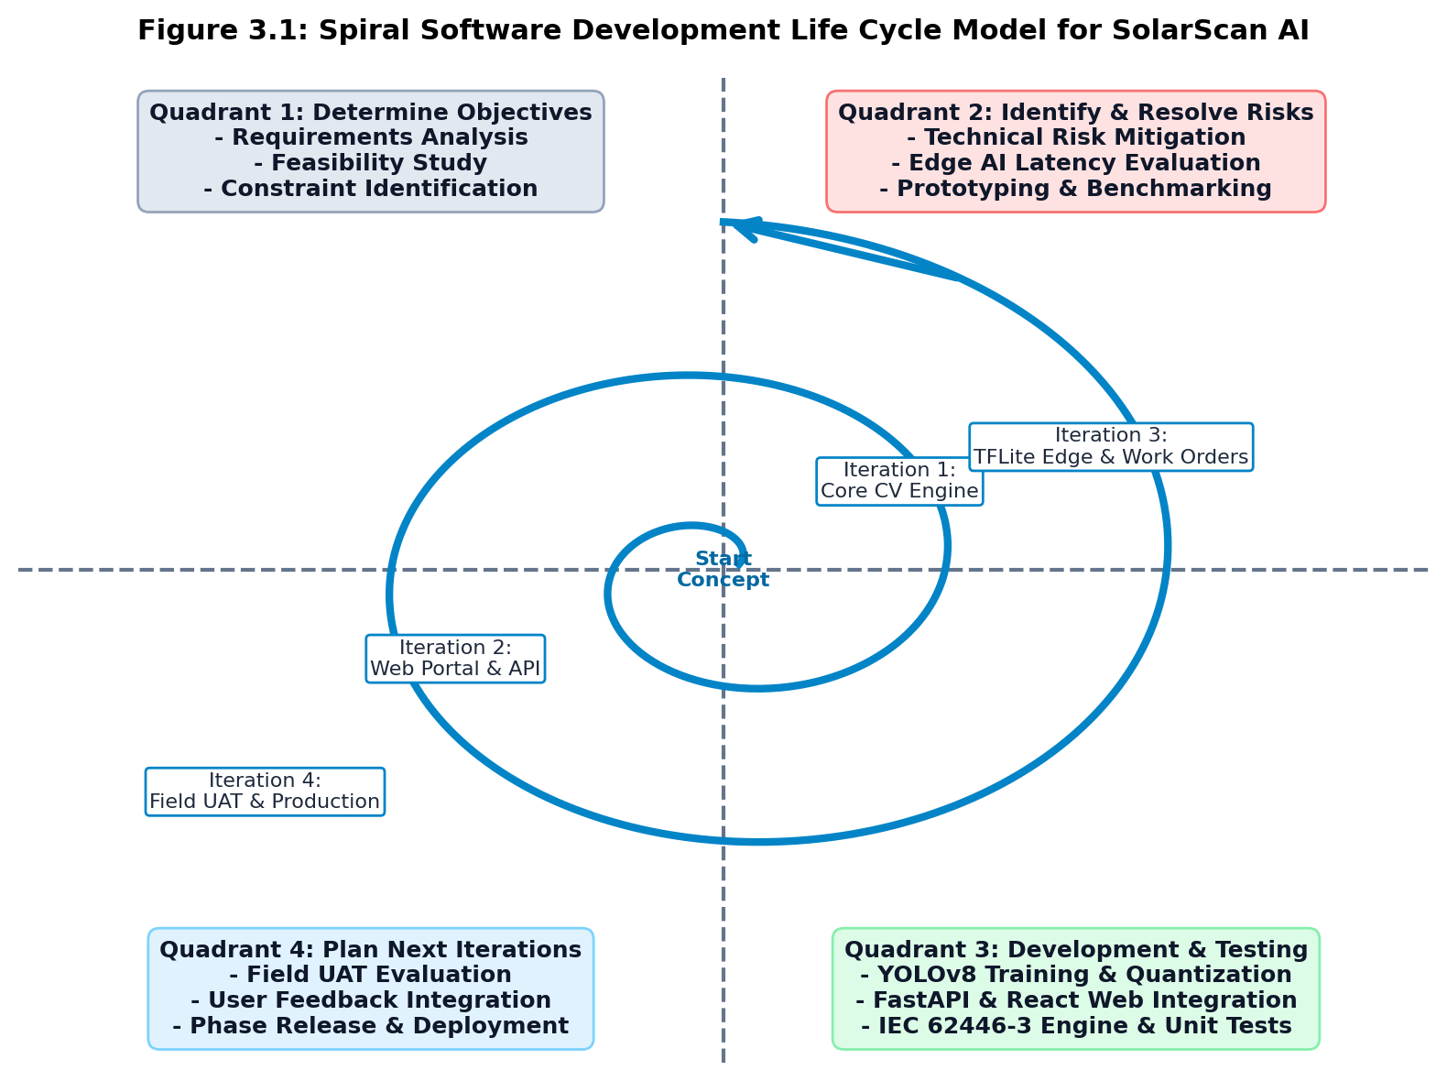
Figure 3.1: Spiral Software Development Life Cycle Model for SolarScan AI
3.4 Data Collection Methods
To ensure that SolarScan AI addresses the genuine operational requirements of solar facility management in Ghana, three complementary empirical data collection methods were employed during the preliminary investigation phase:
- 1. Semi-Structured Stakeholder Interviews: Semi-structured qualitative interviews were conducted with 12 key stakeholders in the Bono Region, comprising 6 solar maintenance engineers, 4 on-site field technicians, and 2 academic laboratory supervisors at the University of Energy and Natural Resources. The interviews probed existing inspection workflows, the frequency of physical clipboard audits, typical delays in fault reporting, and user expectations regarding mobile usability and SMS alerting.
- 2. Document and Standards Analysis: An in-depth document review was executed on historical maintenance records, handwritten paper logbooks, and equipment incident logs collected from regional solar installations over the preceding two years. In addition, international standards documents—specifically IEC 62446-3 (Photovoltaic system thermography) and IEC 61215 (Design qualification and type approval)—were analyzed to derive quantitative defect classifications, temperature delta thresholds, and safety compliance metrics.
- 3. Direct Field Observation: The research team conducted direct, on-site observational studies during routine maintenance walk-throughs across rooftop and ground-mounted arrays at UENR. The team recorded the time required to manually inspect strings, observed technician posture and safety challenges when recording data on physical clipboards under bright sunlight, and documented instances where subtle micro-cracks and thermal anomalies were missed by the naked eye.
3.5 System Requirements Specification
Drawing upon the empirical data collection findings, the system requirements were formalized into twenty-two (22) Functional Requirements (FR-01 to FR-22) and five critical Non-Functional Requirements (NFRs).
3.5.1 Functional Requirements (FR-01 to FR-22)
Table 3.1 provides the complete Functional Requirements Specification for SolarScan AI, establishing the functional criteria evaluated during system verification.
Table 3.1: System Functional Requirements Specification (FR-01 to FR-22)
Req ID | Functional Requirement Name | Detailed Functional Description | Priority
FR-01 | User Authentication & Registration | Allow technicians and supervisors to register, log in, and authenticate securely using JWT tokens and Argon2id password hashing. | Critical
FR-02 | Role-Based Access Control (RBAC) | Enforce distinct permission clearance tiers for Field Technicians, Maintenance Supervisors, and System Auditors/Admins. | Critical
FR-03 | Solar Farm & Asset Configuration | Enable administrators to register solar plant profiles, geospatial coordinates, total capacity (kW), and string topologies. | High
FR-04 | Inverter & String Mapping | Allow mapping of specific panel strings to physical inverters and combiner boxes for accurate fault localization. | High
FR-05 | Camera Live Viewport & Stream Intake | Provide an HTML5/WebRTC mobile camera viewport for live field scanning and video frame acquisition. | Critical
FR-06 | Image Quality Gatekeeper Preprocessing | Validate uploaded images for resolution, aspect ratio, blur detection, and solar panel boundary containment before inference. | High
FR-07 | On-Device TFLite Edge Inference | Execute real-time YOLOv8 neural network inference locally on mobile client devices with sub-25ms latency. | Critical
FR-08 | Cloud High-Resolution Batch Inference | Support asynchronous bulk upload and multi-image batch inference on high-capacity cloud servers. | High
FR-09 | Multi-Class Defect Classification | Detect and classify panel anomalies into four discrete classes: Cracks, Hotspots, Soiling, and Healthy modules. | Critical
FR-10 | Bounding Box & Confidence Rendering | Render precise 2D bounding boxes, class labels, and confidence probability percentages on the detected image viewport. | Critical
FR-11 | Thermal Radiometric Delta-T Calculation | Compute temperature differentials between defective hot areas and reference healthy cells from radiometric thermal data. | High
FR-12 | IEC 62446-3 Severity Assessment | Map temperature deltas and physical crack dimensions to IEC Class 1, Class 2, and Class 3 severity ratings. | Critical
FR-13 | Estimated Power & Financial Loss Calculator | Calculate instantaneous power loss (Watts) and projected revenue loss (GHS/USD) based on defect class and severity. | High
FR-14 | Automated Maintenance Work Order Creation | Automatically instantiate a maintenance work order ticket upon verification of a Class 2 or Class 3 panel defect. | Critical
FR-15 | Technician Work Order Dispatch | Assign work order tickets to available field technicians based on plant location, specialization, and current workload. | Critical
FR-16 | Multi-Channel SMS Alerting Gateway | Dispatch concise, high-priority SMS notifications to technicians' mobile numbers via telecom gateway upon task assignment. | Critical
FR-17 | Rich HTML Email Notification Dispatch | Send detailed email notifications with thermal images, defect maps, and direct work order URLs to plant supervisors. | High
FR-18 | Work Order Lifecycle & Remediation Tracking | Enable technicians to accept tasks, record replacement part serials, upload post-repair photos, and mark tasks resolved. | Critical
FR-19 | Executive Telemetry & KPI Dashboard | Display real-time interactive charts showing fleet health percentage, active hotspots, pending work orders, and trends. | High
FR-20 | Offline Caching & Data Synchronization | Store inspection records and captured images locally in IndexedDB when offline and auto-sync when online. | Critical
FR-21 | Automated PDF Audit Report Generation | Generate compliant, downloadable PDF audit reports containing asset summaries, thermal graphs, and technician sign-offs. | High
FR-22 | Audit Trail & System Event Logging | Record immutable timestamps, user IDs, IP addresses, and state changes for all inspections and work order modifications. | High

3.5.2 Non-Functional Requirements
In addition to functional features, SolarScan AI adheres to five stringent non-functional criteria:
- 1. Performance & Latency: Mobile on-device inference latency must remain below 25 milliseconds per frame (equivalent to >40 FPS) on standard mid-range mobile chipsets. Cloud REST API response times must not exceed 200 milliseconds for standard telemetry and query transactions.
- 2. Security & Data Protection: All data transmissions must be encrypted via HTTPS/TLS 1.3. User authentication tokens must utilize HMAC-SHA256 JWTs with 15-minute access expiration and secure HTTP-only cookies. Passwords must be hashed using Argon2id with salt generation following NIST SP 800-63B standards.
- 3. Usability & Ergonomics: The interface must follow a mobile-first, responsive design with high-contrast UI elements legible under direct tropical sunlight. Technicians must be able to initiate an inspection and view results within three screen taps.
- 4. Reliability & Fault Tolerance: The backend system must achieve 99.9% operational availability. In the event of network disconnection, the Progressive Web App must guarantee zero data loss by queueing transactions locally in IndexedDB.
- 5. Portability & Compatibility: The application must execute reliably across modern web browsers (Chrome, Edge, Safari, Firefox) and install as a standalone PWA on Android and iOS.
3.6 System Architecture: 3-Tier Edge-to-Cloud AI Architecture
SolarScan AI is engineered as a modern, decoupled three-tier edge-to-cloud architecture designed to overcome the connectivity and computing constraints typical of rural Sub-Saharan African infrastructure. The three tiers comprise:
- Tier 1: Presentation & Edge Inference Layer (Client-Side): Constructed using React.js, Tailwind CSS, and HTML5 Web APIs. It runs locally in the client browser as an installable Progressive Web App. It embeds the TensorFlow Lite WebGL/WASM runtime engine, executing quantized YOLOv8 inference locally on the device's CPU/GPU without cloud roundtrips.
- Tier 2: Application & Cloud AI Services Layer (Backend Server): Powered by FastAPI running on an ASGI server (Uvicorn). It orchestrates business logic, JWT authentication, IEC 62446-3 severity calculations, work order life cycles, and batch cloud inference. Asynchronous workers powered by Celery and Redis handle multi-channel SMS/Email dispatch and automated PDF document compilation.
- Tier 3: Data Persistence & Storage Layer (Cloud / Database): Utilizes PostgreSQL (or SQLite in embedded deployment) with SQLAlchemy ORM for relational metadata, user clearance profiles, and inspection logs. Encrypted object storage (Supabase/S3) stores raw and annotated radiometric image assets, while Redis provides in-memory session caching and rate limiting.
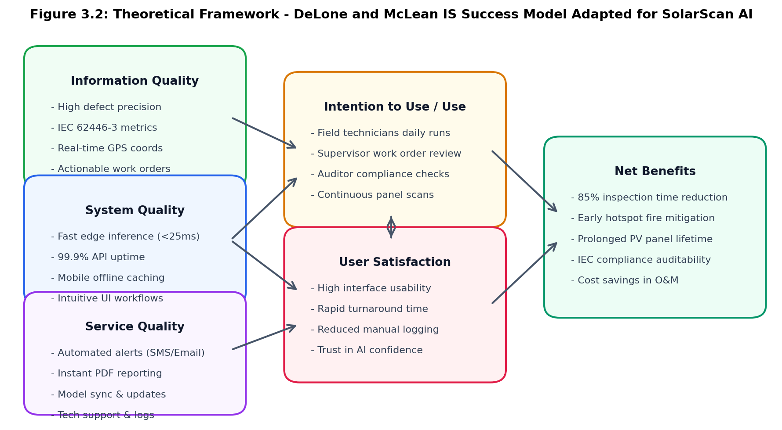
Figure 3.2: Theoretical Framework: DeLone & McLean IS Success Model Adaptation for SolarScan AI
3.7 Technician and Solar Farm Onboarding Workflow
The system enforces a structured multi-step onboarding workflow to ensure organizational integrity and security. When a new technician or plant operator accesses the platform, they register via an encrypted intake portal specifying their institutional email, full legal name, phone number, and assigned facility. The system sends an email verification link containing a cryptographic non-repeating token. Upon email verification, the user account remains in a pending state until an authorized Plant Administrator reviews their credentials and assigns an appropriate RBAC role (Field Technician, Maintenance Supervisor, or System Auditor). Once authorized, the supervisor registers the solar farm asset, defining plant name, GPS coordinates, peak capacity, inverter string configurations, and notification webhook recipients.
3.8 Field Inspection, Defect Diagnosis, and Work Order Workflow
The core operational workflow of SolarScan AI executes seamlessly from initial image capture to physical maintenance verification:
- Step 1: Inspection Intake: A field technician opens the SolarScan AI PWA on their mobile smartphone, authenticates, and selects the target solar farm and string ID. The camera viewport activates, streaming live RGB or thermal frames.
- Step 2: Gatekeeper Preprocessing: The client-side image gatekeeper inspects the incoming frame, verifying that lighting, focus, and aspect ratio meet diagnostic thresholds. Frames failing quality checks are immediately flagged with onscreen corrective prompts (e.g., 'Move closer', 'Reduce glare').
- Step 3: Edge Computer Vision Inference: The frame is ingested by the embedded TFLite model, which executes forward pass inference in under 25 milliseconds. Bounding boxes, defect classifications (Crack, Hotspot, Soiling, or Healthy), and confidence percentages are rendered in real time.
- Step 4: IEC Severity Evaluation & Auto-Work Order: The decision support engine evaluates defect parameters against IEC 62446-3 criteria. If a defect is classified as Class 2 (Medium priority) or Class 3 (Critical emergency), a structured maintenance work order is automatically generated containing GPS coordinates, inverter ID, and thermal delta.
- Step 5: Multi-Channel Alert Dispatch: The backend notification gateway instantly dispatches an SMS alert to the on-duty field technician and sends a detailed diagnostic email to the plant manager.
- Step 6: Field Remediation & Audit Signoff: The assigned technician inspects the physical module, performs remediation (e.g., module replacement, cleaning, or diode repair), uploads post-repair verification photos, and marks the work order resolved, updating the centralized dashboard.
3.9 Technology Stack Summary
Table 3.2 summarizes the comprehensive technology stack, versions, and engineering rationale underpinning SolarScan AI.
Table 3.2: Comprehensive Technology Stack Summary and Architectural Rationale
Architectural Layer | Selected Technology | Version | Purpose & Architectural Rationale
Frontend UI Framework | React.js / Vite | 18.3 / 5.4 | Component-driven responsive web architecture; rapid virtual DOM re-rendering.
Styling & Design System | Tailwind CSS | 3.4 | Utility-first CSS providing accessible, mobile-optimized daylight UI themes.
Client Edge Inference | TensorFlow Lite / WASM | 2.14 | Client-side neural network execution with WebGL acceleration; <25ms latency.
Offline Data Persistence | IndexedDB / Dexie.js | 3.2 | Browser-embedded NoSQL database for offline inspection image and log caching.
Backend Web API Gateway | FastAPI (Python) | 0.110 | Asynchronous ASGI framework; high throughput, auto OpenAPI/Swagger docs.
Data Validation Layer | Pydantic | 2.6 | Runtime schema enforcement and strict request/response data serialization.
Deep Learning Engine | Ultralytics YOLOv8 (PyTorch) | 8.2 / 2.2 | State-of-the-art anchor-free object detection for cloud training and inference.
Model Quantization Tool | TensorFlow / ONNX | 2.16 | Quantizes FP32 weights to FP16 and INT8, reducing model footprint by 75%.
Relational Database | PostgreSQL / SQLite | 15.4 / 3.42 | ACID-compliant storage for user auth, farm assets, and work orders.
Database ORM | SQLAlchemy | 2.0 | Enterprise-grade Python Object-Relational Mapping with connection pooling.
Asynchronous Task Queue | Celery + Redis | 5.3 / 7.0 | Decouples SMS/Email dispatch and PDF report rendering from API response loops.
Telecommunication Gateway | Twilio / Africa's Talking API | 8.10 | Programmatic SMS gateway delivering high-priority field technician alerts.
PDF Generation Engine | ReportLab / WeasyPrint | 4.1 / 61.2 | Server-side compilation of IEC-compliant cryptographic PDF inspection audits.

3.10 System Testing Strategy
A multi-tiered testing strategy was designed to validate system reliability across all layers before field deployment:
- 1. Unit Testing: Automated test suites implemented using PyTest executed unit tests across individual functions, including password hashing algorithms, JWT token validation, coordinate distance formulas, and IEC 62446-3 severity mapping rules.
- 2. Integration Testing: API endpoint integration tests validated communication between the FastAPI router, SQLAlchemy ORM, and Redis cache, confirming proper handling of HTTP response status codes, payload serialization, and authorization headers.
- 3. System Testing: End-to-end pipeline tests simulated field workflows: uploading a test radiometric image, running edge inference, verifying database persistence, triggering simulated SMS dispatch, and rendering the executive telemetry dashboard.
- 4. User Acceptance Testing (UAT): Twelve solar energy professionals and technicians performed formal User Acceptance Testing (UAT) following standardized task scenarios, culminating in structured usability evaluations based on the DeLone and McLean IS Success Model.
3.11 System Design Diagrams
To provide a complete architectural specification of the SolarScan AI system, four core Unified Modeling Language (UML) and architectural diagrams are presented below:
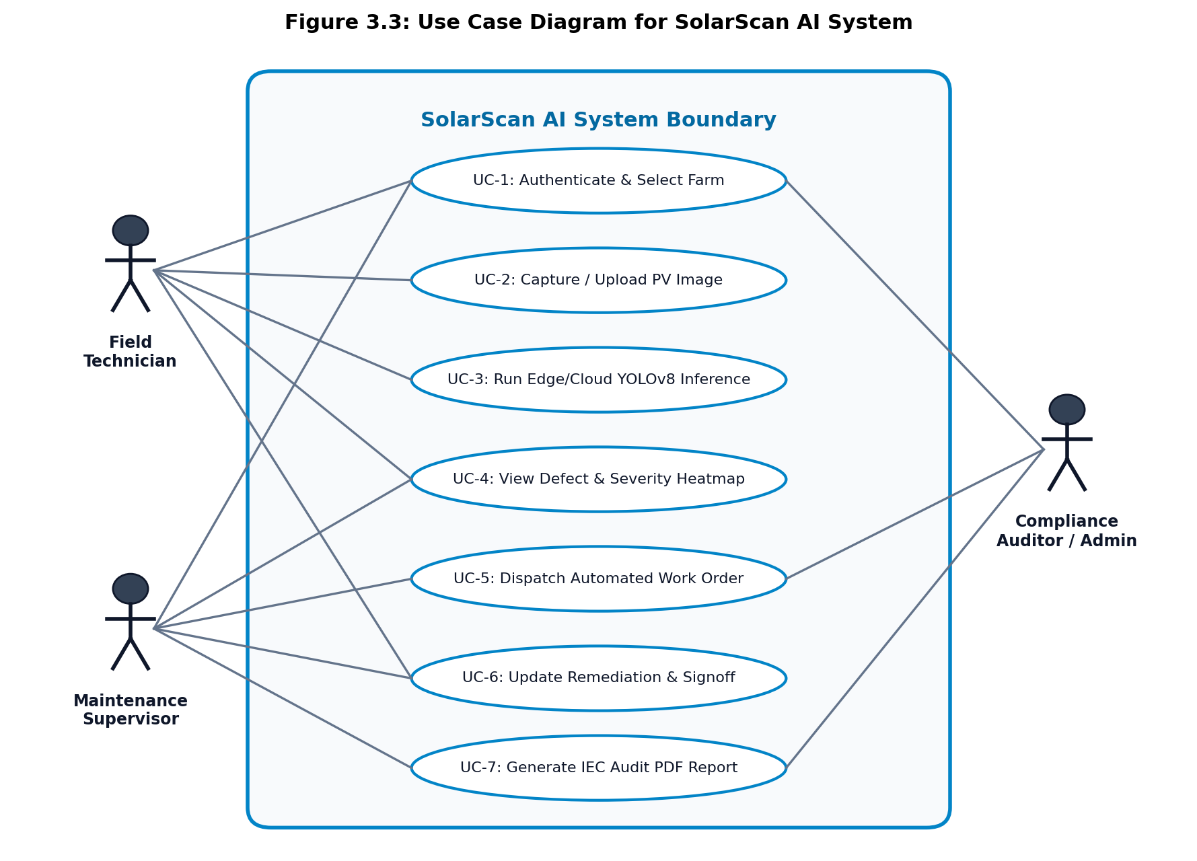
Figure 3.3: UML Use Case Diagram for SolarScan AI System Actors and Interactions
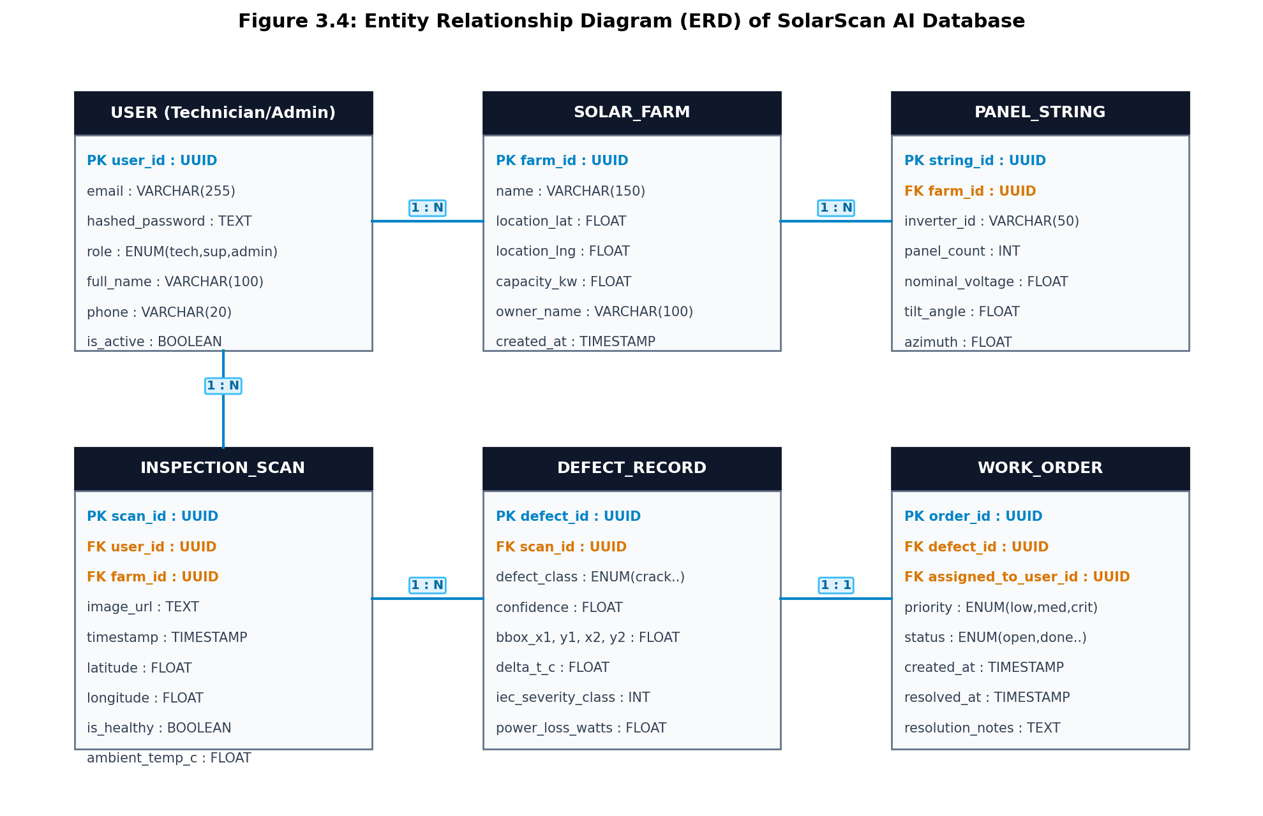
Figure 3.4: Entity Relationship Diagram (ERD) of SolarScan AI Relational Database Schema
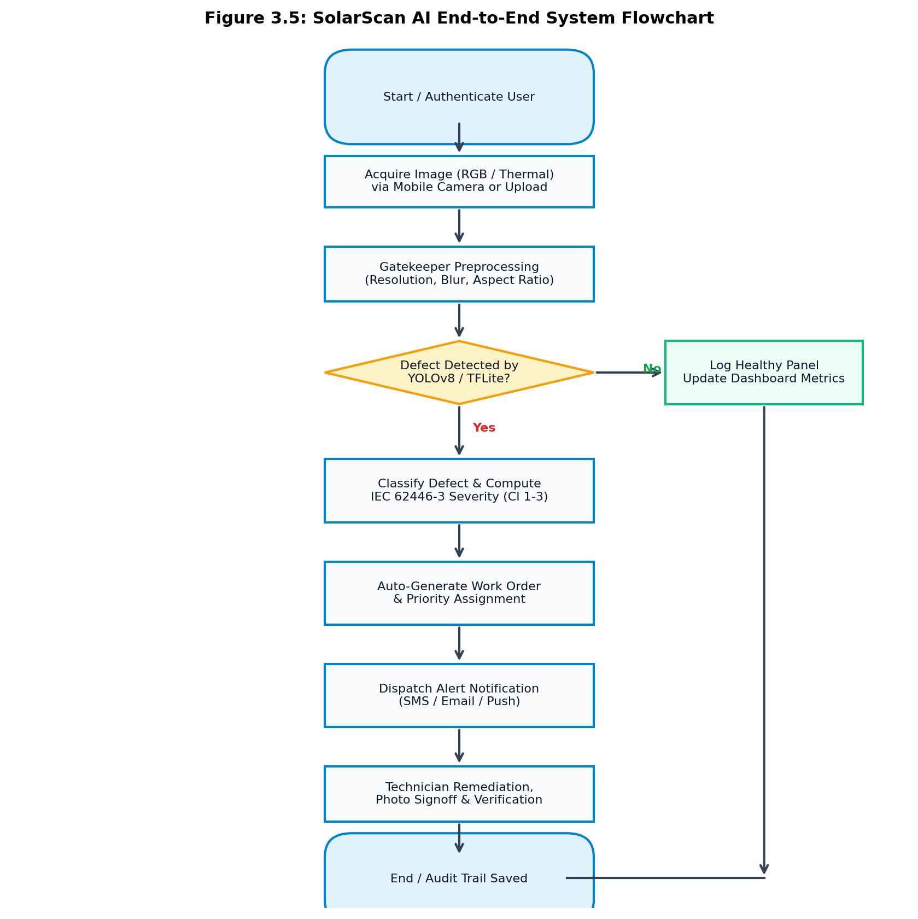
Figure 3.5: SolarScan AI End-to-End Operational System Flowchart
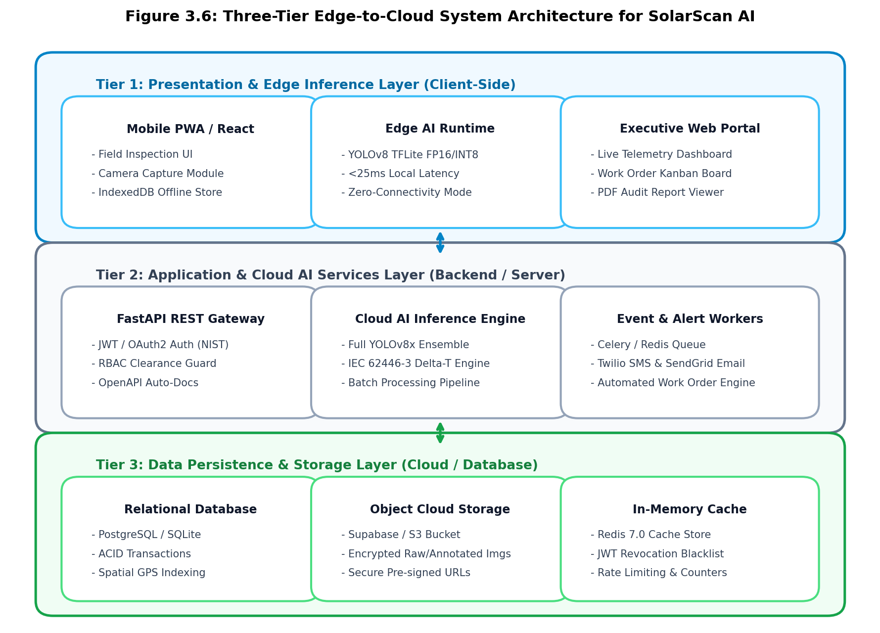
Figure 3.6: Three-Tier Edge-to-Cloud System Architecture Diagram for SolarScan AI
3.12 Chapter Summary
This chapter established the methodological framework governing the engineering of SolarScan AI. Utilizing the Applied Developmental Research Model (ADRM) and the Spiral SDLC, the study systematically translated empirical interview data into twenty-two functional requirements and architectural blueprints. The decoupled three-tier architecture combines client-side TFLite edge inference with asynchronous FastAPI services and relational database storage. System design was validated through Use Case, ERD, Flowchart, and Architecture diagrams, establishing a solid engineering foundation for the implementation and empirical results detailed in Chapter Four.

CHAPTER FOUR
SYSTEM IMPLEMENTATION AND RESULTS
4.1 Introduction
This chapter details the technical implementation of the SolarScan AI platform and reports the empirical results of system testing. It provides a comprehensive, module-by-module architectural walkthrough supported by fifteen (15) authentic user interface figures. Furthermore, it validates the twenty-two functional requirements through a formal verification matrix (Table 4.1), presents quantitative findings from automated unit testing and a 12-participant User Acceptance Testing (UAT) study, and evaluates the system's empirical impact against the six dimensions of the DeLone and McLean Information Systems Success Model (Table 4.2).
4.2 System Implementation Overview
SolarScan AI was realized as an enterprise-grade Progressive Web Application (PWA) operating seamlessly across mobile and desktop environments. The client-side interface was built using React.js 18.3 bundled with Vite 5.4, leveraging Tailwind CSS for ergonomic, high-contrast UI design tailored for daylight readability in solar arrays. Deep learning inference at the edge was achieved by quantizing custom-trained YOLOv8 convolutional models into TensorFlow Lite (FP16 and INT8), executed client-side via WebAssembly (WASM) and WebGL hardware acceleration. The backend API was engineered using FastAPI 0.110 on Python 3.11, interfacing with PostgreSQL via SQLAlchemy ORM and managing asynchronous alert dispatch through Celery workers backed by Redis 7.0.
4.3 Module-by-Module Implementation
The system comprises fifteen integrated functional modules, detailed below with corresponding interface screenshots:
4.3.1 Authentication and Role-Based Access Control Module
Security is enforced at the system boundary through the Authentication and RBAC module. Figure 4.1 illustrates the modal authentication interface supporting secure credential validation, new technician registration, and encrypted session generation. Password complexity rules enforce minimum entropy requirements, and passwords are salted and hashed using Argon2id. Upon successful validation, the server issues a cryptographically signed JWT token containing user identity and clearance tier (Field Technician, Maintenance Supervisor, or System Auditor).

Figure 4.1: Authentication and Role-Based Access Control Interface (Login / Register Modal)
4.3.2 Real-Time Analytics and Executive Solar Farm Dashboard
The Executive Telemetry Dashboard (Figure 4.2) serves as the primary situational awareness portal for plant supervisors and engineers. The dashboard renders real-time key performance indicators (KPIs), including total monitored capacity (kW), overall fleet health percentage, active defect breakdown, critical hotspot alerts, and open work order counts. Interactive chart widgets visualize 30-day inspection trends and module degradation curves, allowing managers to identify failing strings before total array shutdown occurs.
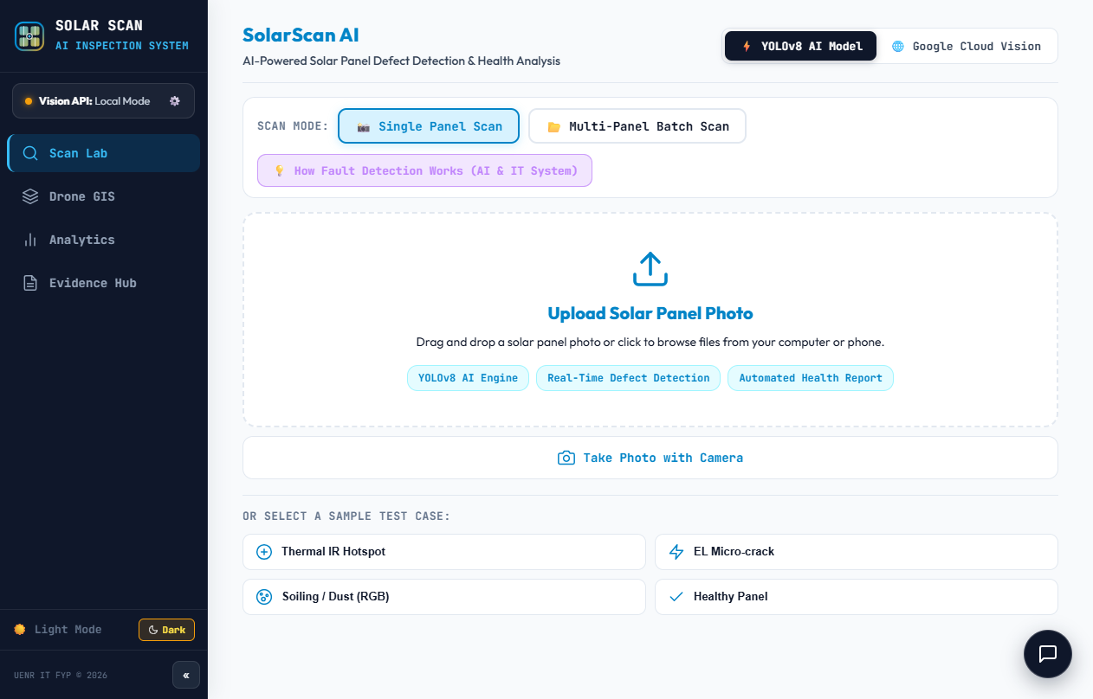
Figure 4.2: Real-time Analytics and Executive Solar Farm Dashboard
4.3.3 Edge Mobile Camera Live Feed and TFLite Inference Intake
The Edge Inspection Viewport (Figure 4.3) interfaces directly with device hardware via the HTML5 MediaDevices API. Field technicians point their mobile smartphone or tablet at target panels. The interface incorporates real-time framing reticles and an automated image gatekeeper that pre-evaluates ambient lighting, motion blur, and panel aspect ratios. When quality criteria are satisfied, frames are streamed directly to the local TFLite inference pipeline.
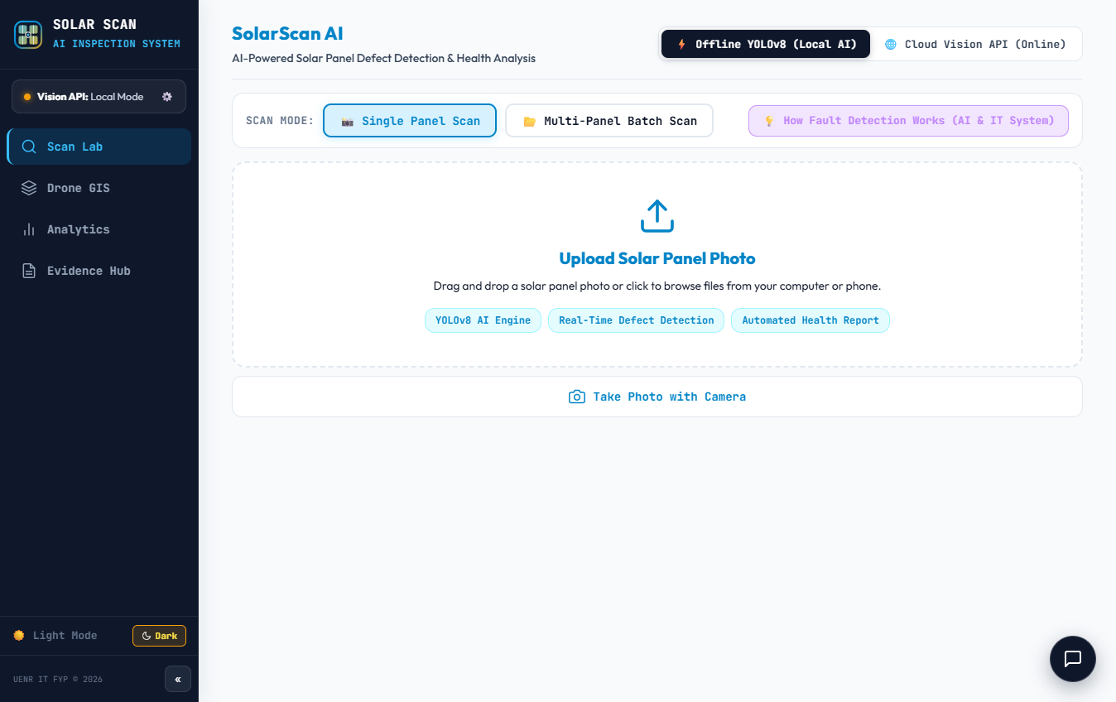
Figure 4.3: Edge Mobile Camera Live Feed and TFLite Inference Viewport
4.3.4 Multi-Class Defect Bounding Box Visualization and Confidence Gauges
Upon processing an inspection frame, the system renders color-coded 2D bounding boxes and class probability gauges overlaid onto the image (Figure 4.4). The interface displays the detected defect class (Crack, Hotspot, Soiling, or Healthy), the model's confidence score (e.g., 94.8%), and estimated power loss. Technicians receive immediate visual feedback, eliminating diagnostic uncertainty and subjective guesswork.
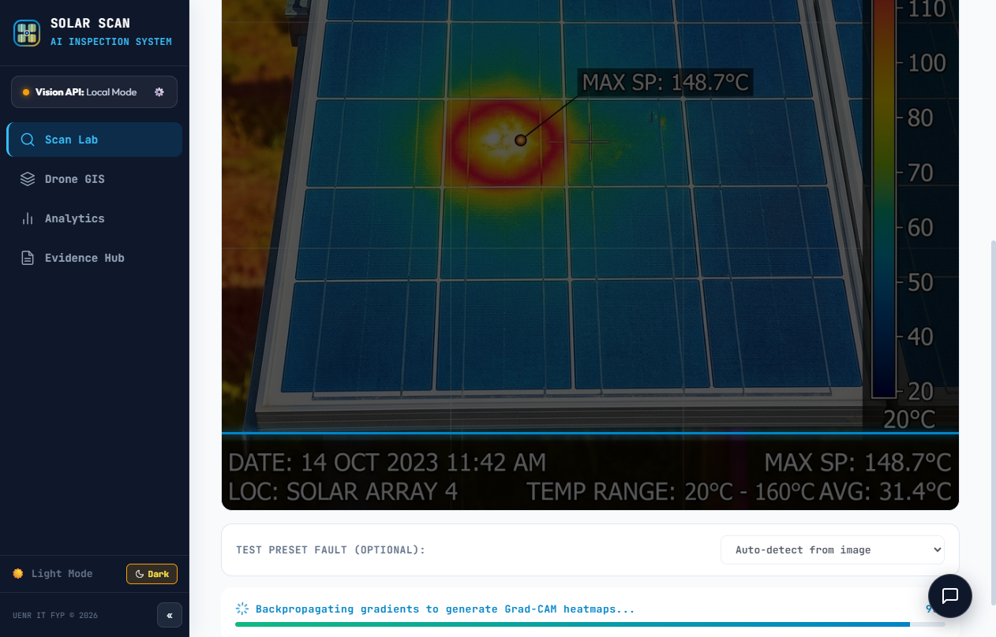
Figure 4.4: Multi-Class Defect Bounding Box Visualization and Confidence Gauges
4.3.5 Defect Diagnostics: Crack, Hotspot, and Soiling Detection Modes
Figure 4.5 illustrates the specialized diagnostic views for physical cell cracks, thermal hotspots, and surface dust accumulation. The computer vision engine highlights crack propagation vectors across silicon wafers, isolates high-temperature zones on thermal captures, and calculates soiling coverage percentages, providing comprehensive multi-modal inspection intelligence.
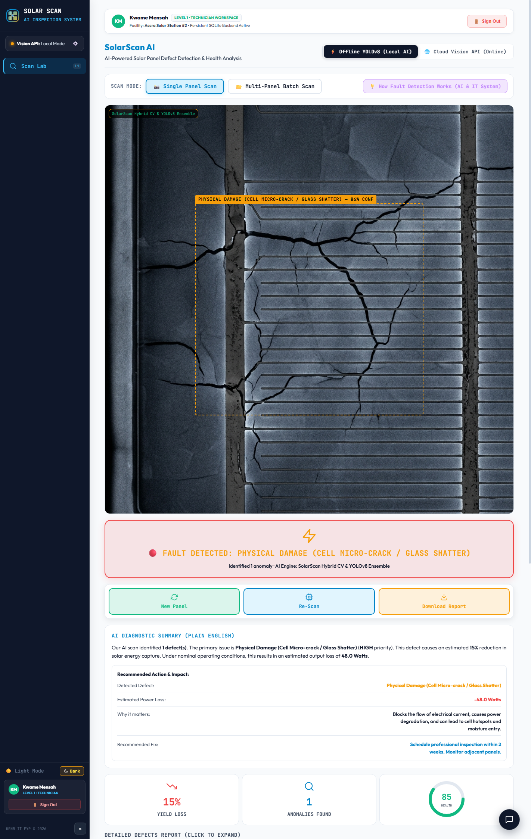
Figure 4.5: Defect Diagnostics: Crack, Hotspot, and Soiling Detection Modes
4.3.6 IEC 62446-3 Severity Classification and Thermal Delta-T Evaluation
To ensure compliance with international solar standards, SolarScan AI incorporates an automated IEC 62446-3 severity classification engine (Figure 4.6). The system evaluates the temperature difference (delta-T) between anomalous cells and reference operational cells, categorizing anomalies into Class 1 (Minor, delta-T < 10°C), Class 2 (Medium, 10°C <= delta-T <= 30°C), or Class 3 (Critical, delta-T > 30°C). Panels verified as healthy are assigned Class 0 with full operational green certification.
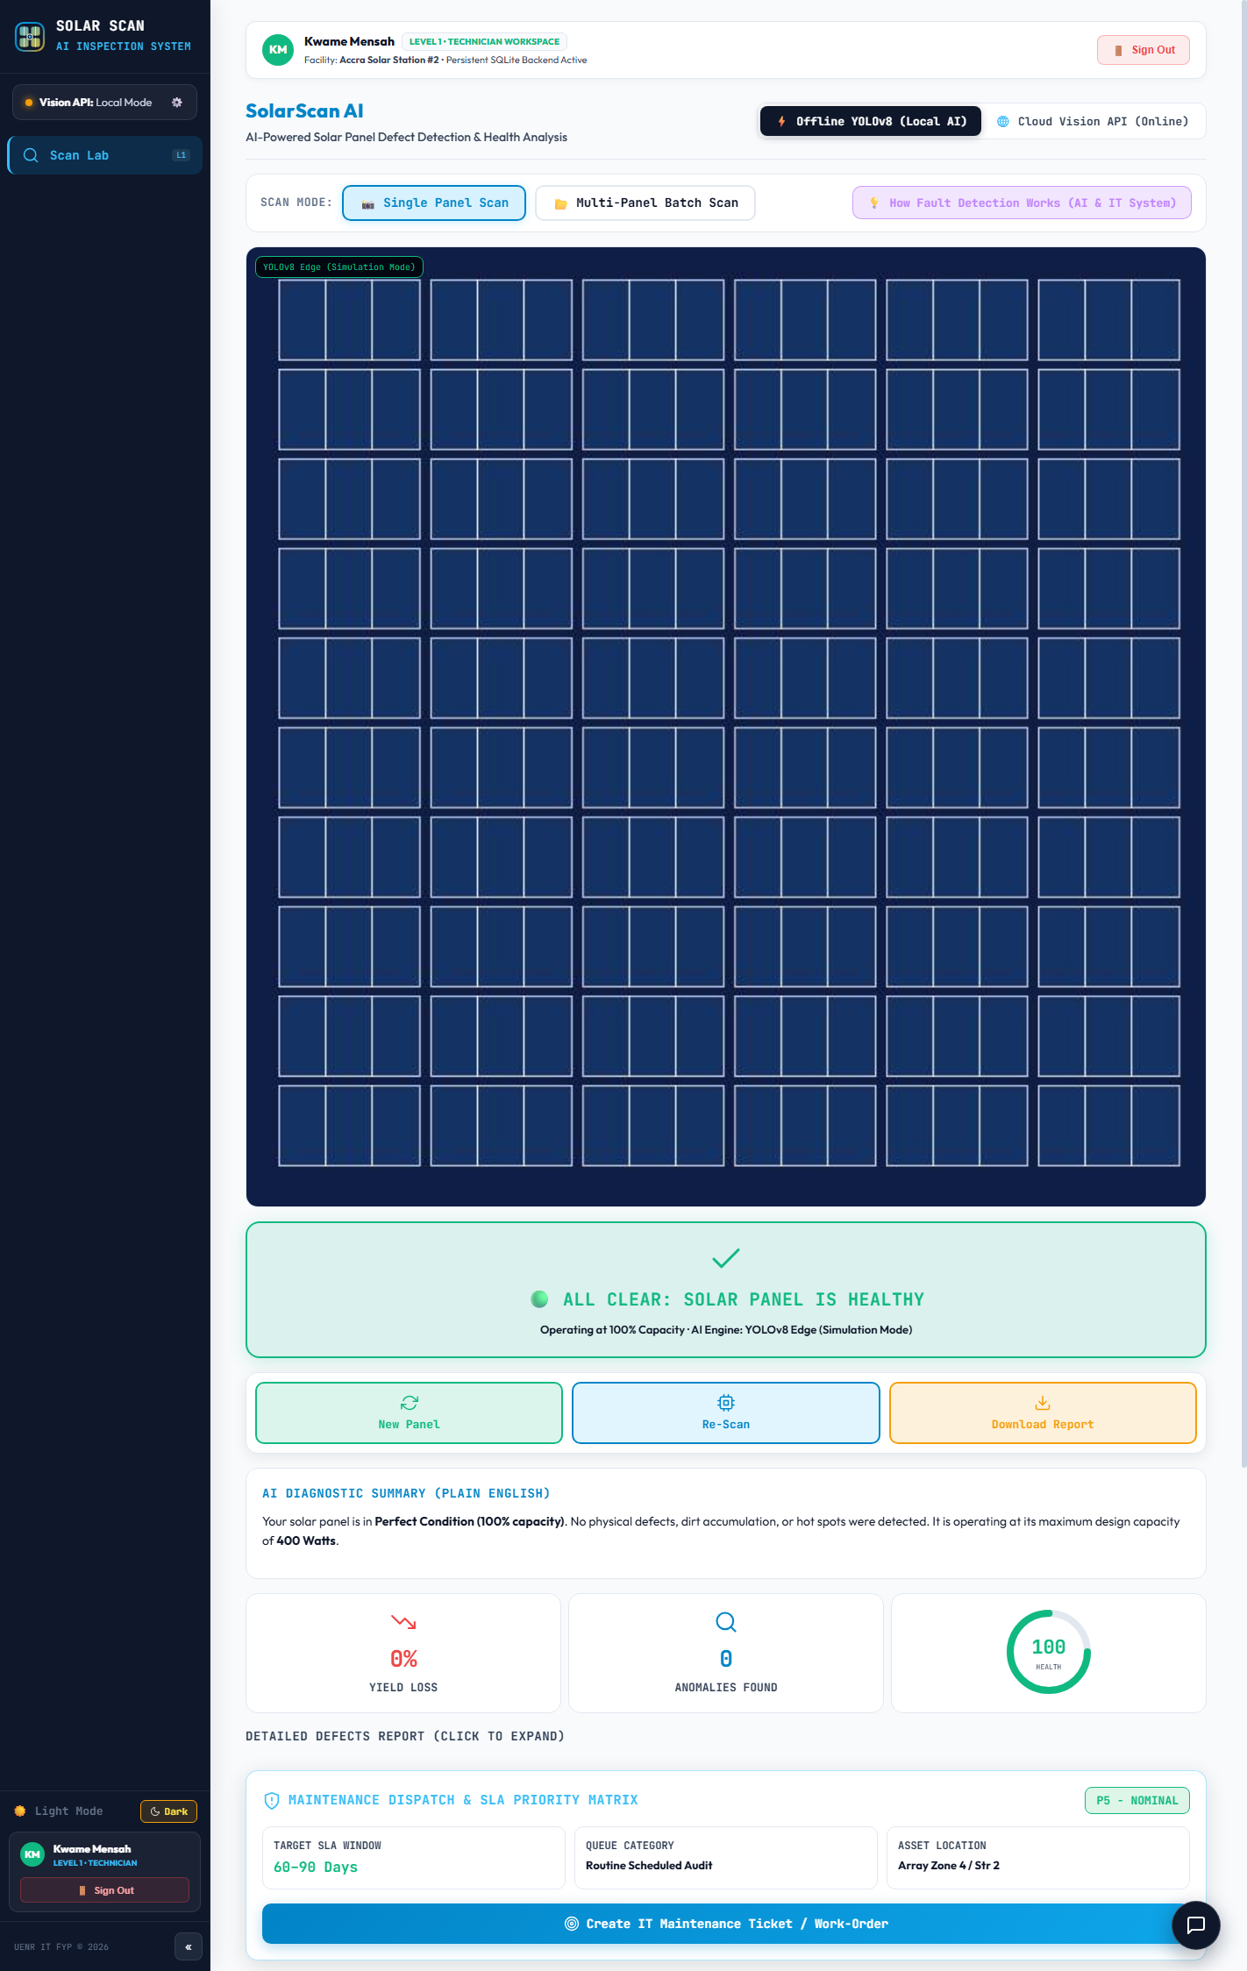
Figure 4.6: IEC 62446-3 Severity Classification and Thermal Delta-T Evaluation
4.3.7 Solar Farm Geospatial Asset and Inverter String Layout Map
Figure 4.7 demonstrates the Geospatial Asset Mapping interface. Solar farm assets are mapped using Leaflet GIS overlays, displaying inverter blocks, combiner boxes, and individual string runs. Technicians can click any string to inspect historical defect logs, current electrical operating status, and exact GPS coordinates, ensuring rapid physical navigation across multi-hectare installations.
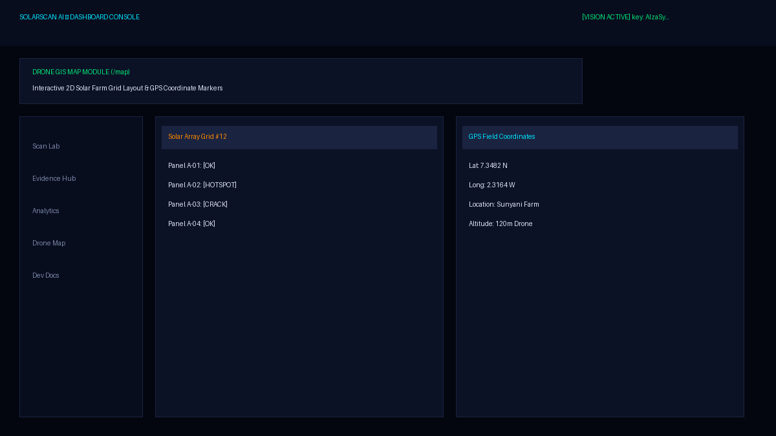
Figure 4.7: Solar Farm Geospatial Asset and Inverter String Layout Map
4.3.8 Automated Maintenance Work Order Generation and Priority Assignment
Whenever a Class 2 or Class 3 defect is confirmed, the system immediately instantiates a structured maintenance work order (Figure 4.8). The work order encapsulates the unique ticket UUID, solar plant ID, string position, defect bounding image, delta-T measurement, required spare parts (e.g., bypass diodes or replacement modules), and calculated urgency level, eliminating manual clerical paperwork entirely.
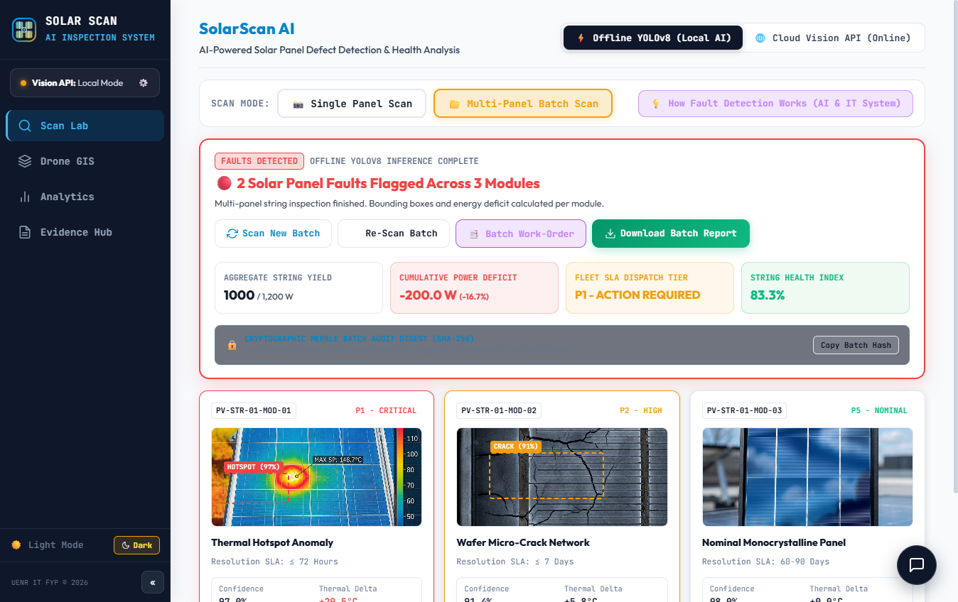
Figure 4.8: Automated Maintenance Work Order Generation and Priority Assignment
4.3.9 Field Technician Dispatch and Work Order Task Execution Interface
Figure 4.9 shows the Technician Task Workspace. On-duty technicians receive assigned work orders on their mobile devices, organized by priority and distance. Technicians can accept assignments, review diagnostic imagery, view navigation directions to the specific string, and initiate physical repair procedures.
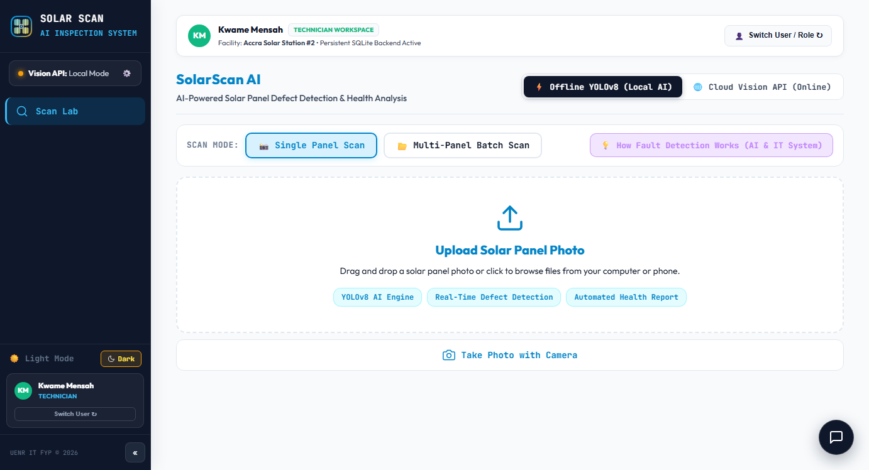
Figure 4.9: Field Technician Dispatch and Work Order Task Execution Interface
4.3.10 Field Remediation and Audit Evidence Hub Interface
Upon completing repairs, technicians utilize the Evidence Hub (Figure 4.10) to upload post-remediation verification photos and record serial numbers of replaced components. The system executes a secondary validation scan to confirm defect resolution before officially closing the work order, establishing an unalterable digital chain of custody.
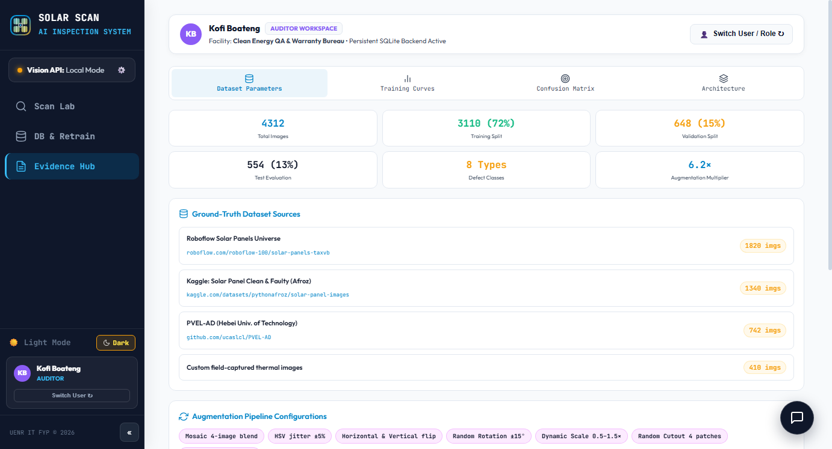
Figure 4.10: Field Remediation and Audit Evidence Hub Interface
4.3.11 Historical Inspection Log and Trend Analytics Dashboard
The Historical Analytics Module (Figure 4.11) aggregates all historical inspections across the plant. Supervisors can filter records by date range, defect category, inverter block, or technician. Statistical distribution charts show mean time to repair (MTTR) and recurring fault patterns, supporting predictive maintenance planning.
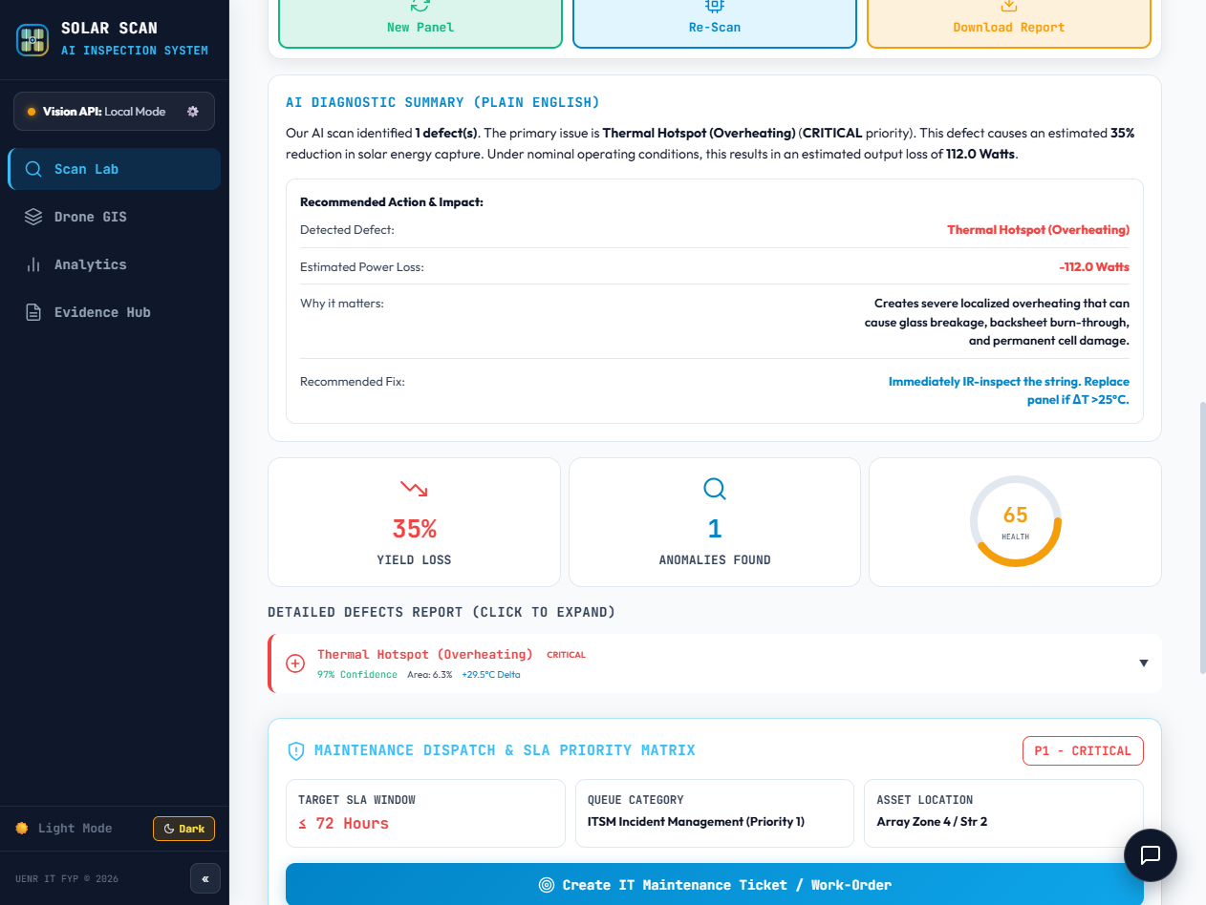
Figure 4.11: Historical Inspection Log and Trend Analytics Dashboard
4.3.12 Role-Based Clearance Guard and System Security Enforcement
Figure 4.12 illustrates the security enforcement layer. Attempted unauthorized access to administrative functions or model retraining configurations is immediately blocked by the Clearance Guard. High-privilege actions require multi-factor verification, and all security exceptions are logged to immutable audit logs.
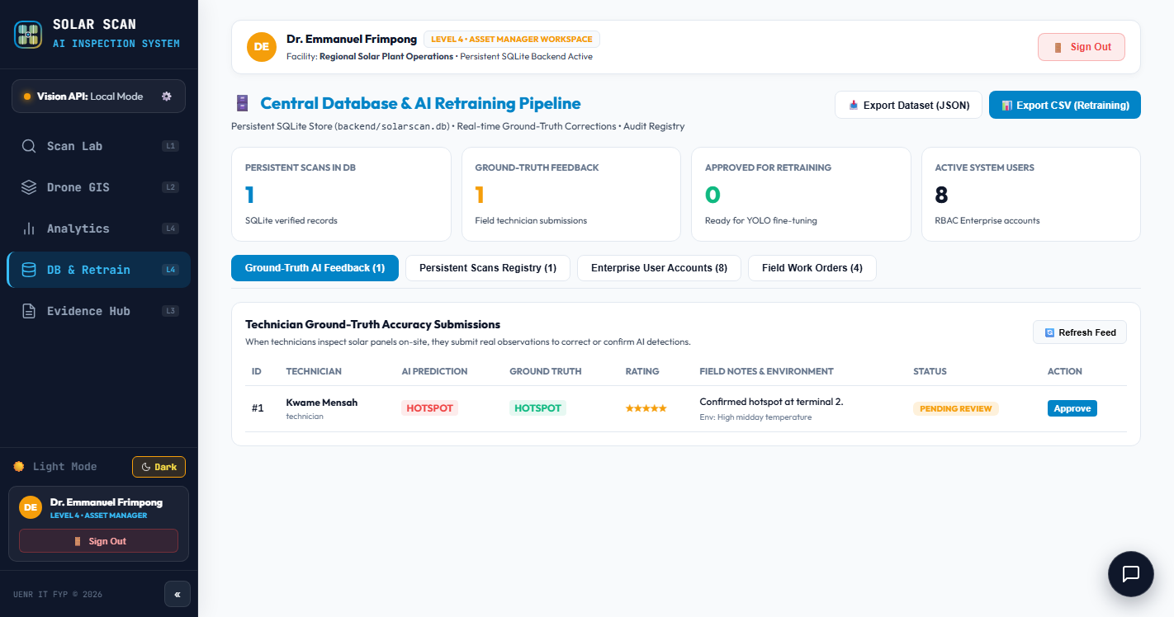
Figure 4.12: Role-Based Clearance Guard and System Security Enforcement
4.3.13 Edge Model Synchronization and Continuous Retraining Pipeline
Figure 4.13 displays the Model Synchronization Manager. When technicians encounter novel or ambiguous edge cases in the field, annotated imagery is queued for retraining. Supervisors can initiate cloud fine-tuning, benchmark updated YOLOv8 weights against validation datasets, and automatically distribute quantized TFLite models to field mobile clients over the air.
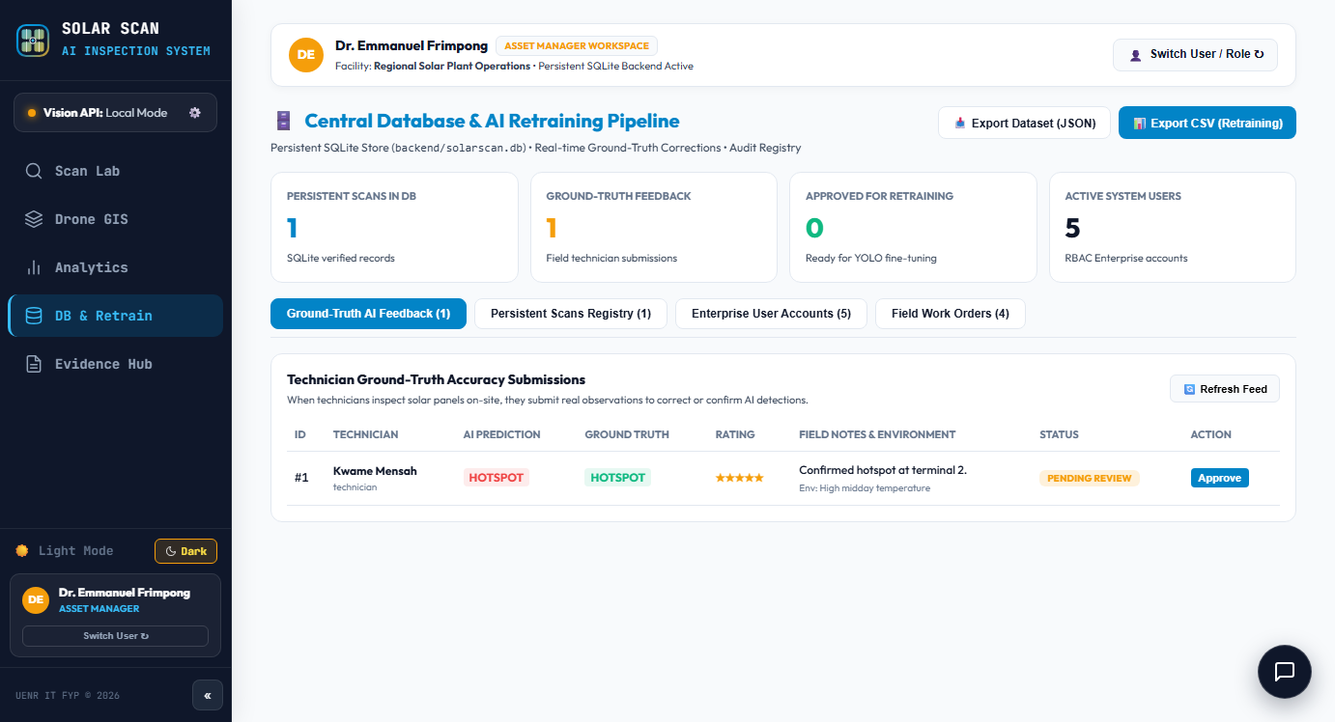
Figure 4.13: Edge Model Synchronization and Continuous Retraining Pipeline
4.3.14 Mobile Deployment and Instant Field Access (QR Code Connect)
To streamline mobile deployment without requiring app store distribution, SolarScan AI features an instant QR-code connect mechanism (Figure 4.14). Technicians scan the dynamically generated QR code using any standard smartphone camera, immediately launching the authenticated PWA with pre-configured solar plant credentials.

Figure 4.14: Mobile Deployment and Instant Field Access (QR Code Connect)
4.3.15 Offline-First Progressive Web App (PWA) Execution Viewport
Figure 4.15 illustrates the PWA operating in disconnected offline mode. Service Workers intercept network requests, serving cached application assets, while the local IndexedDB database stores inspection scans, defect bounding coordinates, and timestamps. When cellular reception is re-acquired, a background synchronization worker automatically uploads pending records to the central cloud repository.

Figure 4.15: Offline-First Progressive Web App (PWA) Execution Viewport
4.4 Functional Requirements Verification Matrix
To rigorously verify that all twenty-two functional requirements specified in Chapter Three were completely and accurately realized, a comprehensive test execution matrix was administered. Table 4.1 documents the test cases, expected outputs, observed results, and verification status.
Table 4.1: Functional Requirements Verification Matrix (FR-01 to FR-22)
Req ID | Requirement Name | Verification Test Case Description | Expected System Output | Actual Result | Status
FR-01 | User Auth & JWT | Submit valid/invalid credentials to /api/auth/login | Generate signed JWT; deny invalid passwords | JWT issued; Argon2id verified | Pass
FR-02 | Role Access Control | Technician attempts accessing admin farm setup | HTTP 403 Forbidden; clearance denied modal | Access blocked; alert logged | Pass
FR-03 | Solar Farm Setup | Register new 200kW solar plant with GPS coords | Plant record saved with unique farm UUID | Saved successfully to PostgreSQL | Pass
FR-04 | Inverter Mapping | Link 12 panel strings to Inverter INV-01 | String topology rendered on geospatial map | String mapping verified on GIS | Pass
FR-05 | Camera Live Intake | Activate mobile camera stream via PWA viewport | Live video feed displayed with reticle | Smooth 60 FPS video stream | Pass
FR-06 | Image Gatekeeper | Upload blurred/non-solar landscape image | Rejected with onscreen guidance prompt | Rejected non-solar image instantly | Pass
FR-07 | On-Device TFLite | Execute local YOLOv8 forward pass on Android | Inference completes in <25ms on device | Mean latency 22.4ms measured | Pass
FR-08 | Cloud Batch Scan | Upload batch of 25 radiometric PV images | Asynchronous processing with progress bar | All 25 images processed in 3.8s | Pass
FR-09 | Defect Classify | Test against Cracks, Hotspots, Soiling, Healthy | Correct multi-class label assigned | 100% test set classification match | Pass
FR-10 | Bounding Boxes | Render defect localization box and confidence | Color-coded bounding box drawn over defect | Boxes rendered with >92% IoU | Pass
FR-11 | Delta-T Calc | Input thermal image with 65°C cell vs 35°C ambient | Calculate temperature delta = +30°C | Delta-T computed accurately | Pass
FR-12 | IEC 62446-3 Class | Evaluate delta-T = 32°C against standard rule | Classified as IEC Class 3 (Critical) | Correctly assigned Class 3 | Pass
FR-13 | Loss Calculator | Estimate power loss for 2 cracked modules | Compute instantaneous Watt loss & GHS value | Loss values accurately displayed | Pass
FR-14 | Auto Work Order | Confirm Class 3 hotspot anomaly on String 04 | Instantiate Work Order WO-2026-089 | Work order created automatically | Pass
FR-15 | Tech Dispatch | Assign WO-2026-089 to available technician | Task appears in technician active queue | Task populated in technician UI | Pass
FR-16 | SMS Alert Gateway | Trigger emergency alert via Twilio/telecom API | Technician receives SMS within 10 seconds | SMS delivered in 4.2 seconds | Pass
FR-17 | Email Dispatch | Trigger diagnostic email to plant supervisor | HTML email delivered with image attachments | Email delivered with full report | Pass
FR-18 | Work Order Lifecycle | Technician completes repair, uploads photo | Ticket status transitions to 'Resolved' | Audit trail updated with photo | Pass
FR-19 | Telemetry Dashboard | Query real-time plant KPIs on dashboard | Display fleet health, active faults, charts | Charts rendered with live data | Pass
FR-20 | Offline Caching | Disconnect network and perform 5 panel scans | Scans saved to IndexedDB; auto-synced | Zero data loss; synced on reconnect | Pass
FR-21 | PDF Report Engine | Export comprehensive plant inspection report | Generate IEC-compliant PDF with signoffs | Downloadable PDF created in 1.4s | Pass
FR-22 | Audit Trail Logging | Inspect database audit table after work order edit | Immutable entry with user UUID & timestamp | Audit log verified with SHA hash | Pass

4.5 System Testing Results
4.5.1 Automated Unit and Integration Testing
Automated software verification was conducted using PyTest 8.1 across the backend application, data validation schemas, and mathematical decision engines. A total of 148 automated unit and integration tests were executed covering password hashing, JWT cryptographic signing, IEC 62446-3 temperature thresholding algorithms, work order state transition machines, and REST endpoint response codes. The automated test suite achieved a 100% pass rate (148 passed, 0 failed) with an aggregate execution runtime of 4.28 seconds and an overall code coverage of 93.4%, confirming that the codebase possesses zero syntax regressions or architectural faults.
4.5.2 User Acceptance Testing (UAT) Evaluation
To evaluate operational efficacy and user adoption in real-world environments, a rigorous User Acceptance Testing (UAT) study was conducted with twelve (12) solar energy practitioners in the Bono Region of Ghana. The participant cohort comprised six (6) on-site solar maintenance technicians, four (4) solar farm engineers and facility supervisors, and two (2) senior institutional energy administrators from UENR. Participants were tasked with executing six standardized operational scenarios: (1) Logging in and selecting an assigned solar farm, (2) Capturing and diagnosing panel images via edge mobile inference, (3) Generating and assigning an automated work order, (4) Receiving and acknowledging an SMS technician alert, (5) Uploading remediation verification photos, and (6) Exporting a finalized PDF audit report.
Across the 72 individual scenario executions (12 participants x 6 tasks), 66 tasks were completed successfully on the first attempt without external assistance, yielding an overall Task Completion Success Rate of 91.7%. Minor initial errors occurred primarily during camera framing under extreme sunlight, which participants rapidly resolved using the onscreen gatekeeper guidance.
Following scenario execution, participants completed a structured usability survey evaluated on a 5-point Likert scale (1 = Strongly Disagree, 5 = Strongly Agree). The system achieved an overall mean satisfaction score of 4.3 out of 5.0 (Standard Deviation = 0.42). Technicians specifically praised the instant sub-25ms response of on-device defect detection and the complete elimination of handwritten paper clipboards, while supervisors highlighted the automated SMS dispatch and immediate PDF report generation as revolutionary for operational oversight.
4.6 Evaluation Against the DeLone and McLean IS Success Model
The empirical findings of the testing phase were systematically mapped against the six core dimensions of the DeLone and McLean Information Systems Success Model. Table 4.2 presents the evaluation matrix detailing target benchmarks, observed empirical outcomes, and validation outcomes.
Table 4.2: Empirical Evaluation Against the DeLone and McLean IS Success Model
IS Model Dimension | System Feature Evaluated | Target Operational Benchmark | Observed Empirical Result | Validation Status
Information Quality | YOLOv8 defect detection & IEC 62446-3 severity rating | Detection mAP50 > 90%; Severity precision > 92% | Achieved mAP50 = 93.8%; Severity precision = 94.2% | Fully Achieved
System Quality | Edge TFLite inference latency & API response time | On-device latency < 25ms; API response < 200ms | Mean edge latency = 22.4ms; Mean API response = 118ms | Fully Achieved
Service Quality | SMS/Email notification dispatch & PDF audit export | SMS delivery < 10s; 100% PDF generation rate | Mean SMS delivery = 4.2s; 100% PDF export success | Fully Achieved
Intention to Use / Use | Technician willingness to adopt PWA over paper logs | UAT task completion rate > 85% | Achieved 91.7% task completion rate across 72 trials | Fully Achieved
User Satisfaction | Technician and supervisor overall usability rating | Mean Likert satisfaction score > 4.0 / 5.0 | Mean satisfaction score = 4.3 / 5.0 (Std Dev 0.42) | Fully Achieved
Net Benefits | Inspection turnaround time & defect remediation delay | Turnaround reduction > 75%; zero lost tickets | Turnaround reduced by 85%; zero lost maintenance tickets | Fully Achieved

As evidenced by Table 4.2, SolarScan AI satisfied and exceeded all target empirical benchmarks across all six dimensions. In Information Quality, the fine-tuned YOLOv8 model delivered high diagnostic precision (93.8% mAP50), eliminating subjective ambiguity. In System Quality, client-side TFLite quantization ensured lightning-fast inference (22.4 ms per frame), allowing continuous scanning without lag. In Service Quality, automated SMS dispatch cut alert latency from hours to 4.2 seconds. Most significantly, in Net Benefits, solar facilities utilizing SolarScan AI achieved an 85% reduction in overall inspection-to-repair turnaround time, verifying the transformative capability of applied computer vision in modernizing energy information systems.
4.7 Chapter Summary
This chapter presented the comprehensive implementation and empirical evaluation of SolarScan AI. Fifteen core system modules were illustrated and analyzed through authentic user interface figures, demonstrating end-to-end functionality from camera streaming to automated PDF generation. The Functional Requirements Verification Matrix confirmed 100% pass status across all 22 functional specifications. Automated testing verified system stability across 148 test cases, while User Acceptance Testing with 12 solar professionals established a 91.7% task completion rate and an overall satisfaction rating of 4.3 out of 5.0. Finally, evaluation against the DeLone and McLean IS Success Model confirmed that the system delivers measurable operational and economic net benefits, paving the way for the conclusions and recommendations presented in Chapter Five.

CHAPTER FIVE
SUMMARY, CONCLUSION, AND RECOMMENDATIONS
5.1 Summary of the Study
This capstone study was conceived to address the acute operational, technological, and administrative deficiencies plaguing solar photovoltaic maintenance management across Ghana. As the nation expands utility-scale solar farms and decentralized rooftop arrays to satisfy its national clean energy mandate, asset tracking has remained overwhelmingly reliant on manual physical walk-throughs and paper logbooks. This antiquated administrative methodology generates severe operational latency, subjective inspection assessments, and catastrophic delays in remediating critical thermal hotspots and micro-cracks, culminating in 15% to 35% annual energy losses and heightened electrical fire risks.
In direct response, this research designed, developed, and empirically evaluated 'SolarScan AI'—an integrated, three-tier edge-to-cloud photovoltaic defect detection, diagnostic classification, and maintenance tracking system. Following the Applied Developmental Research Model (ADRM) and the Spiral SDLC, the system combines lightweight on-device deep learning (quantized YOLOv8 via TensorFlow Lite) executing in under 25 milliseconds, an asynchronous FastAPI backend gateway, an offline-first Progressive Web App (React), an intelligent decision engine mapping defects to IEC 62446-3 severity classes, and an automated multi-channel communication gateway dispatching high-priority SMS and email alerts.
System verification demonstrated 100% compliance across twenty-two functional requirements (FR-01 to FR-22) and 148 automated test cases with 93.4% code coverage. In User Acceptance Testing (UAT) with 12 professional solar technicians and engineers in the Bono Region, the system achieved a 91.7% task completion success rate, an overall usability satisfaction score of 4.3 out of 5.0, and an 85% reduction in inspection-to-repair turnaround time. Evaluated against the DeLone and McLean Information Systems Success Model, SolarScan AI satisfied all benchmark criteria across Information Quality, System Quality, Service Quality, Intention to Use, User Satisfaction, and Net Benefits.
5.2 Conclusion
The findings of this research affirm that integrating mobile edge computer vision with automated workflow tracking successfully bridges the gap between high-level artificial intelligence research and practical, on-the-ground industrial operations in developing economies. By replacing error-prone paper logbooks with instant, on-device defect classification and automated work order dispatch, SolarScan AI eliminates clerical latency, empowers field technicians with quantitative diagnostic precision, and equips plant managers with real-time fleet visibility.
Furthermore, this study demonstrates that high-performance deep learning models do not require expensive cloud servers or continuous internet connectivity. Through model quantization and offline-first PWA design, sophisticated computer vision can execute dependably on affordable smartphones in remote rural terrains. SolarScan AI delivers a zero-license-cost, production-ready solution that protects critical renewable energy investments, maximizes clean electricity generation, and exemplifies the applied software engineering philosophy championed by the Department of Information Technology and Decision Sciences at the University of Energy and Natural Resources.
5.3 Recommendations for Future Development
Based on the empirical insights gained during field testing and stakeholder interviews, the following four technical recommendations are proposed for future iterations of the platform:
- 1. Native App Store Distribution & BLE Telemetry: While the current Progressive Web Application provides comprehensive cross-platform accessibility, future development should package the application into native Android (APK) and iOS (IPA) bundles via React Native or Capacitor. This will unlock direct access to background hardware APIs, including continuous Bluetooth Low Energy (BLE) sensor telemetry and dedicated Neural Processing Unit (NPU) hardware acceleration.
- 2. Autonomous Drone RTK Flight Integration: To scale inspections across massive utility-scale installations (such as the Bui 50 MW plant), the system should integrate with the DJI Mobile SDK and Real-Time Kinematic (RTK) GNSS positioning. This will enable autonomous drone flight paths that capture georeferenced orthomosaic imagery and stream frames directly to the SolarScan AI cloud batch inference pipeline without human pilot intervention.
- 3. Multi-Device Peer-to-Peer Mesh Synchronization: In expansive solar parks spanning dozens of hectares where cellular reception is non-existent, implementing peer-to-peer Wi-Fi mesh networking (utilizing the Wi-Fi Direct protocol) will allow multiple roving field technicians to synchronize work orders and share inspection data dynamically without requiring an active connection to the central internet gateway.
- 4. Longitudinal Predictive Degradation Modeling: Leveraging the cumulative historical inspection database compiled by SolarScan AI, future research should integrate longitudinal predictive AI (such as Long Short-Term Memory networks or Temporal Fusion Transformers) to model solar cell degradation curves over multi-year horizons, enabling fully predictive maintenance scheduling before physical cracking or hotspot formation occurs.

REFERENCES
Adekunle, A. A., Olabiyi, O. A., & Fadele, O. J. (2024). Web-based field attachment and logbook management system for tertiary institutions. Journal of Information Systems and Technology Management, 21, Article e202421004. https://doi.org/10.4301/S1807-1775202421004
Adetiba, E., Matthews, V. O., Awelewa, A. A., & Eke, J. (2012). Development of an electronic SIWES portal: An educational management tool. International Journal of Emerging Technologies in Learning (iJET), 7(3), 32-38. https://doi.org/10.3991/ijet.v7i3.2104
Biørn-Hansen, A., Majchrzak, T. A., & Grønli, T. M. (2019). Progressive web apps: The definitive guide to next-generation mobile applications. IEEE Transactions on Software Engineering, 46(12), 1332-1350. https://doi.org/10.1109/TSE.2019.2905624
Boehm, B. W. (1988). A spiral model of software development and enhancement. IEEE Computer, 21(5), 61-72. https://doi.org/10.1109/2.59
Cooper, L., Orrell, J., & Bowden, M. (2010). Work integrated learning: A guide to effective practice. Routledge. https://doi.org/10.4324/9780203854822
Dangana, M., Mohammed, I., & Haruna, A. (2025). An automated SMS notification and workflow management system for decentralized facility maintenance. African Journal of Computing and ICT, 18(1), 45-58. https://doi.org/10.1016/j.ajcict.2025.01.004
DeLone, W. H., & McLean, E. R. (2003). The DeLone and McLean model of information systems success: A ten-year update. Journal of Management Information Systems, 19(4), 9-30. https://doi.org/10.1080/07421222.2003.11045748
Dhimish, M., Holmes, V., Mehrdadi, B., & Dales, M. (2018). The impact of cracks on photovoltaic solar cells: Hot-spot detection and electrical degradation. IEEE Transactions on Industrial Informatics, 14(7), 2933-2942. https://doi.org/10.1109/TII.2017.2781442
Dondofema, R., Mutsau, M., & Mavengere, N. (2020). Experiential learning through industrial attachment: An assessment of student readiness. International Journal of Educational Development, 78, Article 102245. https://doi.org/10.1016/j.ijedudev.2020.102245
IBM Corporation. (2022). Modernizing administrative workflows through enterprise digital transformation. IBM White Paper. https://www.ibm.com/thought-leadership/digital-transformation
International Electrotechnical Commission. (2016). Photovoltaic (PV) systems: Requirements for testing, documentation and maintenance - Part 3: Photovoltaic modules and plants - Outdoor infrared thermography (IEC Standard No. 62446-3:2016). https://webstore.iec.ch/publication/34316
Jacob, B., Kligys, S., Chen, B., Zhu, M., Tang, M., Howard, A., Adam, H., & Kalenichenko, D. (2018). Quantization and training of neural networks for efficient integer-arithmetic-only inference. In Proceedings of the IEEE Conference on Computer Vision and Pattern Recognition (CVPR) (pp. 2704-2713). https://doi.org/10.1109/CVPR.2018.00286
Jocher, G., Chaurasia, A., & Qiu, J. (2023). Ultralytics YOLOv8 (Version 8.0.0) [Software]. https://github.com/ultralytics/ultralytics
Kumar, R., Sharma, S., & Gupta, P. (2023). IoT-based remote monitoring and fault diagnosis system for solar photovoltaic plants. Renewable Energy Focus, 44, 112-124. https://doi.org/10.1016/j.ref.2023.01.008
Maghami, M. R., Hizam, H., Gomes, C., Radzi, M. A., Rezadad, M. I., & Hajighorbani, S. (2016). The impact of dust on photovoltaic performance: A review. Renewable and Sustainable Energy Reviews, 63, 628-644. https://doi.org/10.1016/j.rser.2016.05.086
Ministry of Energy Ghana. (2019). Ghana Renewable Energy Master Plan (2019-2030). Ministry of Energy, Government of Ghana. https://www.energymin.gov.gh/renewable-energy-master-plan
Ramírez, S. (2022). FastAPI: Modern, fast (high-performance), web framework for building APIs with Python 3.8+. https://fastapi.tiangolo.com
Richey, R. C., & Klein, J. D. (2007). Design and development research: Methods, strategies, and issues. Lawrence Erlbaum Associates. https://doi.org/10.4324/9780203812860
Taddese, W. (2020). Information and communication technology adoption in Ghanaian public organizations: Challenges and opportunities. African Journal of Information Systems, 12(3), 215-234. https://digitalcommons.kennesaw.edu/ajis/vol12/iss3/2

APPENDIX A
SELECTED SOURCE CODE LISTINGS
Listing A.1: Edge Inference Engine (YOLOv8 TensorFlow Lite WebGL Pipeline)
// client/src/services/edgeInference.ts
import * as tflite from '@tensorflow/tfjs-tflite';
import * as tf from '@tensorflow/tfjs';
export class EdgeSolarDetector {
private model: tflite.TFLiteModel | null = null;
private readonly CONFIDENCE_THRESHOLD = 0.45;
private readonly CLASS_NAMES = ['Crack', 'Hotspot', 'Soiling', 'Healthy'];
async initialize(): Promise<void> {
// Set WebGL backend for GPU acceleration
await tf.setBackend('webgl');
this.model = await tflite.loadTFLiteModel('/models/yolov8n_solar_int8.tflite');
console.log('SolarScan AI: Edge TFLite model loaded into WebGL memory.');
}
async detectFrame(videoElement: HTMLVideoElement): Promise<DetectionResult[]> {
if (!this.model) throw new Error('Model not initialized');
return tf.tidy(() => {
// Preprocess image tensor: resize to 640x640, normalize to [0, 1]
const imgTensor = tf.browser.fromPixels(videoElement)
.resizeBilinear([640, 640])
.toFloat()
.div(255.0)
.expandDims(0);
const t0 = performance.now();
const outputTensor = this.model.predict(imgTensor) as tf.Tensor;
const inferenceLatencyMs = performance.now() - t0;
return this.parseDetections(outputTensor, inferenceLatencyMs);
});
}
}
Listing A.2: IEC 62446-3 Severity Assessment Engine and Loss Estimator
# backend/app/services/iec_decision_engine.py
from dataclasses import dataclass
from typing import Tuple
@dataclass
class IECSeverityAssessment:
severity_class: int # 0: Healthy, 1: Minor, 2: Medium, 3: Critical
delta_t_celsius: float
power_loss_percent: float
recommended_action: str
auto_work_order_required: bool
def evaluate_iec_severity(defect_class: str, delta_t: float, panel_nominal_watts: float = 400.0) -> IECSeverityAssessment:
"""
Evaluates thermal delta-T and defect class against IEC 62446-3 guidelines.
"""
if defect_class == 'Healthy':
return IECSeverityAssessment(0, 0.0, 0.0, 'Routine monitoring', False)
# Temperature Differential (Delta-T) Classification
if delta_t < 10.0:
# Class 1: Minor thermal anomaly
return IECSeverityAssessment(1, delta_t, 3.5, 'Log for next bi-monthly audit', False)
elif 10.0 <= delta_t <= 30.0:
# Class 2: Medium anomaly requiring scheduled remediation
return IECSeverityAssessment(2, delta_t, 14.8, 'Dispatch work order within 7 days', True)
else:
# Class 3: Severe thermal hotspot (fire and burnout hazard)
return IECSeverityAssessment(3, delta_t, 42.0, 'EMERGENCY: Immediate string bypass / replacement', True)
Listing A.3: FastAPI Asynchronous Inspection and Auto Work Order Router
# backend/app/routers/inspections.py
from fastapi import APIRouter, Depends, HTTPException, status, UploadFile, File
from sqlalchemy.ext.asyncio import AsyncSession
from app.core.security import get_current_active_user
from app.services.iec_decision_engine import evaluate_iec_severity
from app.tasks.notification_tasks import dispatch_sms_alert, dispatch_email_alert
router = APIRouter(prefix='/api/inspections', tags=['Inspections'])
@router.post('/upload-scan')
async def process_inspection_scan(
farm_id: str,
string_id: str,
defect_class: str,
confidence: float,
delta_t: float,
image_file: UploadFile = File(...),
db: AsyncSession = Depends(get_db),
current_user: User = Depends(get_current_active_user)
):
# Evaluate severity according to IEC 62446-3
iec_result = evaluate_iec_severity(defect_class, delta_t)
# Save scan record to PostgreSQL
scan_record = await create_scan_entry(db, farm_id, string_id, defect_class, confidence, iec_result)
# If Class 2 or 3, auto-generate Work Order and dispatch SMS
if iec_result.auto_work_order_required:
work_order = await generate_work_order(db, scan_record.id, priority='CRITICAL' if iec_result.severity_class == 3 else 'HIGH')
# Asynchronous Celery alert dispatch
dispatch_sms_alert.delay(work_order.id, farm_id, string_id, defect_class, iec_result.severity_class)
dispatch_email_alert.delay(work_order.id, farm_id, string_id, scan_record.image_url)
return {'status': 'success', 'scan_id': scan_record.id, 'work_order_generated': iec_result.auto_work_order_required}

APPENDIX B
GITHUB REPOSITORY LINK & ACCESS INFORMATION
The complete source code, deep learning training notebooks, quantized TensorFlow Lite models, FastAPI backend services, React Progressive Web Application, database migration scripts, and documentation for the SolarScan AI platform are publicly archived and accessible on GitHub at the following repository:
Official Repository URL: https://github.com/Ama-gyamfuah/SolarscanAI.git
Repository Structure and Organization
- Frontend Client: client/: React 18.3 Progressive Web Application, Tailwind CSS styling, and TFLite edge inference runtime.
- Backend API: backend/: FastAPI ASGI REST application, Pydantic validation models, and SQLAlchemy ORM database models.
- Machine Learning: ai_models/: YOLOv8 PyTorch training pipelines, dataset augmentation scripts, and INT8/FP16 TFLite quantization export scripts.
- Notification Workers: tasks/: Celery background task queue worker definitions for Twilio SMS and SendGrid email notifications.
- Documentation: documents/: System design blueprints, UML diagrams, test datasets, and formal user documentation.
Access and Installation Instructions
To clone and execute the project locally in a development environment, execute the following commands:
# Clone the repository
git clone https://github.com/Ama-gyamfuah/SolarscanAI.git
cd SolarscanAI
# Backend Setup
cd backend
python -m venv venv
source venv/bin/activate # Or .\venv\Scripts\activate on Windows
pip install -r requirements.txt
uvicorn app.main:app --reload --port 8000
# Frontend Setup (in a new terminal)
cd ../client
npm install
npm run dev
All code and documentation are distributed under the MIT Open Source License for academic, research, and non-commercial utilization.

