Hands-on : C2C Recommendation

Contacts :
damien.desesquelle@amaris.com francois.chabannes@amaris.com

Project version: 1.0

Github repository: https://github.com/amaris-bootcamp/churn-prediction

Important note: this hand-on is a collaborative project. The content and solution provided in this version is not perfect and you may find better ways to do things! Let us know if you brought improvements or explore new ways of doing this and we will use your Github branch to update the ‘solution’ branch and this pdf file.

You can already create a new branch on the Github sent above with your name.

Introduction and context

You work for a news company and you have been asked to develop a content to content recommendation system. The objective is that when users finish reading an article on our website, they are suggested similar articles to the one they just read. Hence, your objective is to develop a solution that computes the similarities between our news articles, and updates a graph database to store the relationships between news articles.

In this project, two microservices will be developed. A first one will scrap the website of BBC news and will send articles to an Azure Event Hub. A second microservice will be triggered when a news article arrive on the Azure Event Hub. This micro-service will read the streaming articles and will vectorize them. It will also compute the similarities between the incoming articles and the existing ones in the CosmosDB database and will insert the new articles in the graph database.

To orchestrate those two micro-services, we will first use Azure Functions (AZF), which is a serverless compute service that enables you to build, deploy and scale event-driven microservices.
In a last part, we will se how we could orchestrate this solution using Azure Kubernetes Service (AKS).

Good to know

The goal of the content-based method is to develop a measure of similarity between items so that items that are similar to items that were liked or consumed by the target-user can be recommended.

The overall method is to:
- For each item, extract text information about the content (e.g.: item description, item name, name of the writer or producer in case it’s a book or a movie, etc.).
- Convert items into vectors by encoding the descriptive text using techniques such as Bag of Words, TF-IDF or embedding techniques such as word2vect, doc2vect or any other more sophisticated text embedding models.
- Compute the similarity between all the items using, for example cosine similarity.
- Recommend the N most similar items to the ones already used or liked by the user.

Advantages:
- When a new item is created (e.g.: a new article is published), it can directly be recommended to users if it shares many common features (key words, topics, entities…) with items that were previously consumed or liked by users. Hence, it is unaffected by the cold-start problem. Another advantage of the content-based recommendation is that it is much easier to explain than collaborative filtering. It is possible to know why a certain recommendation was made, because it uses feature models and does not try to infer hidden user preferences.

Drawbacks:
- However, they suffer from overspecialization when users begin to receive only recommendations similar to items they have already encountered and will not be recommended something new that they might like. The major drawback of content-based recommendation is the need for in-depth knowledge and description of the characteristics of the features in the items, which is not always easy to obtain (e.g.: video contents or retail products with no meta-data).

Relevant orders of magnitudes for a news company in Belgium:

- Number of articles in database: 300K – 400K articles. Articles don’t have all the same lifetime (weather articles won’t stay for as long as cultural articles).
- Number of new articles per day: 200 – 400.
- Number of customers: 3M subscribers.
- Similar articles have similarity values roughly around 0.5-0.7.

Scrapping the news articles

Using the python script in XXX, get familiar with how the BBC articles are being extracted by playing with this bit of code locally.

The API key for NewsApiClient is: 6fdb9fb9f5154d1c8073d732a744fb9f

In the next steps, we will send those news articles to an Azure Event Hub.

Creating Resources

Your local work directory

Download the project from the template branch on git. It’s recommended to use Visual Studio Code for this project. Make sure the folder Azure Functions is empty as this where we will create the different functions for AZF. The folder src contains bits of code that you will reuse through the project.

Azure Functions

Azure Functions is a serverless compute service provided by Microsoft Azure that allows you to run event-triggered code in a serverless environment without the need to manage infrastructure. It lets you execute small, single-purpose functions in response to various events, such as HTTP requests, timers, or external triggers, making it suitable for building scalable and cost-effective applications.

1 – Create a new Function App hands-on-C2C-{yourname} in the subscription E5-Business-AMAVLA using the resource group rg-datalab-hands and a python runtime stack. Our solution was made using a Python 3.8 runtime, so unless you want to do the project without using the files provided and the requirements.txt, you should use Python 3.8 too.

Azure Event Hub

Azure Event Hubs is a scalable and fully managed real-time data streaming platform provided by Microsoft Azure, designed to ingest, process, and analyze large volumes of event data from various sources, such as IoT devices, applications, and services. It enables you to build event-driven, distributed applications and allows seamless integration with other Azure services and third-party analytics tools.

1 – Go to the Azure Event Hub event-hub-hands-on and create a new Event Hub article-generation-{yourname}.

2 – What is the parameter partition count ? Taking into account that are only consumer will be an Azure Function, that we won’t handle high volumes and that we want to minimize costs, what should be the value for that parameter ?

Azure CosmosDB

Azure Cosmos DB is a globally distributed, multi-model database service that enables you to build highly responsive and scalable applications with support for various data models like document, key-value, graph, and column-family.
Cosmos DB Gremlin is a component of Azure Cosmos DB that provides support for the Gremlin graph query language, allowing developers to work with and query graph data in Cosmos DB to model complex relationships and analyze interconnected data.

1 – Go to the CosmosDB account cosmosdb-amavla-recommendation.

2 – Create a new graph news-articles, stored in a new database news-recommendation-{yourname}. When creating your graph, you will have to choose a partition key. A partition key must be one of the properties of the article vertices (‘title’, ‘publishedAt’, ‘description’, ‘content’). It determines how data is distributed across physical partitions in CosmosDB. It’s usually recommended to use a property that:
- has high cardinality
- is often used in where and group by in queries
- is not skewed or unevenly distributed

Sending news articles to Azure Event Hub with Azure Functions

1 – On your Azure Function App hands-on-C2C-{yourname} you can find on the tab Overview documentation on how to create Azure Functions. It’s recommended to use VS Code to develop and deploy Azure Functions. You will need to install the extension Azure Function on your VSC.

From VSC, once on the Azure tab, click on the trigger next to Workspace and create a new project. Browse to your folder Azure Functions.
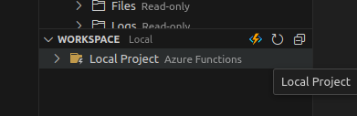

2 – Create a new function within this project and select a timer trigger template and schedule it every 12 hours. In the subject, we named your function article_generation_TimerTrigger. You should now be able to observe the new folder and files created in the folder Azure Functions:

- Azure Functions

- host.json : Specifies configuration settings for the Azure Functions host, such as function timeout, host version, and extension bundle details. In our context t’s used to specify how to processes events from the Event Hub, including batch size, checkpoint frequency etc, to control event processing behavior.

- requirements.txt : Lists the Python packages and their versions required by your Azure Function to ensure the correct environment is set up when deploying or running the function.

- local.settings.json : Contains local development settings and connection strings, enabling you to configure environment-specific variables for testing and debugging your Azure Functions locally.

- article_generation_TimerTrigger
      - function.json : Defines the metadata and configuration for an individual Azure Function, including trigger bindings, input and output bindings, and other function-specific settings.
      - __init__.py : The Python that contains the code for this Azure Function.

For now, this project exists only locally and you will later deploy it to your Azure Function App by doing so:
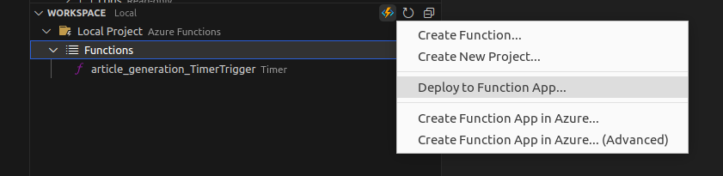

3 – Using the resources in XXX/src/Azure Functions, update the files:

- init.py : you have to define the connection to the Event Hub in order to define a Event Hub Producer Client. Then you have to create a batch and send it to the Event Hub. You can use the python file clean_article.py to clean the content of the articles or you can make this cleaning youtself. For now we can hardcore the credentials to the resources until the first deployment but we will hide them later in the hands-on.

- function.json : our function will provide an output, without reading an input, hence we only have “direction” = “out”. Update the connection settings for the Azure Event Hub that will receive the news articles. Careful : you are not supposed to hardcode variables in the function.json file. You must create those variables by declaring new application settings (configuration tab of your Azure App Function). Once those application settings defined, you can use the variable names in your function.json file.

- requirements.txt : simply copy the one provided in src/Azure Functions. In AZF, the requirements.txt file is on the level of the Function App, not on the level of the function. Reminder: this requirements file work for Python 3.8.

- host.json : update the file so that the Azure Function runtime will:
      - Save its progress checkpoint after processing one event.
      - Process one event at a time.
      - Preload two events in advance for faster processing.

Tip : in the Azure Event Hub Namespace event-hub-hands-on, two shared access policies have been created ; sender_policy and listen_policy. Use the sender_policy connection string for your function.json file (via the application settings).

4 – Deploy your function to your Azure Function App from VSC.
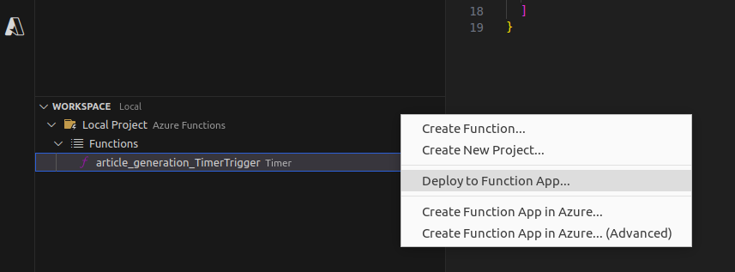

If the deployment is successful you should see your Time Trigger Function appear in hands-on-C2C-yourname.

Once you’ve clicked on your function inside your Azure Function App, you can use the monitor tab to make sure the last runs were successful.
In case of errors, make sure the connection settings to the Azure Event Hub are correct.

Tip : in case you get the error message "Deployment 'latest' not found" you should reset the publish profile on the overview tab f your Azure App Function.

5 – To avoid hardcoding the credentials of the Azure Event Hub in the init.py you can also call the variables declared in the Application Settings of your Azure Function App. You can call any variable set as application parameter in your Azure Function App by using os.environ.get(“myvar”).

6 – Make sure that the Azure Function is running like expected by looking at the logs (tab monitor in the Azure Function App) and by going on your Azure Event Hub. You should see messages arriving :

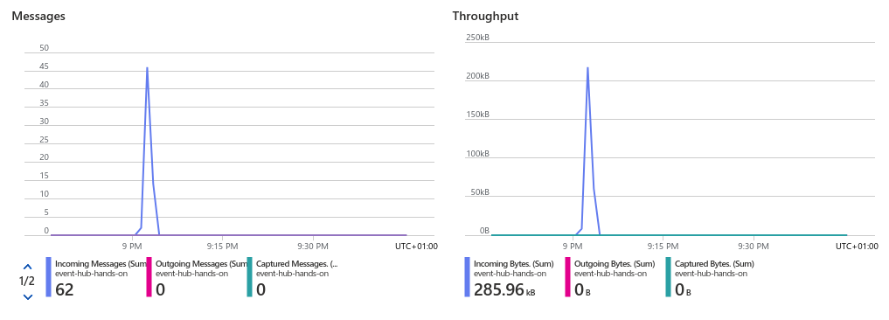
At the moment, there are no outgoing messages are we are not reading from this Azure Event Hub yet.

Update the CosmosDB database with Azure Functions

1 – Create a new function from VSC (by clicking on the trigger sign next to Workspace, once on the Azure tab) and use a Azure Event Hub trigger template. We named our function article_similarity_EventHubTrigger.

2 – Using the code inside XXX/article_similarity, update the code of this new Azure Function.

The overall purpose of this python script is:

- To receive an incoming article and extract its content into a dictionary in the main() function.

- To apply the function insert_article() to this new article converted to a dictionary. This function will:

  - Check that the arriving article is not already in the CosmosDB graph.

  - Extract labels from the article by doing an API call of an open-source model (label_article.py). This model is going to detect if the article is about sports, entertainment, business, politics or tech. For a scoring : {sport : 1, entertainment : 2, business: 3; tech : 4, politics: 5} it means the articles is most likely about sport and/or entertainment and least likely to be about politics. This will be useful to compute similarity between articles that are already relevant to each other in order to save time and compute power.

  - Query the articles in the graph that have same categories that the arriving article.

  - Iterate through all those selected articles in the graph and compute their similarity with the arriving article and insert the new article by specifying the similarity relationship between each articles. We will create a similarity relationship only if the similarity score is higher than 0.4.

Now you have to:

- Update the function.json and the beginning of init.py that reads the database names and connection strings, by updating the Application Settings.

- Complete the main() function so that you extract the incoming article and parse it into a dictionary.

Notes :

  - The use of async def allows for non-blocking I/O operations, enabling efficient and concurrent handling of incoming articles. In short, the program works faster and doesn't ignore new articles while it's busy with others.

  - We are using await insert_article(). The await keyword in this function is used to tell the program to wait for the insert_article operation to finish before moving on to the next event. It ensures that the program doesn't continue processing events until the current article has been inserted into the graph database.

  - Before the main() function, we are using nest_asyncio.apply(). It allows you to handle asynchronous event-driven operations, such as processing incoming articles concurrently, without interfering with the event loop used by the Azure SDK for Event Hubs. Without it, you would face issues with event handling and potential blocking of other tasks.

  - The input parameter events is a list containing the events. The length of events can be set in the function.json file via the parameter maxBatchSize.
      - Small Batch:
        - Pros: Low latency, resource-efficient.
        - Cons: Increased processing overhead, higher network traffic.
      - Big Batch:
        - Pros: Efficient processing, reduced network overhead.
        - Cons: Higher latency, resource-intensive.

- Complete the function insert_articles().

  - Create a Gremlin client gremlin_client and connect to the Cosmos DB graph.

  - Using gremlin_client.submit(), check that the incoming article is not already in the database. In our case we will use the title or an article as its identifier.

  - Compute labels of the new article using get_best_tags() and add them to the dictionary that contains the property of the article.

  - Execute a gremlin query that create a node for the new article with the properties: title, description, publishedAt, content, sport, entertainment , business, tech, politics.

  - Submit a gremlin query that fetch the last 200 articles that have at least one label in common in their top two labels. You can extract all the titles of those article into a list.

  - Iterate through this list of article titles. For each title, query the content, description and use it to compute the similarity of the new article.

  - If the similarity value is superior than the predefined threshold (~0.4), run a gremlin query to create a new similarity relationship between the two articles.

3 – Make sure that there are now outgoing messages leaving your Azure Event Hub. Go to your CosmosDB graph and make sure you are successfully inserting articles.

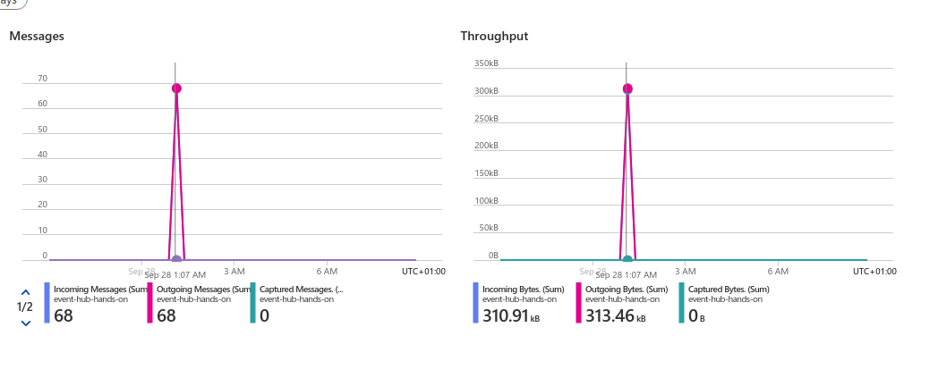

The first articles won’t have similarities relationships as you won’t have enough history yet. After a few runs of the function article_similarity_EventHubTrigger, you should start seeing similarity relationships being created between articles:
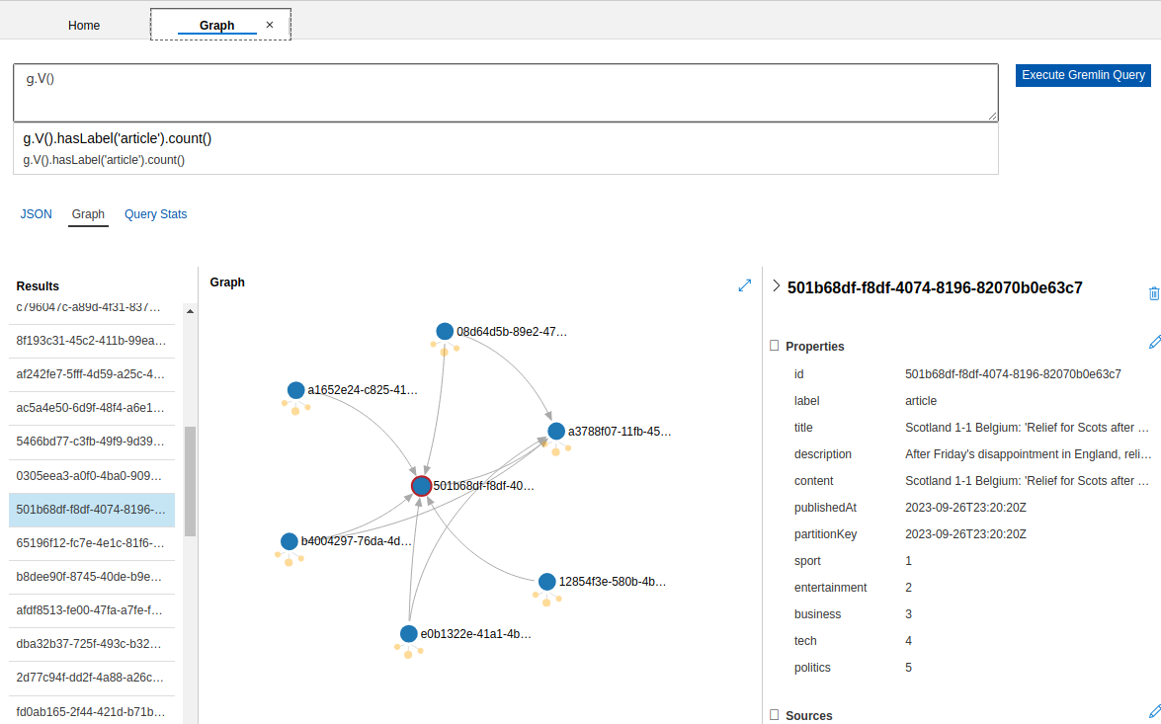

4 – Once you get a few days of history, get familiar with the graph database and the gremlin querying language by querying:

- All the articles with “Belgium” in the description.
- The count of articles per day.
- The 20 most recent articles.
- All the articles linked by a similarity relationship that is higher than 0.7.

Improving the deployment of the project

You are reaching the end of the guided path. Time for you to explore yourself in more autonomy. Please let us know of your progress and we will update this pdf and our solution branch based on your findings !

Potential next steps for this project are related to the deployment of the project:

1 – Using deployment slots and the deployment Center in Azure Function, set up Continuous Integration and Continuous Deployment (CI/CD) for this Azure Functions project.

2 – Instead of using Azure Functions, use Azure Kubernetes Service (AKS), create two microservices for the article generation and article insertion in the graph database and create CI/CD pipeline.

