What is a branch ? What is branching ?

* A branch is an “alternative universe” of your project, where you can experiment with new ideas (e.g. new data analyses, new data transformations, new statistical methods). After experimenting, you can then “merge” your changes back into the master branch.
* Branching isn’t just for group collaborations, you can use branching to collaborate with yourself, e.g., if you have a new idea you want to play with but do not want to have that idea in master yet.
* The “master” branch (the default in GitHub) is your best draft. You should consider anything in “master” as the best thing you’ve got.
* The workflow using branches consists of
  1. Create a branch with an informative title describing its goal(s).
  2. Add commits to this new branch.
  3. Merge the commits to master

Branching Overview:

Make changes, additions, improvements on a branch; once you are satisfied merge the content or files of that branch to you Master. (The Master, or Master branch is the original file document that you may want to modify).

STEP 1 Create a new Github repository

STEP 2 Go to the Bash terminal and create a README.md file

12407@DESKTOP-M8SMUFL MINGW64 ~/Documents/Folder11 (master)

$ touch README7.md

Step 3 Go to the README7.md file and edit it. (When you go to the README7.md file click on it and choose a text editor, I chose note pad) Enter and save the message “This is good Branching practice”

Step 4 Now enter the command ls. You should see the README7.md file

12407@DESKTOP-M8SMUFL MINGW64 ~/Documents/Folder11 (master)

$ ls

Diamondsfile.Rmd README7.md

README5.md "UTF-8''STAT412612CLASSWORK1.pdf"

README6.md irisfile.R

Step 5

12407@DESKTOP-M8SMUFL MINGW64 ~/Documents/Folder11 (master)

$ git init

Reinitialized existing Git repository in C:/Users/12407/Documents/Folder11/.git/

Step 6

12407@DESKTOP-M8SMUFL MINGW64 ~/Documents/Folder11 (master)

$ git add README7.md

Step 7

12407@DESKTOP-M8SMUFL MINGW64 ~/Documents/Folder11 (master)

$ git commit -m "README7.md push"

Step 8

12407@DESKTOP-M8SMUFL MINGW64 ~/Documents/Folder11 (master)

$ git remote add forty <https://github.com/spingarn1974/repo2.git>

Step 9

12407@DESKTOP-M8SMUFL MINGW64 ~/Documents/Folder11 (master)

$ git remote -v

12407@DESKTOP-M8SMUFL MINGW64 ~/Documents/Folder11 (master)

$ git push -u forty master You have now pushed the README7.md file to GitHub

Now create a branch

Step 10

12407@DESKTOP-M8SMUFL MINGW64 ~/Documents/Folder11 (master)

$ git branch branch9 I have created a new branch called branch9 (Use your last name followed by the number 1 for your branch name)

Now move to the branch

Step 11

12407@DESKTOP-M8SMUFL MINGW64 ~/Documents/Folder11 (master)

$ git checkout branch9 I have now switched to branch9

12407@DESKTOP-M8SMUFL MINGW64 ~/Documents/Folder11 (branch9)

Note above that you are now on the newly created branch instead of the master

Step 12

Now create the following Rmarkdown file and save it to the your Bash Directory location. This is the file that will be merged to your master branch. I named it Diamondsfile2

```{r}

library(tidyverse)

library(dplyr)

diamonds%>%

select(price, color, x)

```

Step 13

Run the command ls and you should see it saved.

12407@DESKTOP-M8SMUFL MINGW64 ~/Documents/Folder11 (branch9)

$ ls

Diamondsfile.Rmd README7.md

Diamondsfile2.Rmd "UTF-8''STAT412612CLASSWORK1.pdf"

README5.md irisfile.R

README6.md

Step 14

12407@DESKTOP-M8SMUFL MINGW64 ~/Documents/Folder11 (branch9)

$ git add Diamondsfile2.Rmd

Step 15

12407@DESKTOP-M8SMUFL MINGW64 ~/Documents/Folder11 (branch9)

$ git commit -m "branch9 push"

Step 16

12407@DESKTOP-M8SMUFL MINGW64 ~/Documents/Folder11 (branch9)

$ git push forty branch9

Now go to GitHub

Image 1

Click the green tab Compare & Pull request

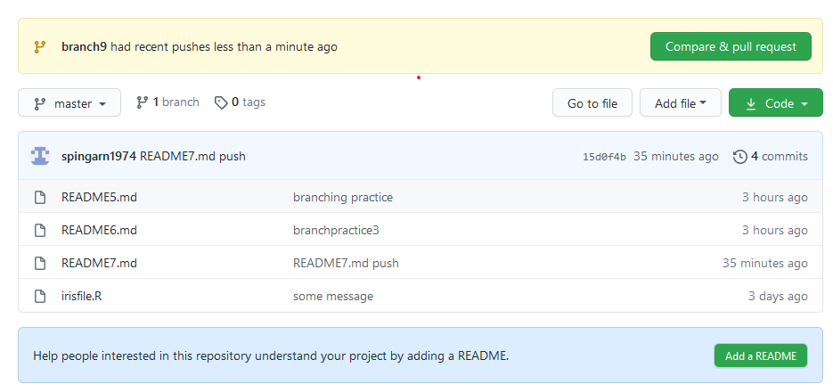

Image 2

Click the green tab Create pull request at the bottom of the screen

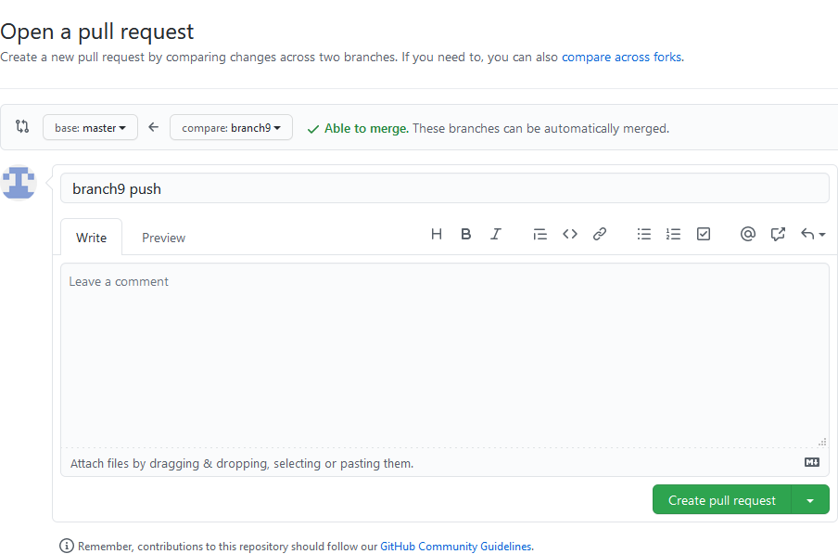

Click on the Merge pull request green tab at the bottom

Image 3

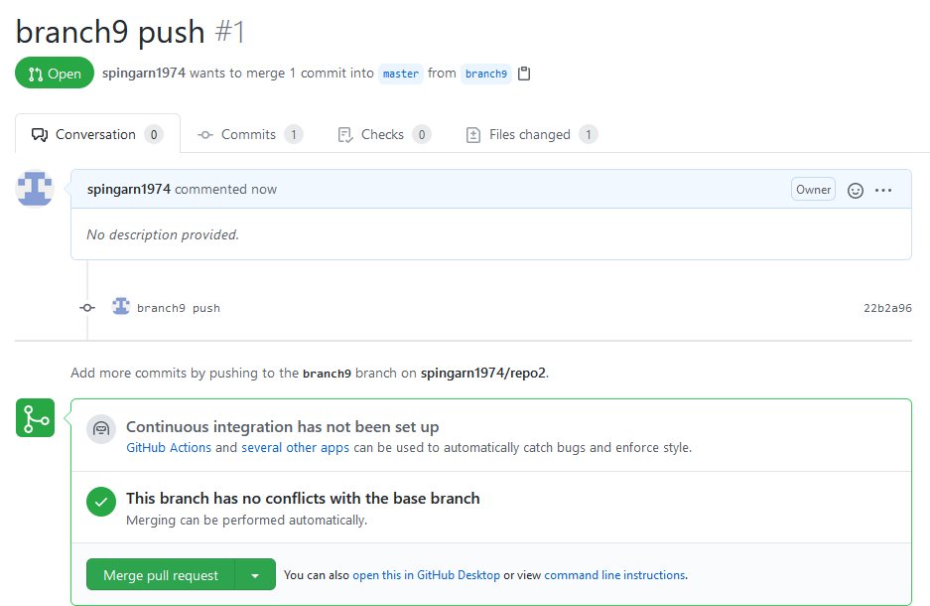

Click on the Confirm merge green tab at the bottom

Image 4

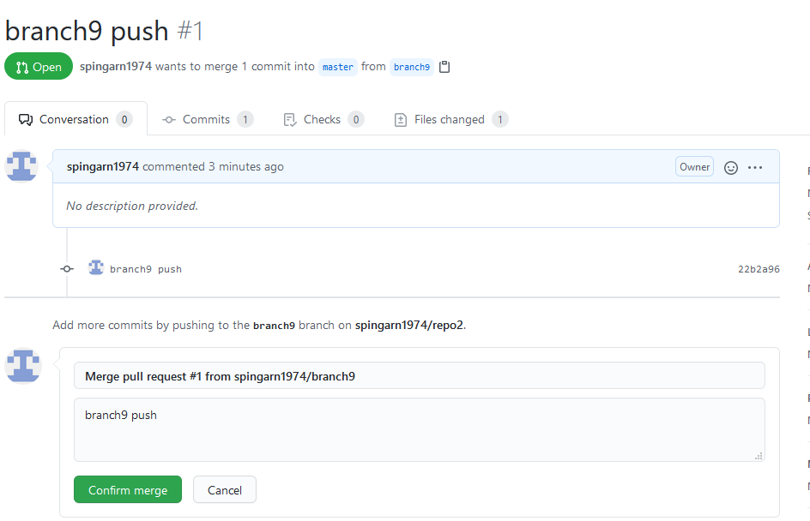

Image 5

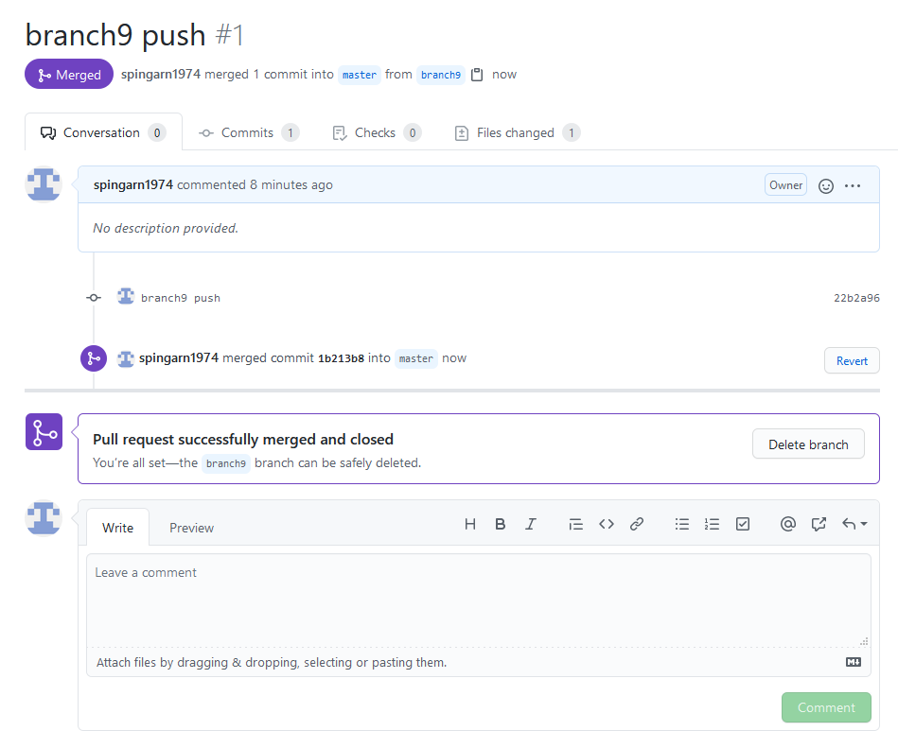

Email the url for this page (Image 5)