DS 413/613 Classwork/Lab Web Scraping

Email an Rmarkdown File and a Word File that shows all required code and output.

Using the following link , <https://www.imdb.com/best-of/highest-rated-movies-of-2019/ls091392448/>

1) Show and use R code and the Web Scraping methods illustrated in class to collect data on the top 20 movies of 2019. The first five rows of the data table to be produced are given below. Do not forget to use Chrome and Selector Gadget.

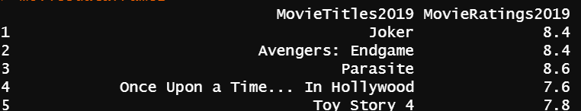

2) Use and show R code that will produce the following summary values for the variable MovieRatings2019:

a) Minimum b) Maximum c) Q1 d) Median e) Q3 f) Mean

3) Use and show R code to produce a boxplot for the variable MovieRatings2019