DS 413/613 FINAL EXAM Summer 2021

**Problem 1**

Using the following link,

<https://forecast.weather.gov/MapClick.php?CityName=Washington&state=DC&site=LWX&textField1=38.895&textField2=-77.0373&e=1#.YLPCyflKiUk> . Show and use R code and the Web Scraping methods illustrated in class to collect data on weather for Denver Colorado. The entire table is given below (There may be differences in your table, but structurally, you should get a table very similar to the one shown below.. Do not forget to use Chrome and Selector Gadget.

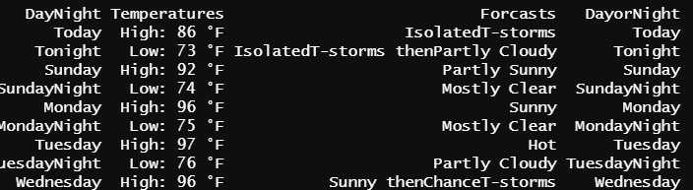

**Problem 2**

a) Use data.table coding to read in the nyc14 data as was done in class. Assign the data table to the variable **flights3**

b) Use data.table coding to modify flights3 so that only the column variables **origin**, **dest**, and **carrier** appear.

c) Now use data.table coding that reflects an origin of JFK, a destination of SEA and a carrier of only Delta Airlines DL.

d) Use data.table coding to remove the variable **air_time** from the original flights3 data table.

e) Use and show data.table coding to output the maximum and the minimum values for the variable **distance.**

f) Use two or three sentences to explain the summary provided below and then use and show data.table coding to produce the table.

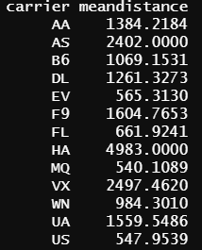

You need only email a Word or Pdf document that shows code for Python problems

**Problem 3**

a) Use and show python code to arrange the elements of the array in ascending order (from left to right)

Vector3 = np.array([12,3,16,23,11,9,20,15,7,17,2])

Vector3

b) Use and show python code that will extract all elements of the array given below that are greater than 12.

Vector3 = np.array ([12,3,16,23,11,9,20,15,7,17,2])

Vector3

c) Use and show python code that will produce the mean for the elements in the array below..

Vector3 = np.array ([12,3,16,23,11,9,20,15,7,17,2])

Vector3

d) Use and show python code that will read in the excel sheet estate data; that is posted on blackboard. Assign the data the variable **estate**.

e) Use and show python code that will show rows 200 and 201 of the estate data table

f) Use and show python code to determine if there are houses in the estate data that are less than $400000 that have 4 bedrooms.

g) Grouping by the variable **Quality**, of the estate data , use and show python code that will show maximum minimum counts bathrooms.