DS 413/613 Homework 10 ShinyApps

Instructions: Email the R files whose code will generate the following shiny apps

1) This shiny app will generate a histogram for any selected variable of the data table **mtcars**

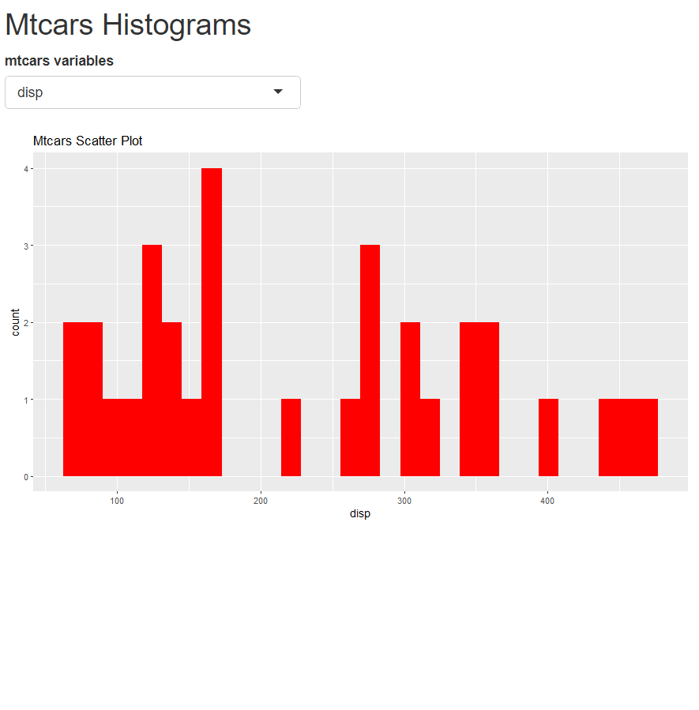

2) This shiny app will generate the summaries for each variable of the mtcars data table and will also generate the

multiple choice options for the question given at the bottom. More that one of the possible selections can be chosen.

