DS413613 Homework 5 Key

James Dickens

2/25/2021

# DS 413/613 Homework 5 key  
  
Stockreturns <- c(-8.36, 1.63, -2.27, -2.93, -2.70,   
 -2.93, -9.14, -2.64, 6.82, -2.35,   
 -3.58, 6.13, 7.00, -15.25, -8.66,  
 -1.03, -9.16, -1.25, -1.22, -10.27,  
 -5.11, -0.80, -1.44, 1.28, -0.65,  
 4.34, 12.22, -7.21, -0.09, 7.34,   
 5.04, -7.24, -2.14, -1.01, -1.41,   
 12.03, -2.53, 4.33, 1.35)  
Stockreturns

## [1] -8.36 1.63 -2.27 -2.93 -2.70 -2.93 -9.14 -2.64 6.82 -2.35  
## [11] -3.58 6.13 7.00 -15.25 -8.66 -1.03 -9.16 -1.25 -1.22 -10.27  
## [21] -5.11 -0.80 -1.44 1.28 -0.65 4.34 12.22 -7.21 -0.09 7.34  
## [31] 5.04 -7.24 -2.14 -1.01 -1.41 12.03 -2.53 4.33 1.35

# 1  
mean(Stockreturns)

## [1] -1.124615

# 2  
sd(Stockreturns)

## [1] 5.977673

# 3) Assuming a normal distribution, use and show R code to find the   
# proportion of returns that are less than -1.5.  
pnorm(q = -1.5, mean = -1.124615, sd = 5.977673)

## [1] 0.4749637

#4) Assuming a normal distribution, use and show R code to find the return   
# value that is above 70% of the returns  
qnorm(p = 0.70, mean = -1.124615, sd = 5.977673 )

## [1] 2.01008

# 5) Use and show R code to find Q1 for the data.  
qnorm(p = 0.25, mean = -1.124615, sd = 5.977673 )

## [1] -5.156494

# 6) Explore the data by producing and examining a boxplot and checking for  
# normality.  
  
boxplot(Stockreturns)

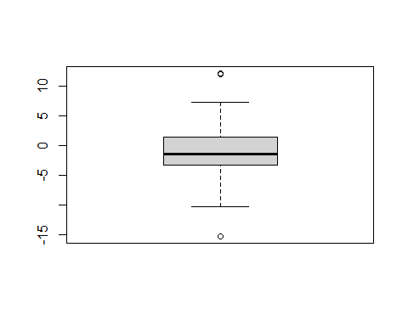

qqnorm(Stockreturns)  
qqline(Stockreturns)

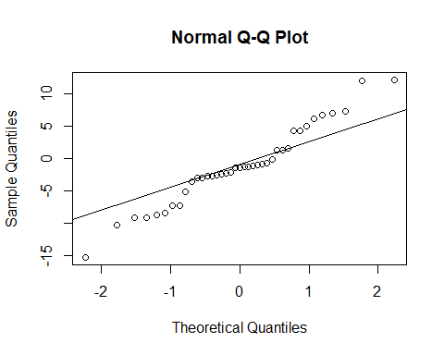

# 7) State the appropriate null and alternative hypothesis required for the   
# appropriate t test.  
 #H(o) : popmean = .95  
 #H(a) : popmean < .95  
   
# 8) Use and show R code that will output the needed p value and confidence  
# interval to determine if the null hypothesis should be rejected.  
   
 t.test(Stockreturns,mu=.95, alternative = "less", conf.level = .95)

##   
## One Sample t-test  
##   
## data: Stockreturns  
## t = -2.1674, df = 38, p-value = 0.01827  
## alternative hypothesis: true mean is less than 0.95  
## 95 percent confidence interval:  
## -Inf 0.4891698  
## sample estimates:  
## mean of x   
## -1.124615

# 9)  
  
# The null hypothesis should be rejected. The broker performed worse.