DS 413/613 Homework 9 Web Scraping using an API

Instructions: Generate an Rmardown file and a Word file that shows all required code and output. Push your files to GitHub Repository.

1) Use and show a census API key that gives you access to the ACS data

2) Using ACS census data from 2015, show and use R code to do the following:

a) Produce a tibble that shows the median income estimates and the margin of errors for white males in the counties of California. The required variable code starts with the characters BO1OO1. Use the table to find the other characters.

The first five rows of your tibble are provided below:

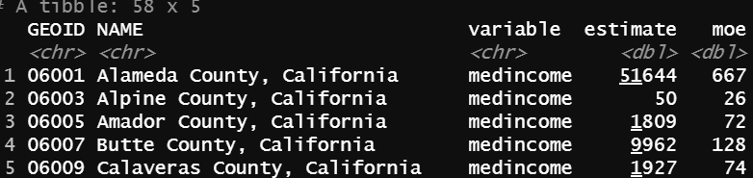

b) Use a dplyr functions to change your table of part a so that it reflects estimates that are greater than $30,00 dollars and list the estimates in descending order.

c) Using the tibble that you produced in part b, use and show R code that will show the county that has a median income estimate of 51644 and a margin of error of 667.

d) Use and show R code that will produce the following graph.

