DS 413/613 Classwork/Lab2 ShinyApps

Instructions: Email the R files whose code will generate the following shiny apps

1) This shiny app will generate a histogram for any selected variable of the data table **mtcars**

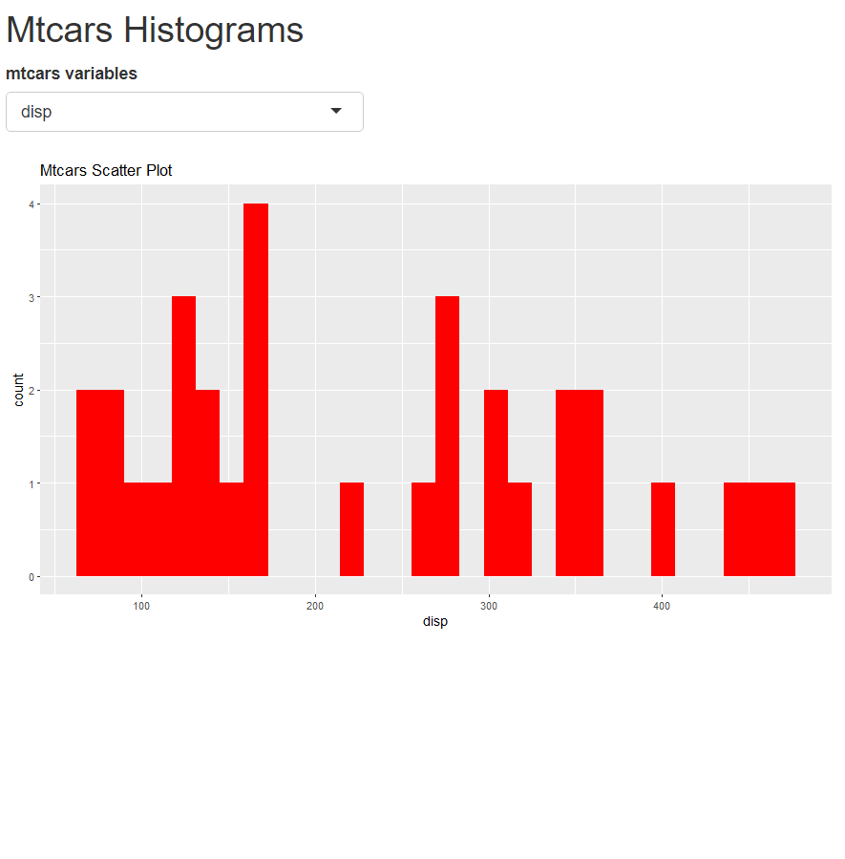

2) This shiny app will generate the summaries for each variable of the mtcars data table and will also generate the multiple choice options for the question given at the bottom. More that one of the possible selections can be chosen. Give the app a title of your choosing. The multiple choice item at the bottom should be reactive.

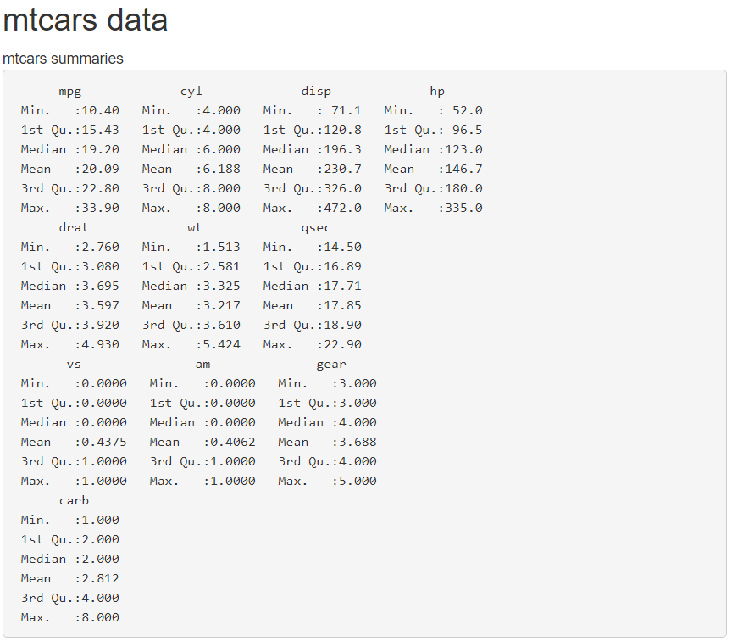

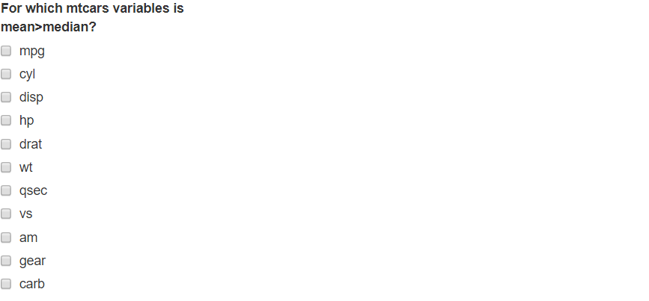

3)

Provided is a Shiny App that I created using the notes and code that we have used in class up to this point. The app consists of a boxplot and a histogram produced by randomly selected values that are normally distributed. Inputting values in the sample size box will in turn produce different boxplots and histograms accordingly.

I am providing most of the code needed to produce the app. **Your assignment is to add code to the server component that will produce the histogram and adjust the coding so that your app will reflect your name (not mine).**

Email me the R script file that has the code that will produce the entire Reactive app.

ui <- fluidPage(

h2("BoxPlot and Histogram", style = "color:red"),

h4("by James Dickens"),

numericInput(inputId = "n", label = "Sample size"),

plotOutput(outputId = "histogramplot")

)

server <- function(input, output) {

output$boxplot <- renderPlot({

boxplot(rnorm(input$n))

})

}

shinyApp(ui = ui, server = server)

An image of the app is on the following page.

